**Course Description**

In this course, you'll learn to work with data using tools from the tidyverse in R. By data, we mean your own data, other people's data, messy data, big data, small data - any data with rows and columns that comes your way! By work, we mean doing most of the things that sound hard to do with R, and that need to happen before you can analyze or visualize your data.

But work doesn't mean that it is not fun - you will see why so many people love working in the tidyverse as you learn how to explore, tame, tidy, and transform your data. Throughout this course, you'll work with data from a popular television baking competition called "The Great British Bake Off."

#### **Explore your data**

You will start this course by learning how to read data into R. We'll begin with the readr package and use it to read in data files organized in rows and columns. In the rest of the chapter, you'll learn how to explore your data using tools to help you view, summarize, and count values effectively. You'll see how each of these steps gives you more insights into your data.



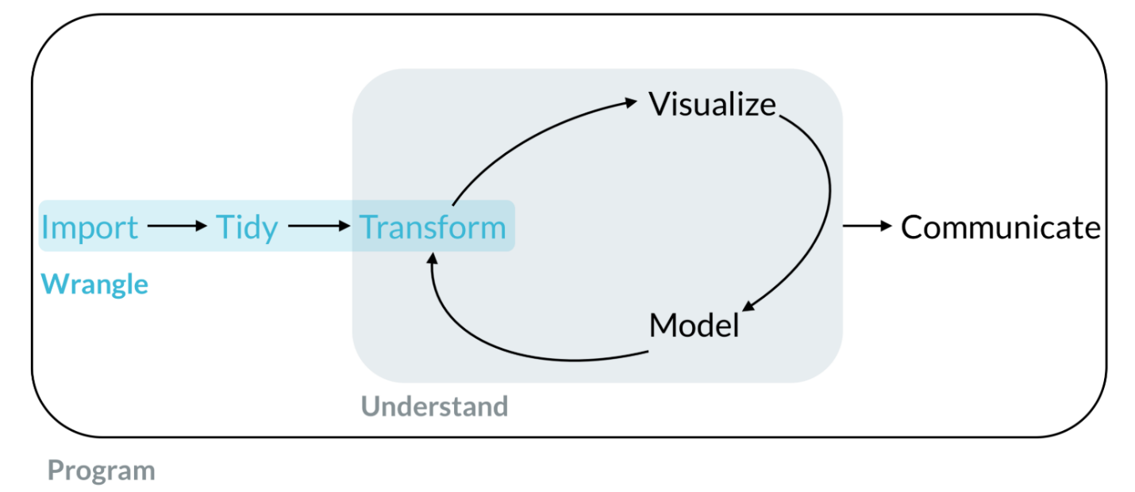

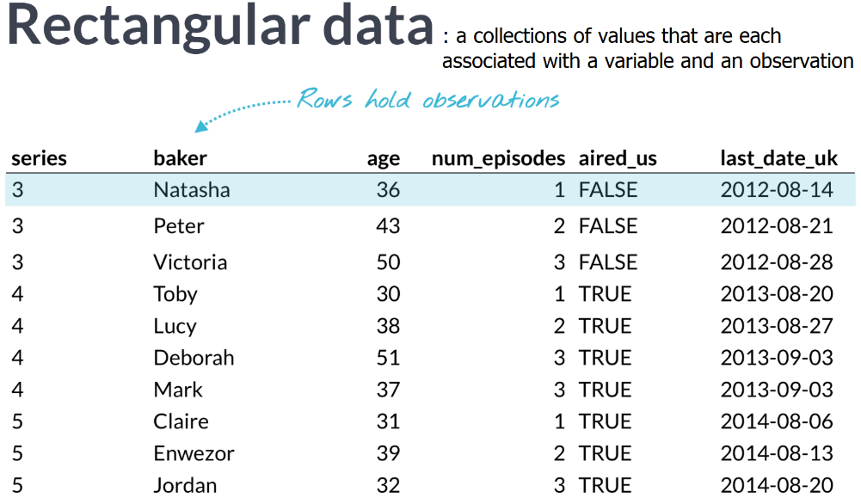

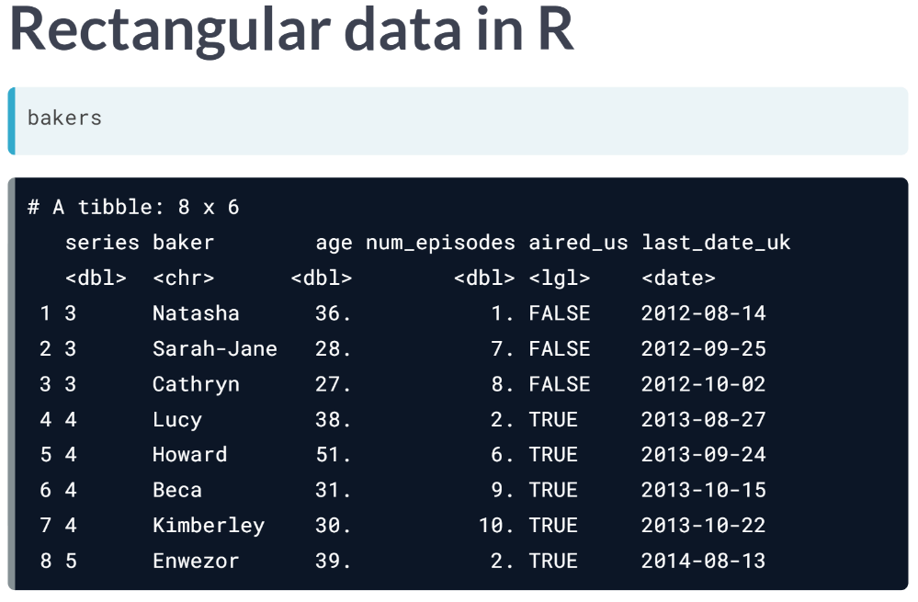

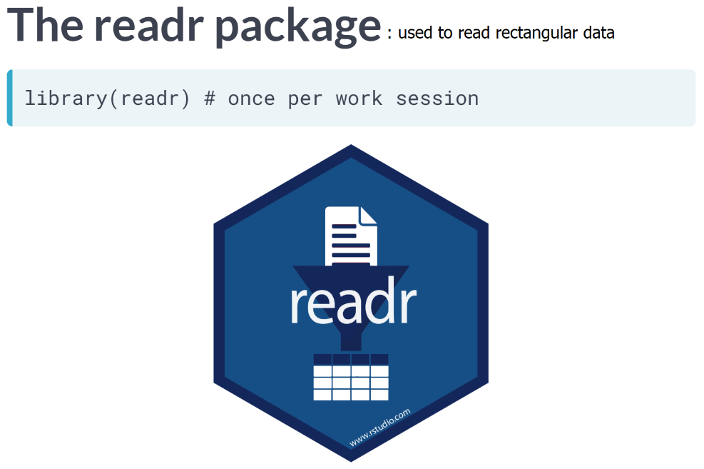

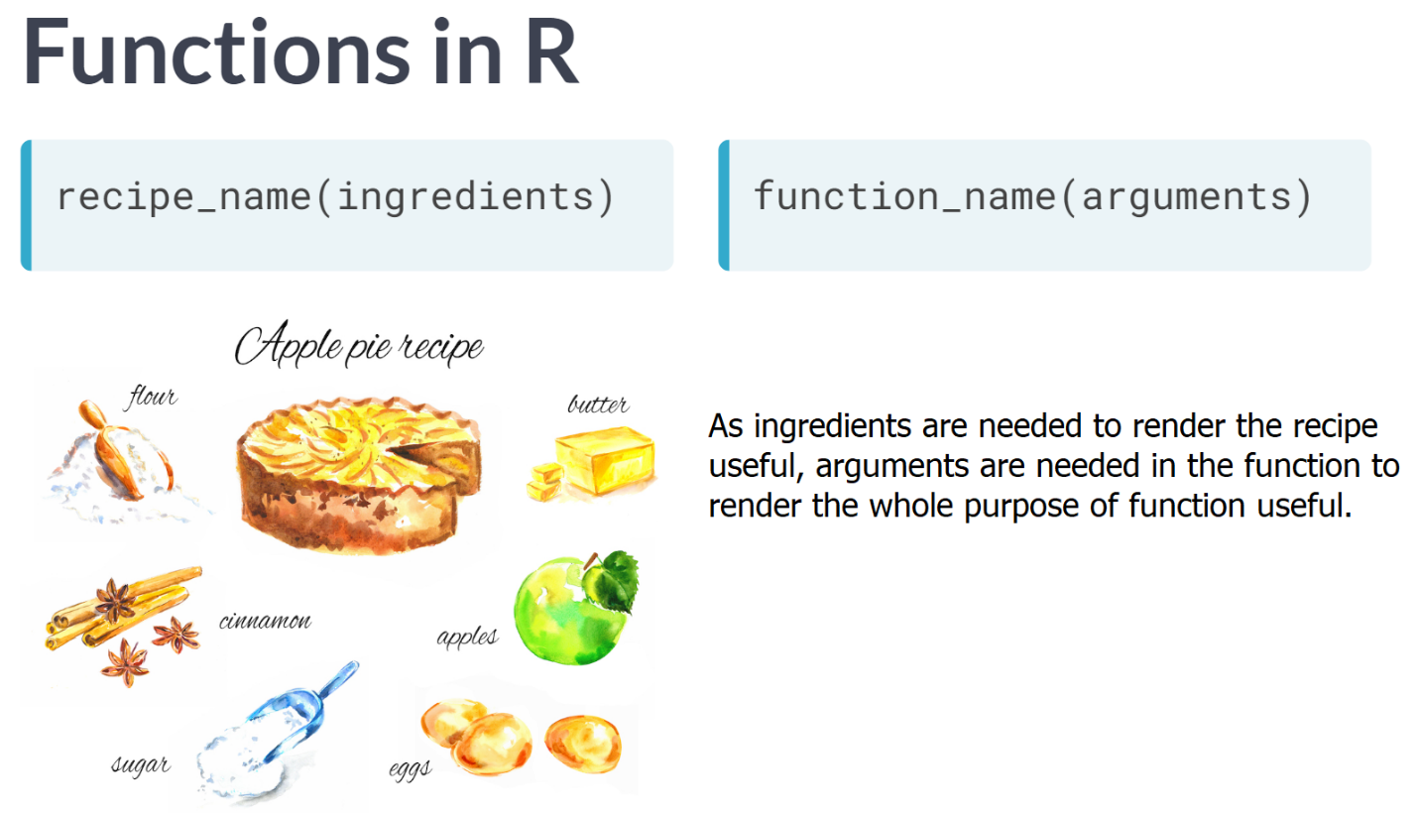

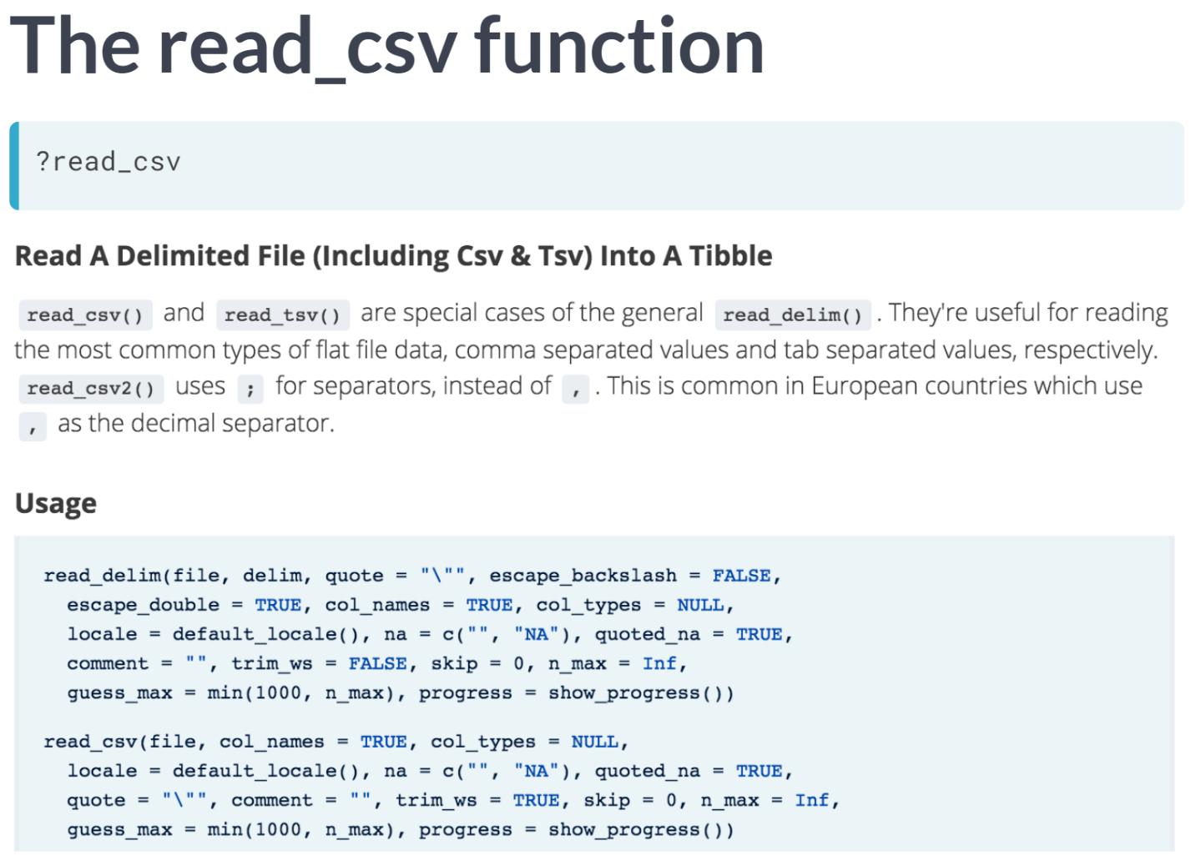

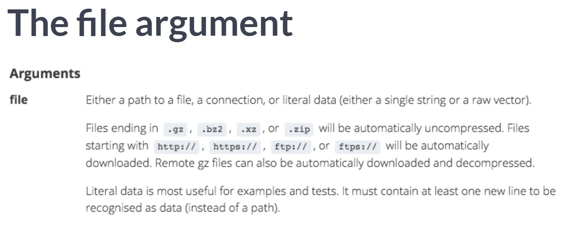

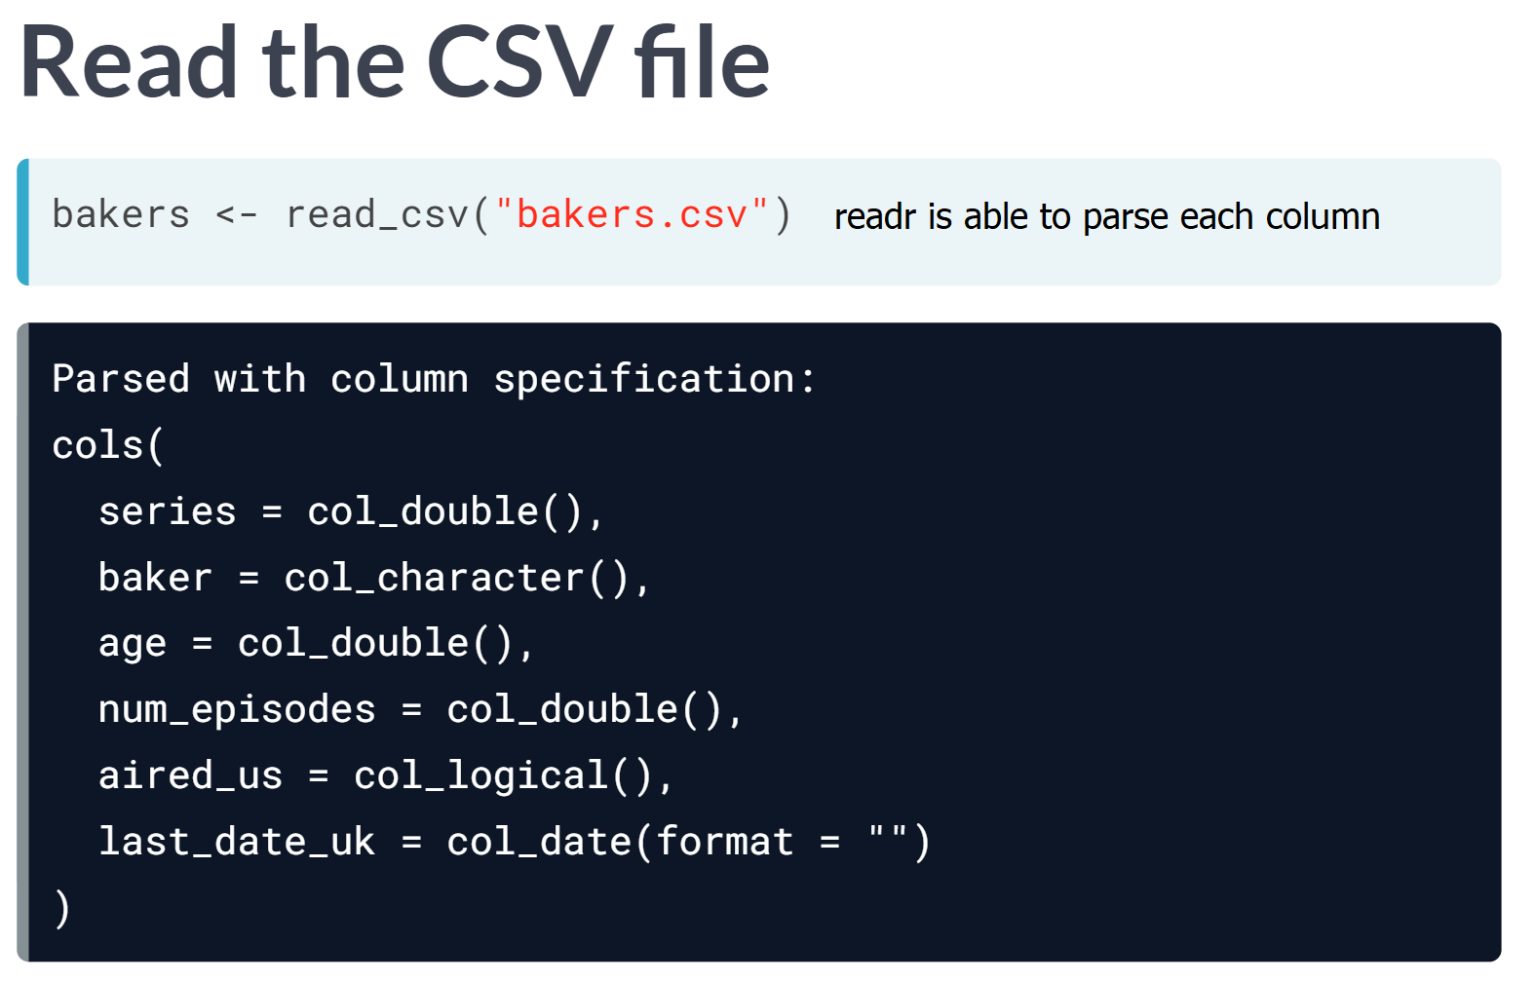

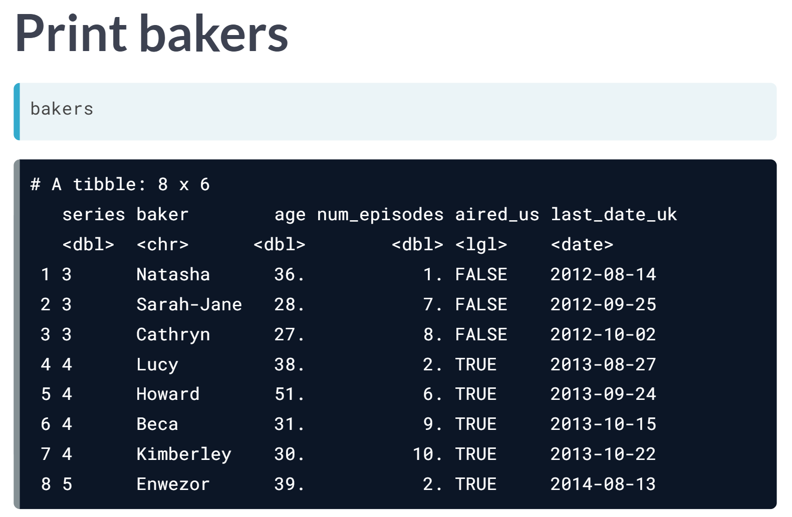

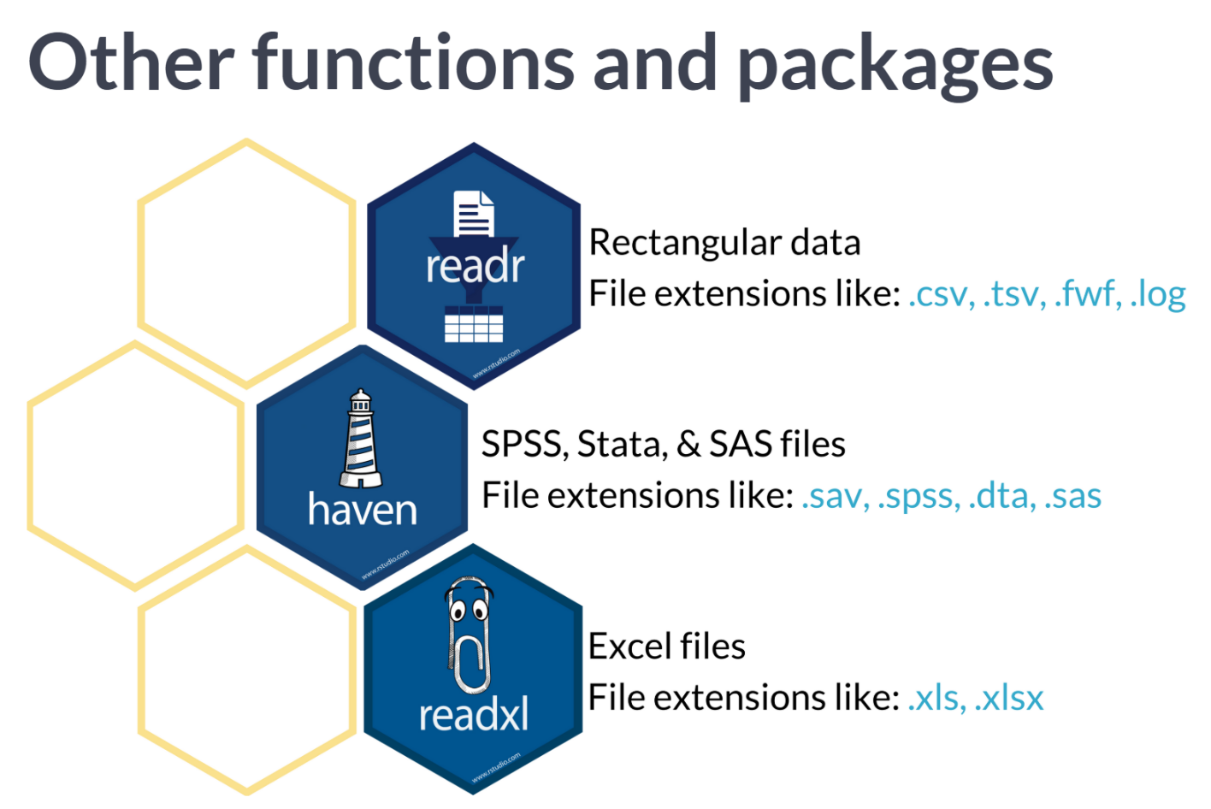

# Read a CSV file

In this exercise, you'll use read_csv() twice. The first time you will only specify the filename, but you'll notice a problem with the imported data. The second time you'll use a new argument called skip to fix the problem. Remember to use ?read_csv to read more about arguments like skip and how to use them.

The data you'll work with is from "The Great British Bake-Off." The file "bakeoff.csv" contains data for each episode of the show, organized by series and baker.

This course touches on a lot of concepts you may have forgotten, so if you ever need a quick refresher, download the [***Tidyverse Cheat Sheet***](https://datacamp-community-prod.s3.amazonaws.com/e63a8f6b-2aa3-4006-89e0-badc294b179c) and keep it handy!

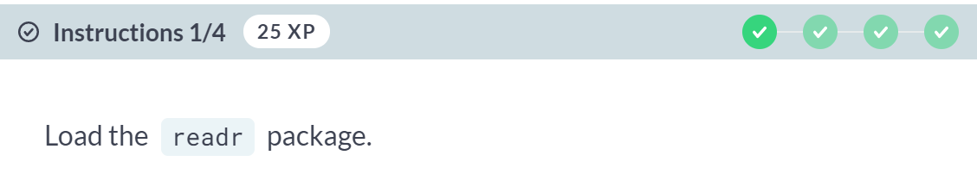

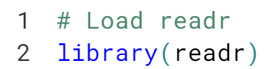

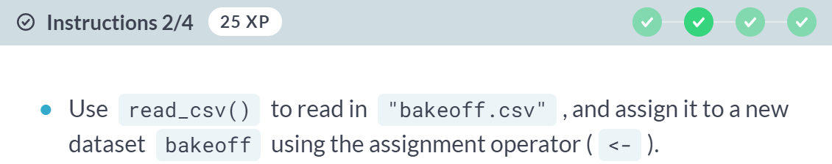

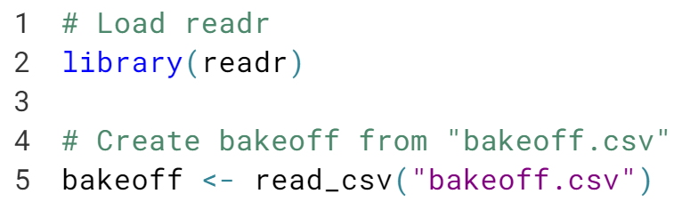

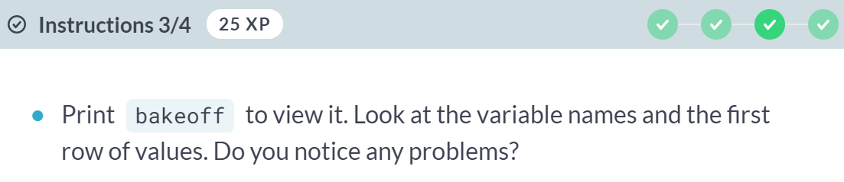

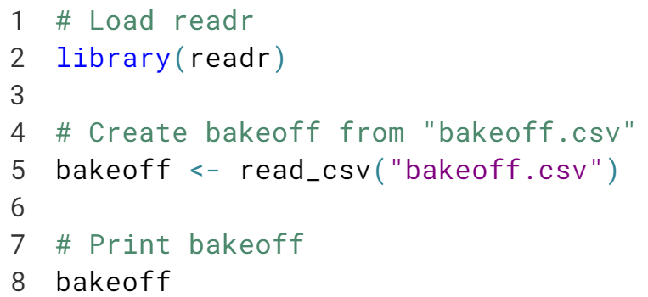

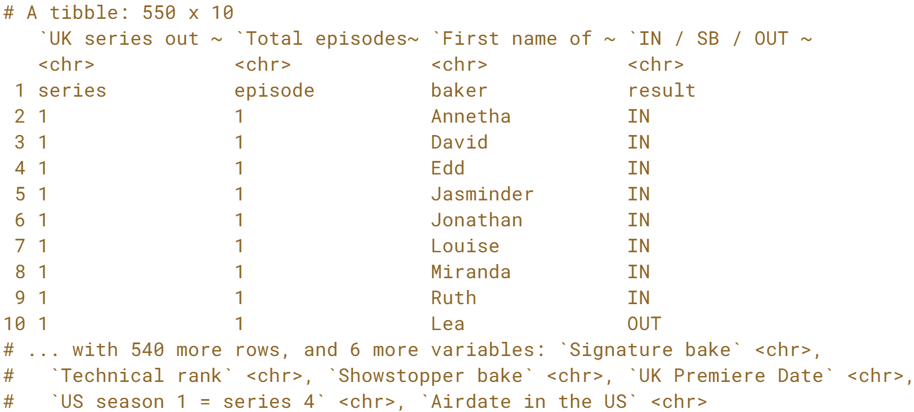

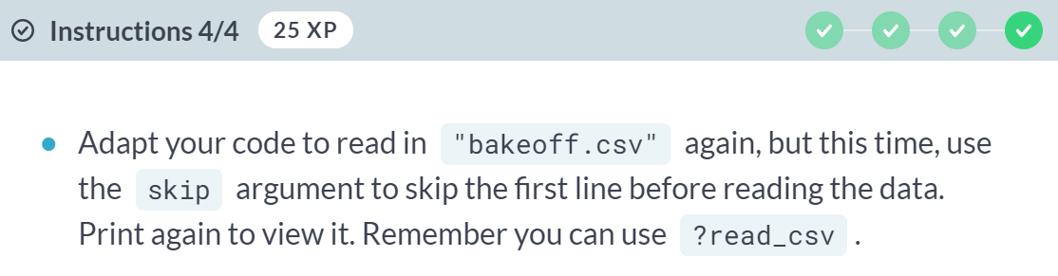

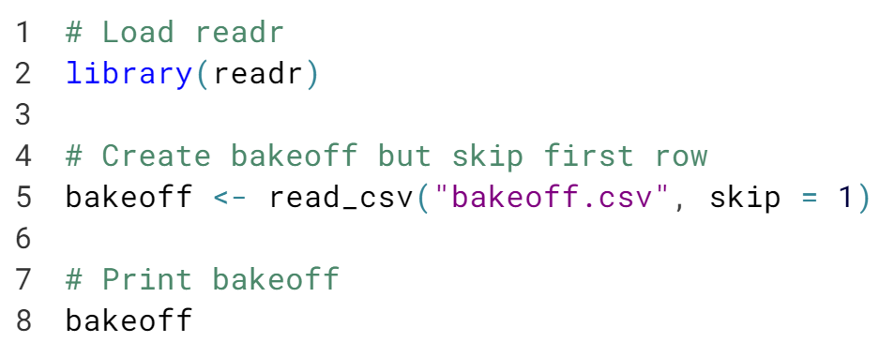

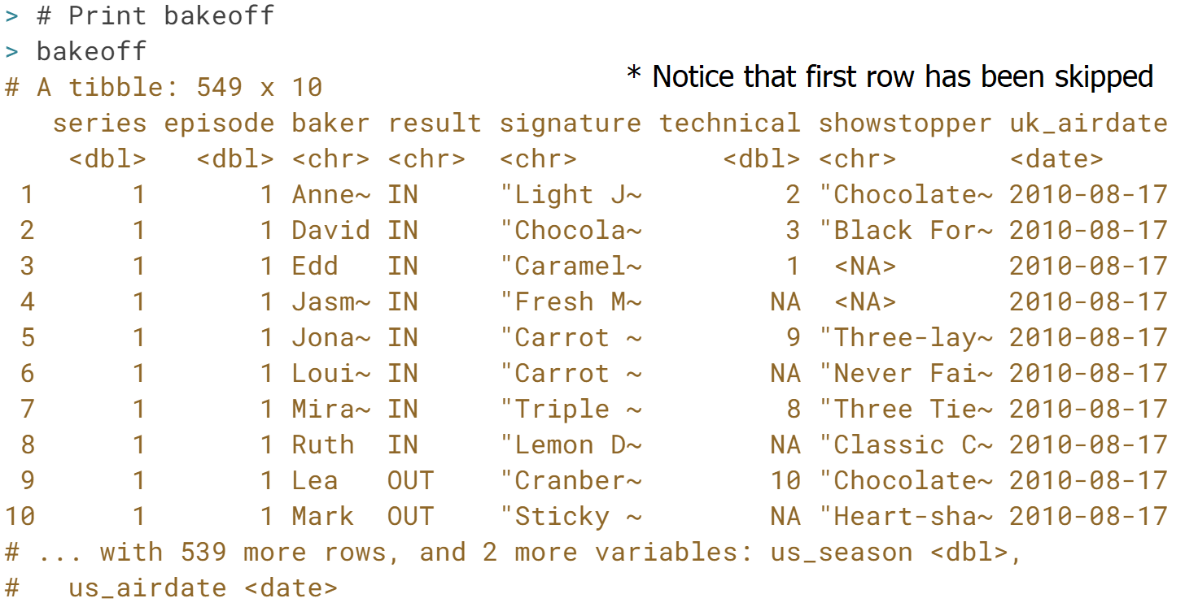

Great job! Our original import had 3 problems: we had 1 extra observation, our first row stored the true variable names, and all column types were characters. Adding skip = 1 worked because the default argument for col_names is TRUE.

# Assign missing values

The read_csv() function also has an na argument, which allows you to specify value(s) that represent missing values in your data. The default values for the na argument are c("", "NA"), so both are recoded as missing (NA) in R. When you read in data, you can add additional values like the string **"UNKNOWN"** to a vector of missing values using the [**c()**](https://www.rdocumentation.org/packages/base/versions/3.5.0/topics/c) function to combine multiple values into a single vector.

The [**is.na()**](https://www.rdocumentation.org/packages/base/versions/3.5.1/topics/NA) function is also helpful for identifying rows with missing values for a variable.

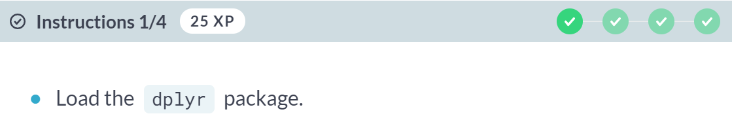

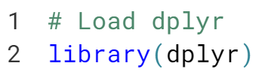

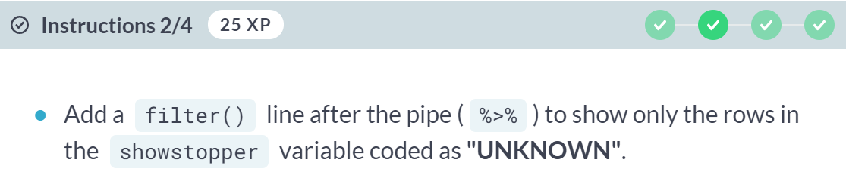

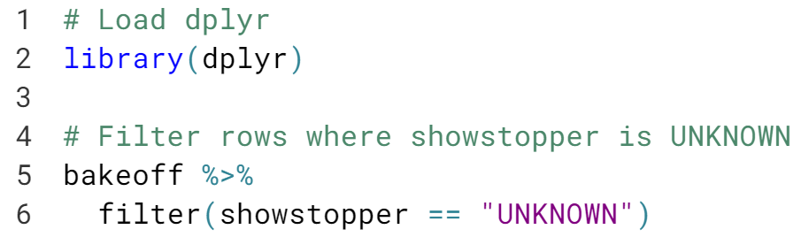

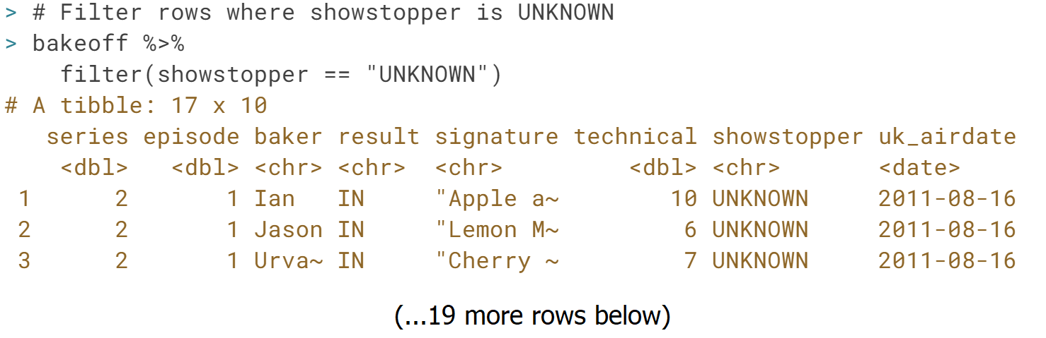

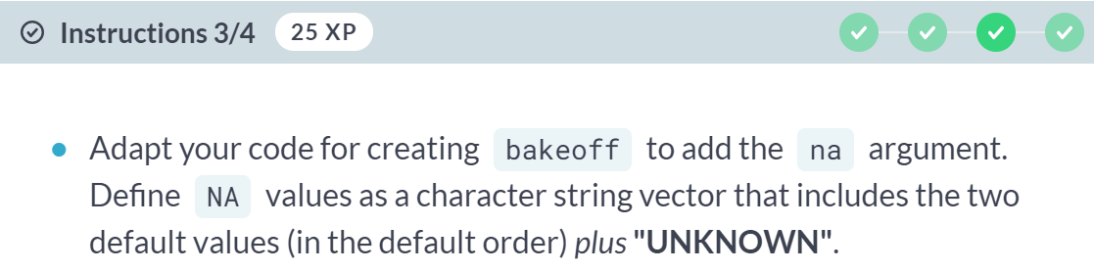

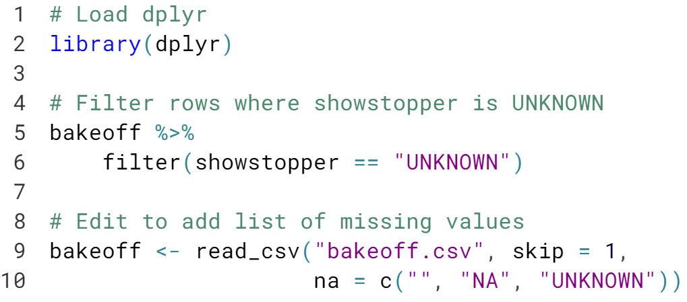

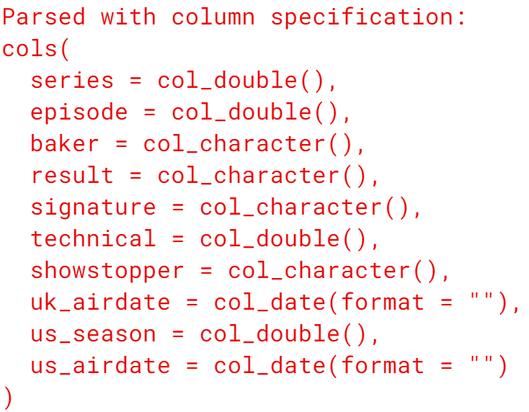

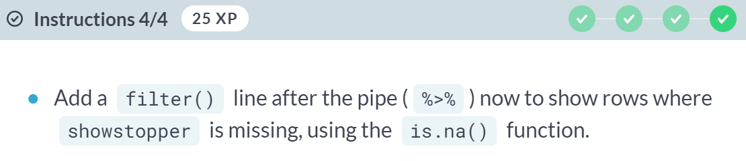

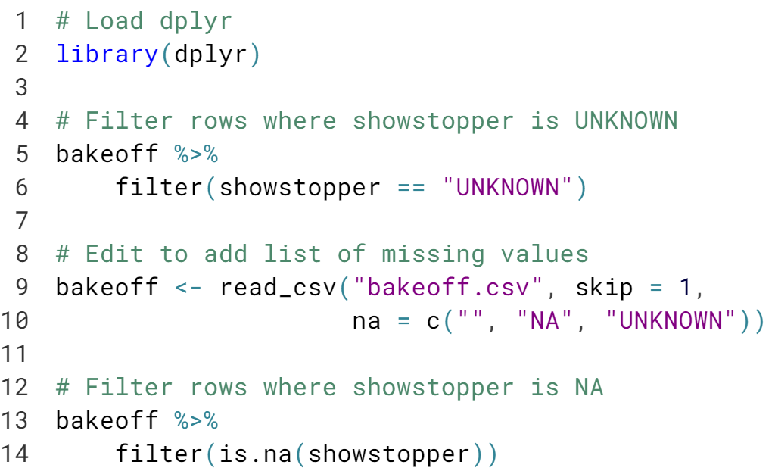

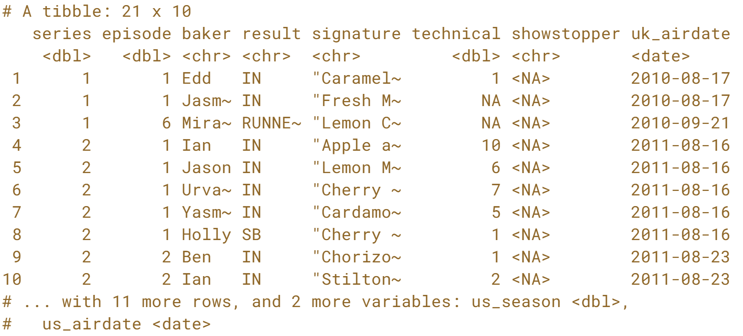

Great. We only had 4 missing values for the showstopper variable to start, but now all 21 are present and accounted for.



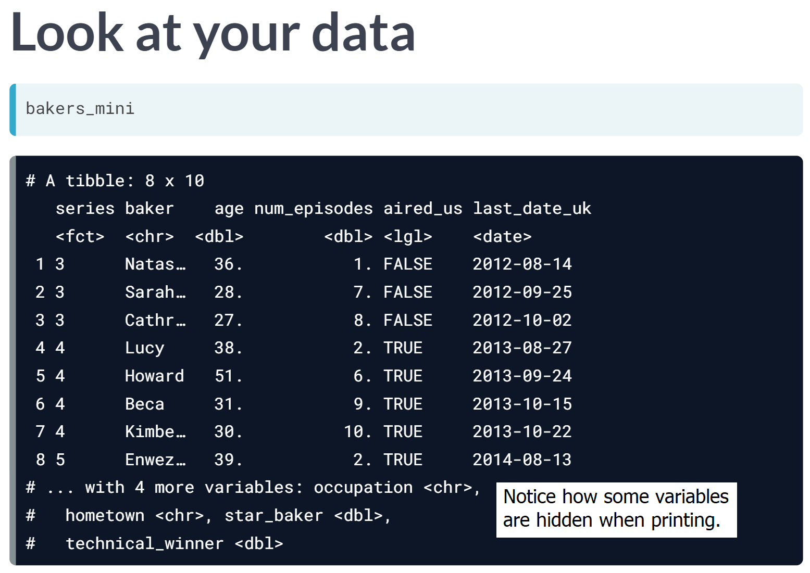

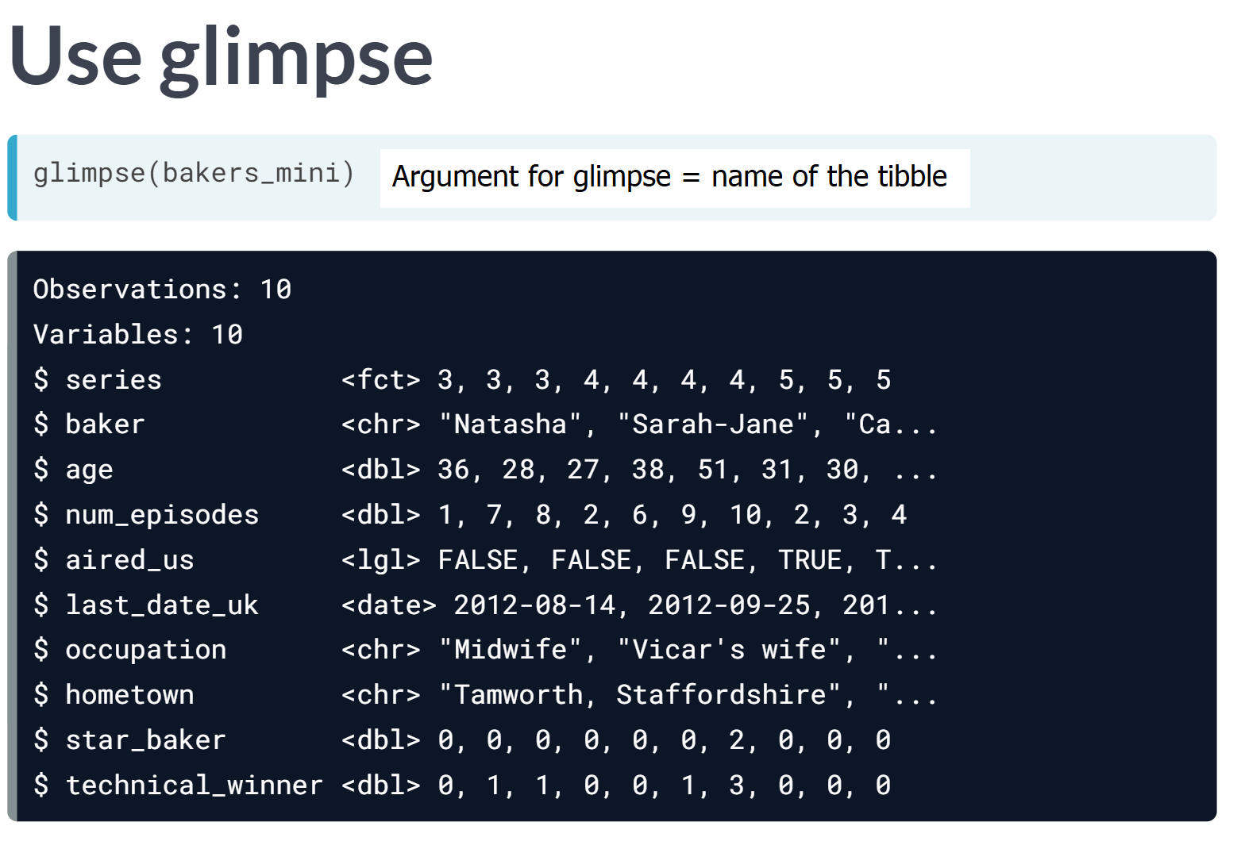

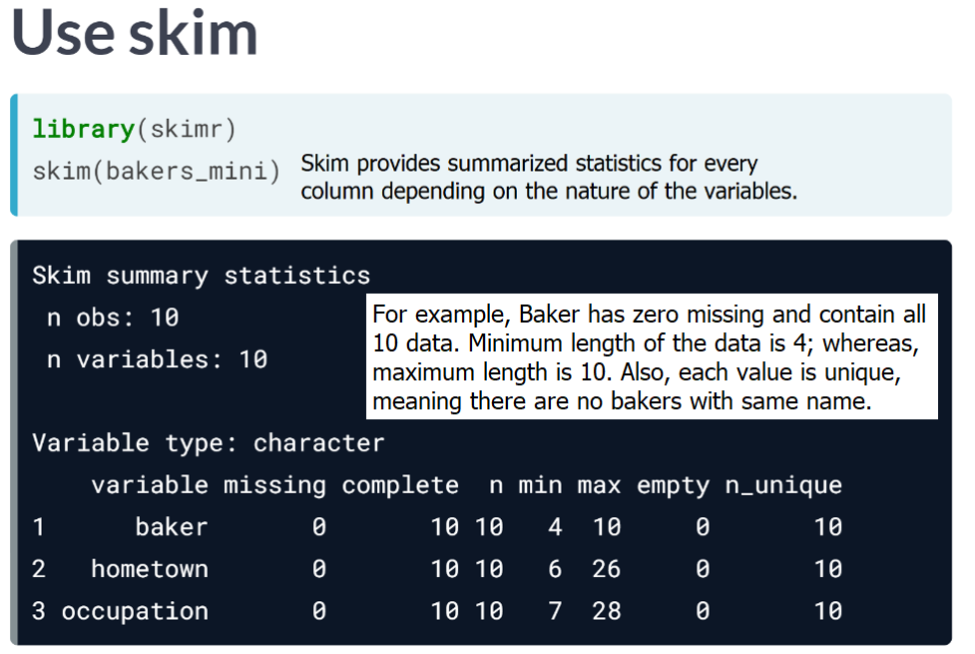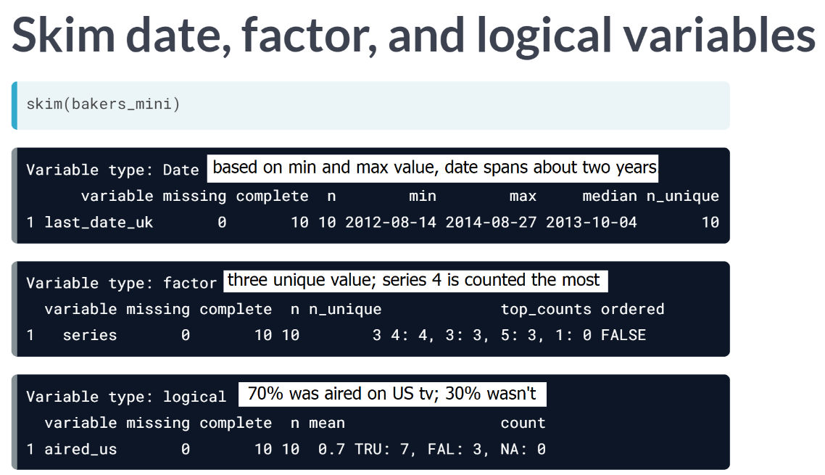  
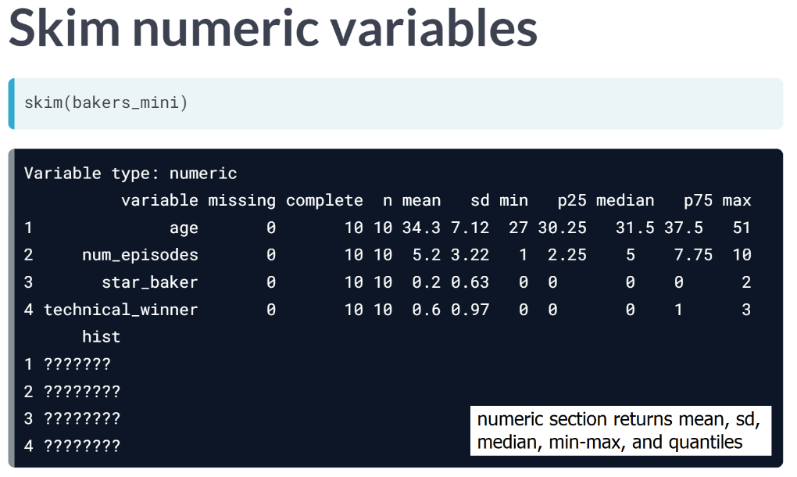

# Arrange and glimpse

From here, if we don't ask you to load a package, you can assume it's already loaded.

You can combine [**glimpse()**](http://tibble.tidyverse.org/reference/glimpse.html) with other functions in a sequence using the pipe (%>%) operator. For example, you can use other dplyr functions like arrange first, then use glimpse by adding a line after the final pipe (%>%):

bakers_mini %>%

arrange(age) %>%

glimpse() # no argument needed here

Take a glimpse of the bakeoff data we imported in the first set of exercises. On which date did the first episode of the show air in the US?

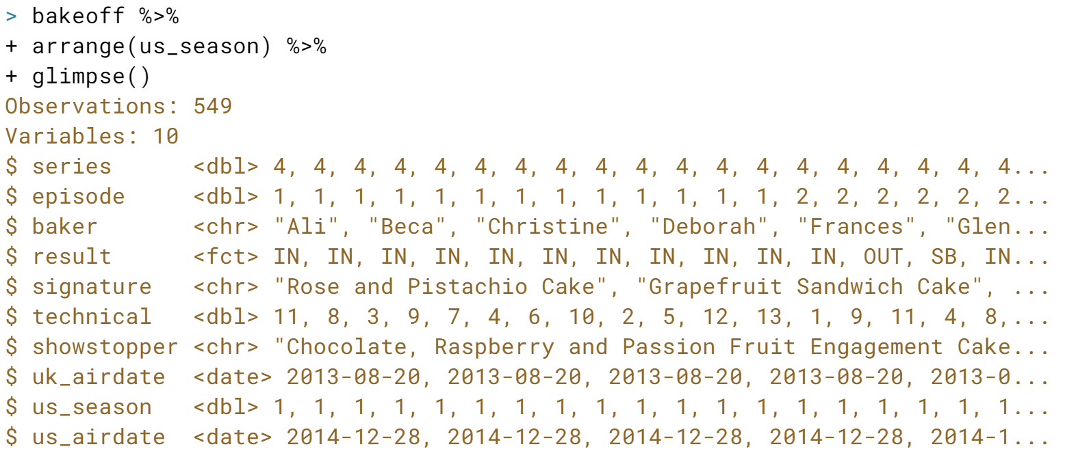  


# Summarize your data

You can combine [**skim()**](https://www.rdocumentation.org/packages/skimr/versions/1.0.2/topics/skim) with other functions in a sequence using the pipe (%>%) operator. For example, you could use other dplyr functions like group_by first, then use skim() by adding a line after the final pipe.

bakers_mini %>%

group_by(series) %>%

skim() # no argument needed here

This will produce summary statistics for each series. Let's practice this!

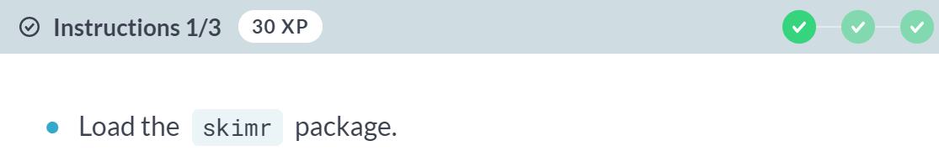

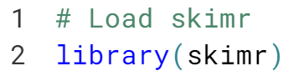

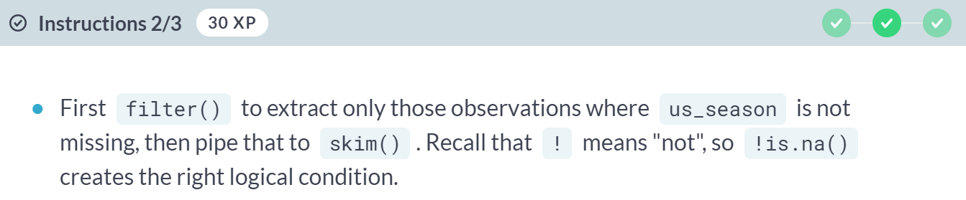

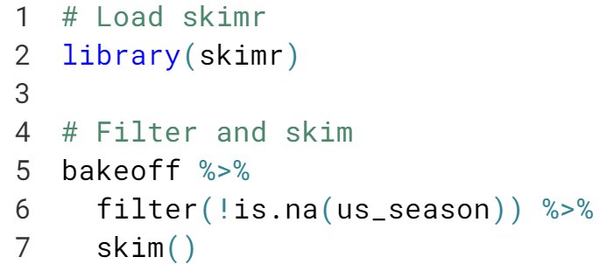

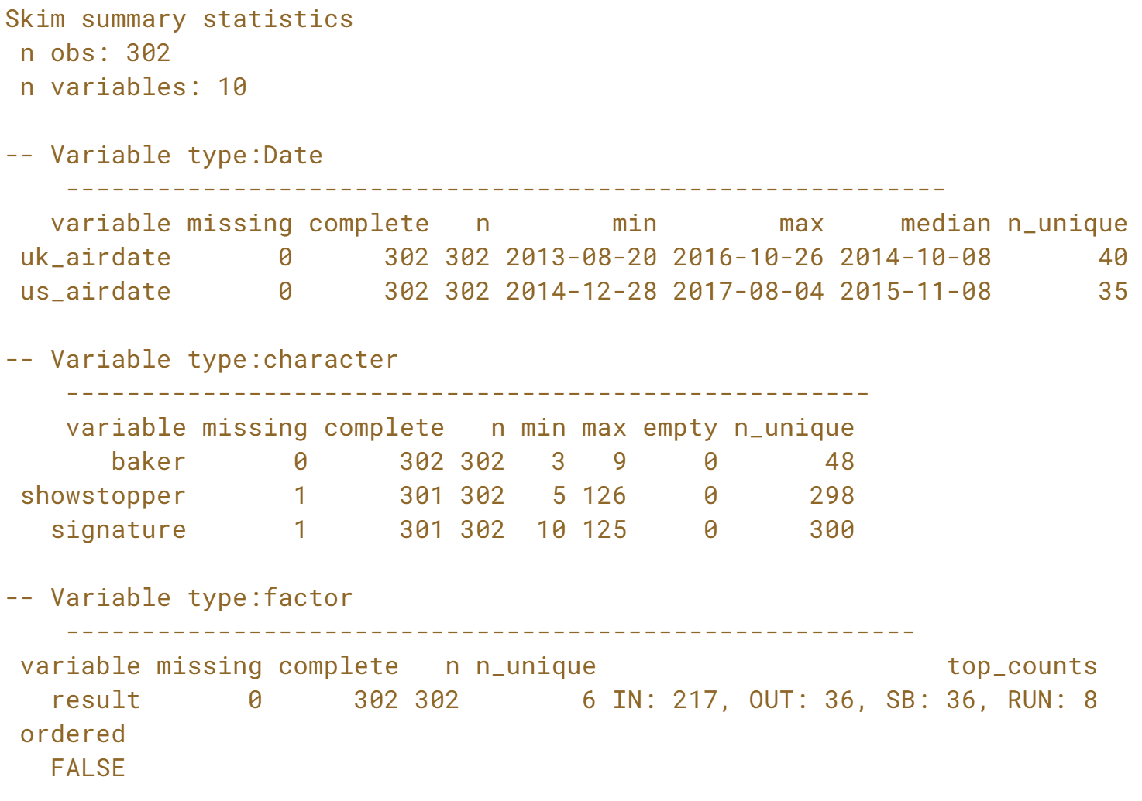

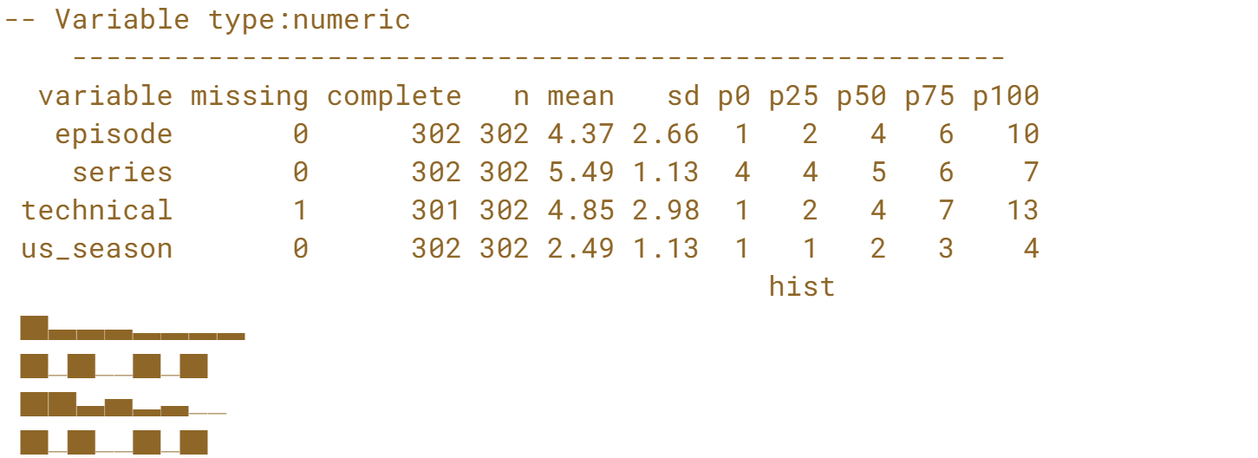

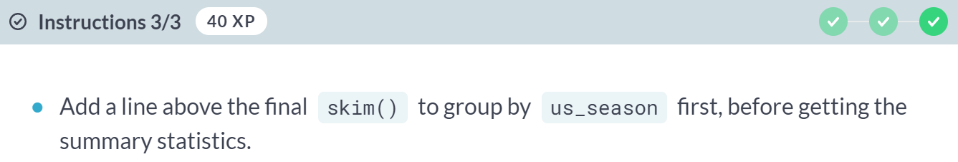

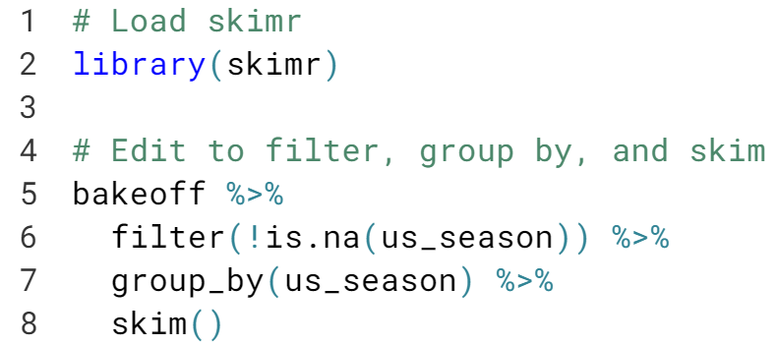

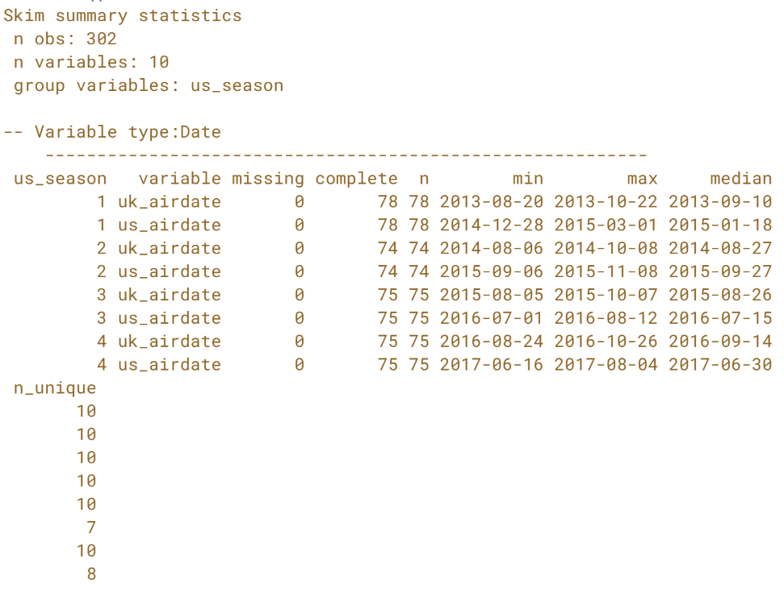  
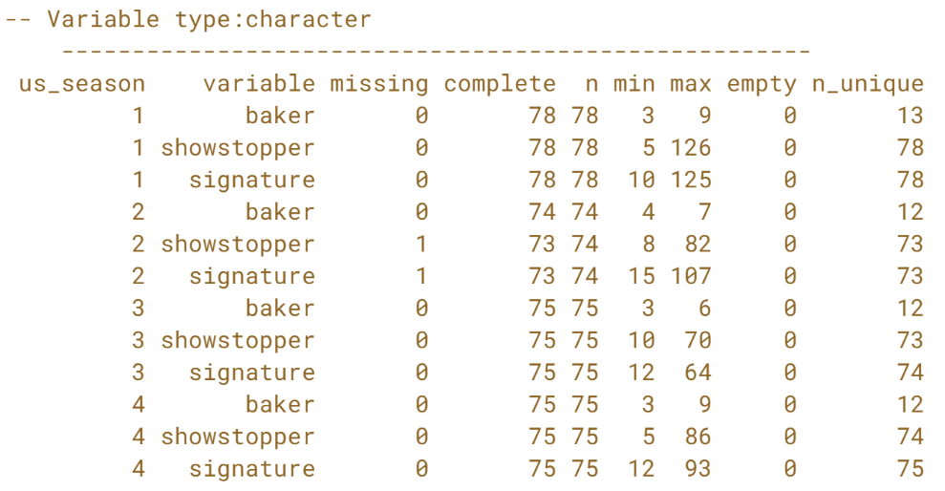

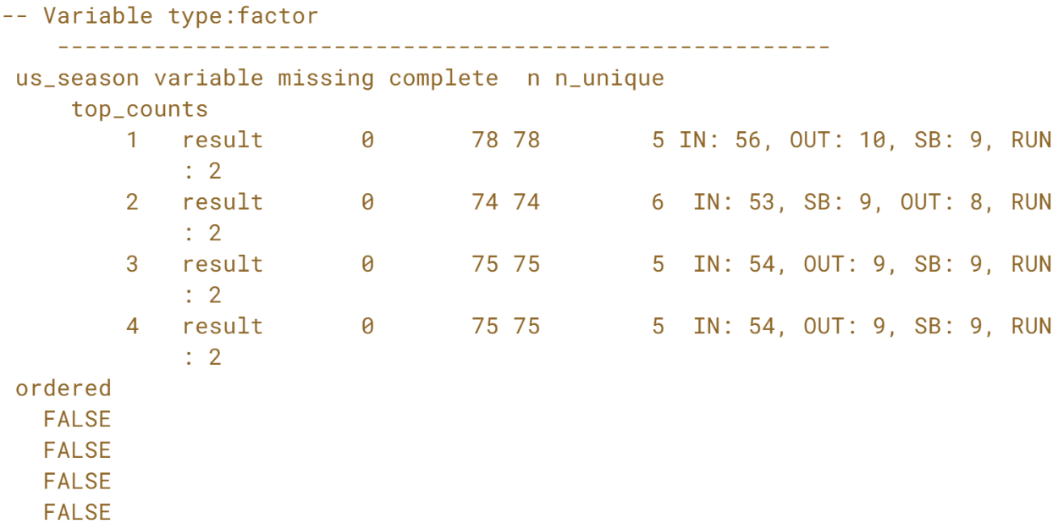

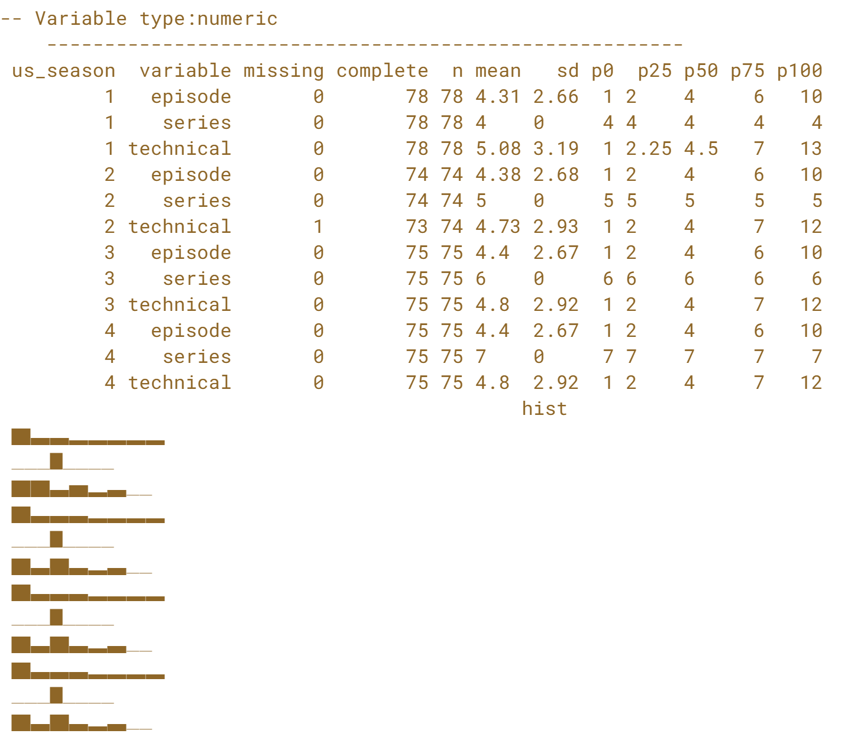

Nice piping & skimming! Producing quick grouped summaries with the skim function is a real time (and sanity) saver.

# Know your variable types

How many variables of each type do we have in the bakeoff data? You may use any of the data science tools we've learned for getting to know your data (dplyr and skimr are loaded for you). You may also want to try piping a skimmed object to summary(), also from the skimr package:

tibble_name %>%

skim() %>% # no argument needed here

summary() # no argument needed here

(Pressing *Enter* in the console will not add a new line, but will run the code on the current line. If you'd like to add a new line before running your code, you can use *Shift*+*Enter*)

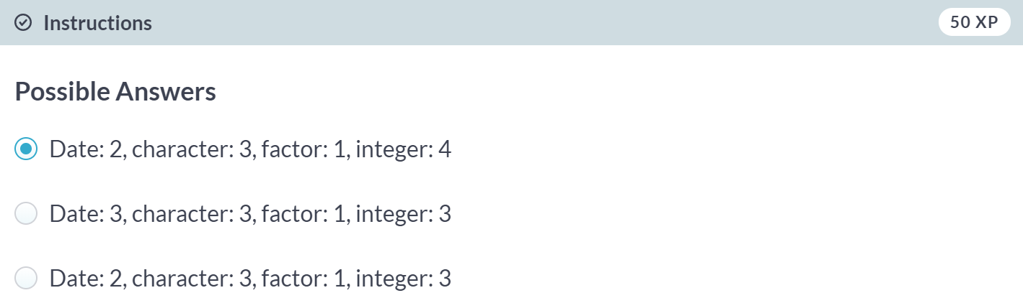

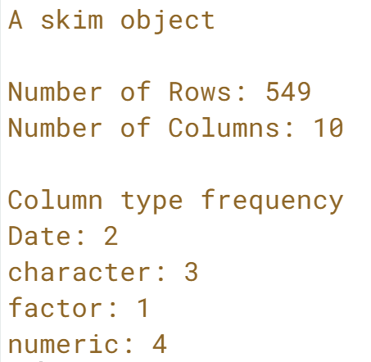



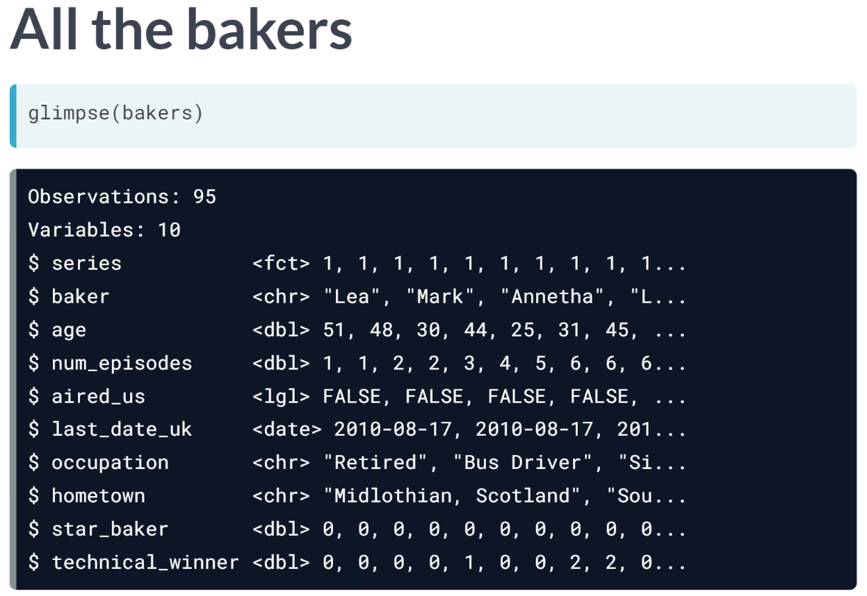

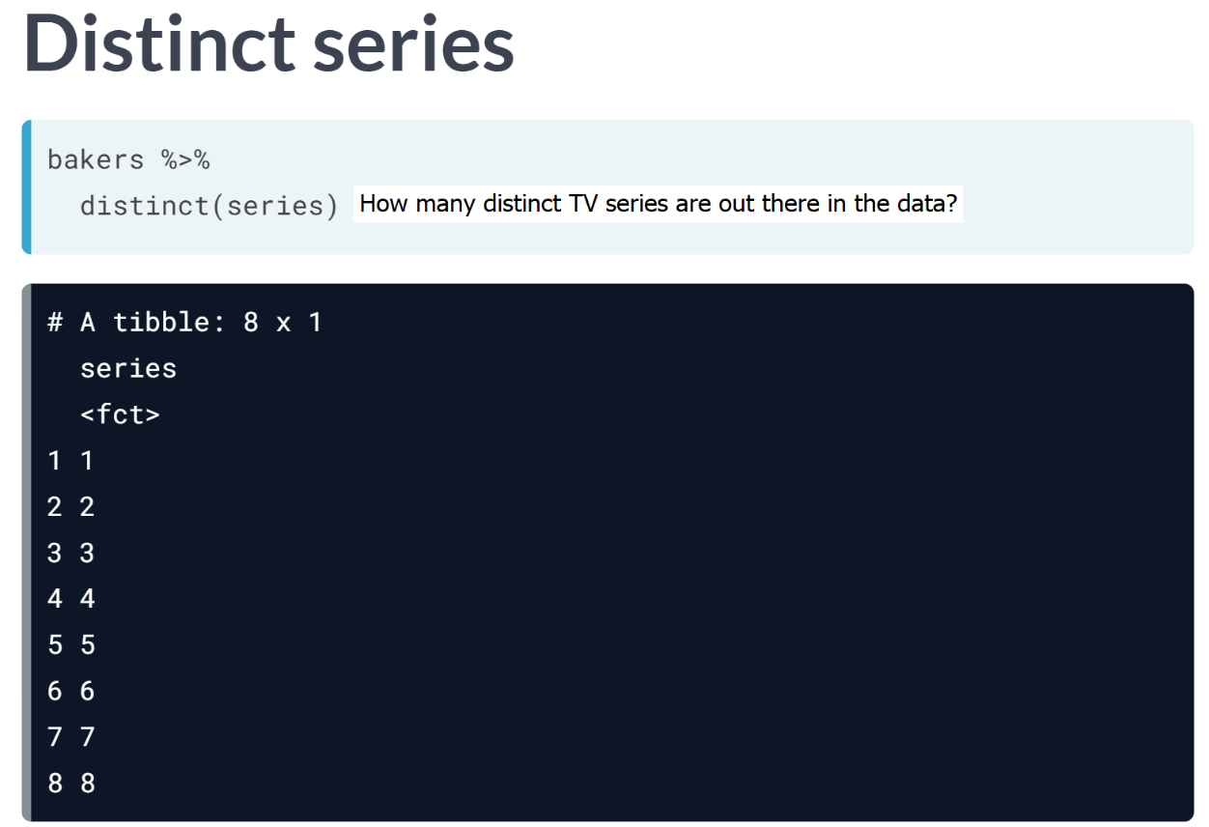

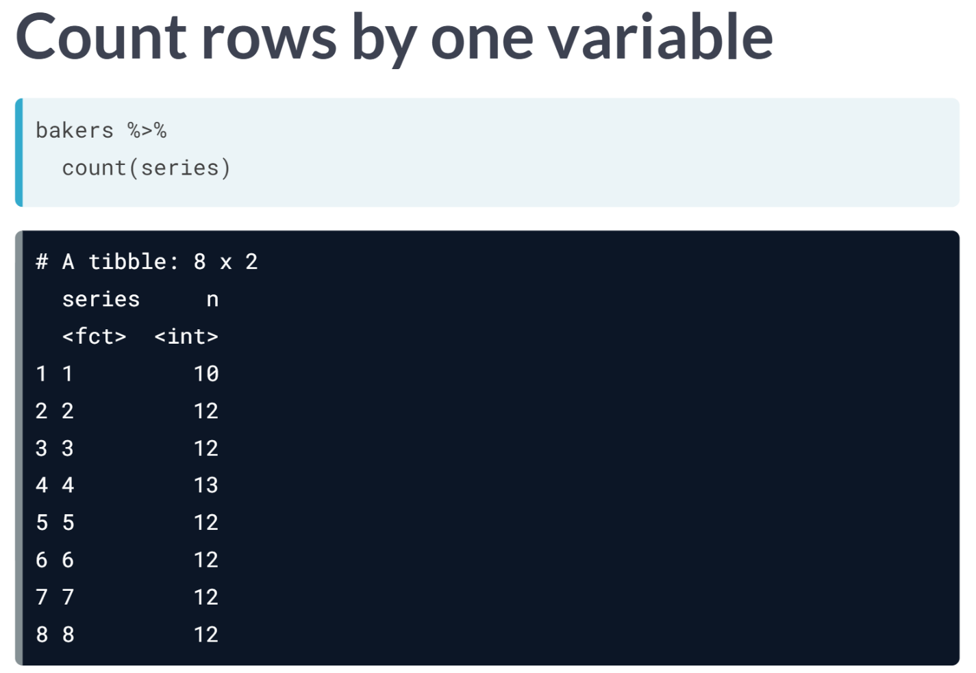

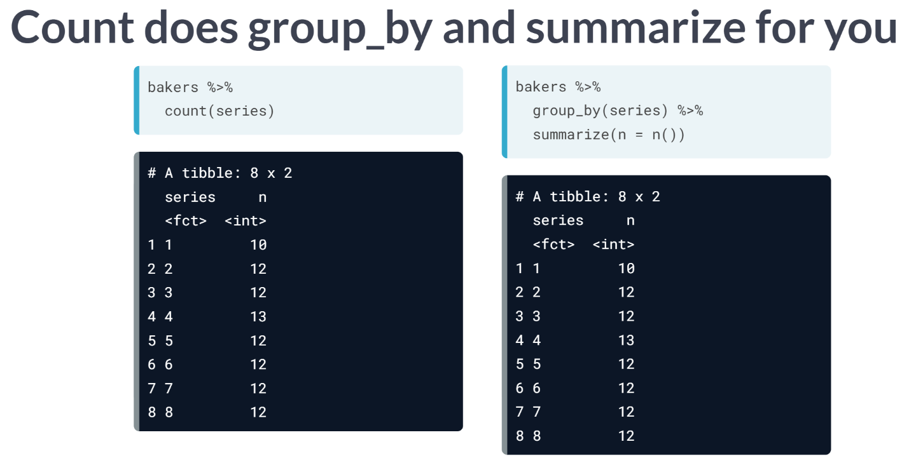

***Count()*** function combines both ***group_by()*** and ***summarize()*** function into one.

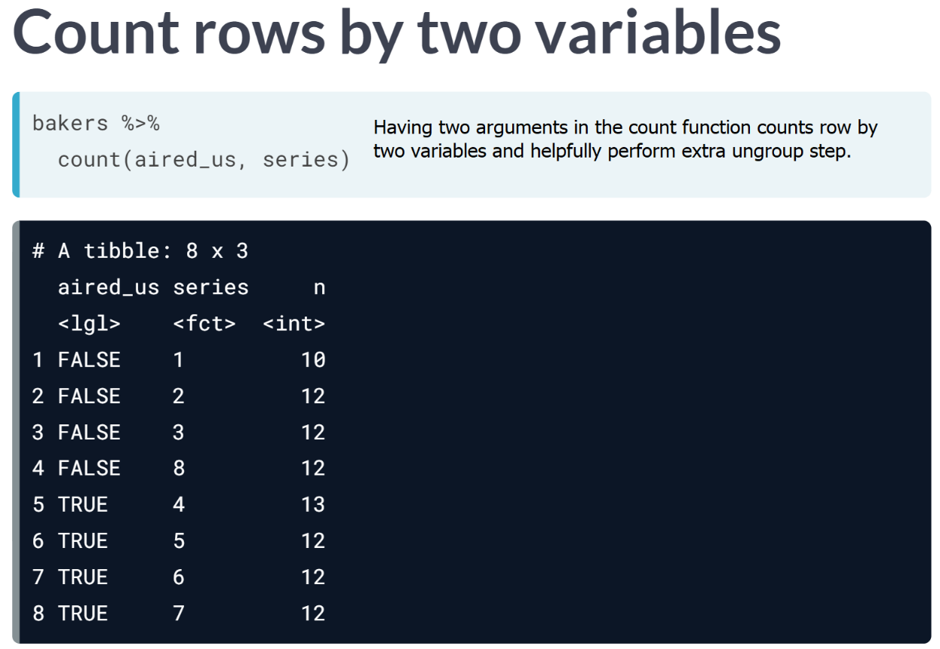

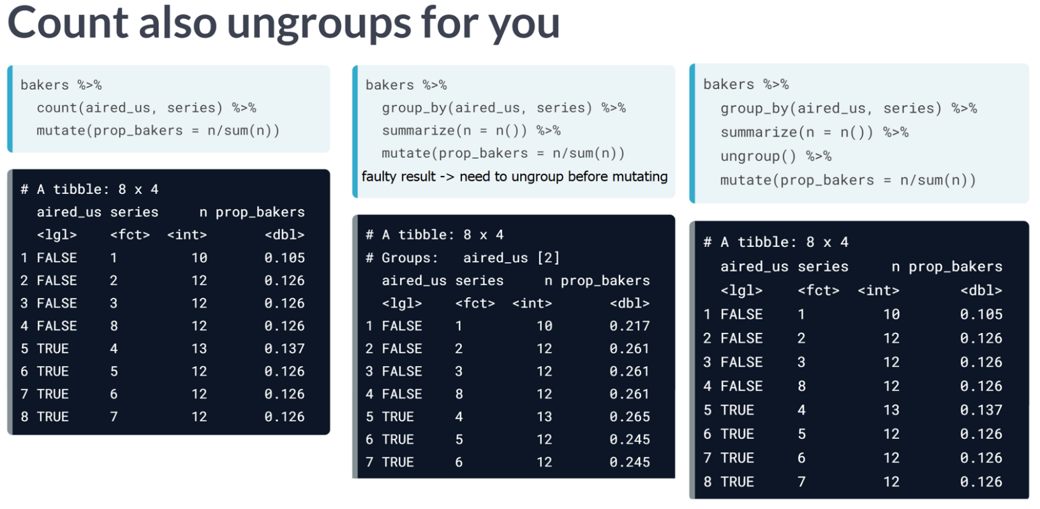

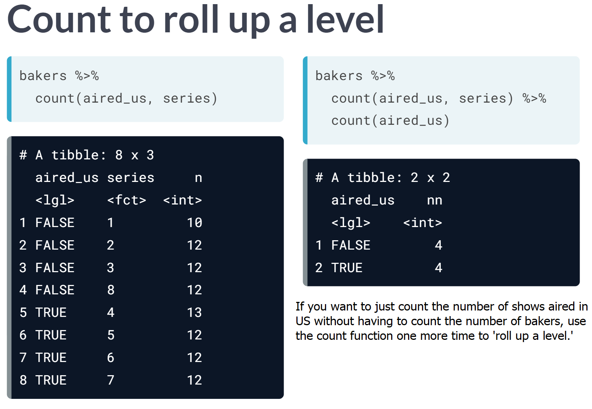

# Distinct and count

In every episode of "The Great British Bake-Off", bakers complete 3 challenges and the show's judges award the title "Star Baker" to the baker who excelled in that week's challenges (with the exception of the finale). Each baker's result for every episode is stored in bakeoff- result is a character variable, and the value "SB" stands for star baker.

  
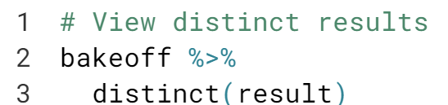

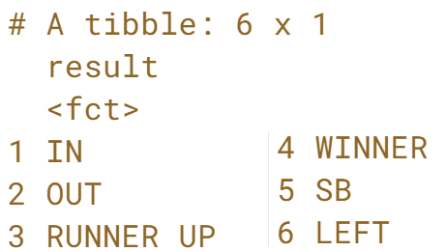Yes, “SB” is one of distinct value.

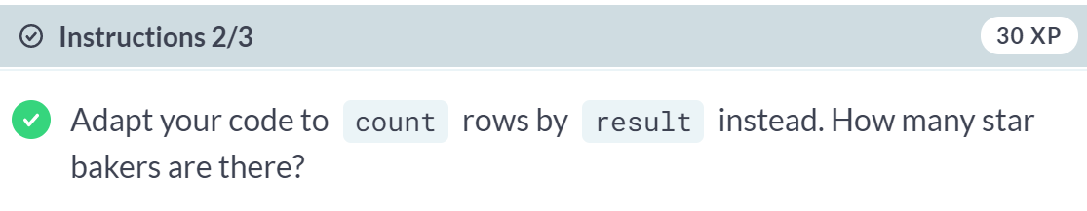  
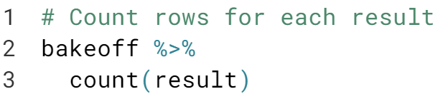

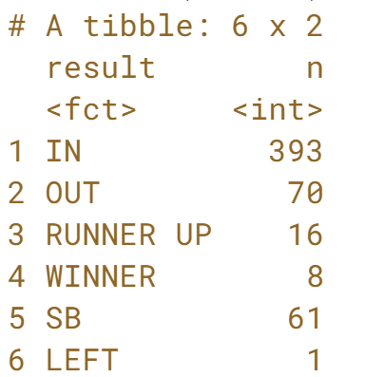There are 61 star bakers out there.

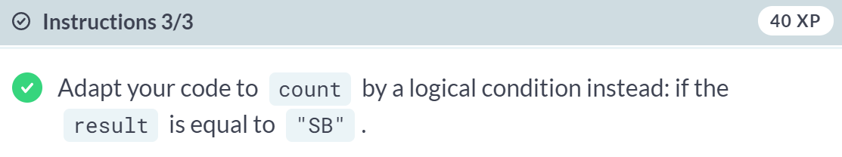

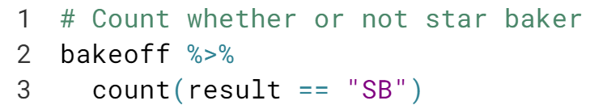

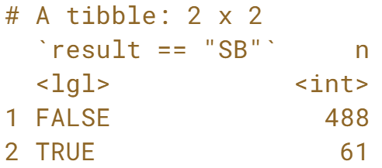

Notice there are 488 results that are not star baker.

# Count episodes

In the video, here's how we used count() back-to-back to roll up a level of detail across series:

bakers %>%

count(aired_us, series) %>%

count(aired_us)

# A tibble: 2 x 2

aired_us nn

<lgl> <int>

1 FALSE 4

2 TRUE 4

Recall that bakeoff includes each baker's result for every episode. Let's practice counting the number of episodes per series.

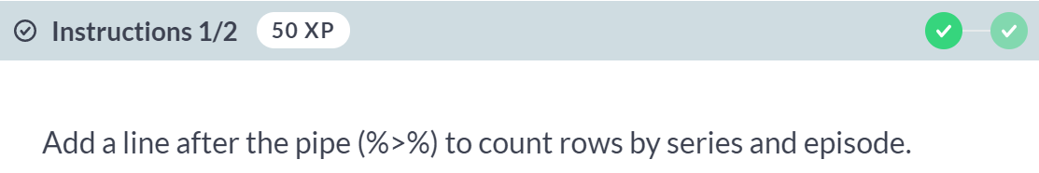

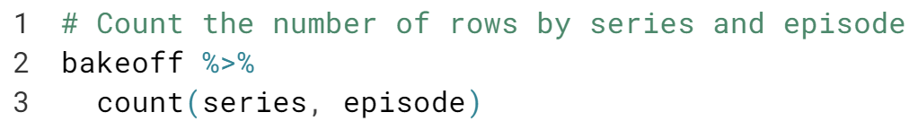

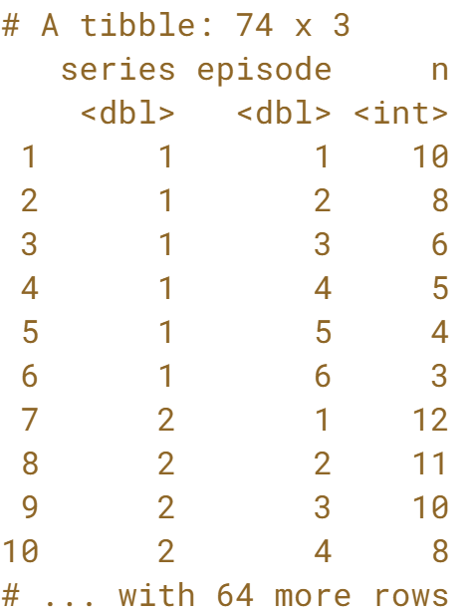

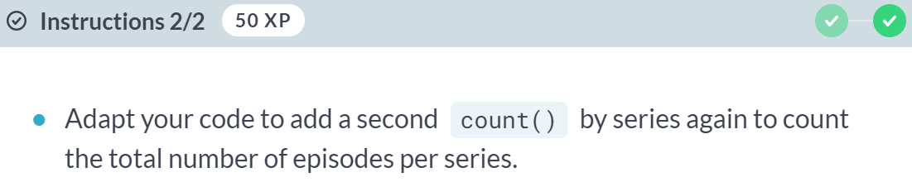

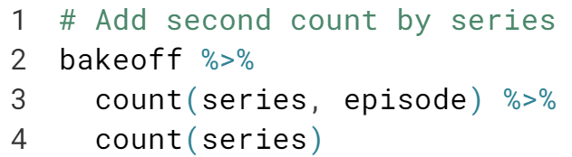

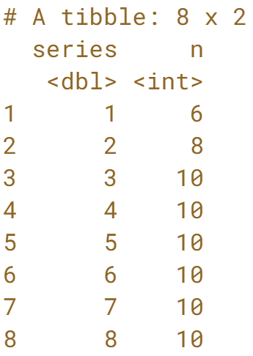

Great work- you can see that by series 3 we were treated to 10 episodes with each new series!

# Count bakers

In the last exercise, here's how you used count() back-to-back to count episodes by series:

bakeoff %>%

count(series, episode) %>%

count(series)

# A tibble: 8 x 2

series nn

<int> <int>

1 1 6

2 2 8

3 3 10

4 4 10

5 5 10

6 6 10

7 7 10

8 8 10

Now, using the same bakeoff data, you'll practice that again, focusing on counting bakers.

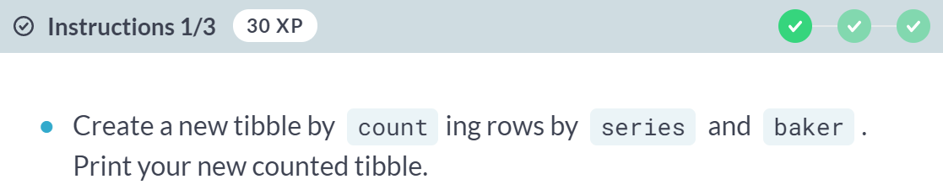  
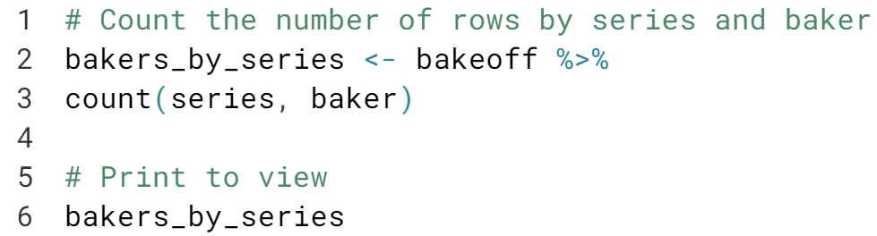  
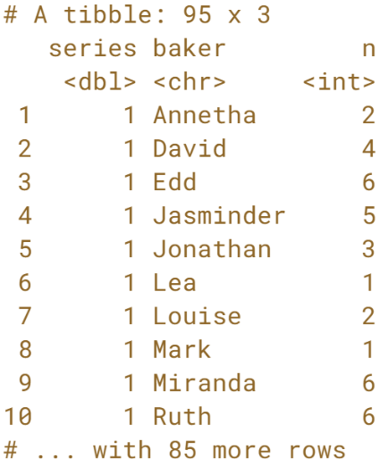



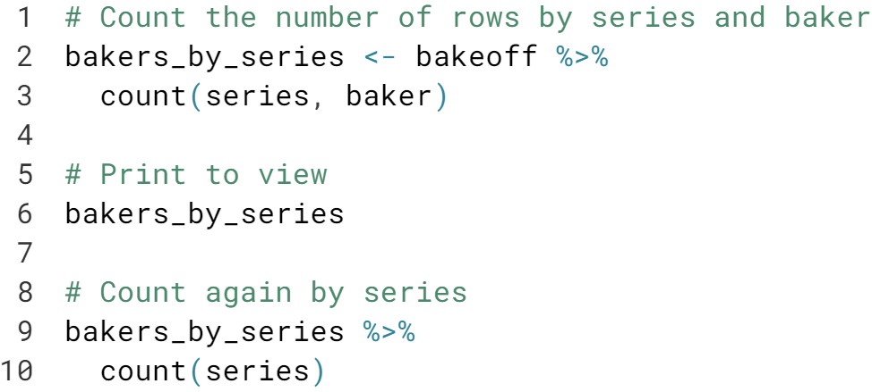

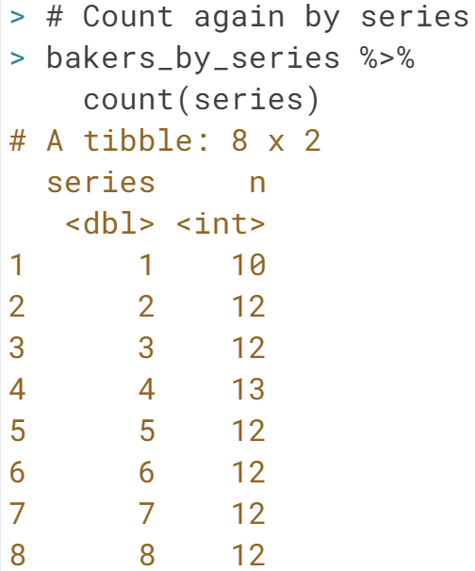

Good work- Series 4 had the most bakers with 13 totals (a baker's dozen!).

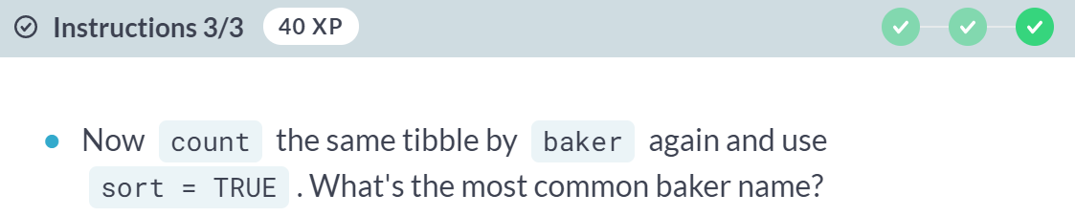

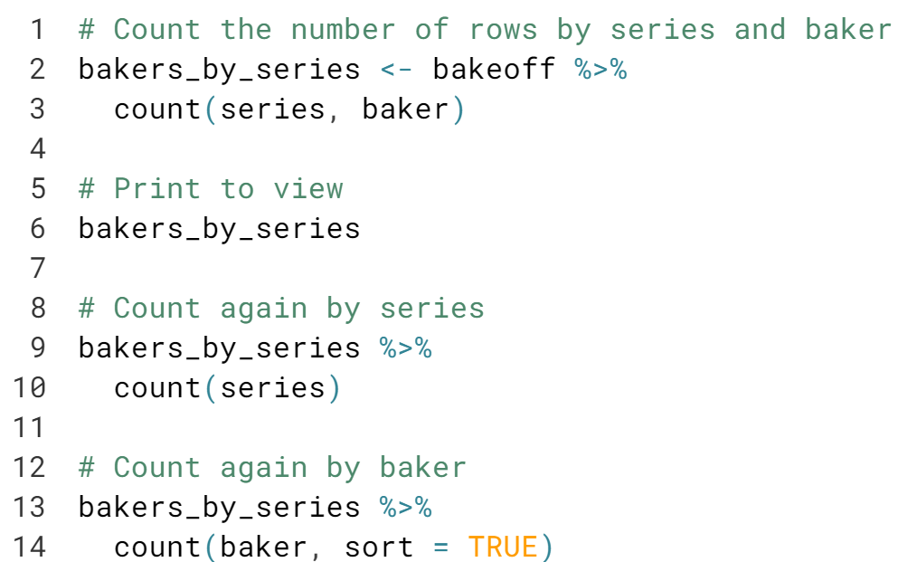

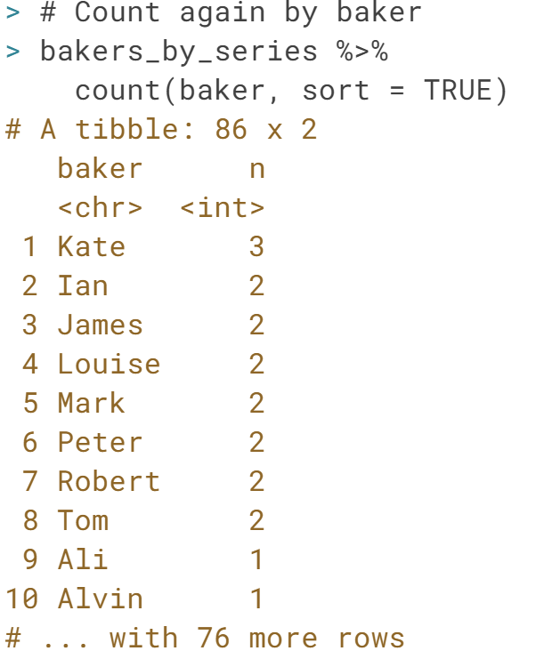

Good work - Kate is the most popular name- Kates have appeared in 3 different series.

# Plot counts

You can learn a lot about your data by counting, but sometimes you can learn even more by plotting counts. This is especially true when you have lots of things to count! With eight series, 74 episodes, and 95 bakers, a plot can be more helpful than a table of numbers. We'll use ggplot2 (already loaded for you) to visualize the number of bakers across episodes for each series from bakeoff.

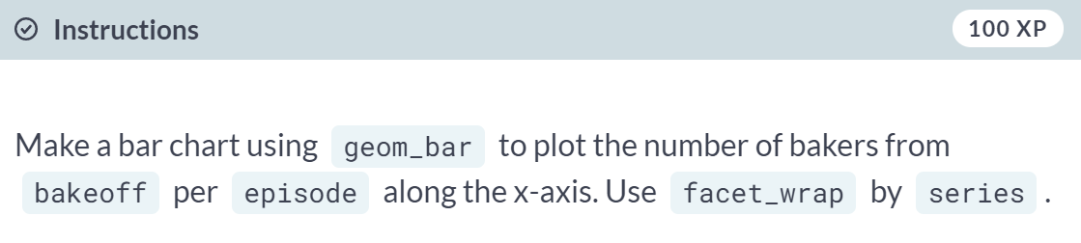

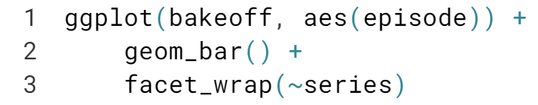

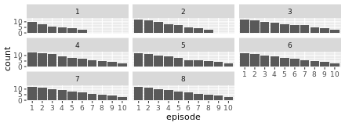

Notice how this plot is a great sanity check: the number of bakers tends to go down with every episode (never up!), with a few exceptions where no one was eliminated. Also, you can see that there are fewer episodes in the first two series. Finally, you can see that there are always three bakers who make it to the series finale.

#### **Tame your data**

#### In this chapter, you will learn some basics of data taming, like how to tame your variable types, names, and values.



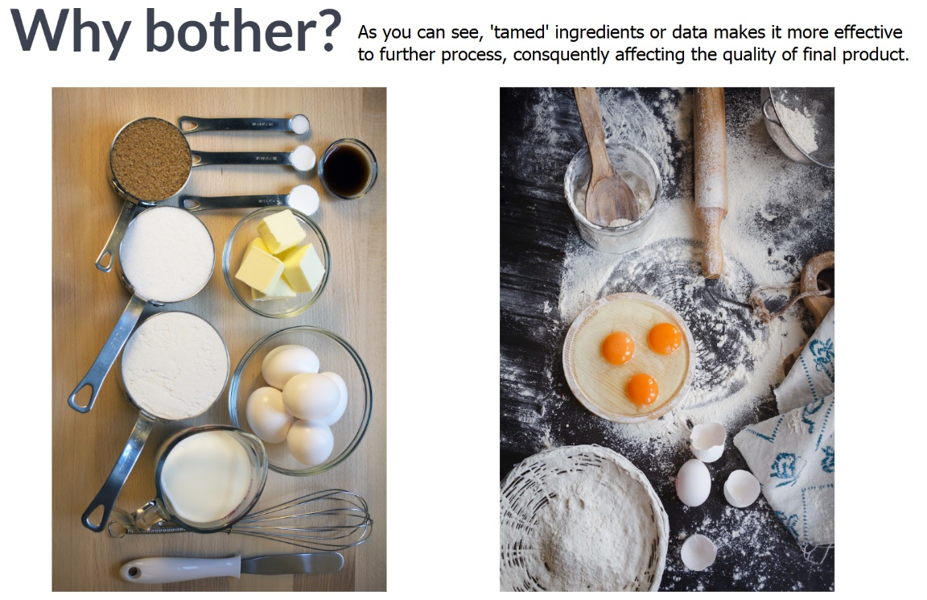



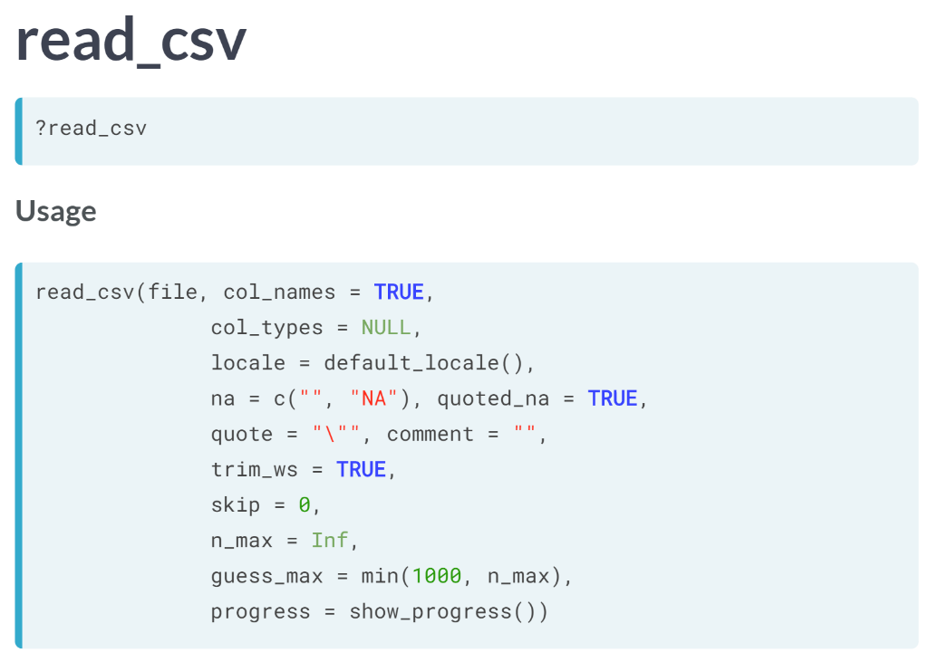

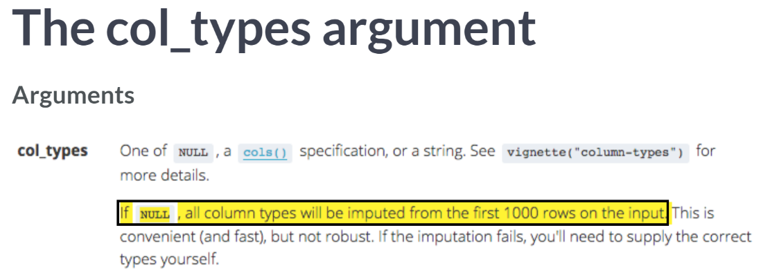

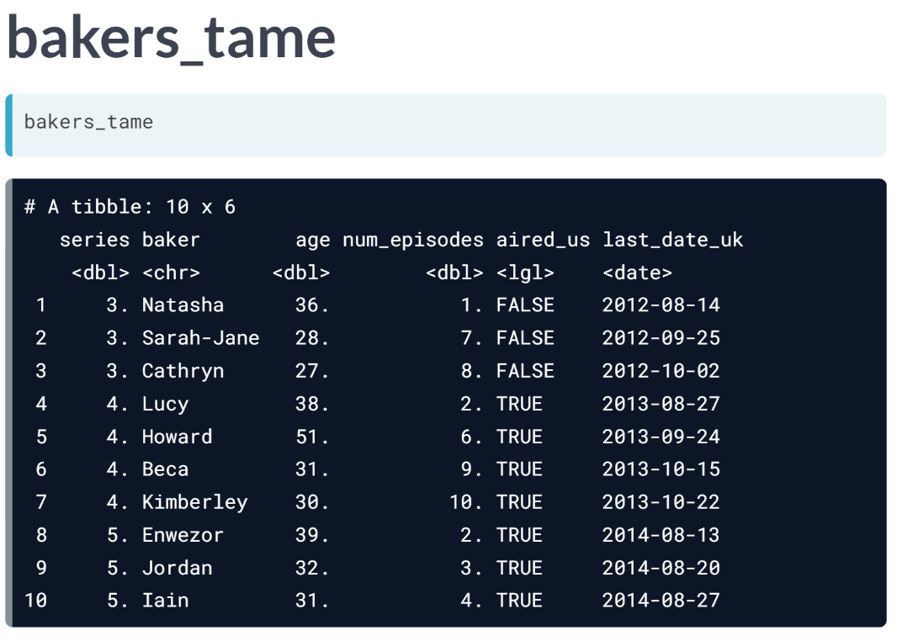

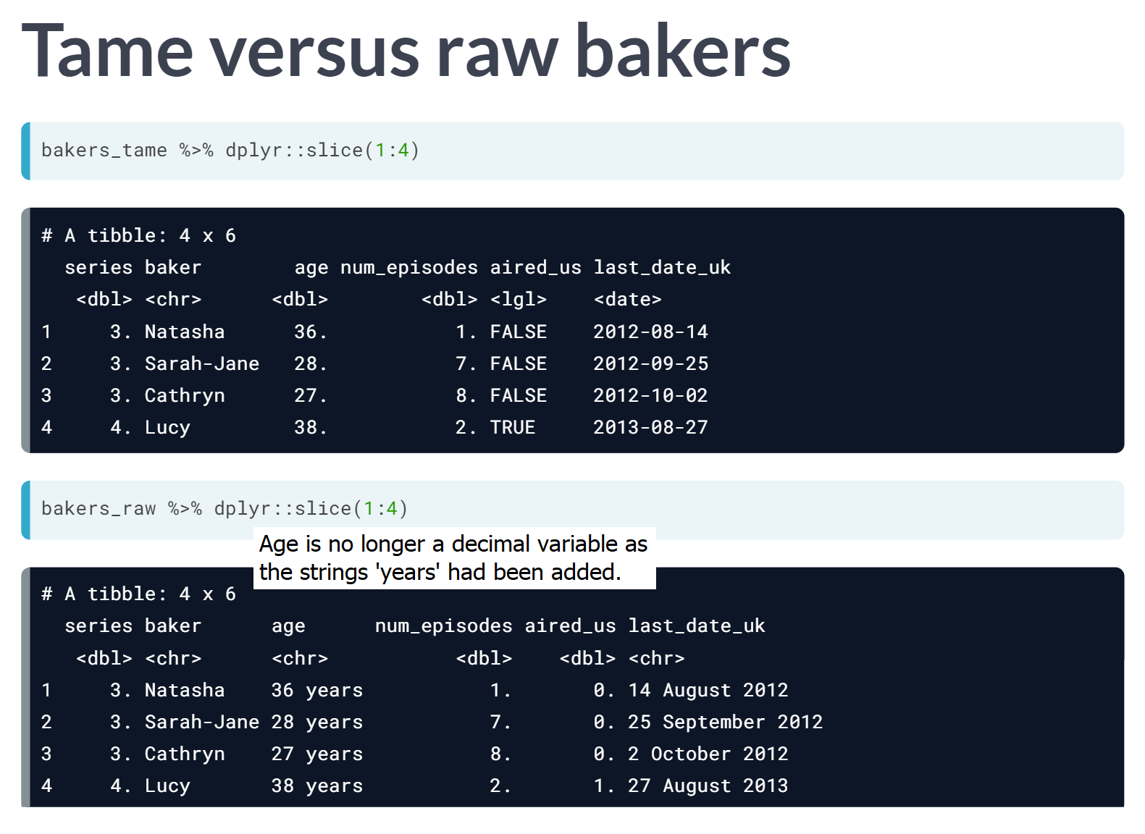

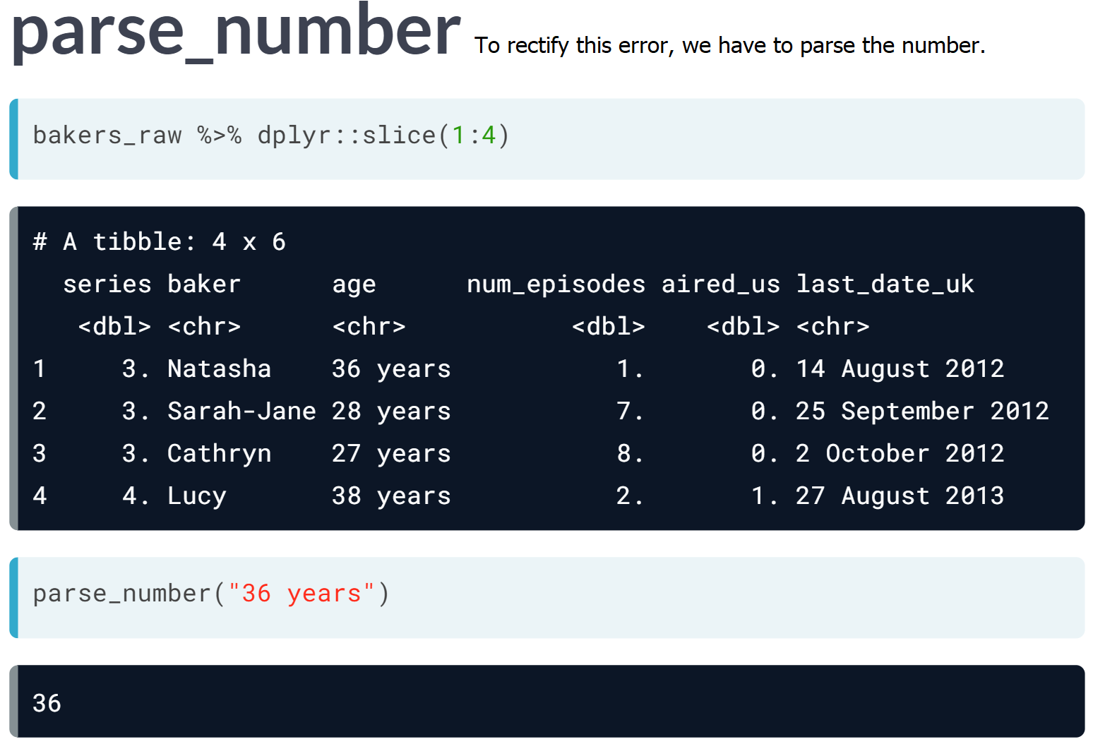

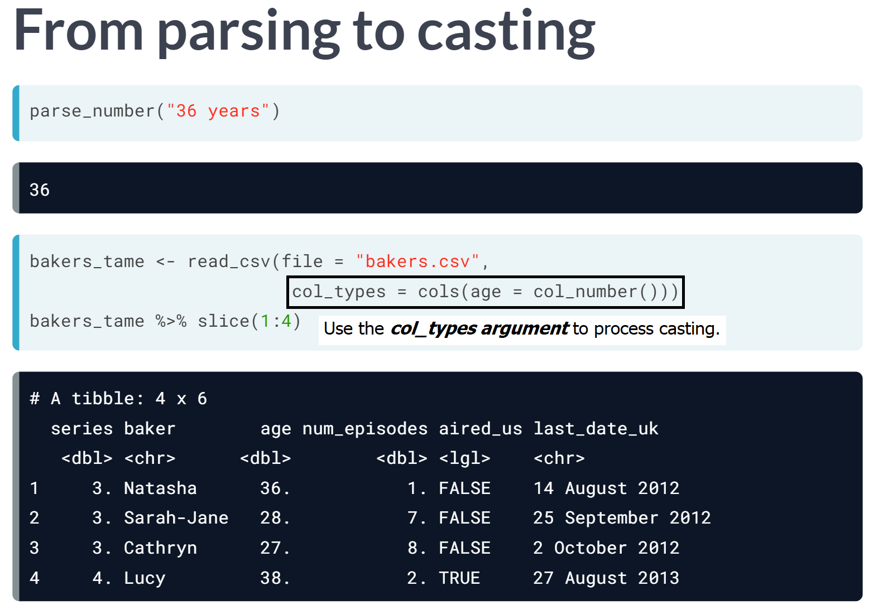

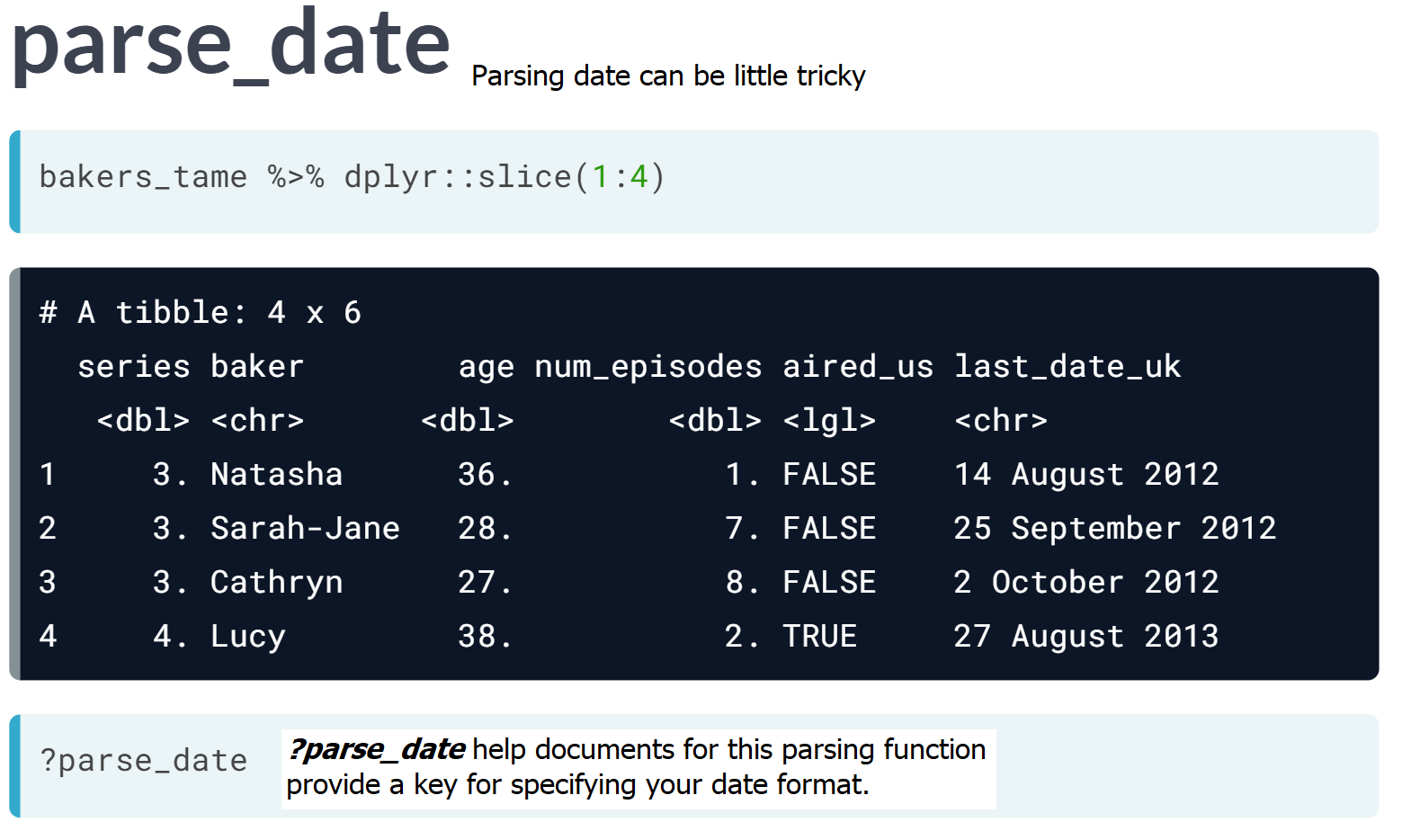

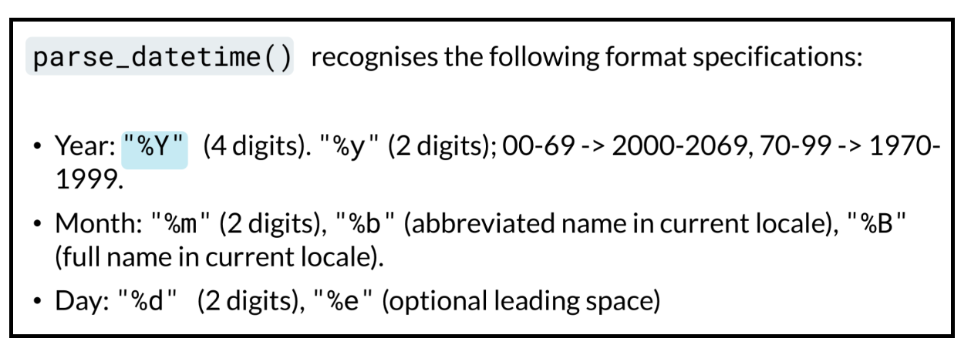

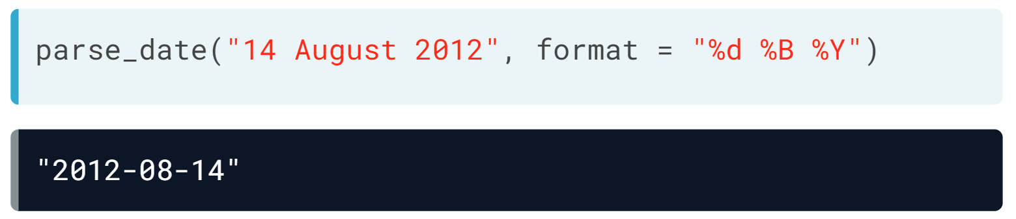

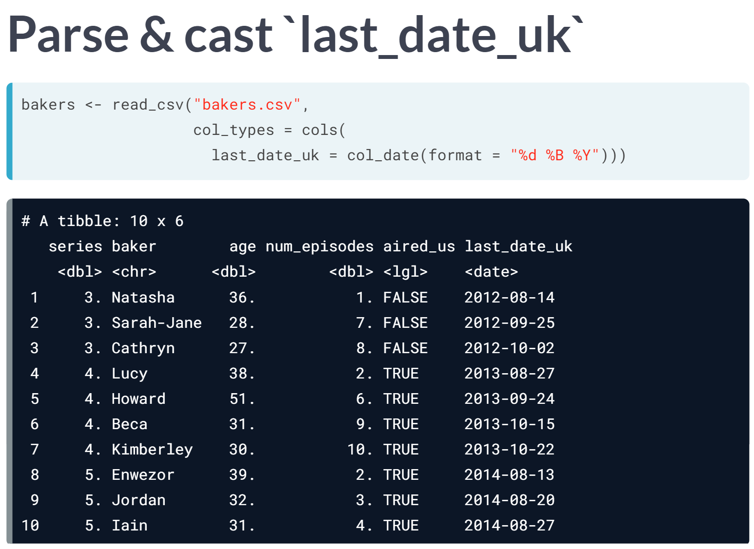

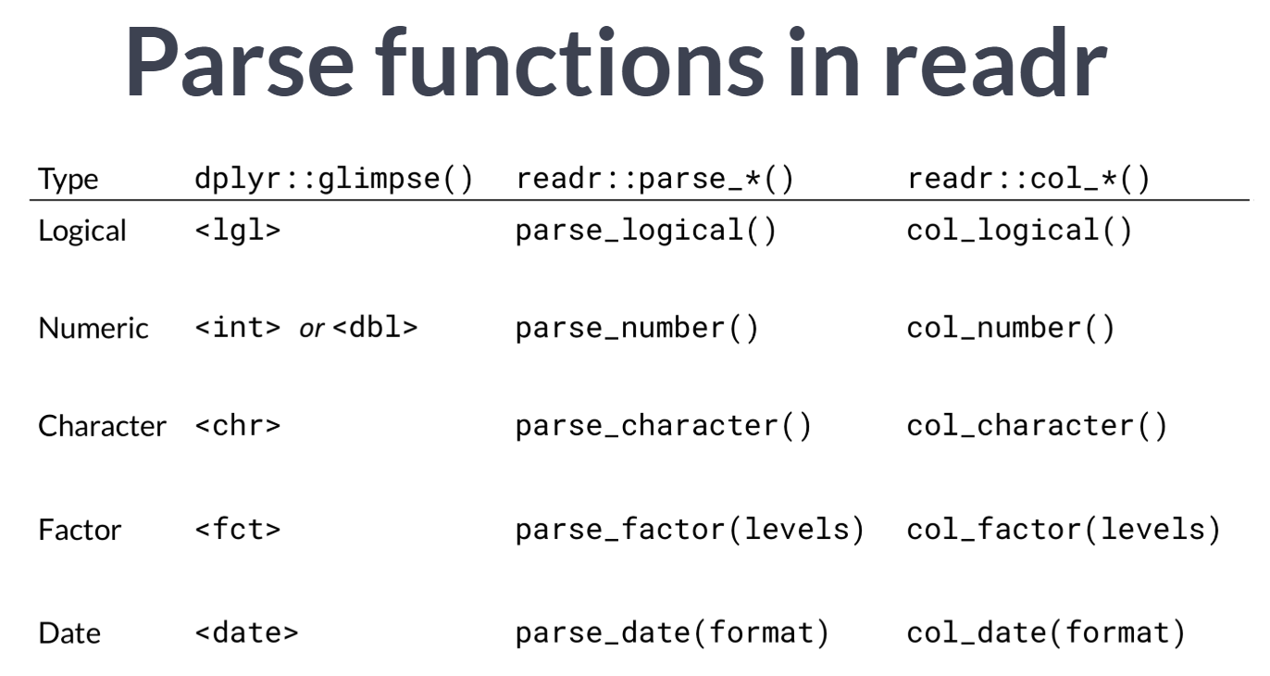

# Cast a column to a date

As we saw in the video, a good workflow for parsing dates using readr is to, for example:

* Use parse_date("2012-14-08", format = "%Y-%d-%m") first, then
* Use col_date(format = "%Y-%d-%m") within cols() as the col_types argument of read_csv().

In "desserts.csv", the variable uk_airdate is formatted like "17 August 2010". Let's parse, then cast this variable!

Later on in Chapter 4, we'll showcase some functions from the lubridate package to help you extract data from dates, once they are cast properly.

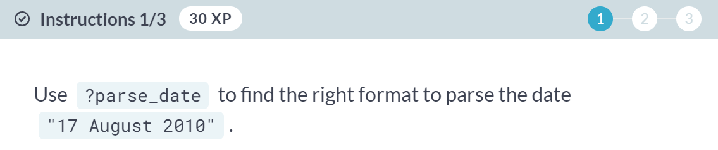





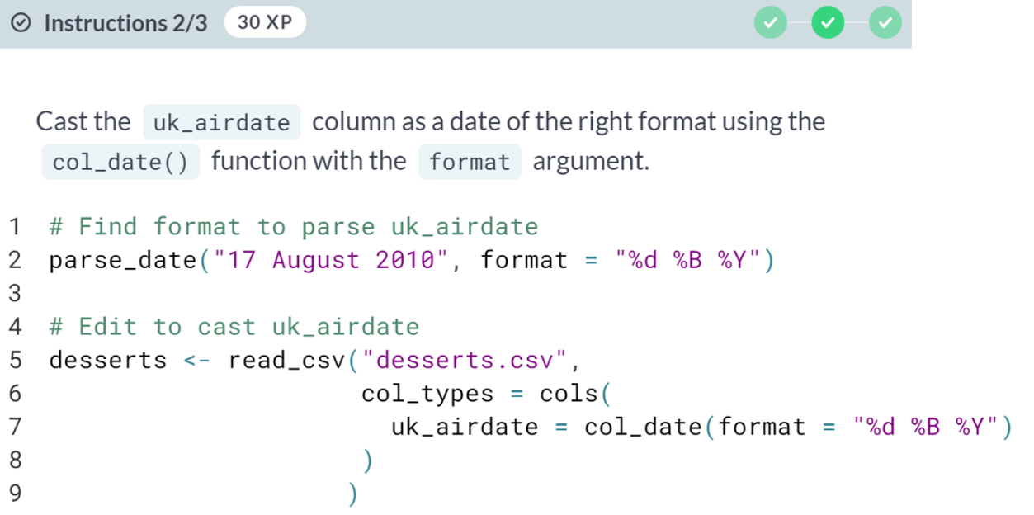

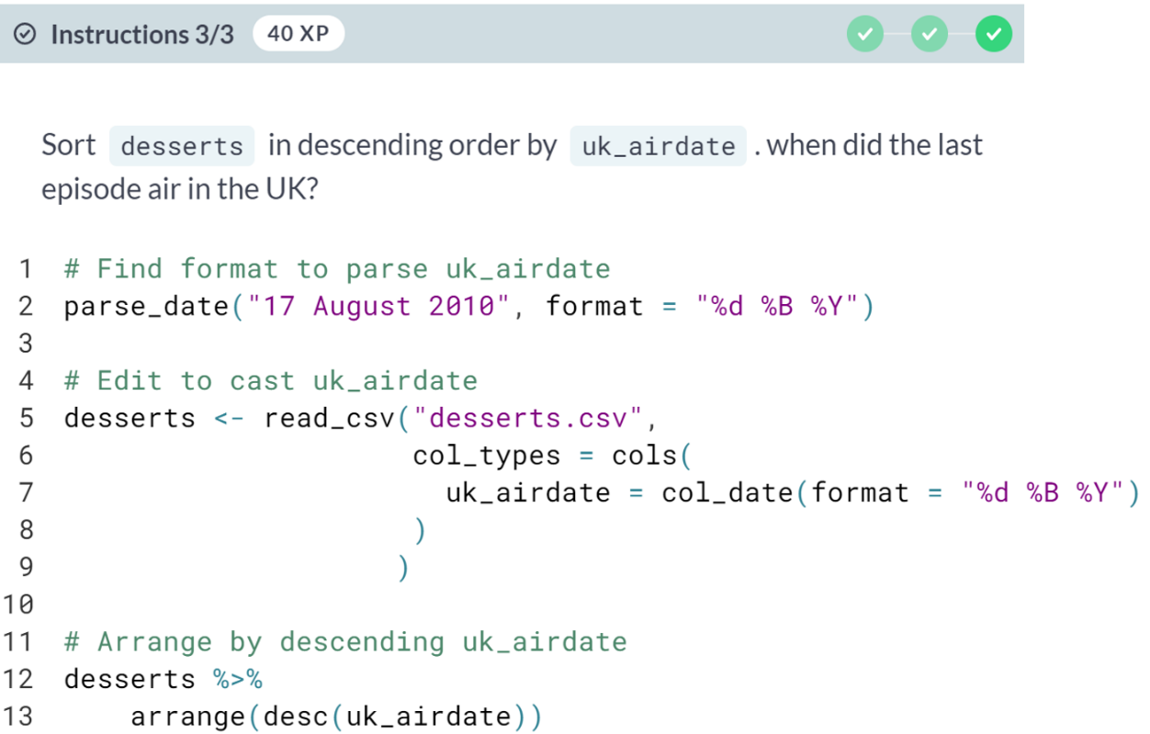

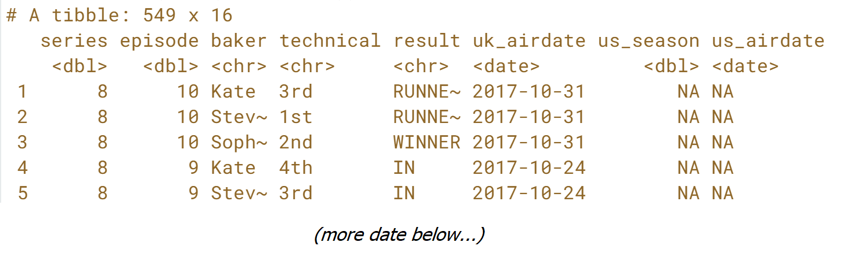  
Looking good! Notice that ***us_airdate*** didn't need to be cast - this is because the date format %Y-%m-%d is unambiguous, so it is automatically parsed as a date by readr.

# Cast a column to a number

In the video, we saw a good workflow for parsing columns using readr:

* Use parse_number() to practice, then
* Use col_number() to cast.

But sometimes you'll need to start with casting, then diagnose parsing problems using a new readr function called [**problems()**](https://www.rdocumentation.org/packages/readr/versions/1.1.1/topics/problems). Using problems() on a result of read_csv() will show you the rows and columns where parsing error occurred, what the parser expected to find (for example, a number), and the actual value that caused the parsing error.

Let's practice this with "desserts.csv", which includes data about the judges' ranks for each baker in the technical challenge, for every episode.

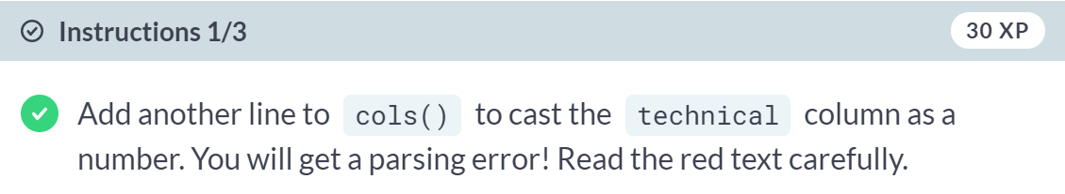

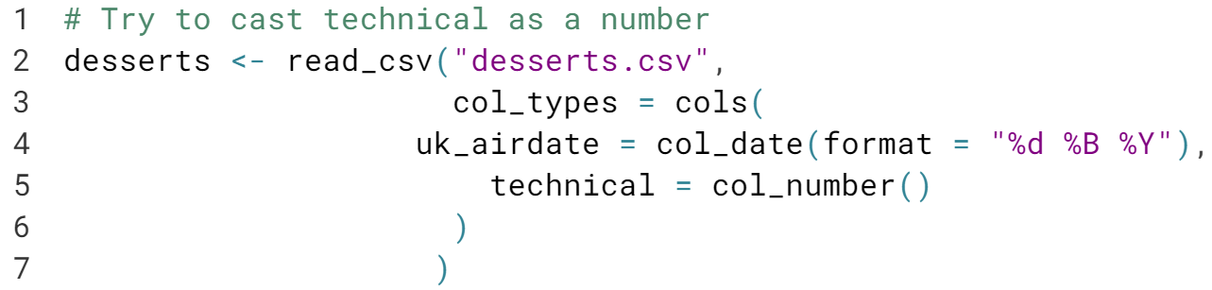

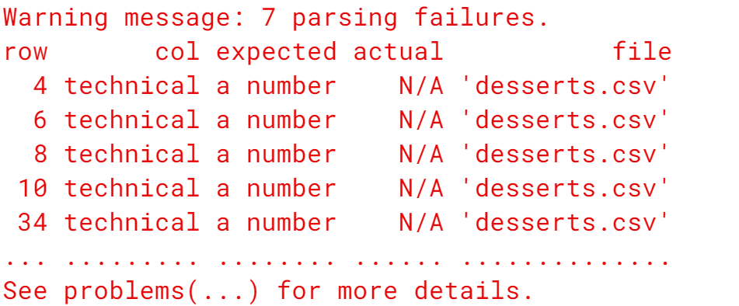

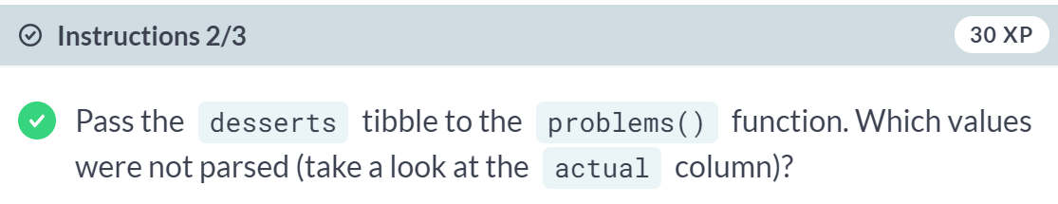

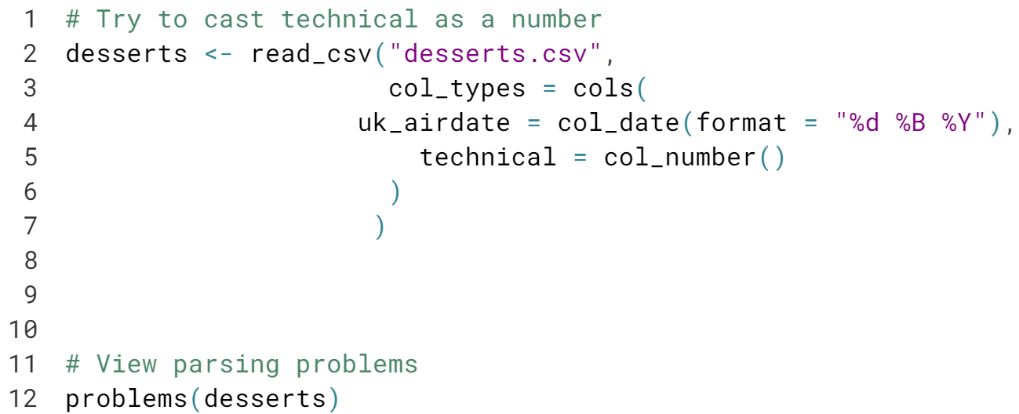

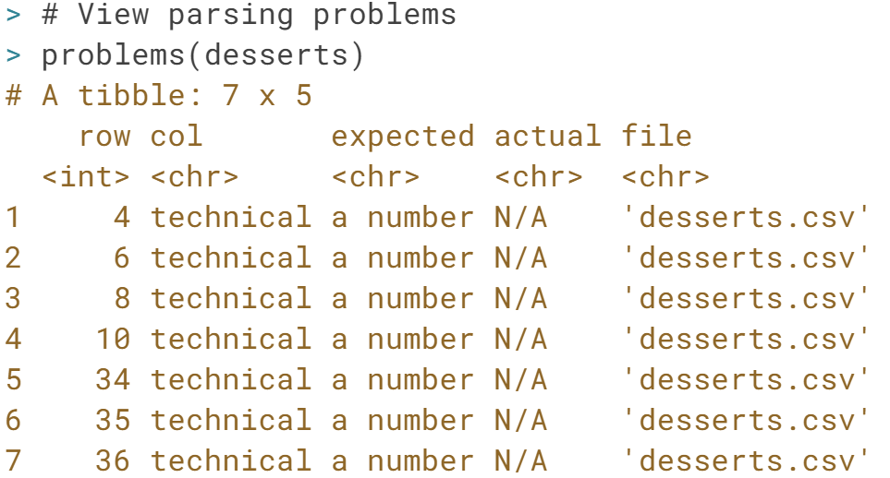

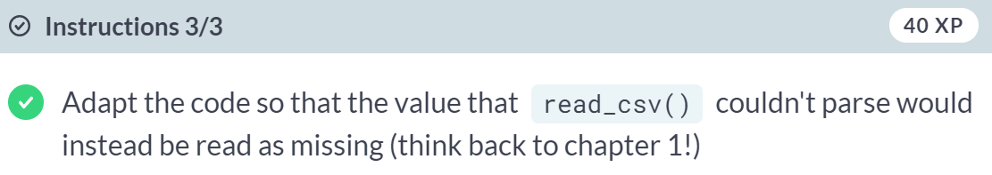

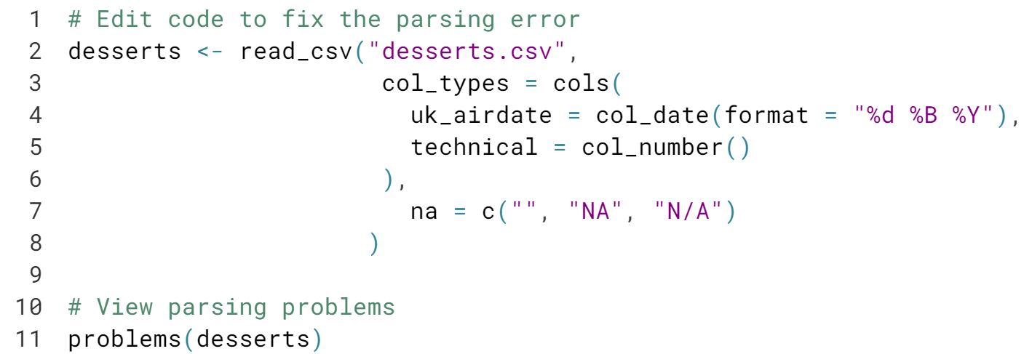

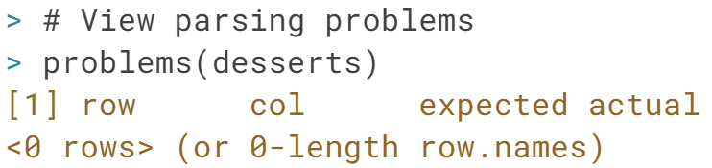

# Cast a column as a factor

Factors are categorical variables, where the possible values are a fixed and known set. For example, take a simple factor like bake below:

bake <- c("pie", "cake", "neither")

parse_factor(bake, levels = NULL)

[1] pie cake neither

Levels: pie cake neither

You can use parse_factor() to parse variables and col_factor() to cast columns as categorical. Both functions have a levels argument that is used to specify the possible values for the factors. When levels is set to NULL, the possible values will be inferred from the unique values in the dataset. Alternatively, you can pass a list of possible values.

This is the last time you'll read in "desserts.csv"! This time, you will look at the result column, which contains the outcome of the competition for each baker.

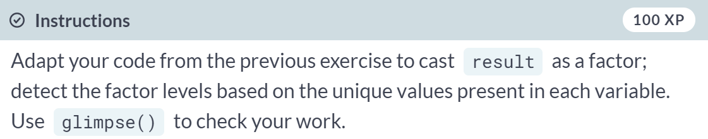

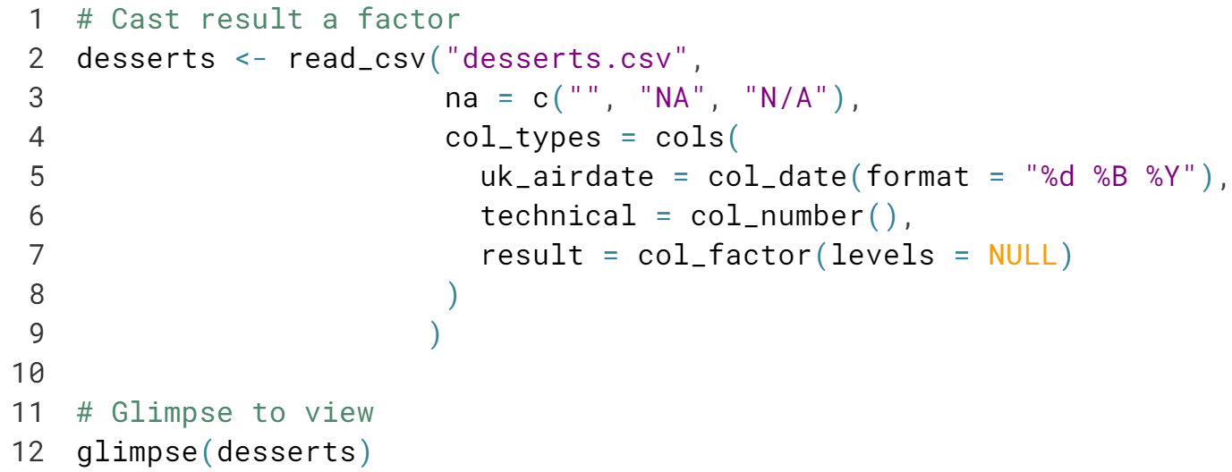

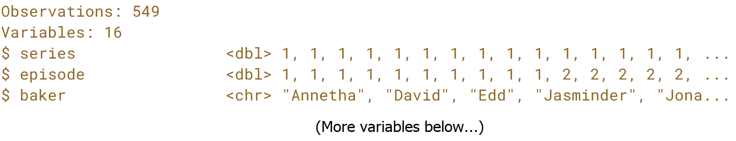  
While it takes a lot of work up front, casting column types when you import can make your analyses easier to reproduce.



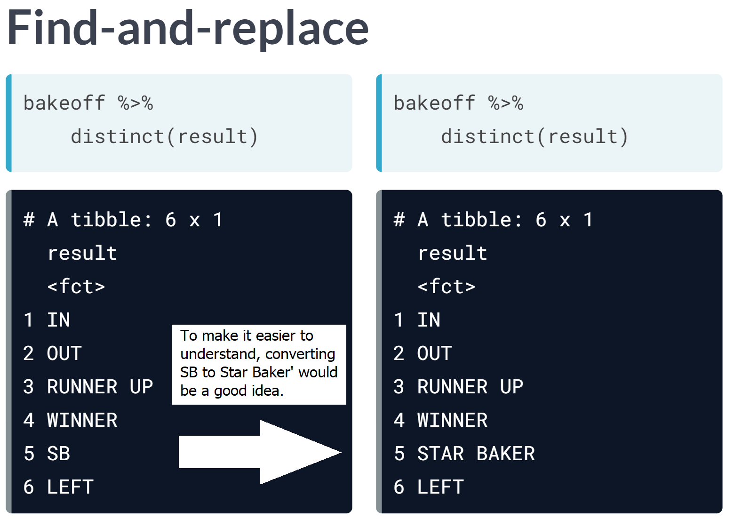

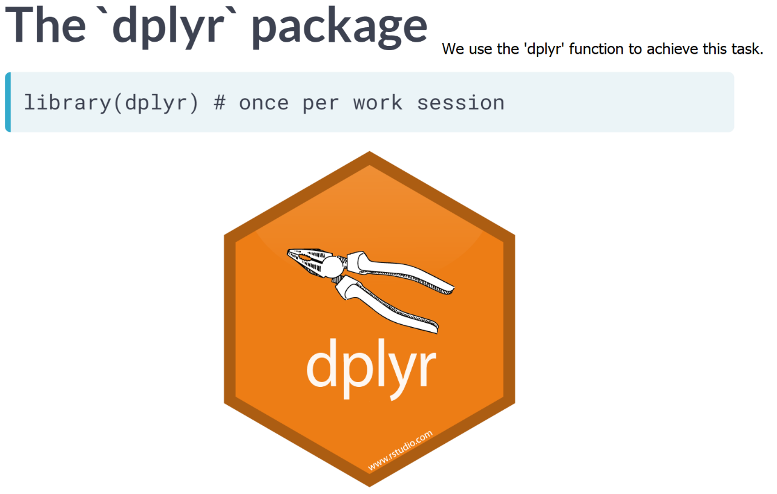

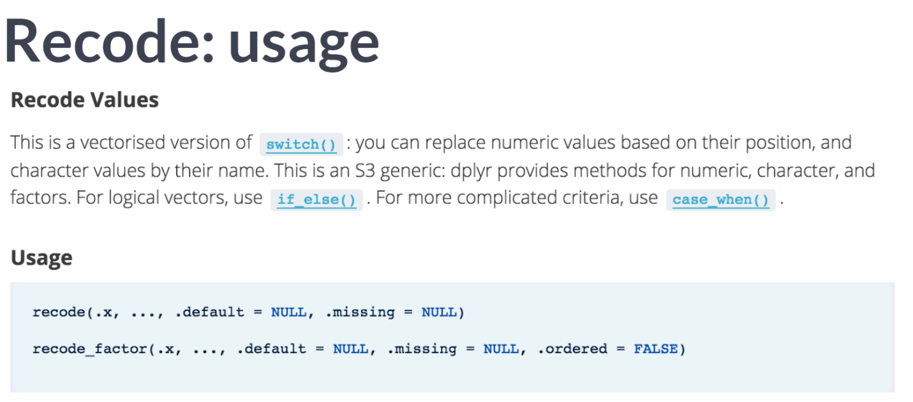

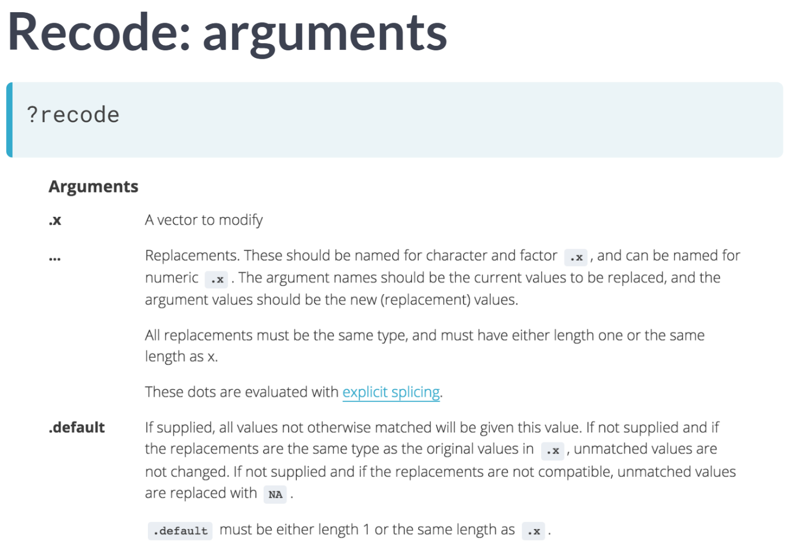

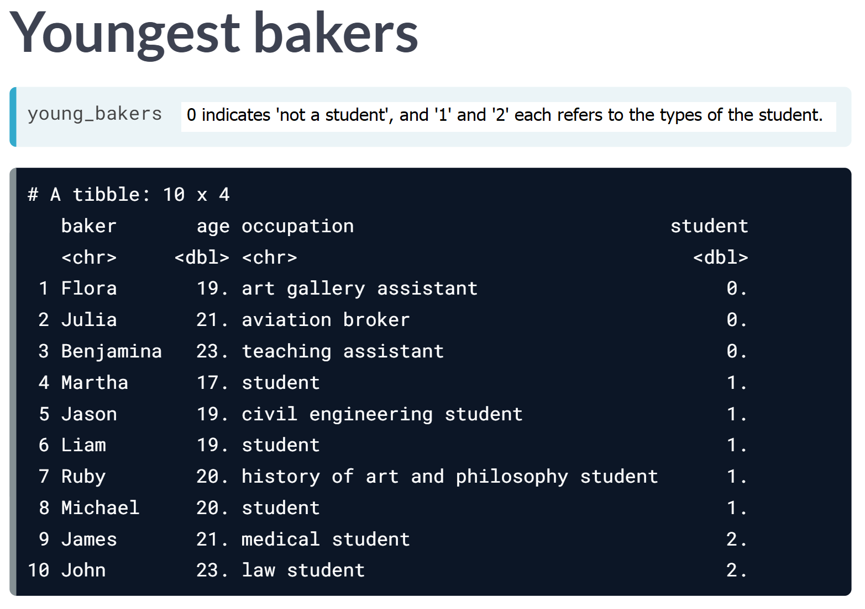

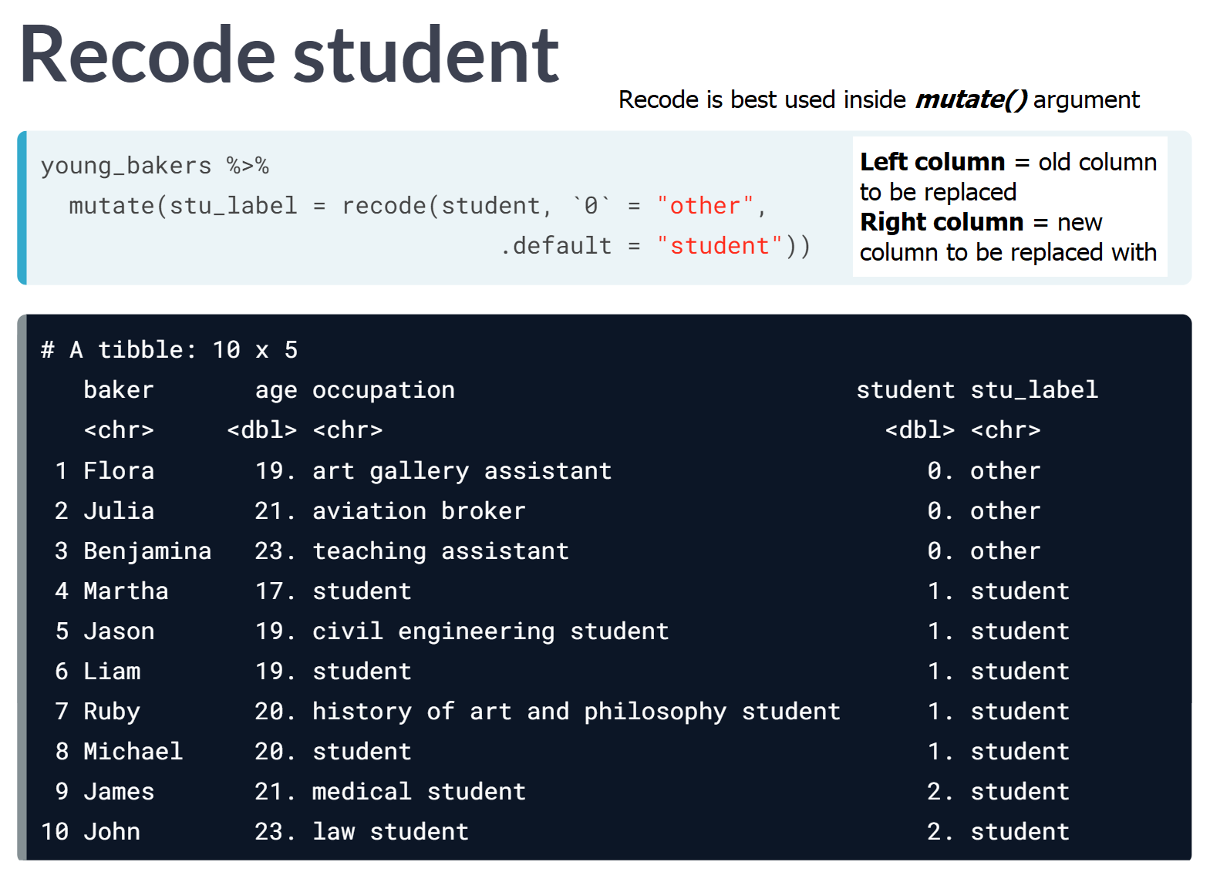

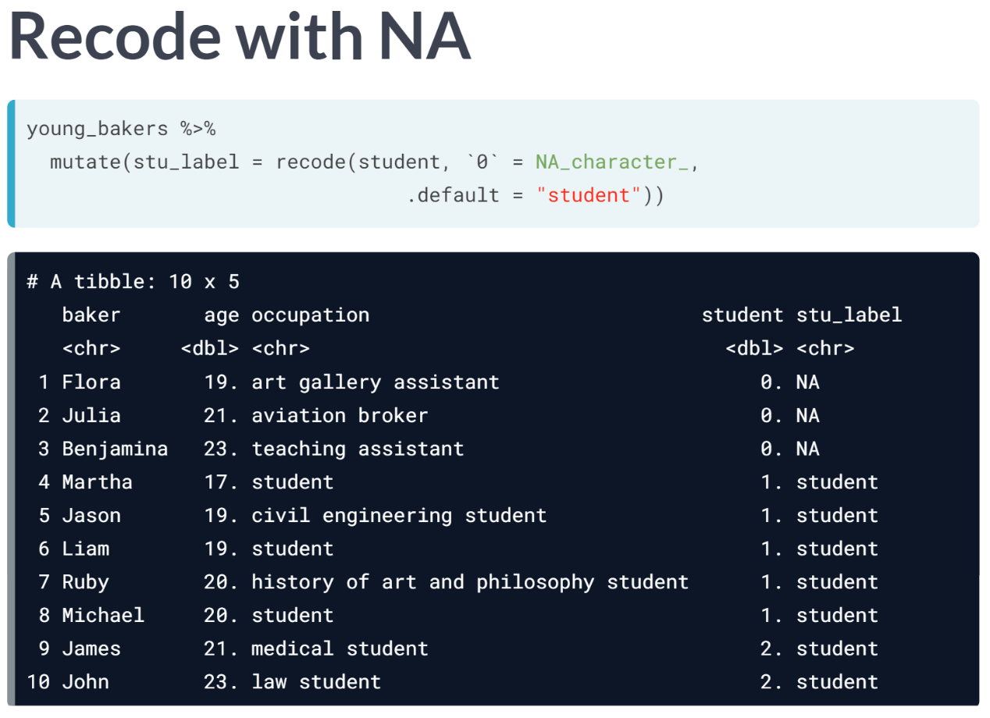

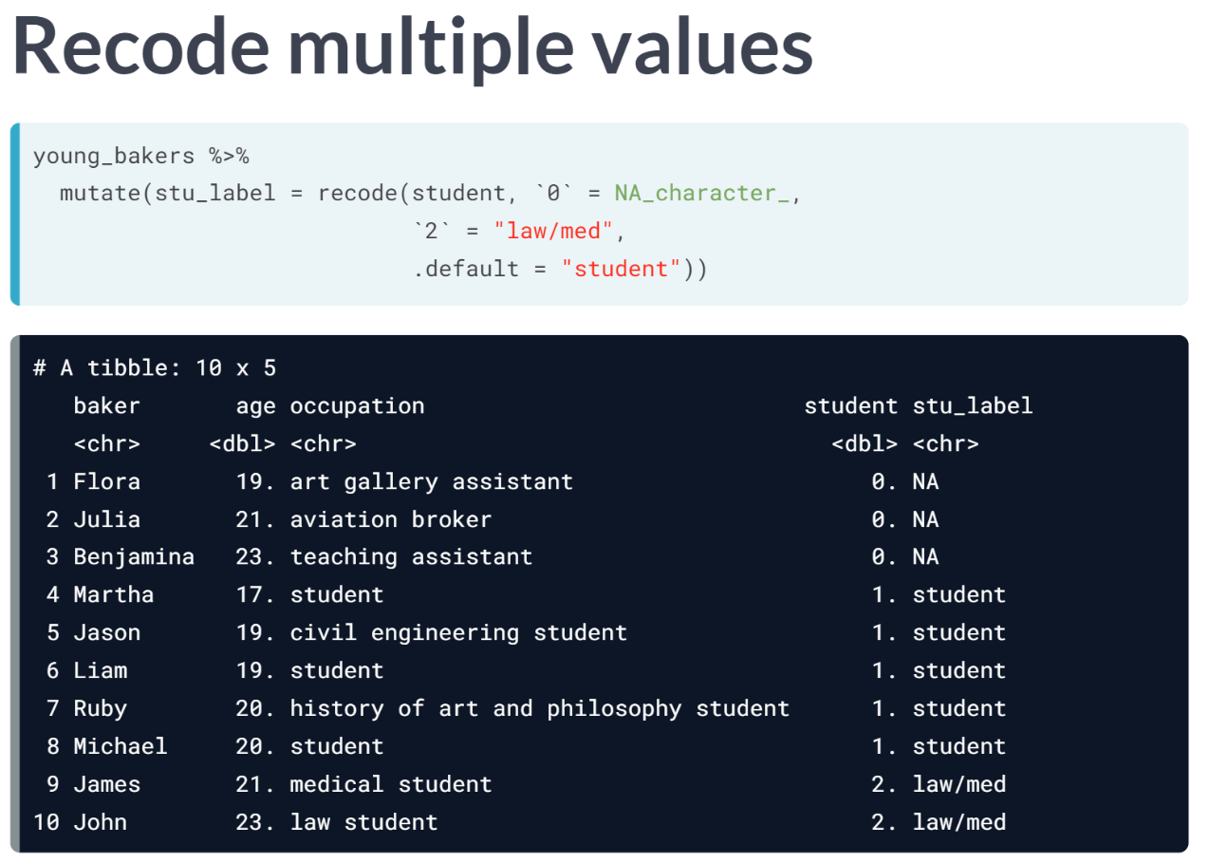

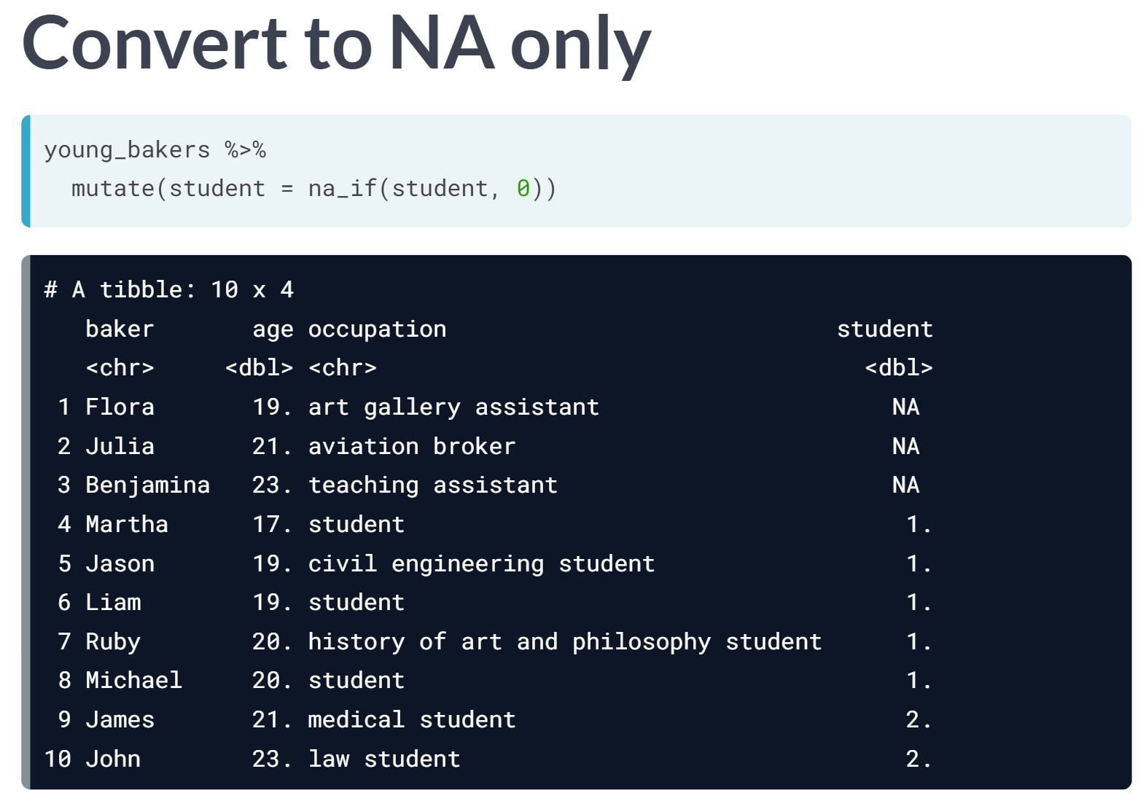

# Recode a character variable

In this exercise, you'll [**recode()**](https://www.rdocumentation.org/packages/dplyr/versions/0.7.3/topics/recode) the nut variable in the desserts data. This is a character variable that tells us, for each bake, whether a nut was a key ingredient and if so, what kind of nut!

Remember that the arguments of recode() are the variable that you want to recode, and then an expression of the form old_value = new_value. recode() is most useful when used inside a mutate() to create a new variable or reassign the old one.

Often you want to recode a certain value as missing. In this case, it is important to preserve the data type of the variable. R has built-in words to indicate missing data of various types, for example NA_character_ for missing value for a character variable, or NA_integer_ for missing integer data. The NA value is of the logical type.

Remember that you can use ?function_name_here to read more about arguments and how to use them.

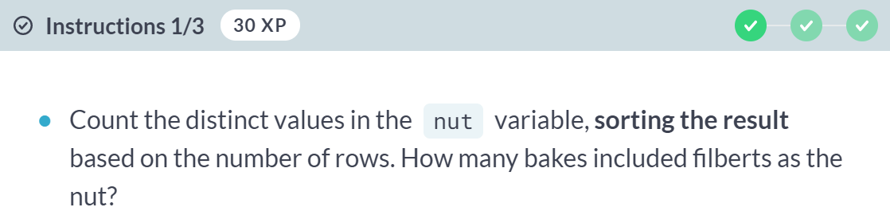

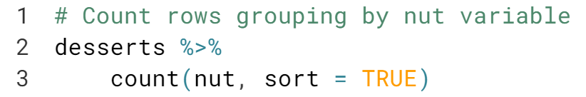

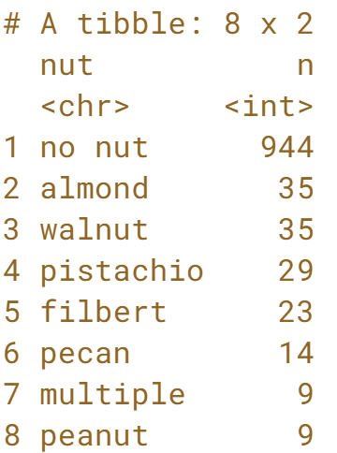

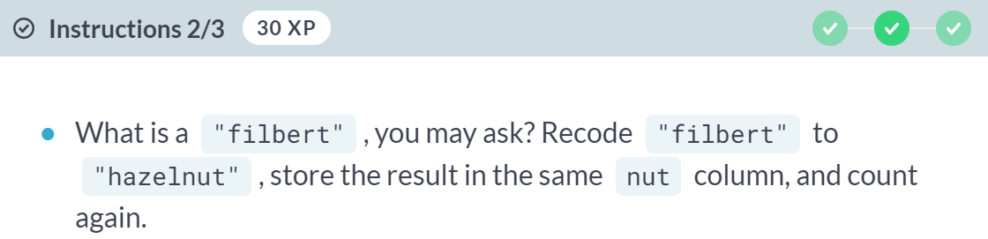

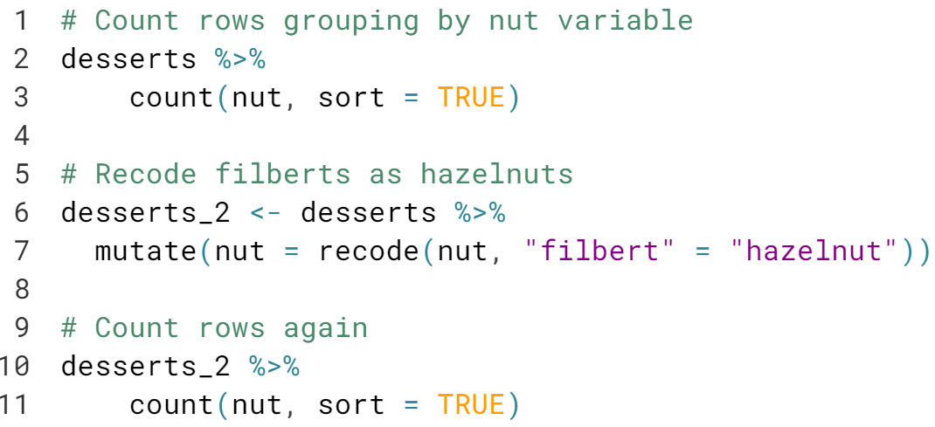

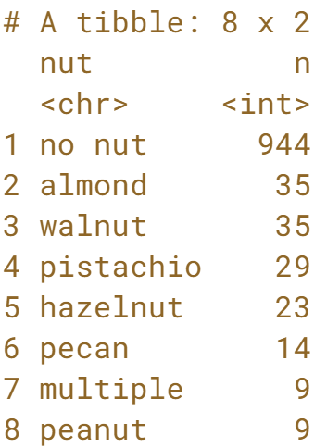

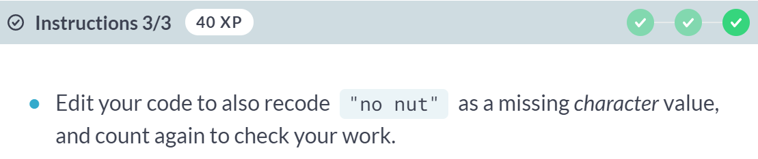

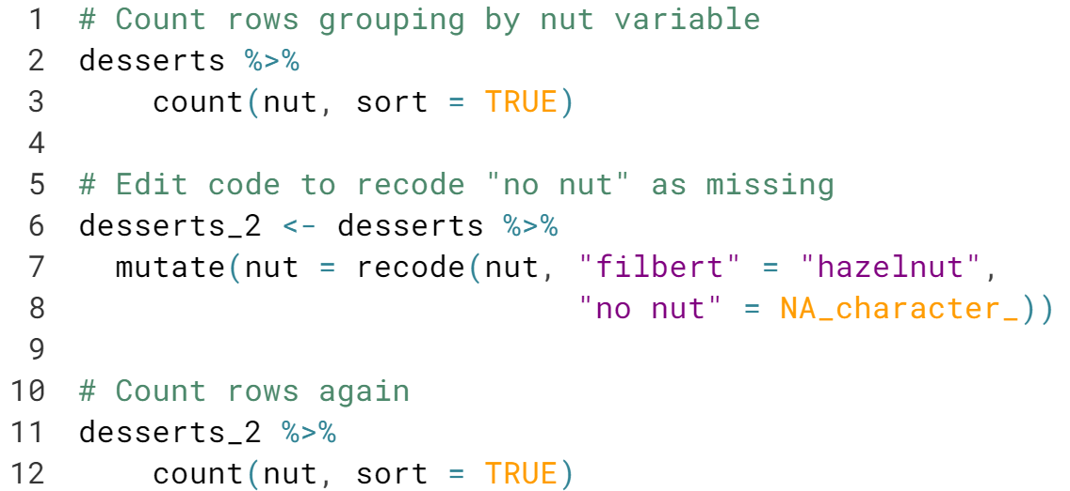

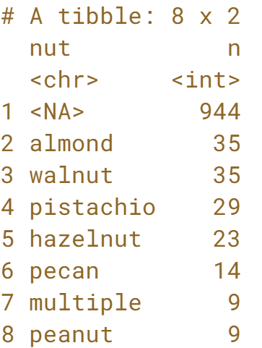

Nice! NA is a logical constant, so it is always helpful to remember the NA constants like ***NA_character_*** and ***NA_integer_*** when working with strings or numbers. Always know your variable types!

# Recode a numeric variable

Dummy variables are often used in data analysis to bin a variable into one of two categories to indicate the absence or presence of something. Dummy variables take the value 0 or 1 to stand for, for example, loser or winner. Dummy variables are often factor variables as opposed to numeric - we'll cover more about factors in the last chapter.

In desserts, the technical variable is a number representing the judges' ranks for each baker in the technical challenge, for every episode (remember to run glimpse(desserts) to take a peek). In this exercise, you will recode the numeric technical variable to a new factor dummy variable.

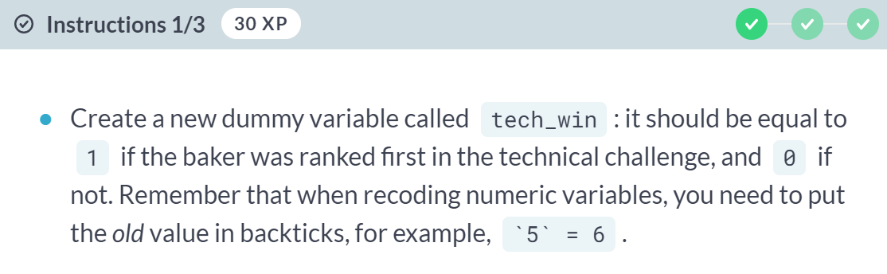

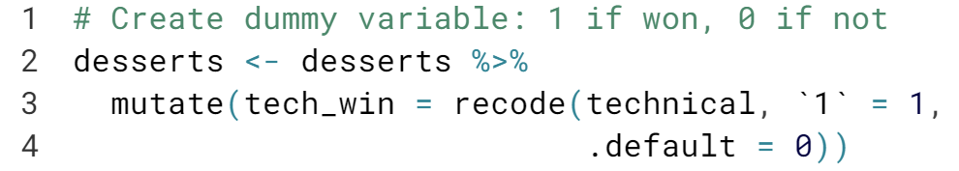

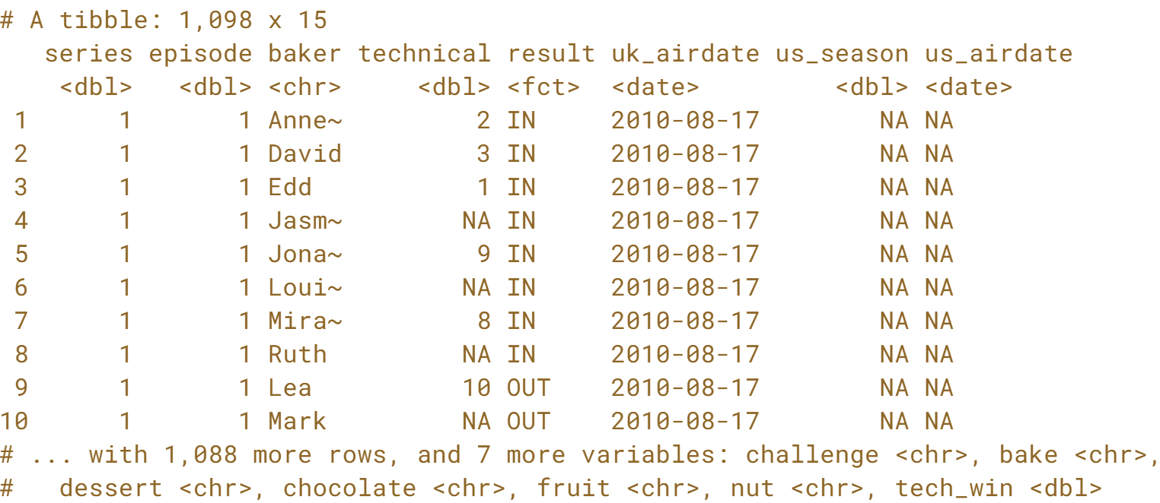

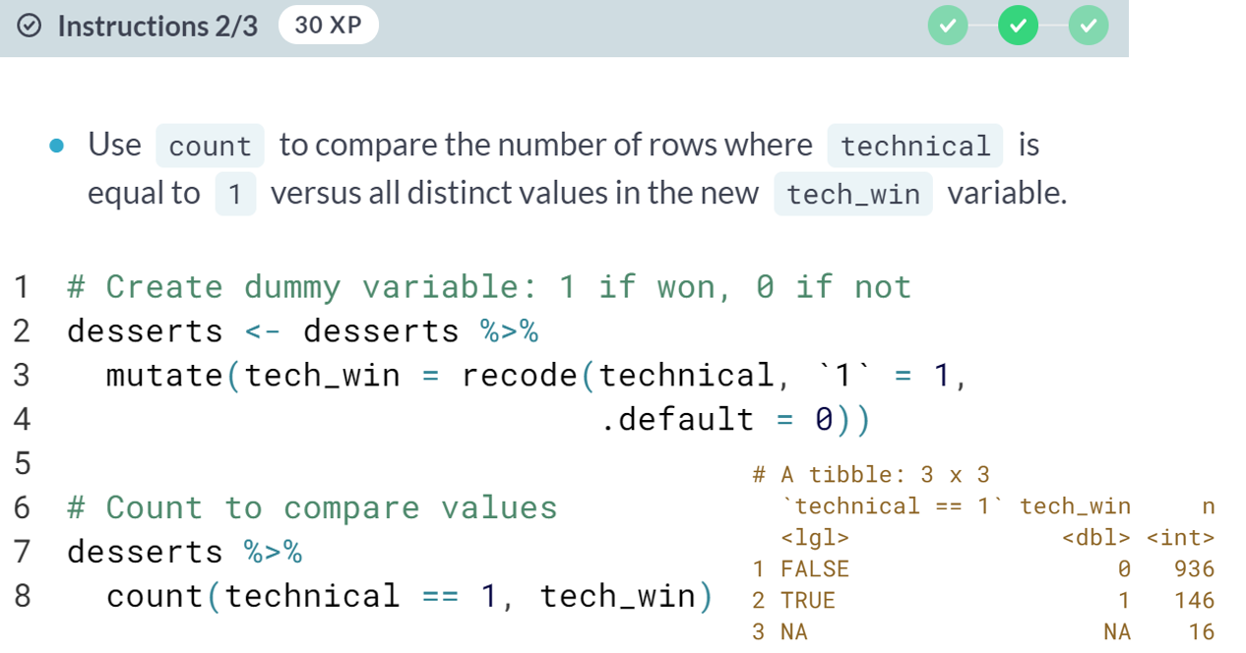

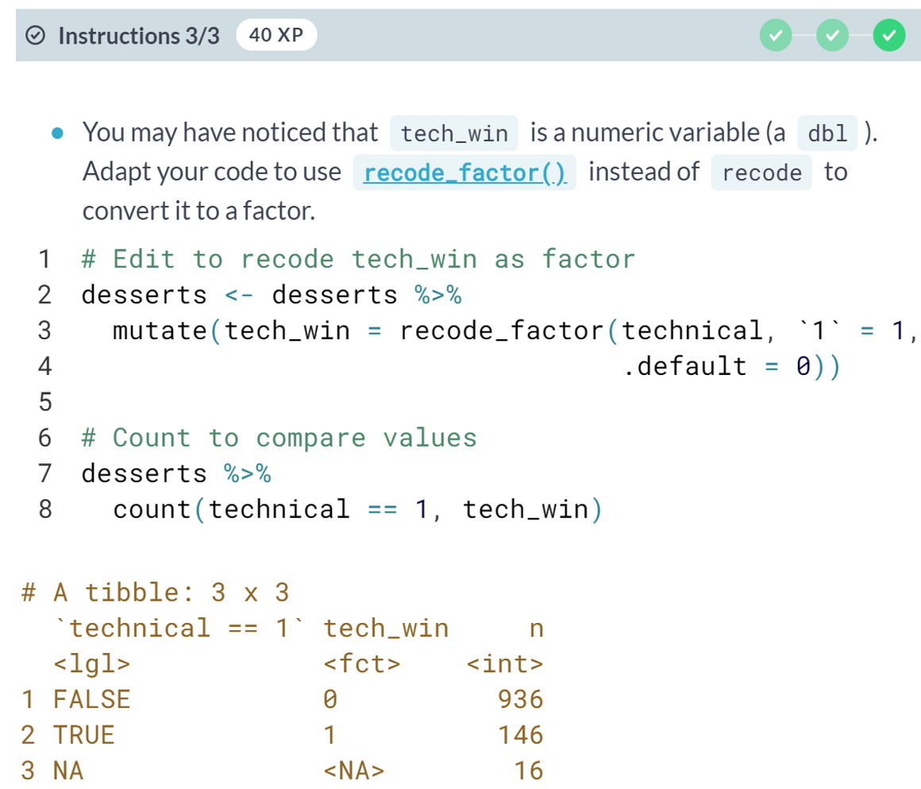



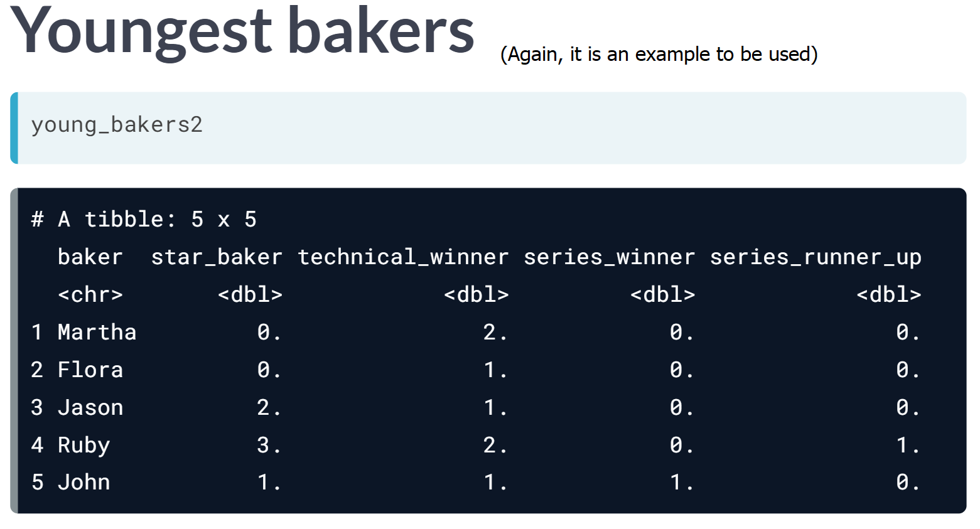

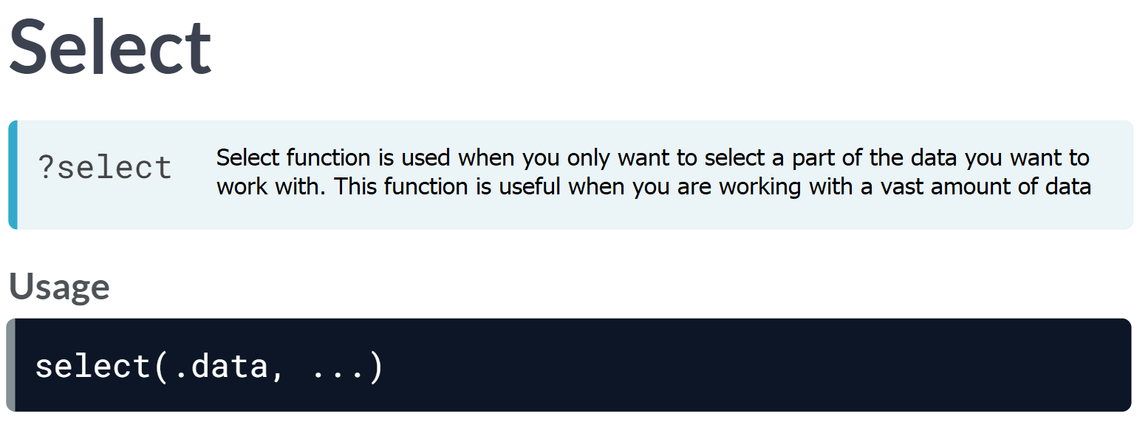

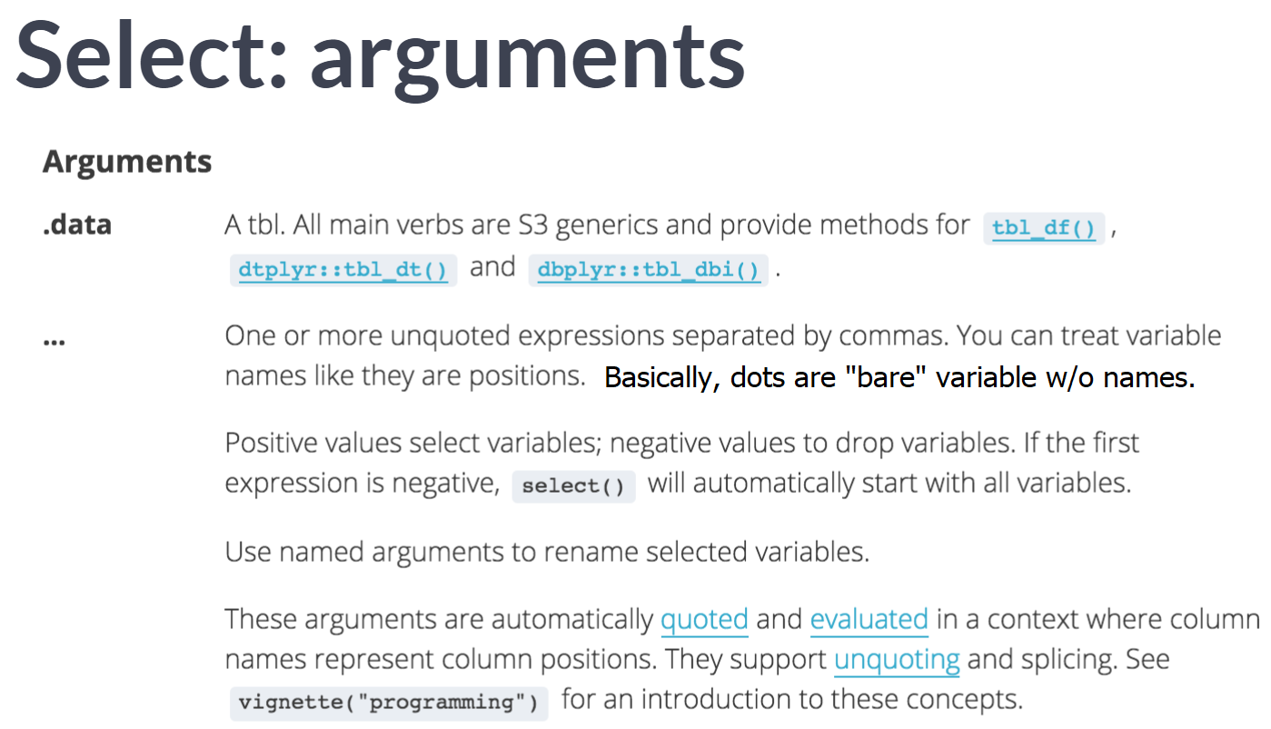

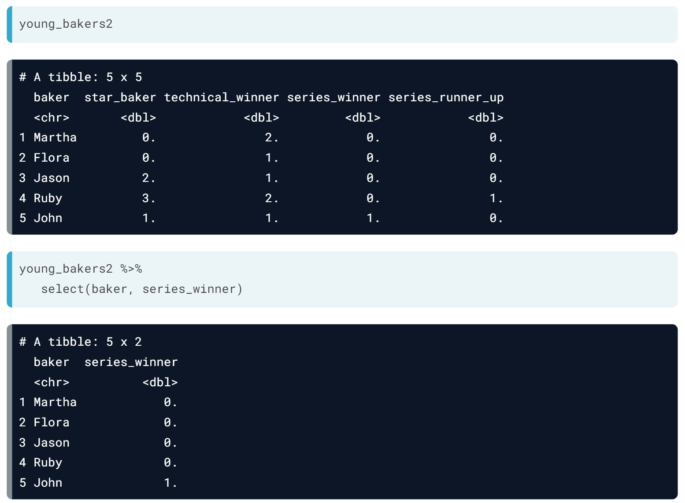

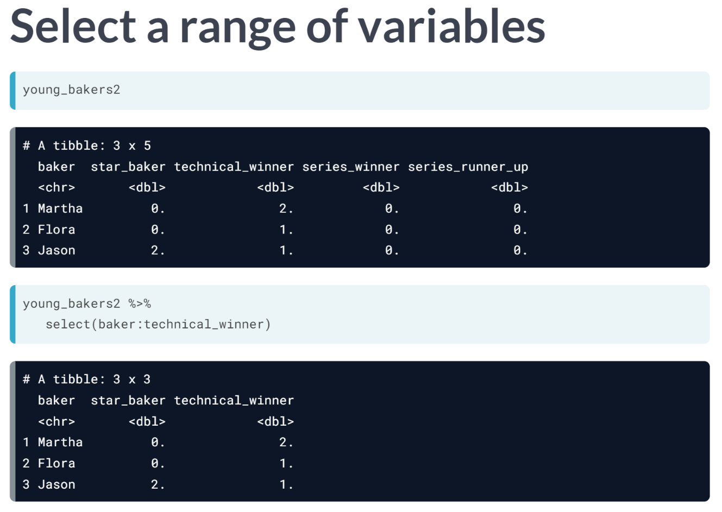

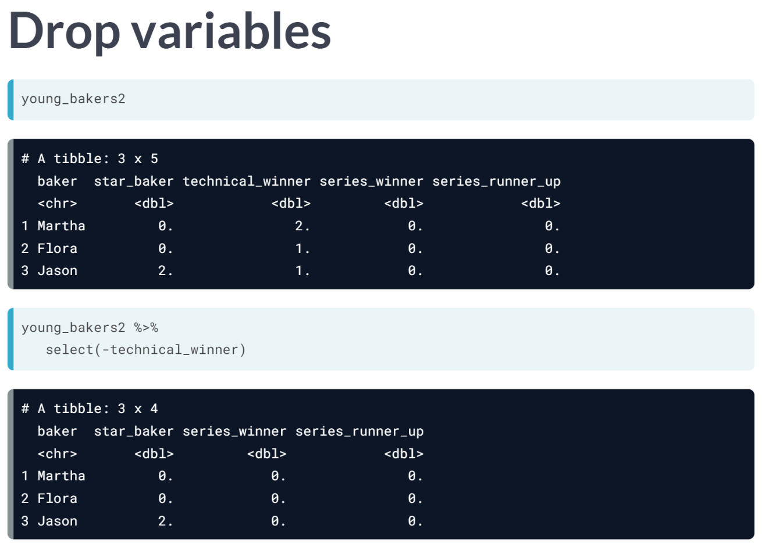

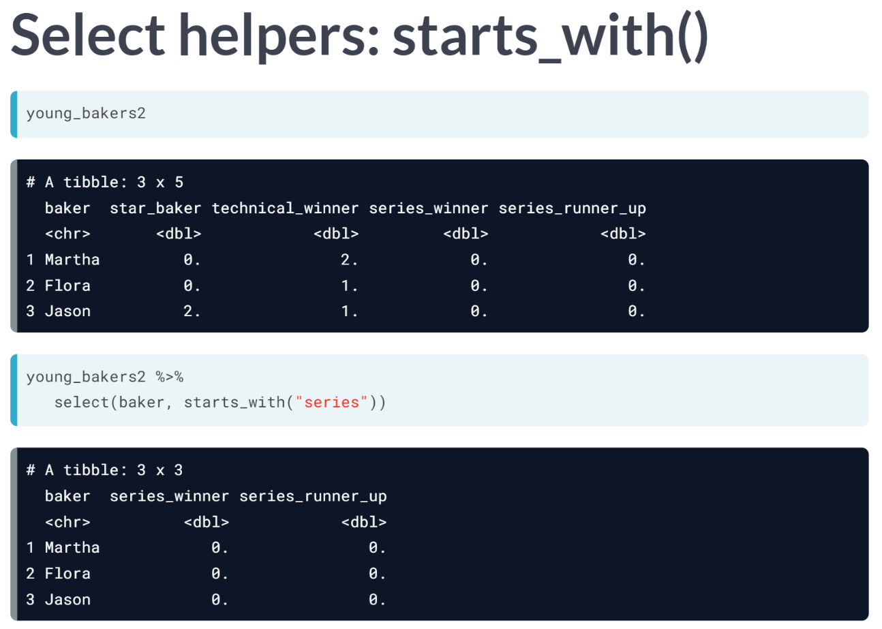

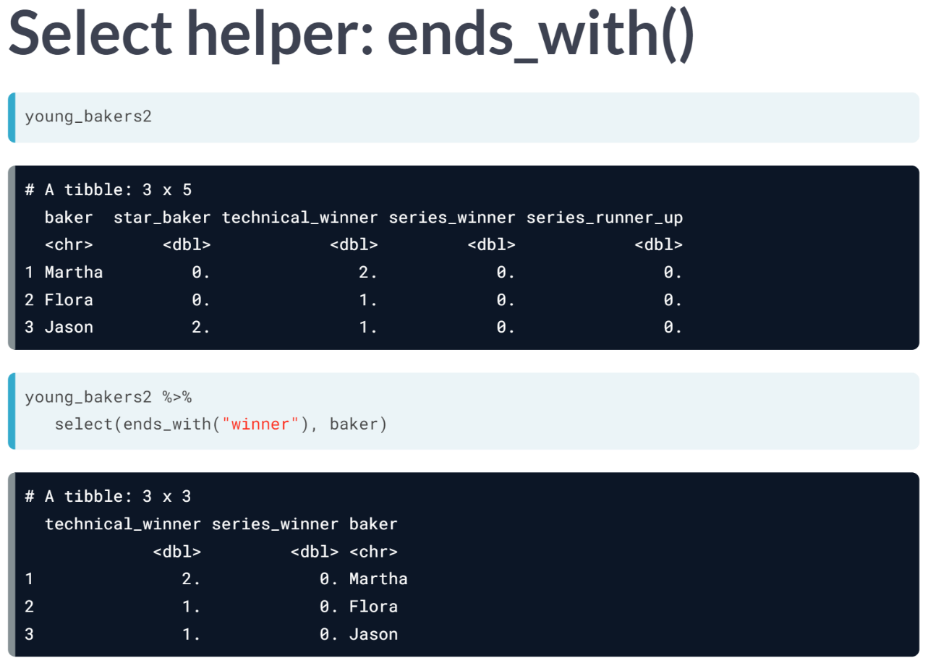

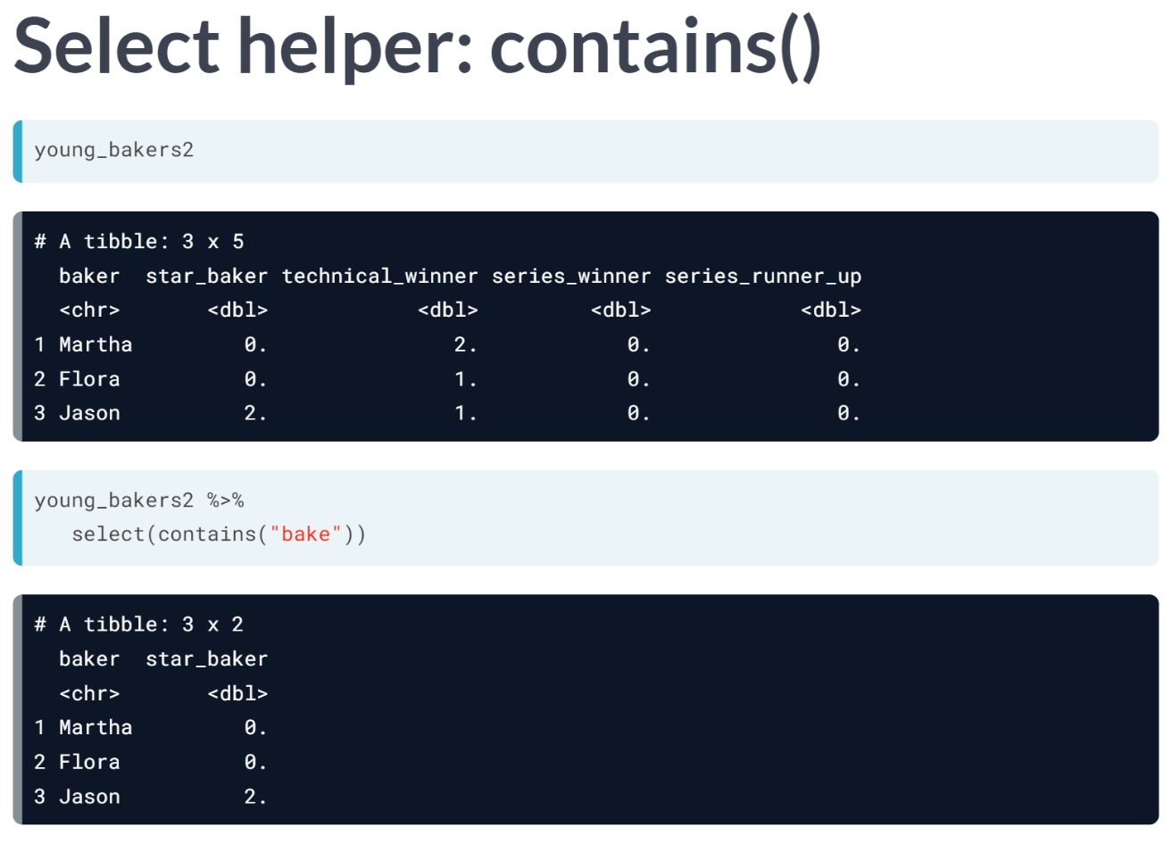  
  
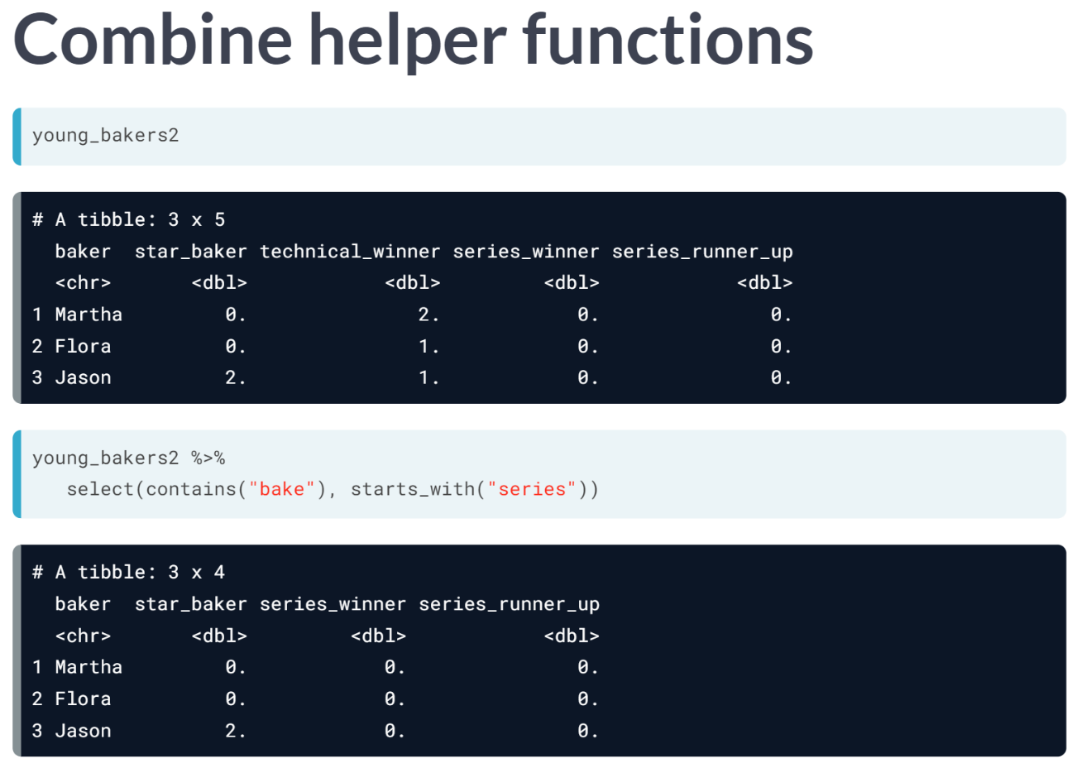

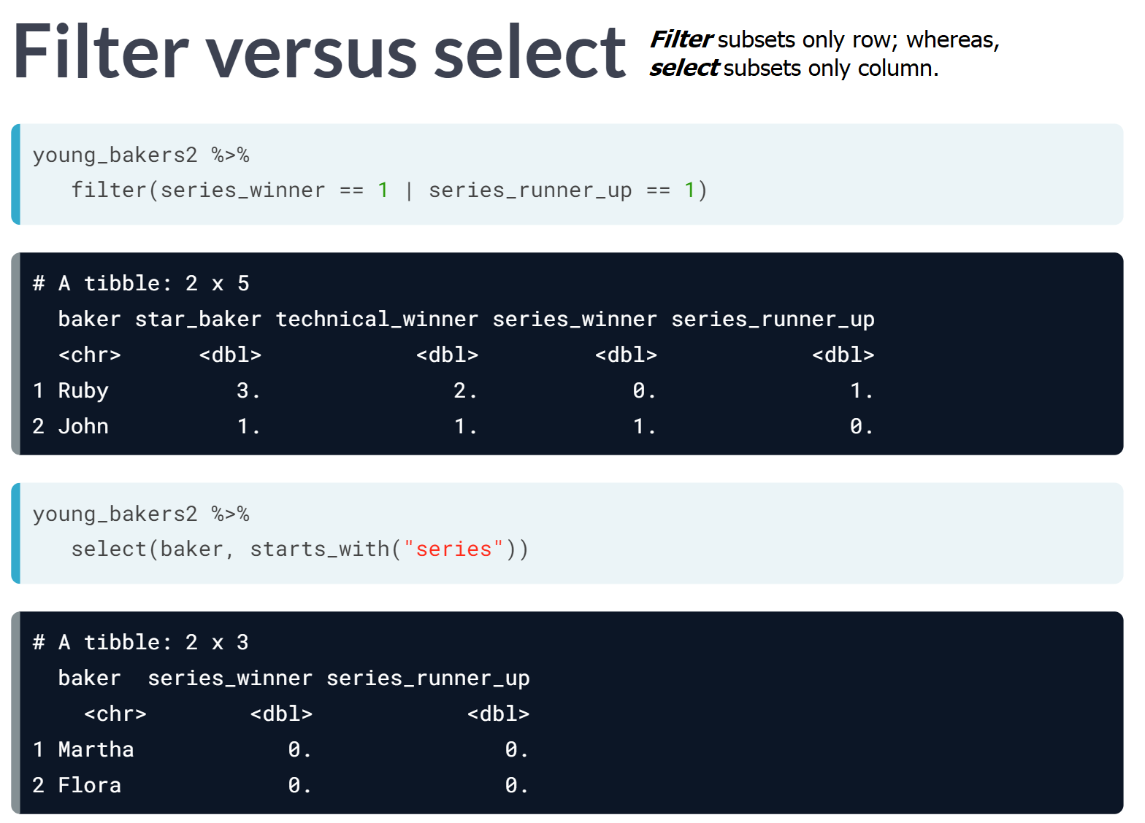

# Combine functions with select

The ratings data tells us about how many UK viewers tuned in to watch "The Great British Bake-Off" for each episode of each series. If you explore ratings in console, you'll see that there is a separate variable for the number of viewers for each episode. A key question we'll return to in Chapter 3 is: how many more viewers watched the finale than the premiere episode?

Use the data science tools you've learned so far to answer:

*For series with 10 episodes, which showed the most growth in viewers from the premiere to the finale? Which showed the least?*

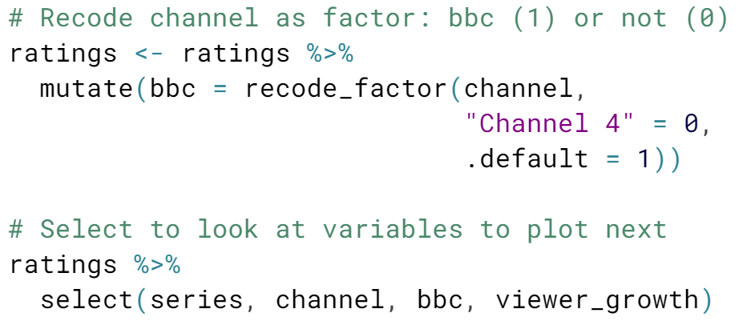

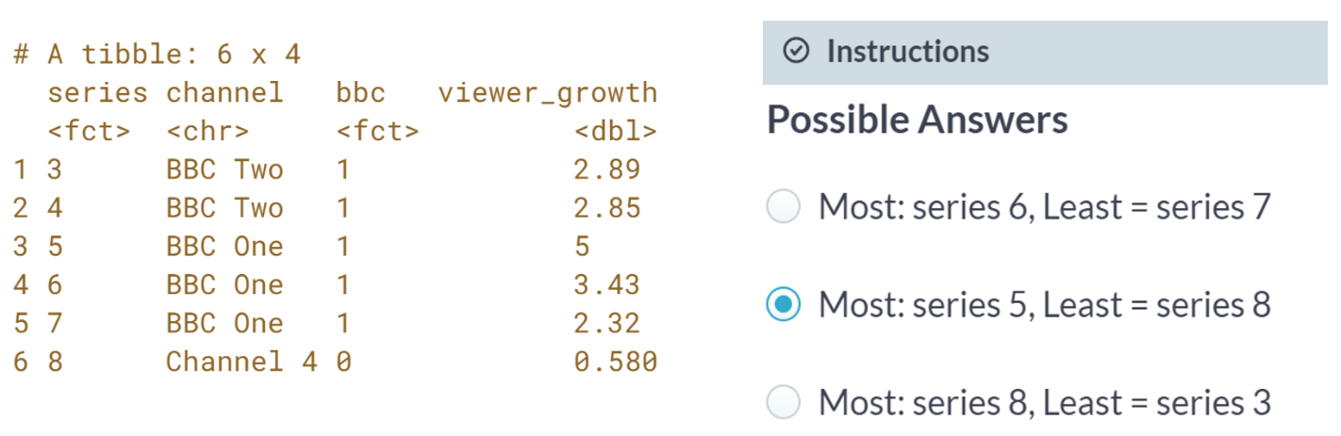

Series 5 on BBC One showed the most, while series 8 on Channel 4 showed the least.

# Recode factor to plot

In the last exercise, you may have used mutate() to find the difference between the number of premiere and finale episode viewers for each series. This variable, which I created and called viewer_growth, is now available in ratings, and feel free to check out it.

Now let's practice using select() to check the result of another mutate with recode_factor().

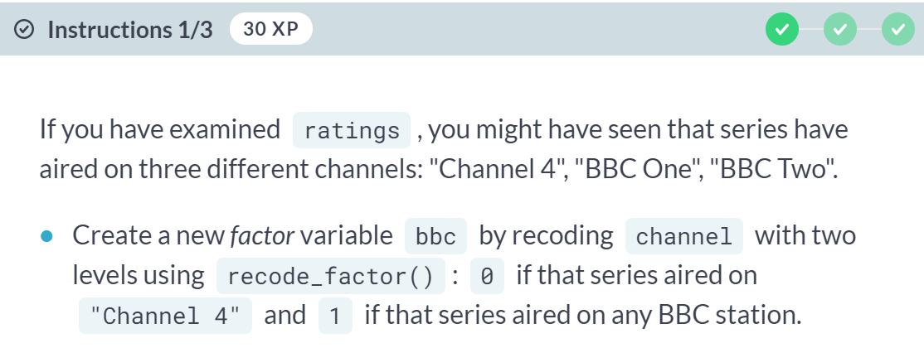

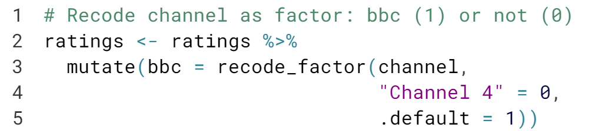

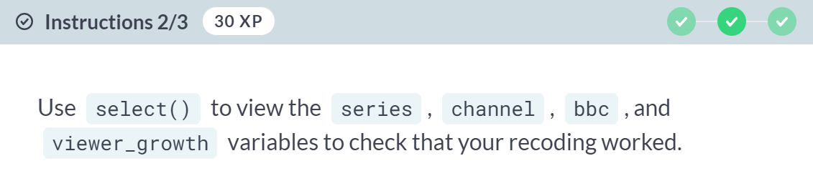

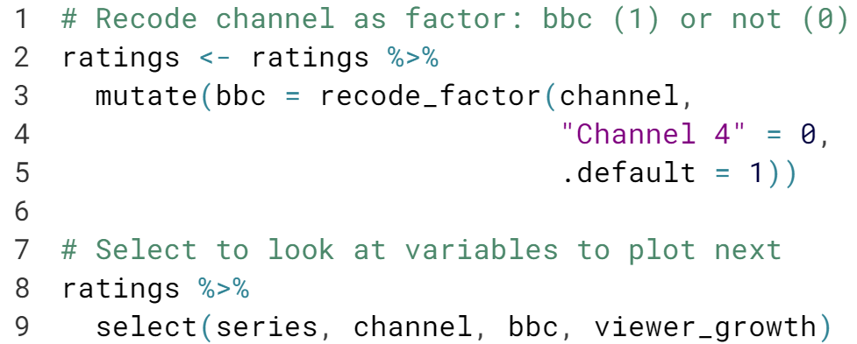

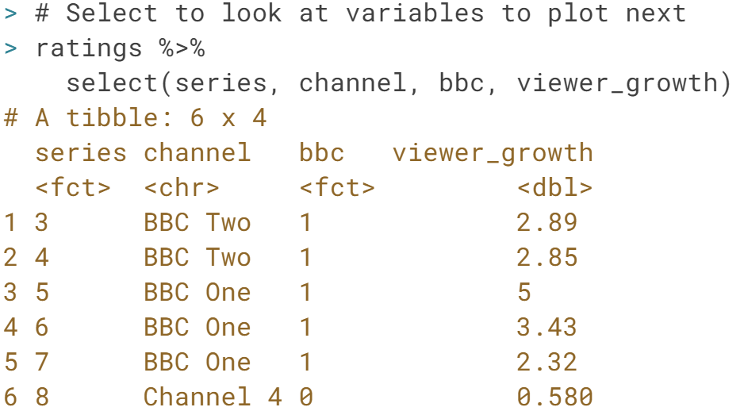

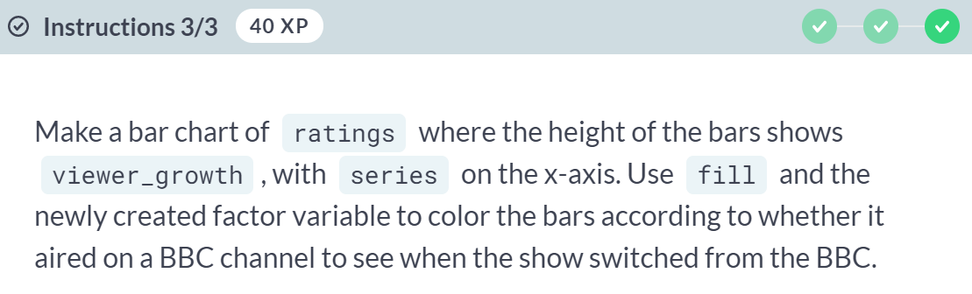

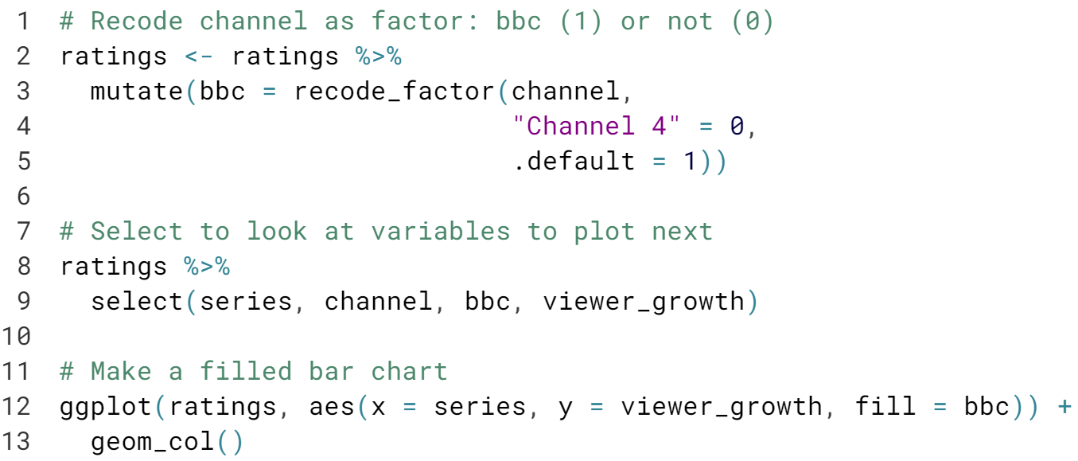   
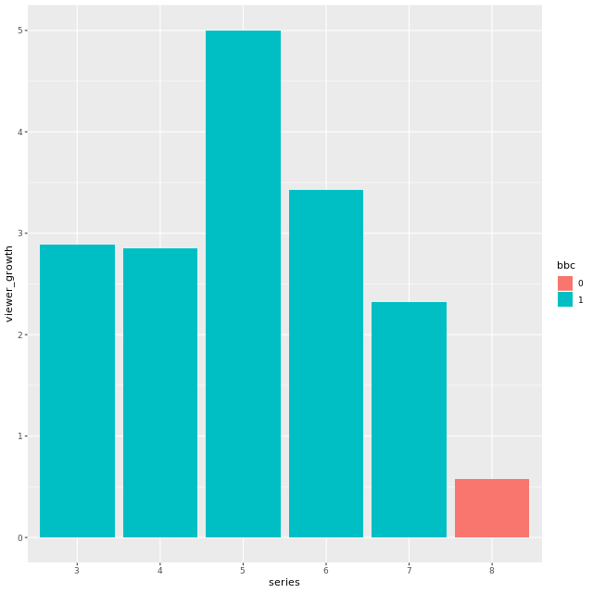

# Select and reorder variables

As we have seen, selecting a subset of columns to print can help you check that a mutate() worked as expected, and rearranging columns next to each other can help you spot obvious errors in data entry.

The [**select() helpers**](https://www.rdocumentation.org/packages/tidyselect/versions/0.2.4/topics/select_helpers) are functions that you can use inside select() to allow you to select variables based on their names.

In this exercise, you'll work with the ratings data, and you'll use a new helper function called [**everything()**](https://www.rdocumentation.org/packages/tidyselect/versions/0.2.4/topics/select_helpers) which can be useful when reordering columns. Use ?everything to read more. You will learn more about using helper functions in the next lesson.

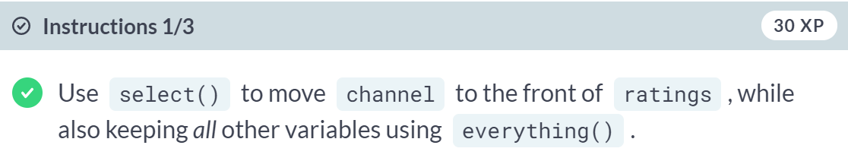  
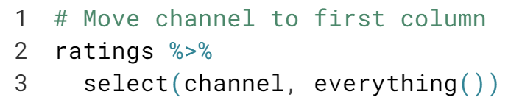

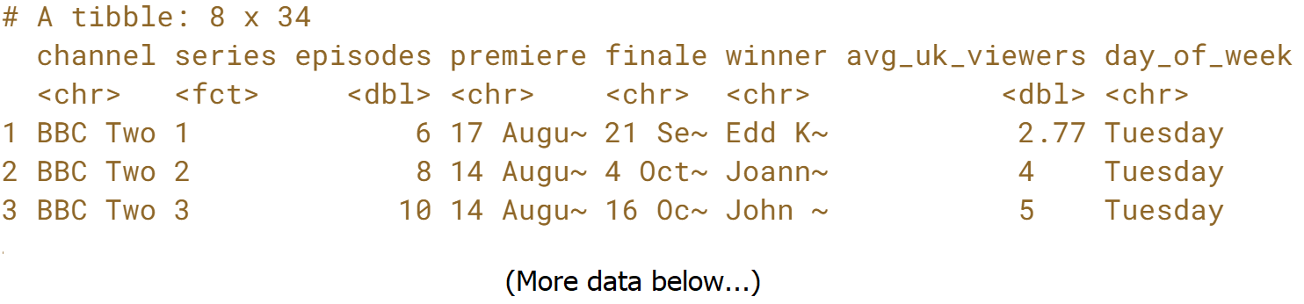

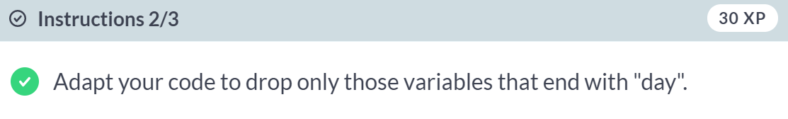

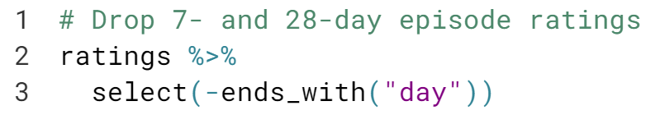

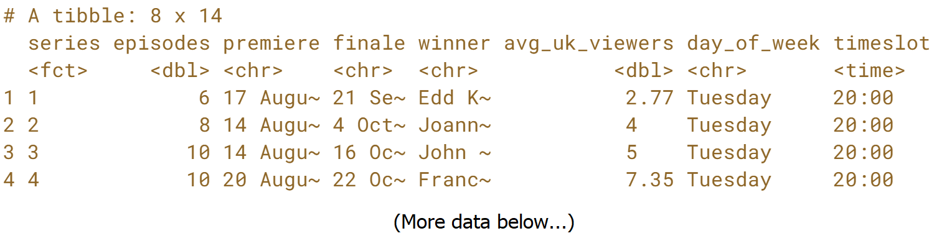



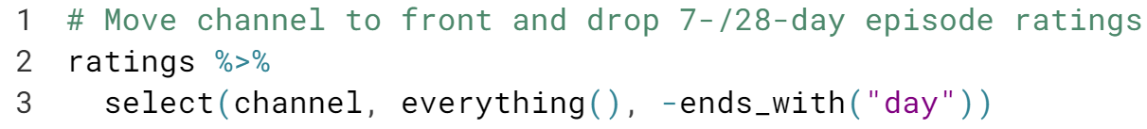  
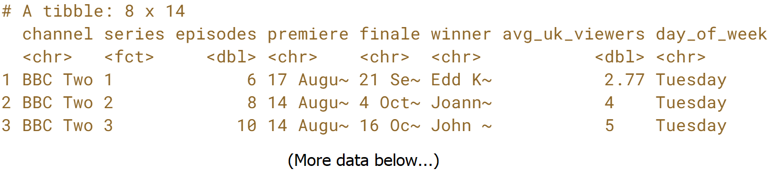  
***everything()*** is a great little helper! If it had been placed at the end, it would have added back in all the columns that end with "day". Placing it before deselecting columns, though, is a real time-saver.



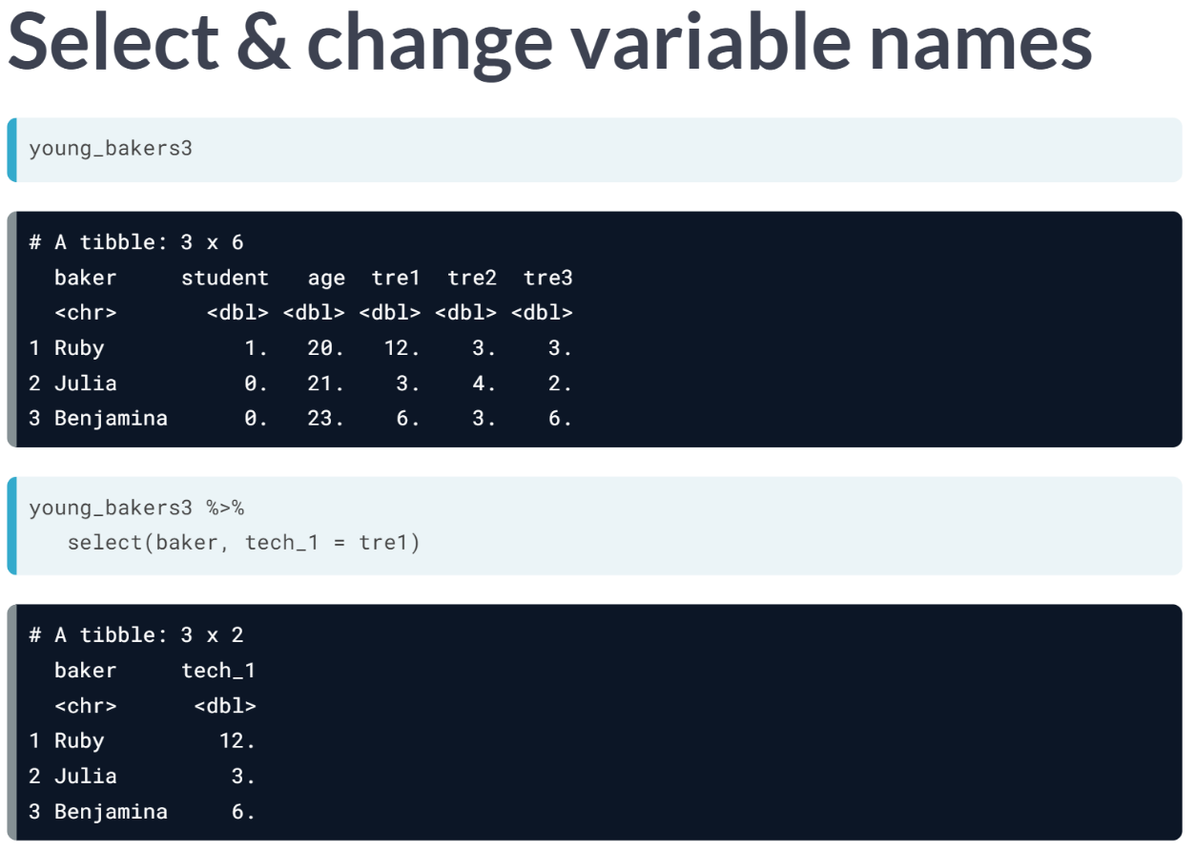

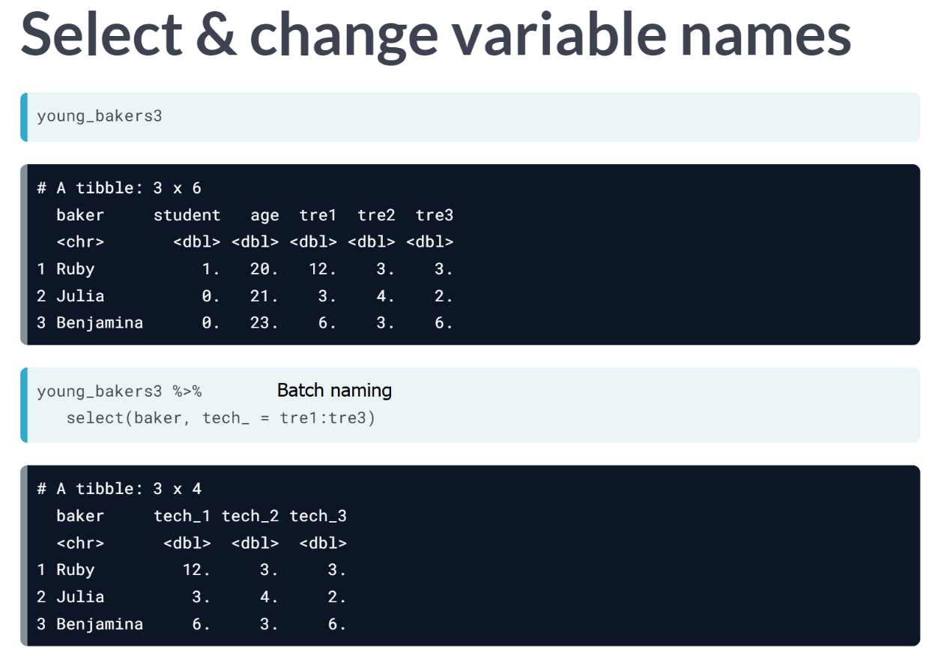  
Keep in mind that this type of batch-naming only works when order of columns are consecutive.

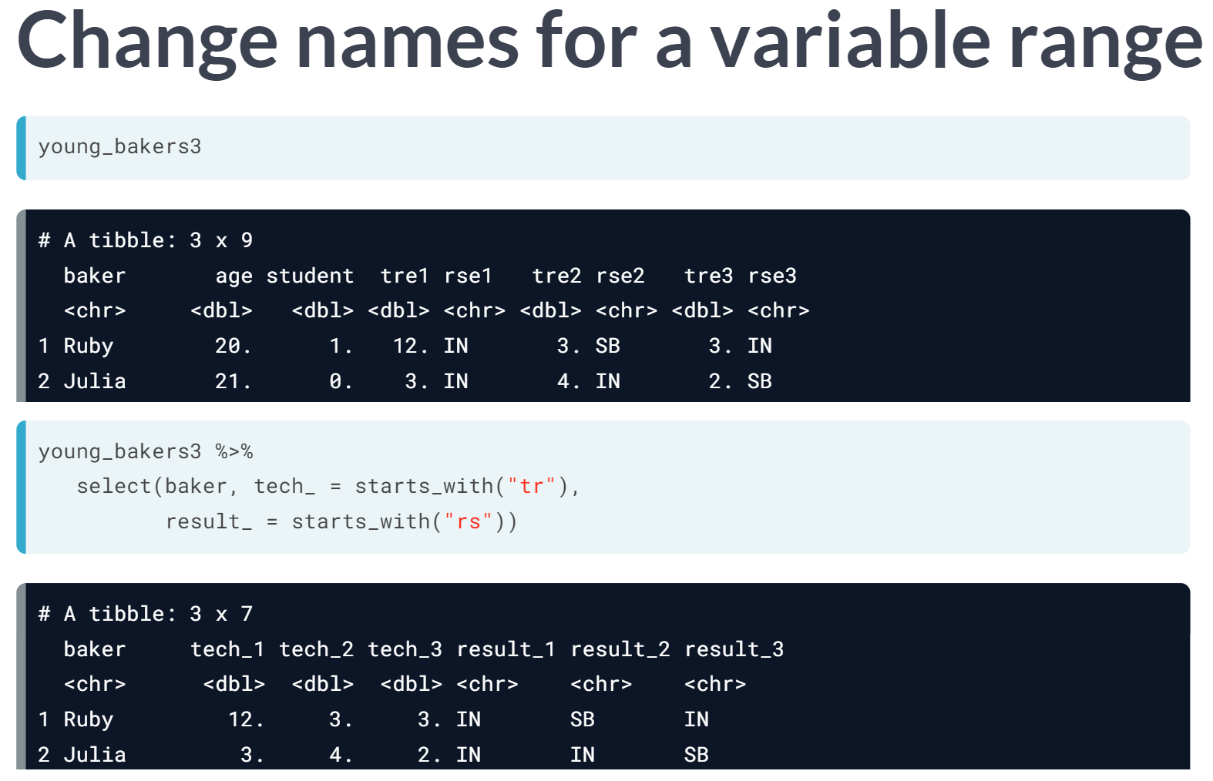

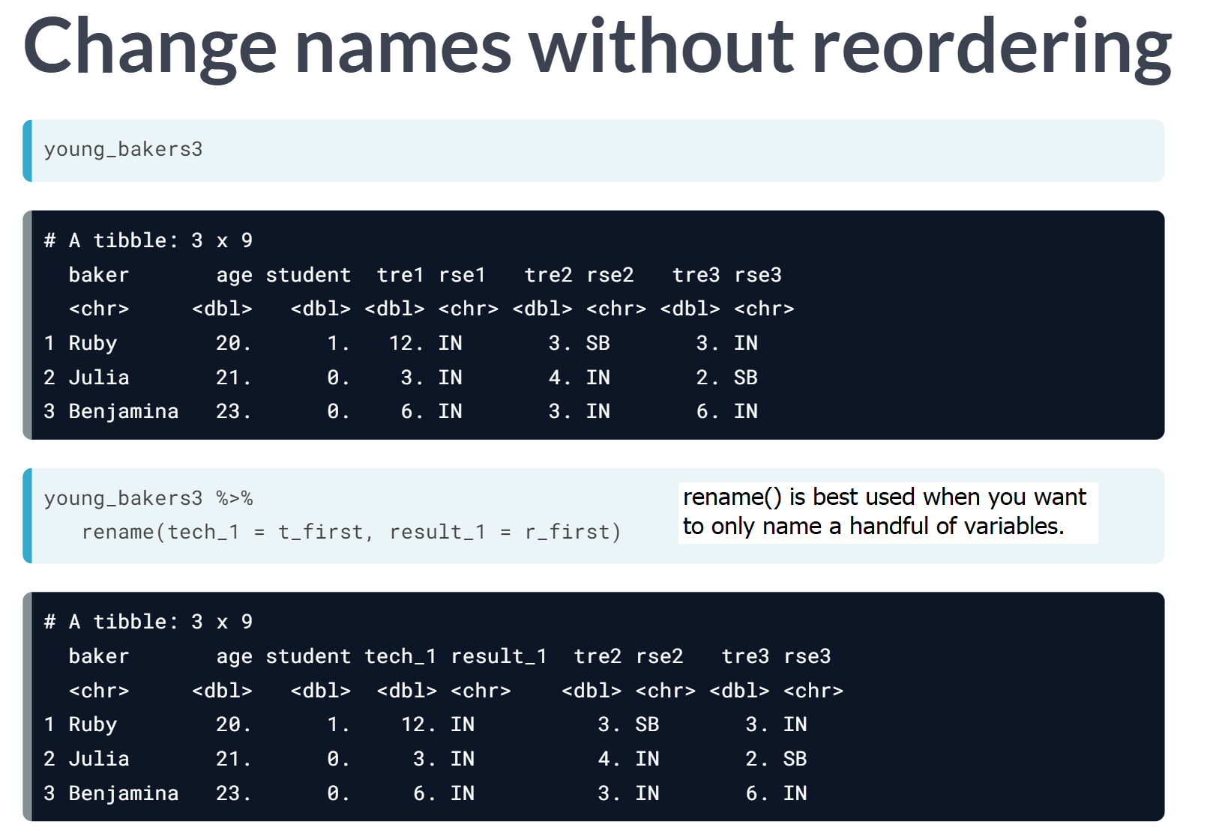

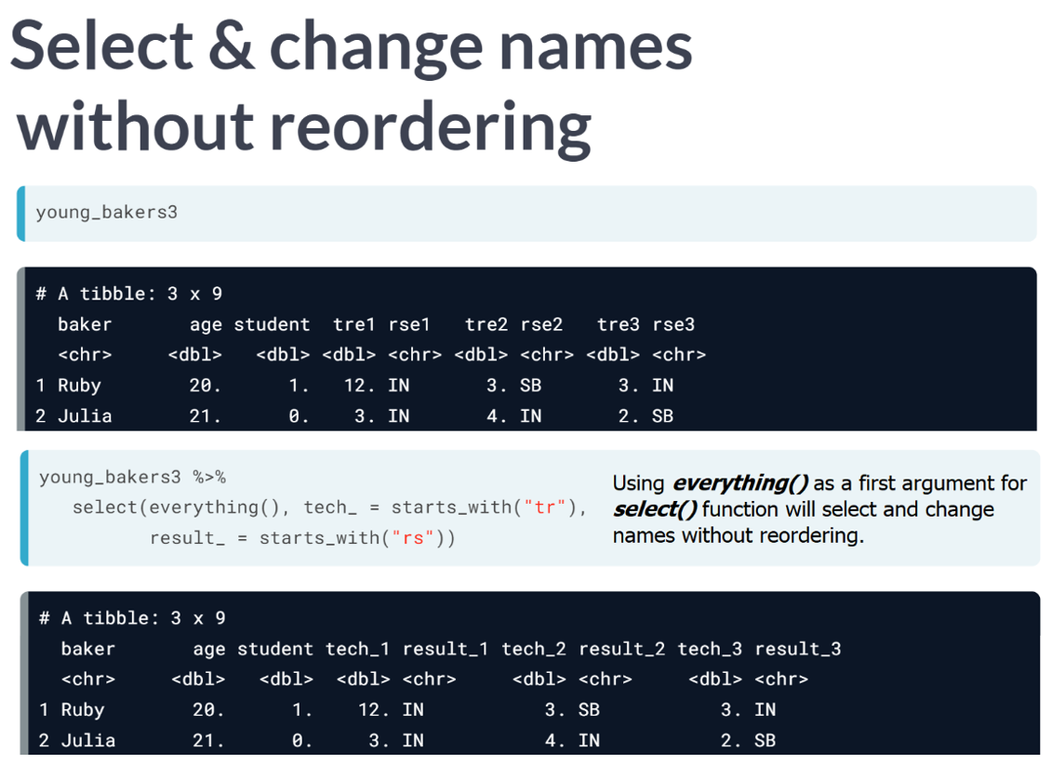

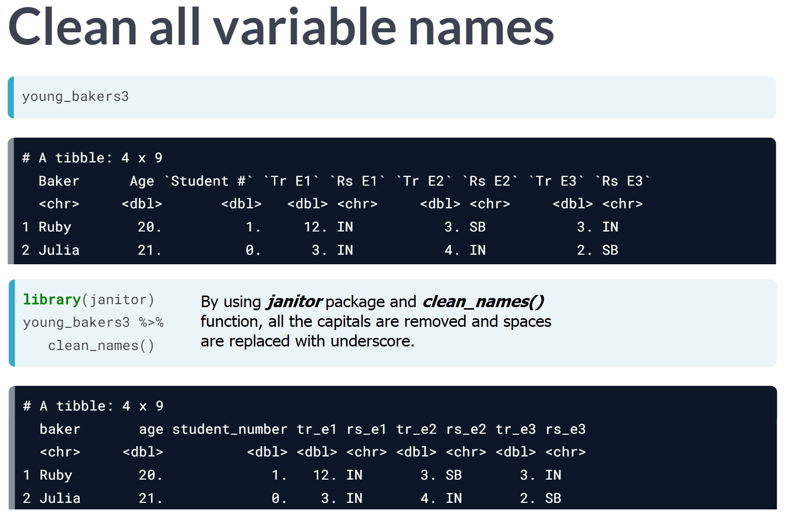

# Reformat variables

In the video, you saw how to use [**clean_names()**](https://www.rdocumentation.org/packages/janitor/versions/1.0.0/topics/clean_names) from the janitor package to convert all variable names to snake_case. Here is how:

library(janitor)

young_bakers3 <- young_bakers3 %>%

clean_names()

The function clean_names() takes an argument case that can be used to convert variable names to other cases, like "upper_camel" or "all_caps".

Let's practice using the messy_ratings tibble. Remember you can use ?clean_names to see the function arguments and how to use them.

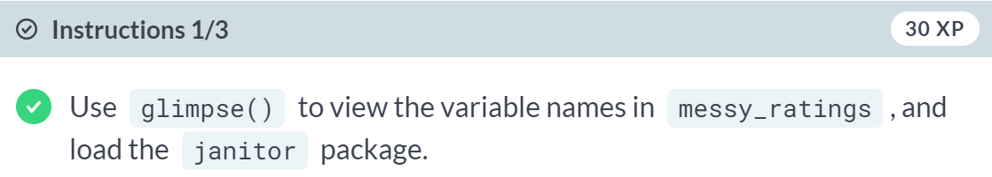

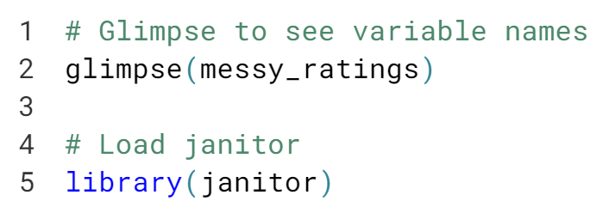

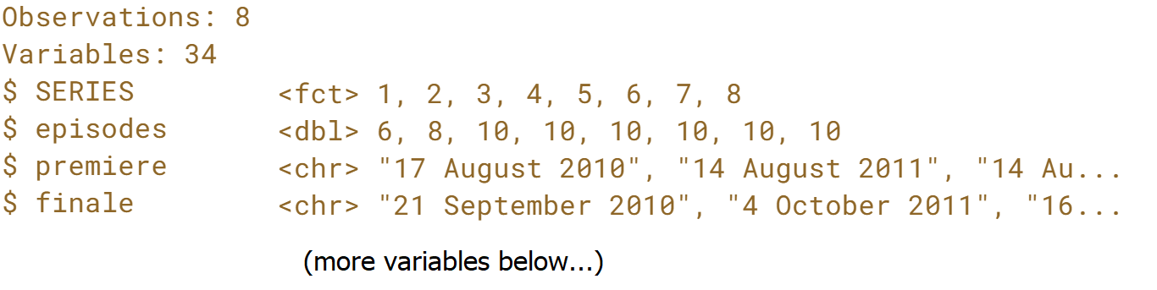

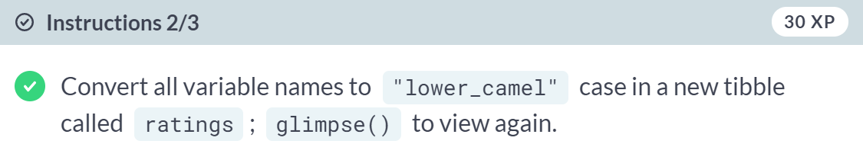

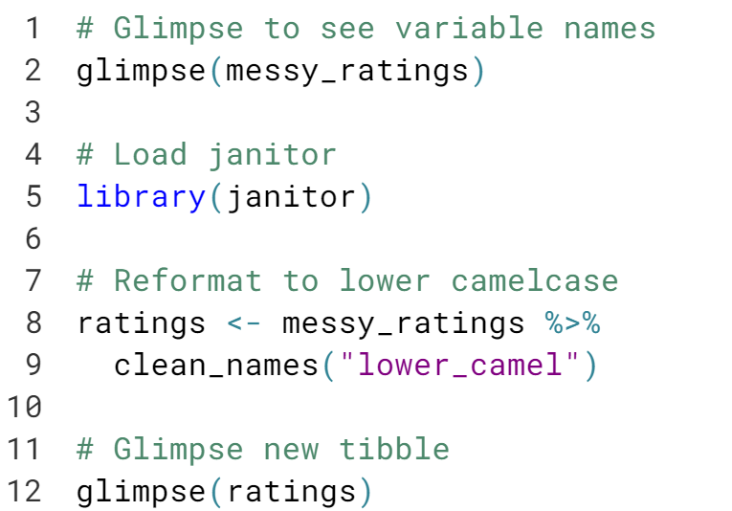

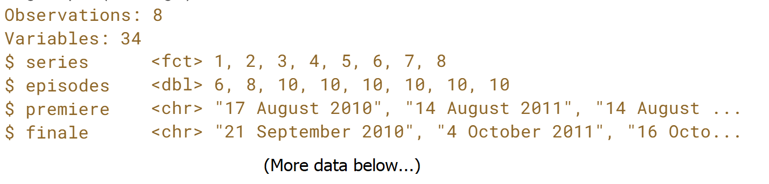

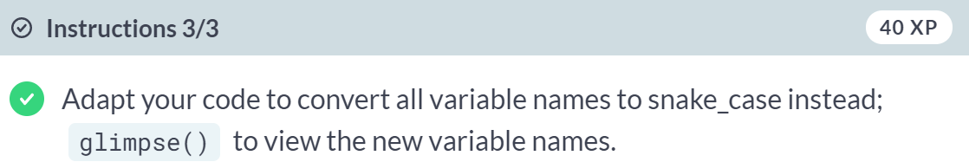

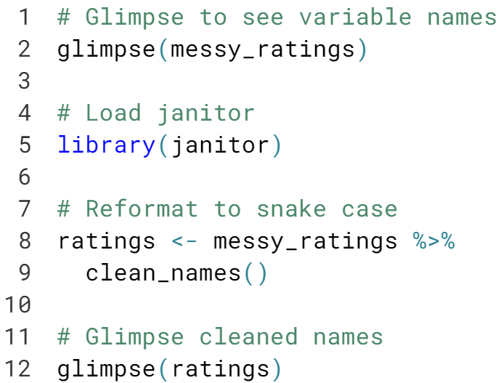

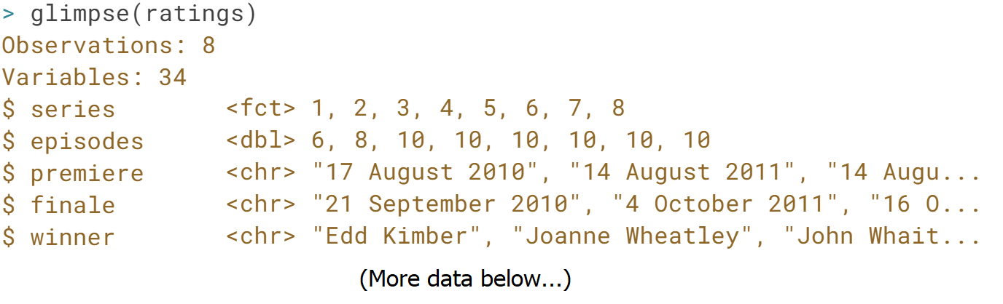

# Rename and subset variables

In the next chapter, when we reshape data to be tidy, you'll see the importance of having tame variable names.

Now that our variable names in ratings have been converted to snake_case, you'll practice combining renaming with select() helper functions to take advantage of the variable name structure.

As mentioned in the video, to rename a group of variables, you only need to specify a prefix of the new name.

For example, my_tbl %>% select( new_name_ = starts_with("oldname") ) will find all variables in my_tbl whose names start with oldname, enumerate them, then rename each variable as new_name_<N>, where N is a number. If my_tbl has variables oldname, oldname_v1, oldname3, running the statement above will replace these names with new_name_1, new_name_2, new_name_3. Notice how we only specified new_name_ in select(), and the numbers were appended automatically!

Take a second to glimpse() at ratings in your console, and take note of the variables that store data about the number of viewers. Can you see the pattern in their names? In this exercise, you will first select those variables using a helper function, and then rename them!

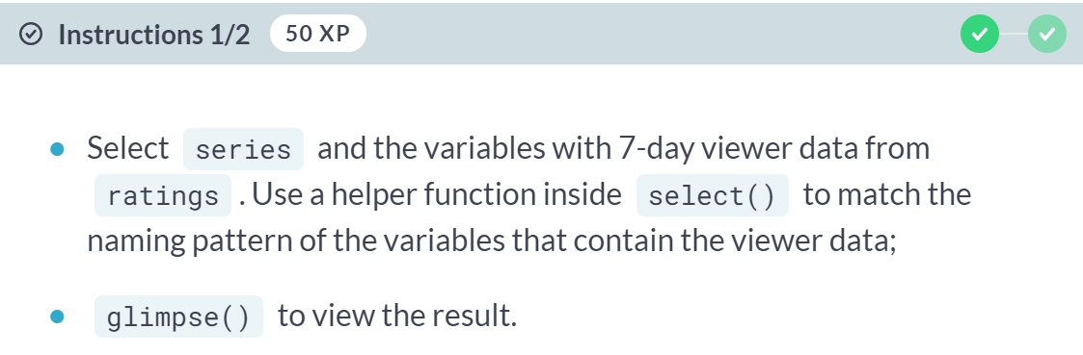

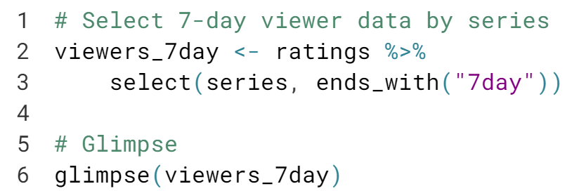  
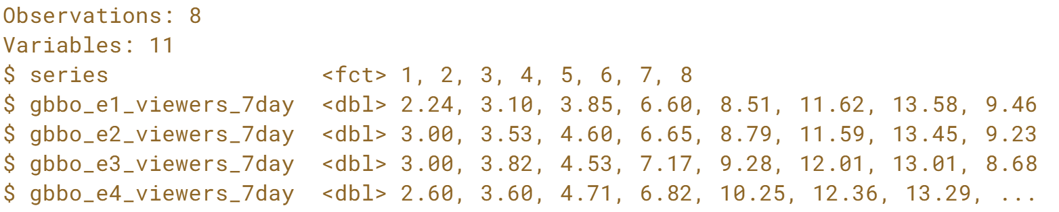

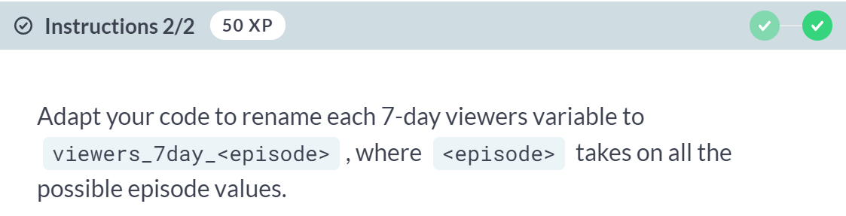

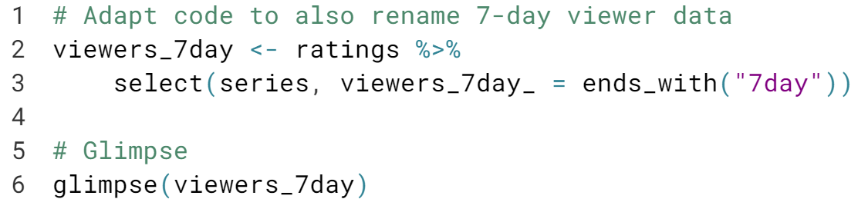

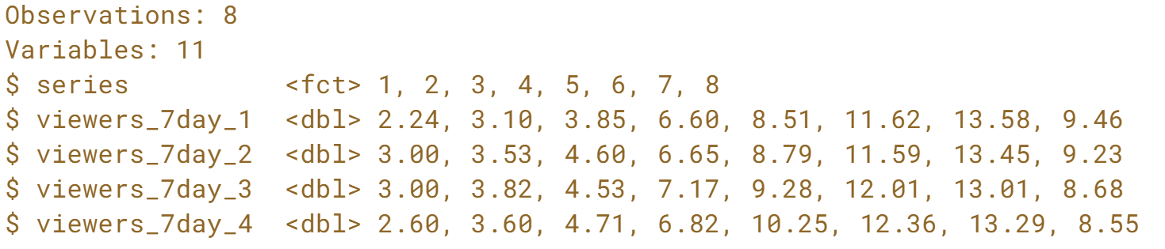  
Great job batch renaming! Using select helper functions is a powerful way to tame your variable names. Tame names make it easier to tidy your data.

# Rename and reorder variables

In the previous exercise, you renamed all the variables in ratings that end with "7day" and kept only a subset of variables. In this exercise, you'll adapt that code to drop some specific columns, while keeping and reordering other columns.



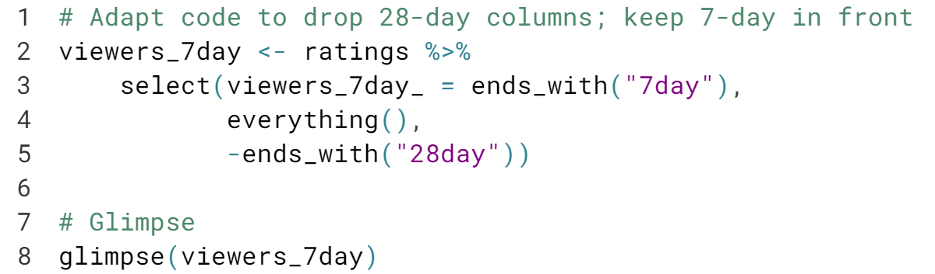

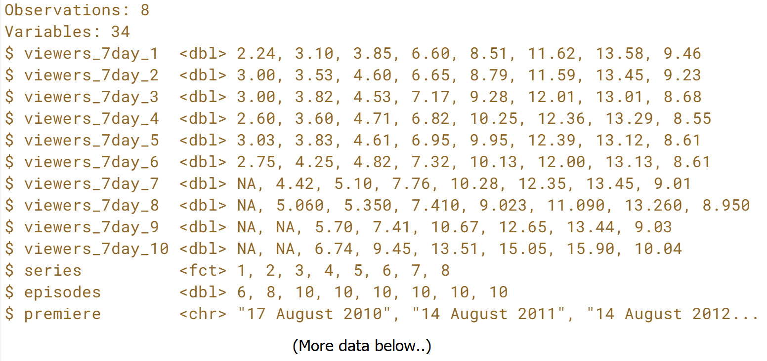

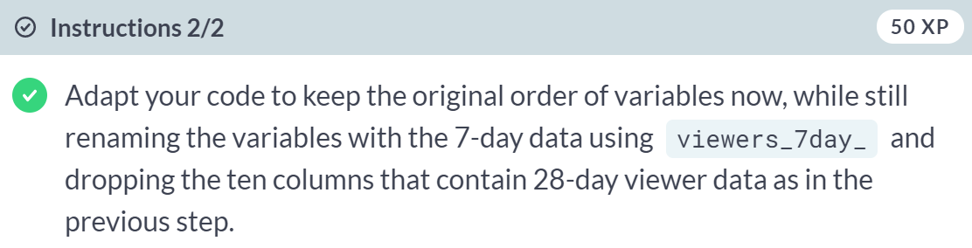

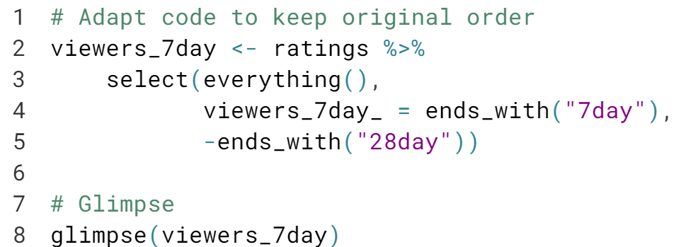

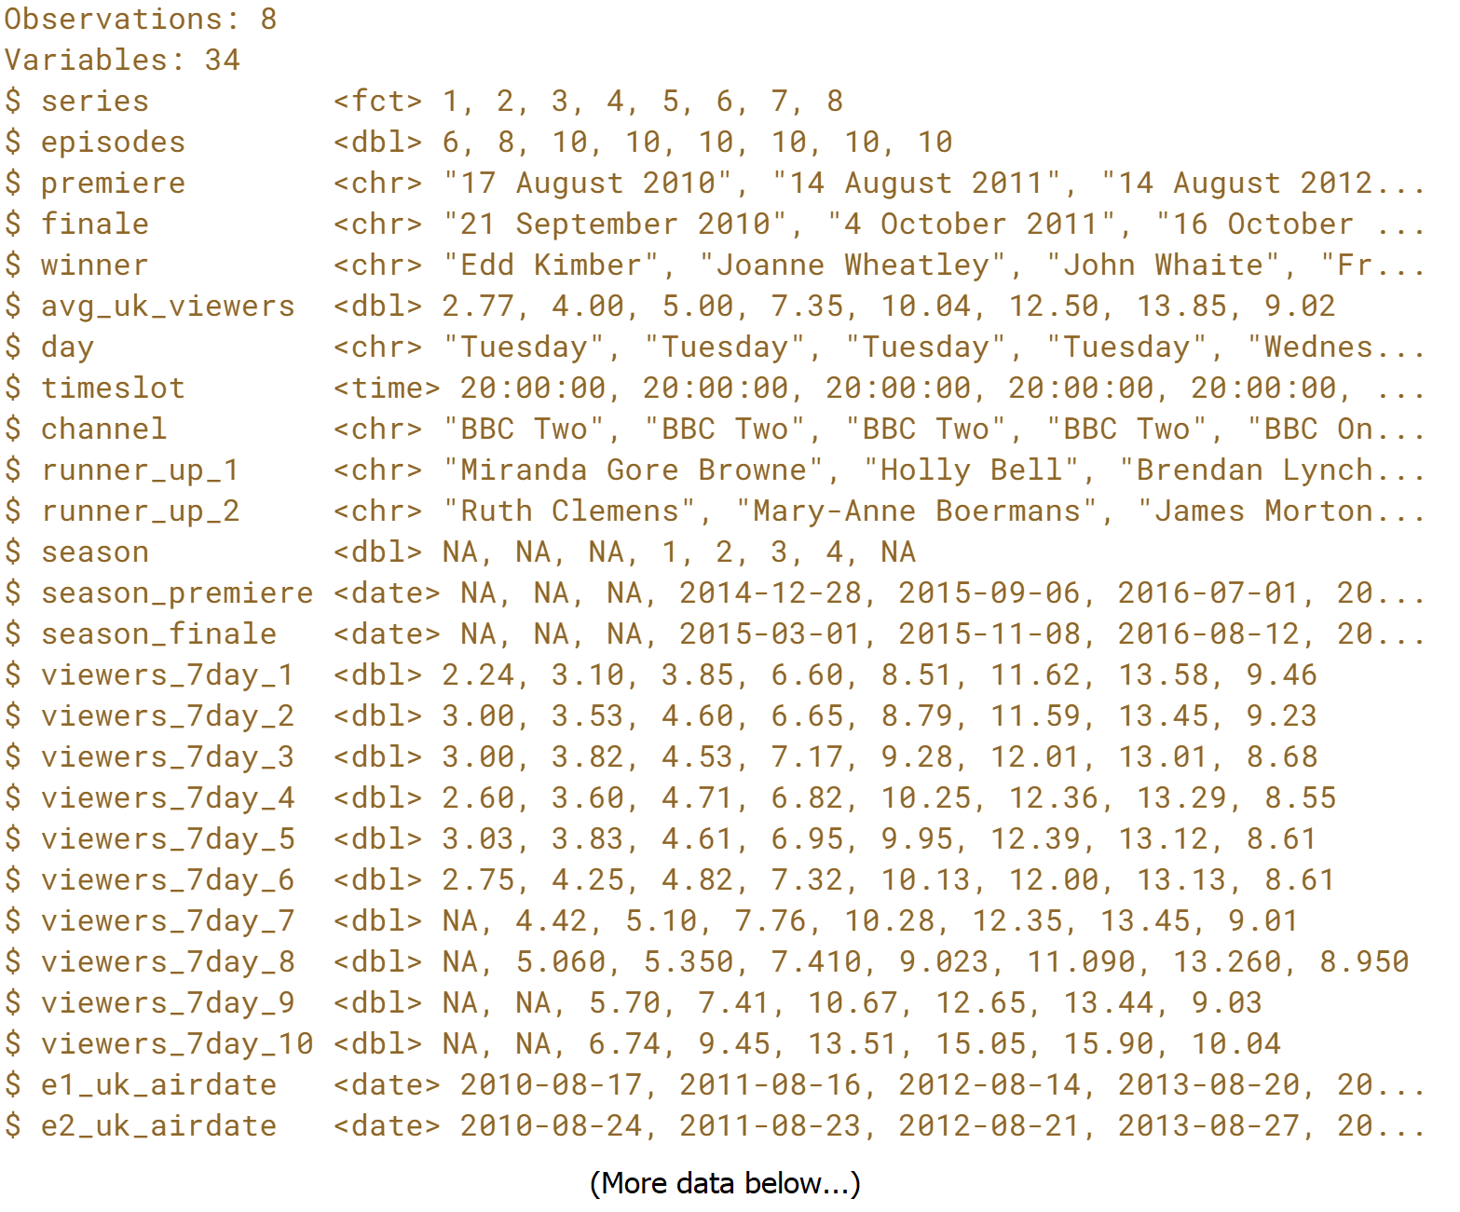

#### **Tidy your data**

#### Now that your data has been tamed, it is time to get tidy. In this chapter, you will get hands-on experience tidying data and combining multiple tidying functions together in a chain using the pipe operator.



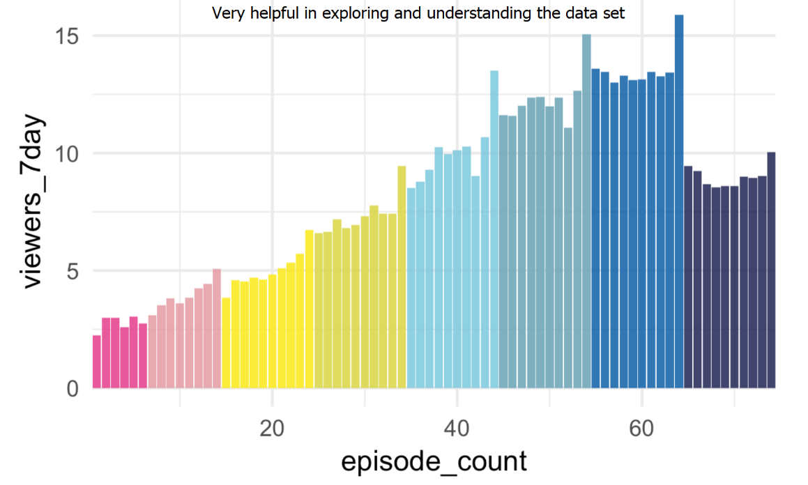  
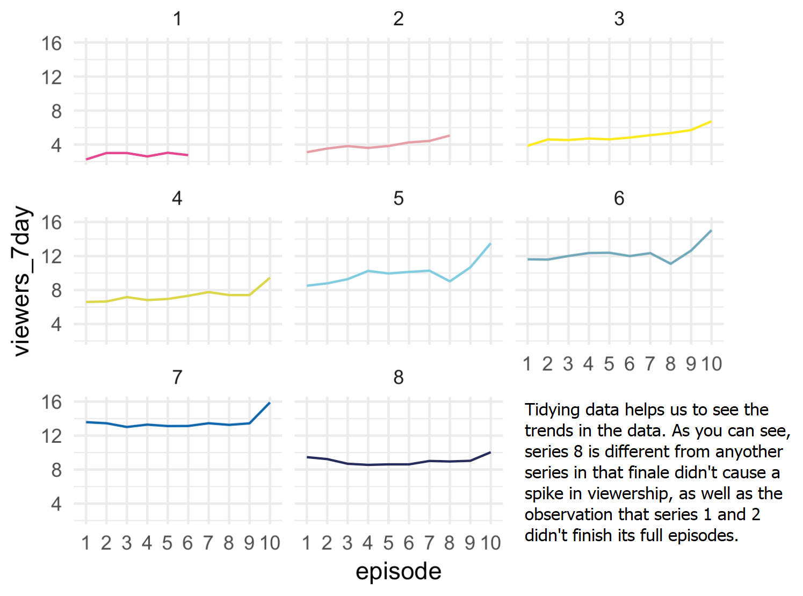



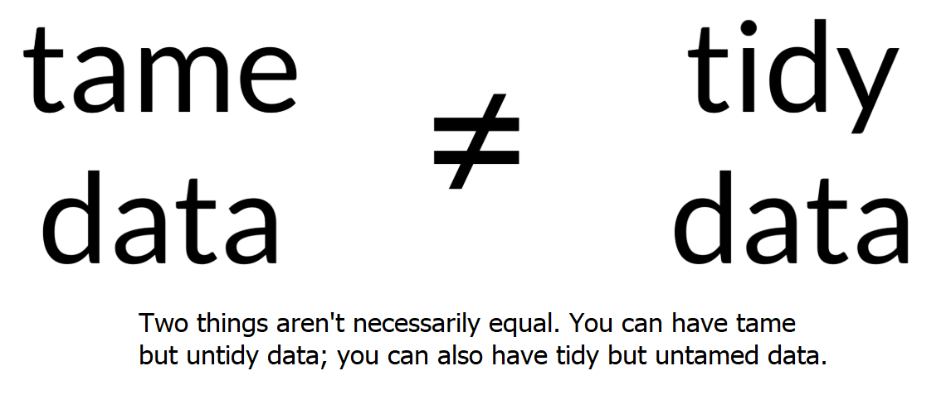

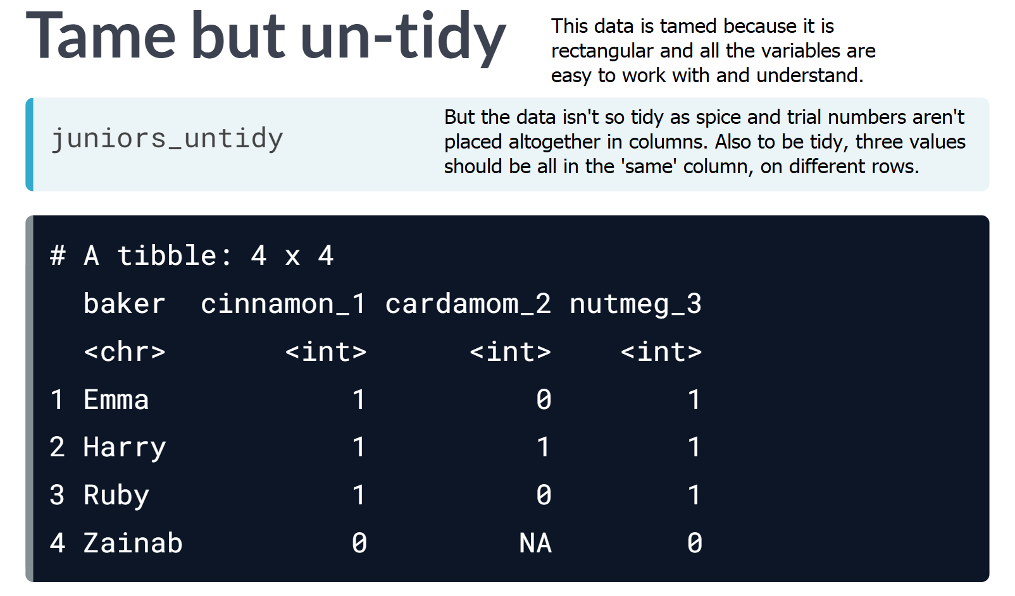

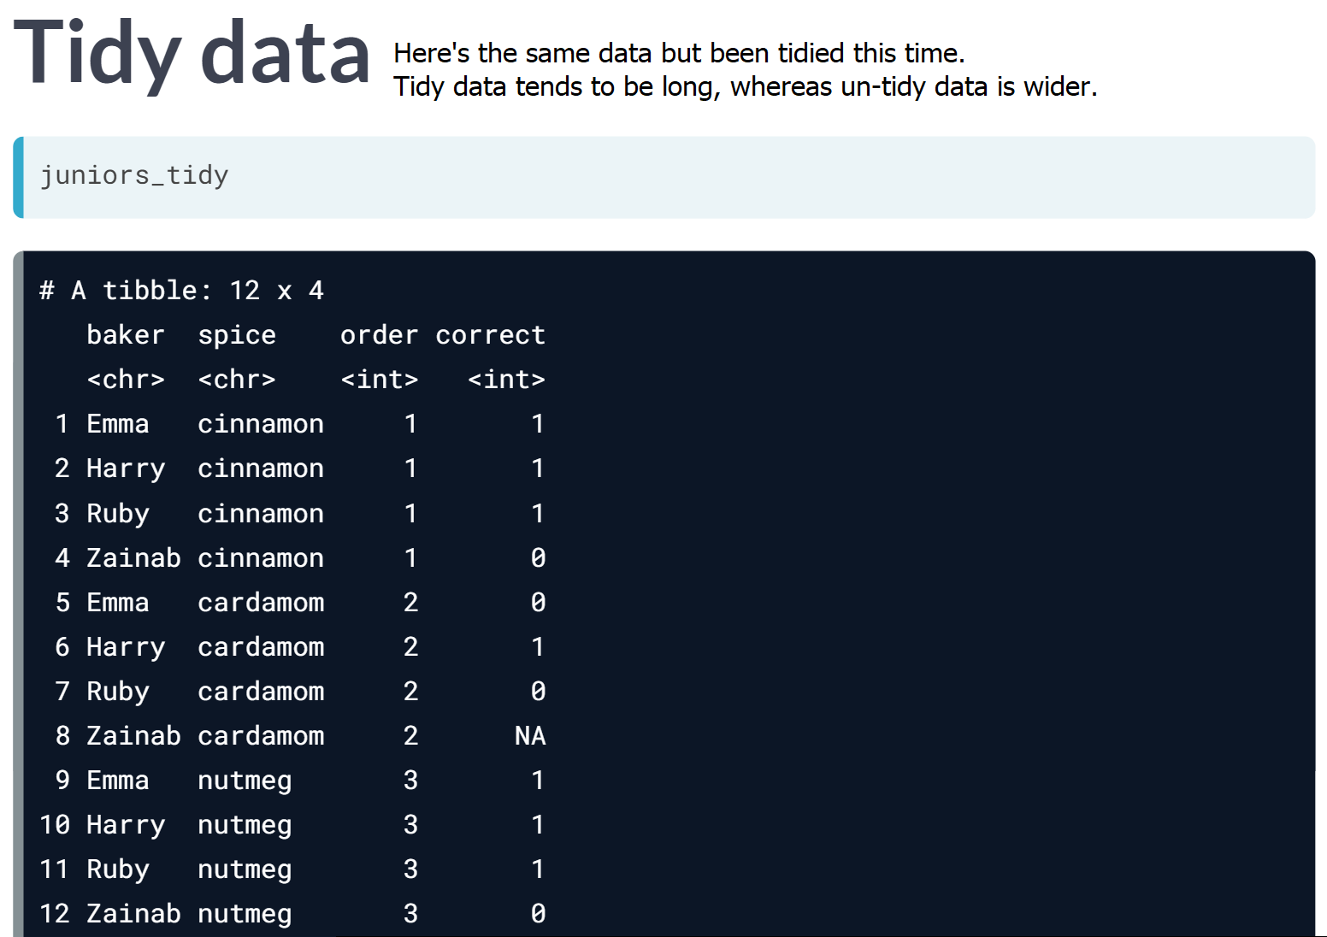

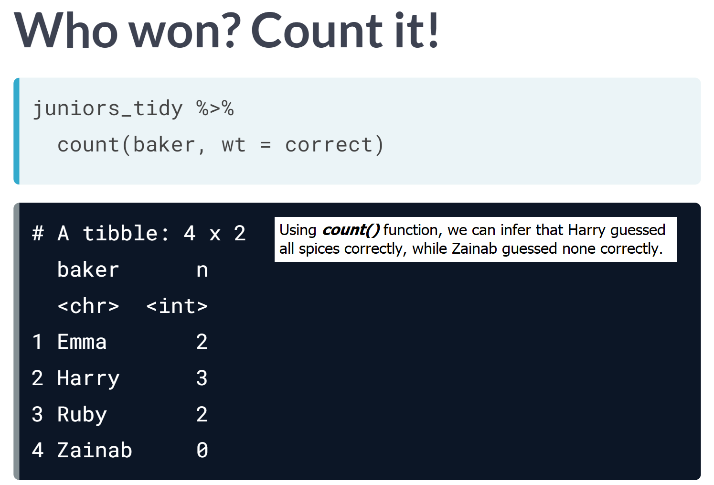

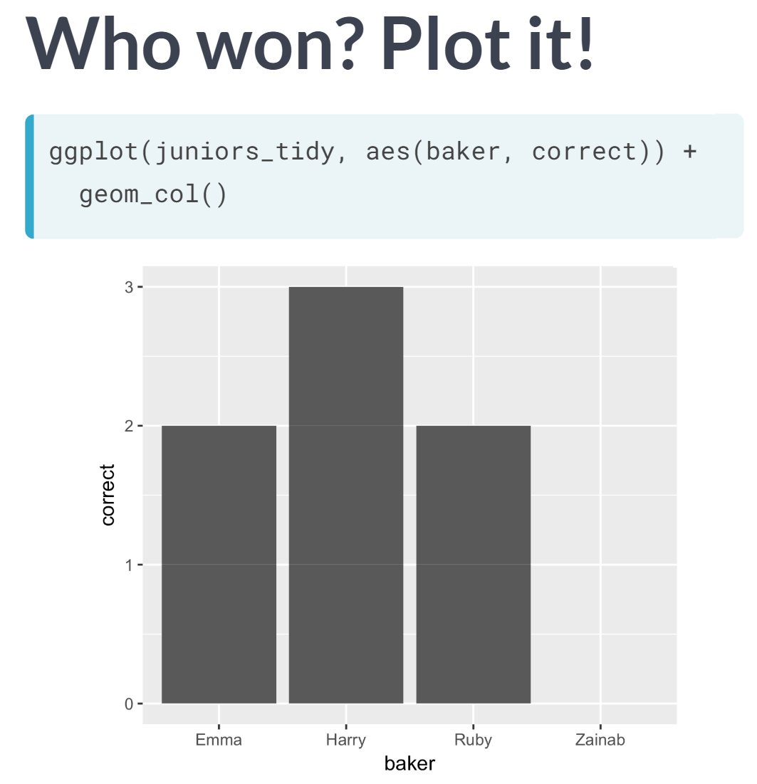

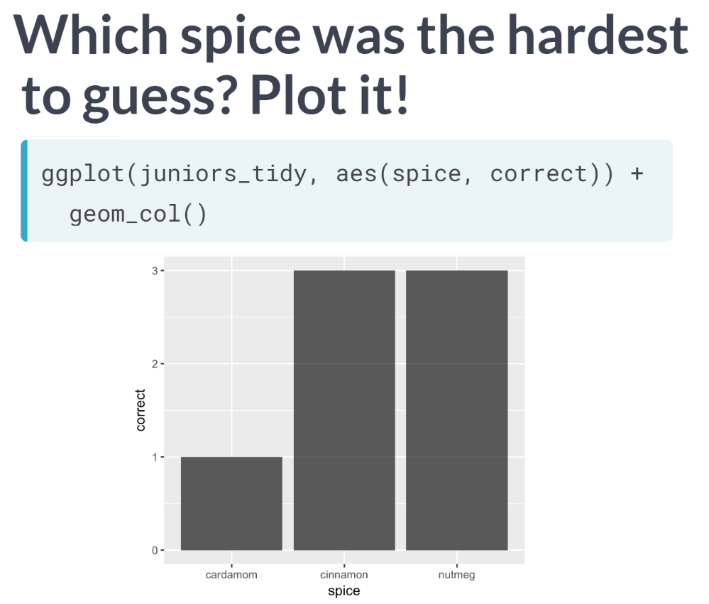

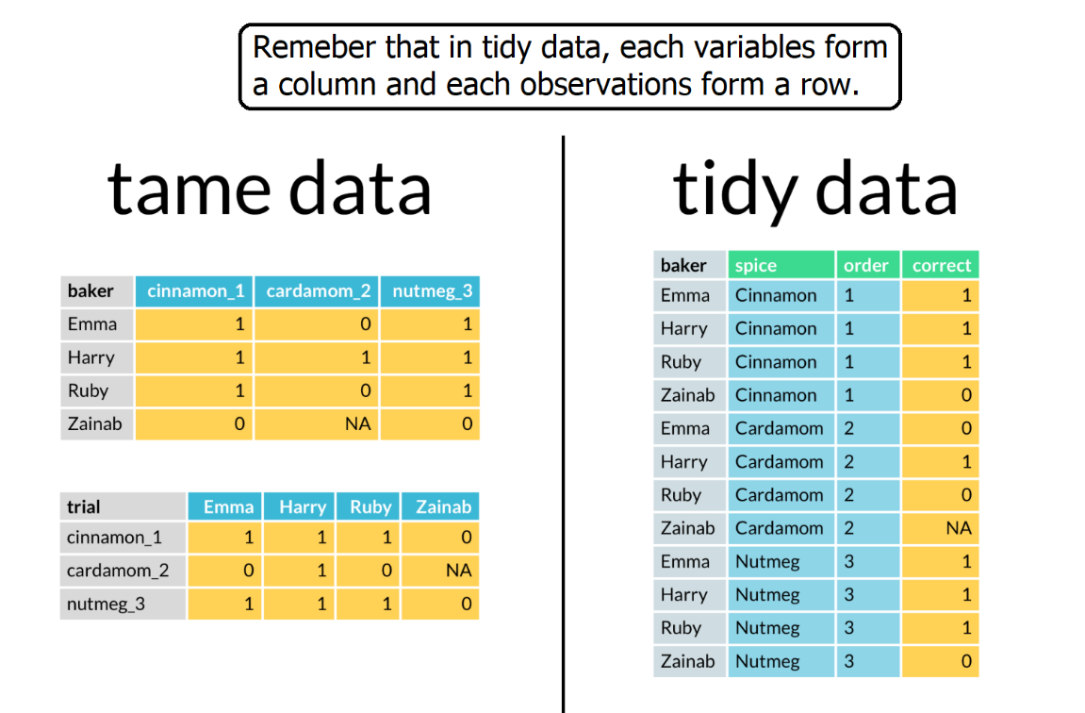

# Tidy line-up

Four data frames are loaded for you. They each contain some data on the number of viewers who watched episodes of the "The Great British Bake-off". Determine which one is tidy.

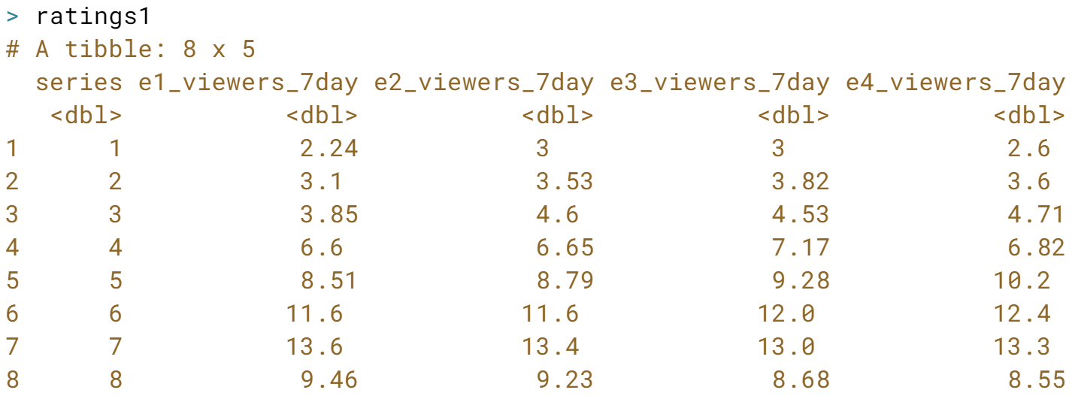

**Incorrect**- this one has a variable, *episode number*, in the variable names.

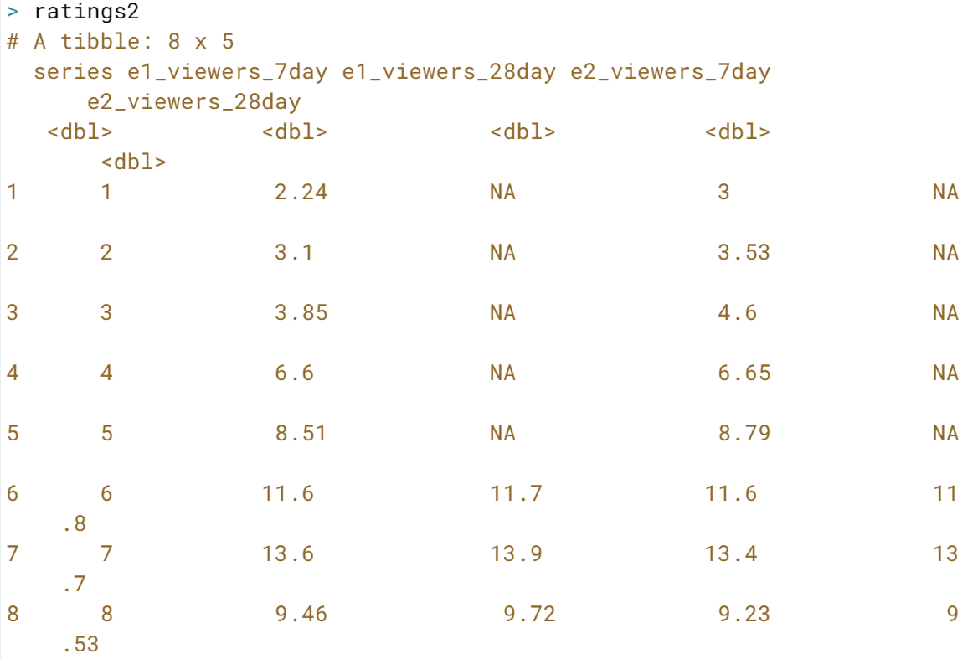

**Incorrect**- this one has two variables, *episode number* and *time window*, in the variable names.

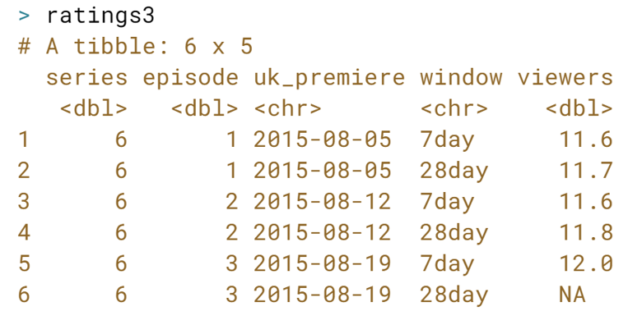

**Correct!**

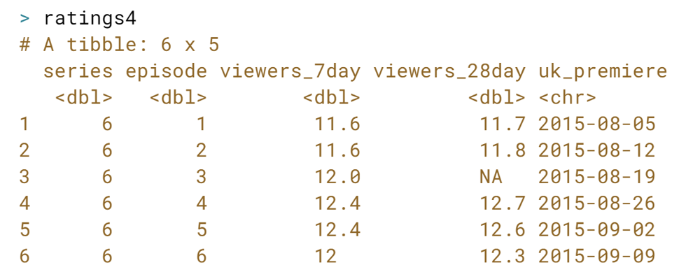  
**Incorrect**! This one still has a variable, *time window in days*, in two variable names.

# Plot untidy data

We'll start by visualizing the number of show viewers (in millions, cumulative across seven days) across series by episode using the ratings data.

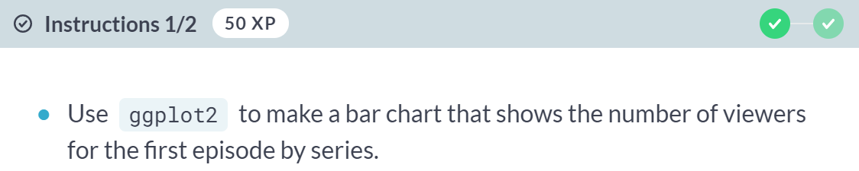

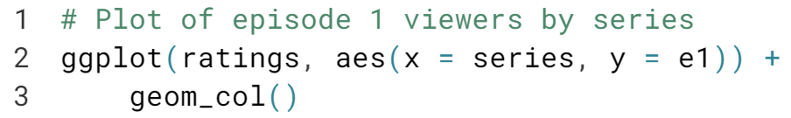  
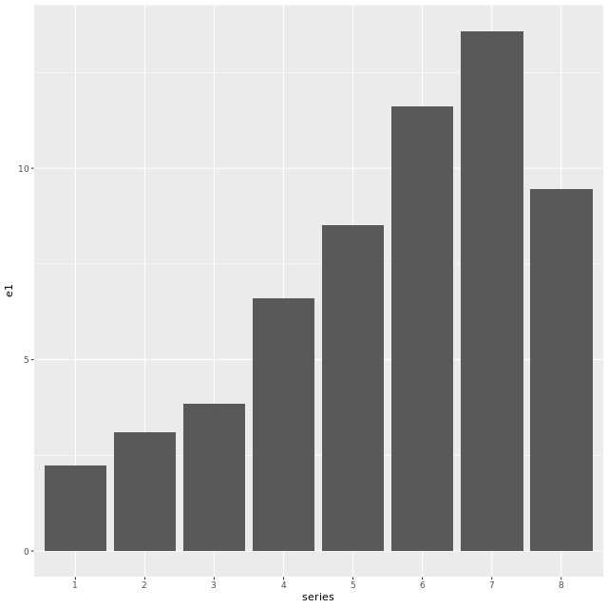

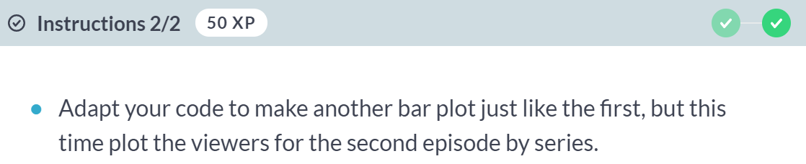

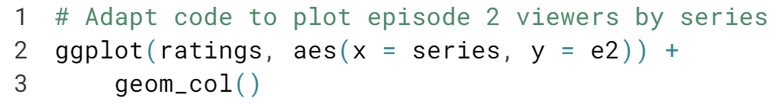  
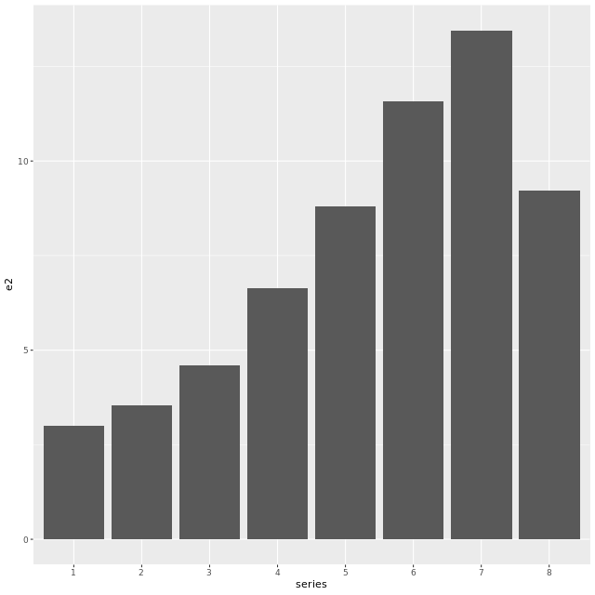  
Series 8 was the first with different hosts on a different channel. Do you notice a pattern? To draw any conclusions, we'd want to plot the viewers for every episode though- aren't you glad you weren't asked to make all 10 plots? Wouldn't it be nice if episode were a variable we could use?

  
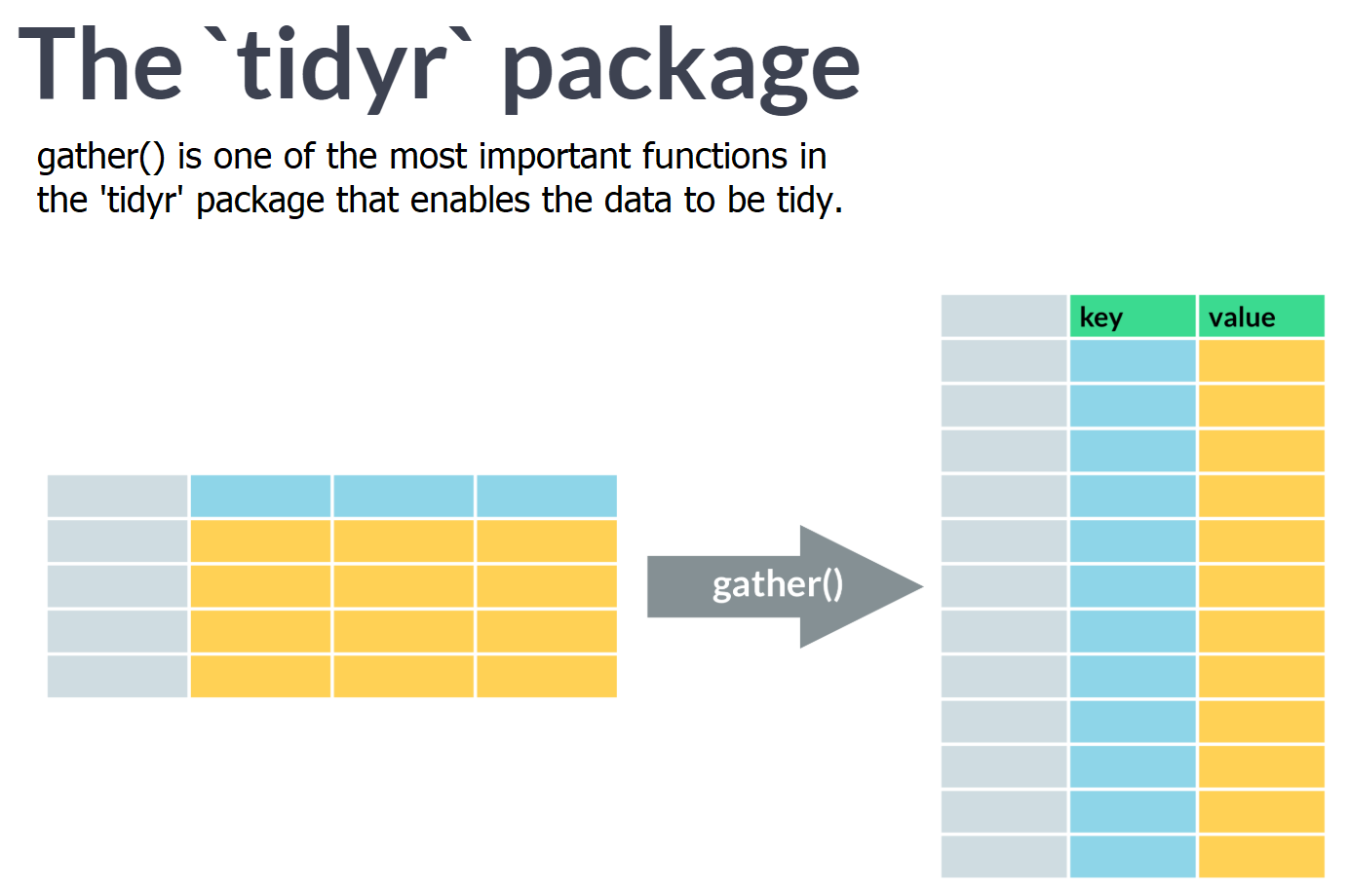

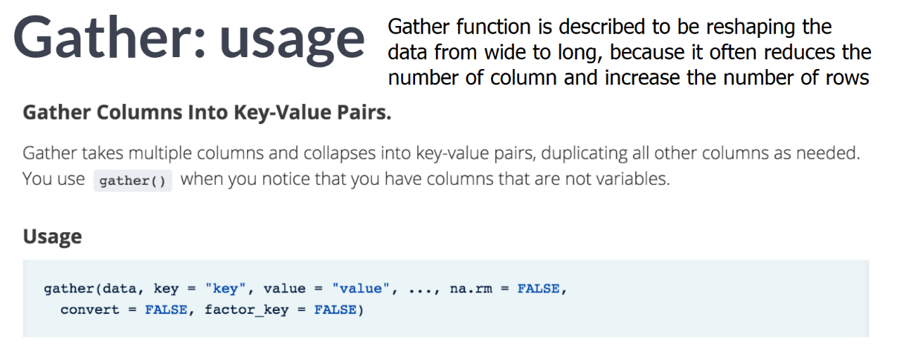  
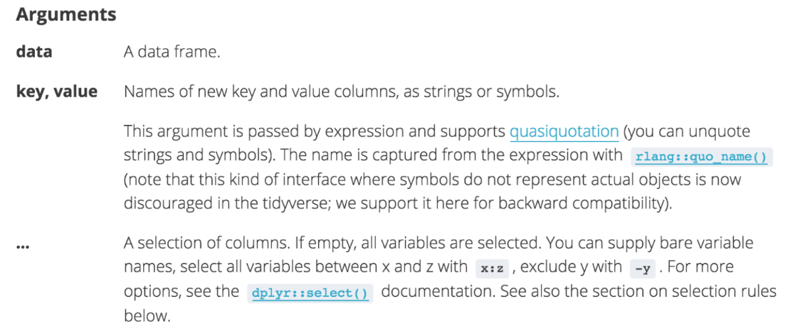  
Ellipses is where we name the column to gather using bare variable names, but we can also use the ***dplyr::select()*** helpers.

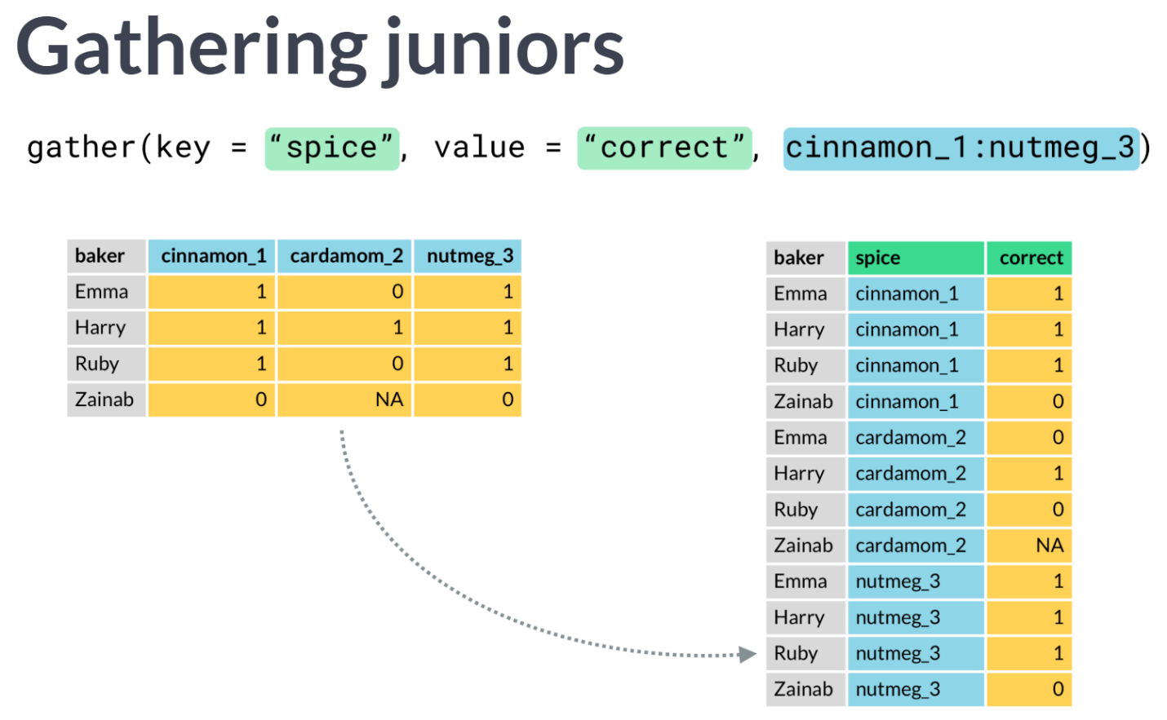

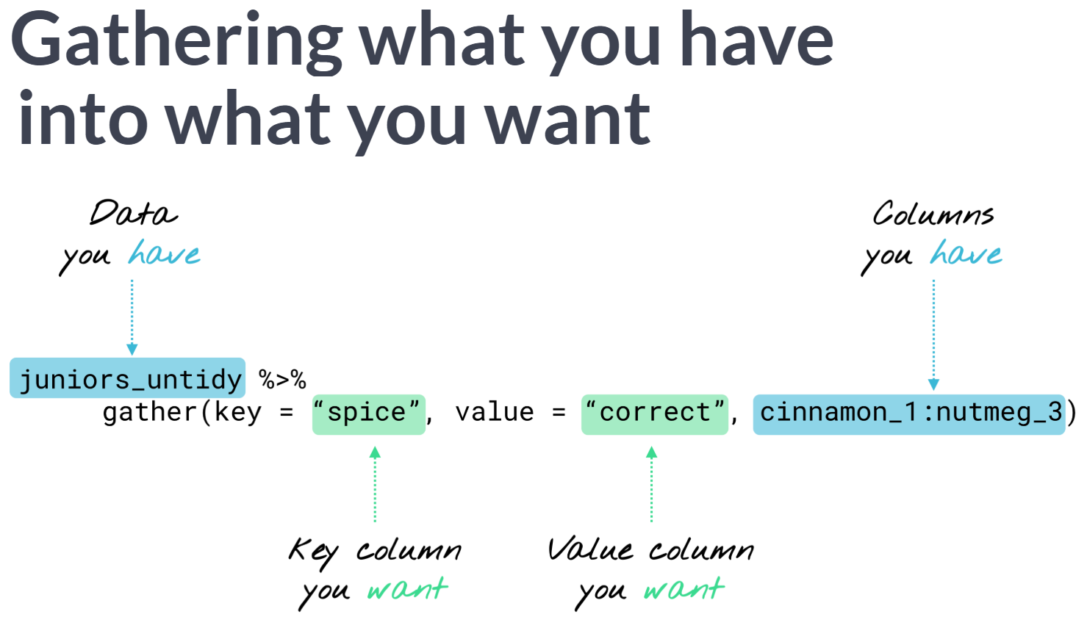  
Key column will contain original value names, and value column will contain original cells.  
Remember that we can use colon operator to select a range of existing, consecutive variables to gather by name.

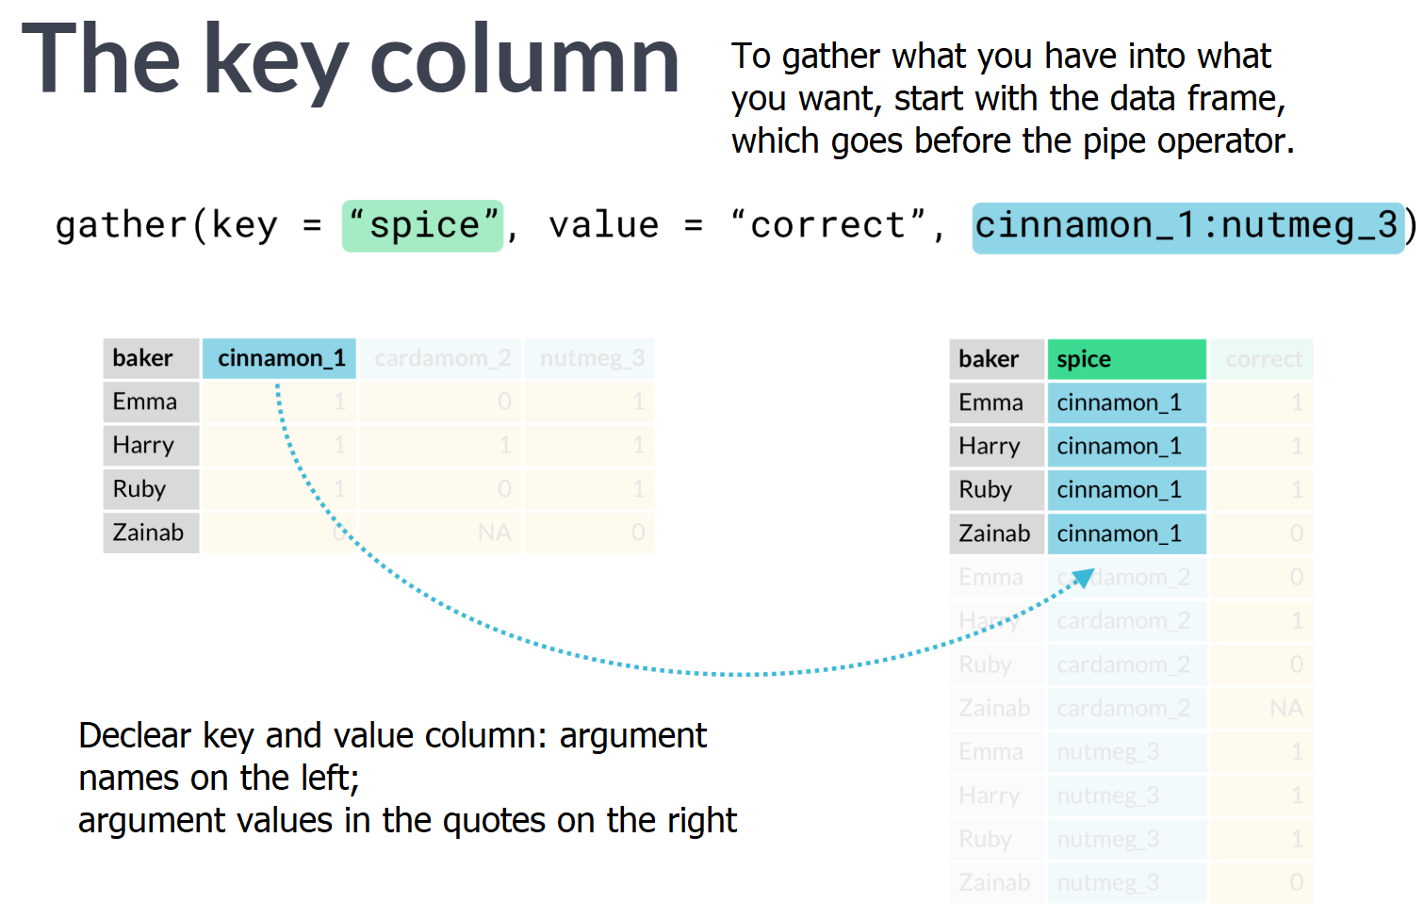  
  
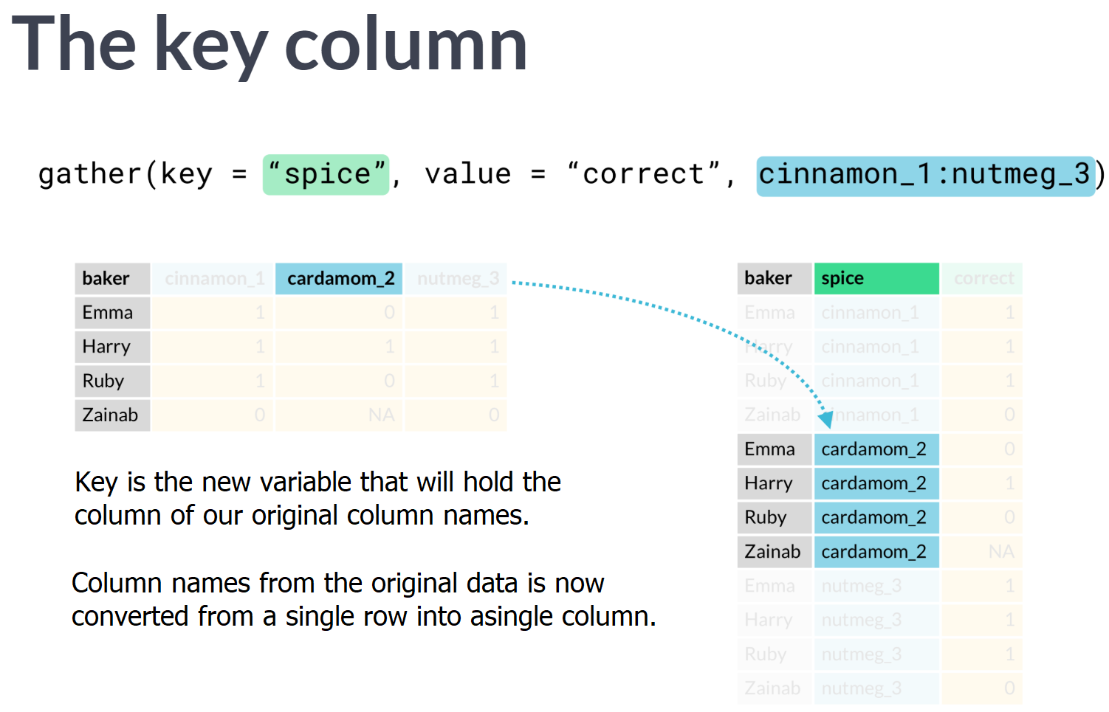

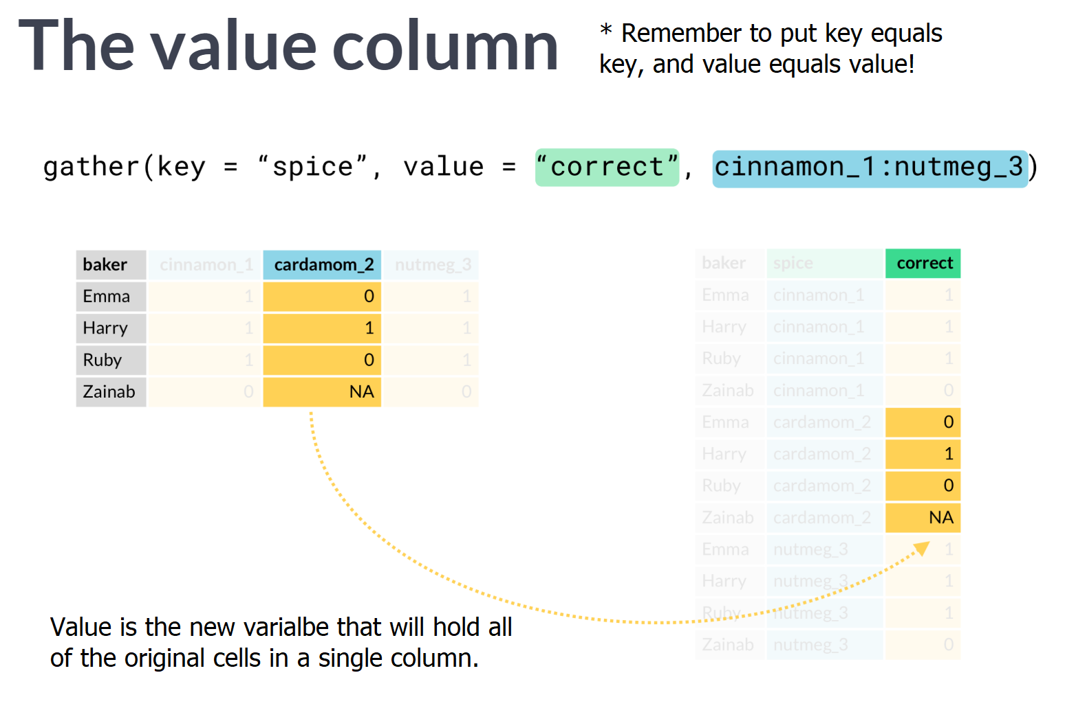

# Gather by hand

Type mini in the console to see a small un-tidy data frame. On a sheet of paper, sketch out the tidy version of this data. In the tidy version, what is in the "value" column in the sixth row (not counting the header row)?

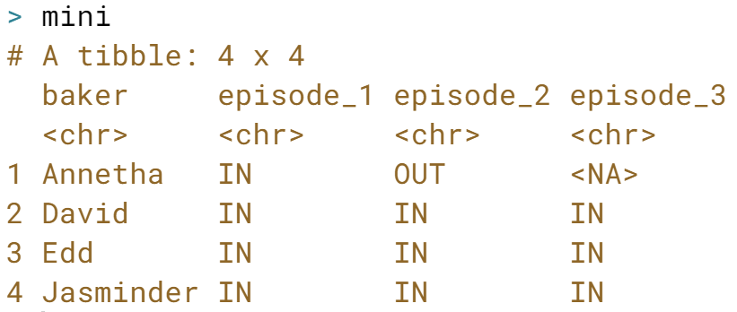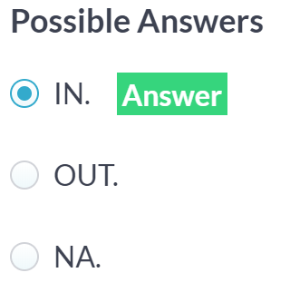

Correct! David was IN in episode 2.

# Gather & plot

In a previous frustrating exercise working with untidy data, we attempted to visualize viewers per episode across series with the untidy ratings data.

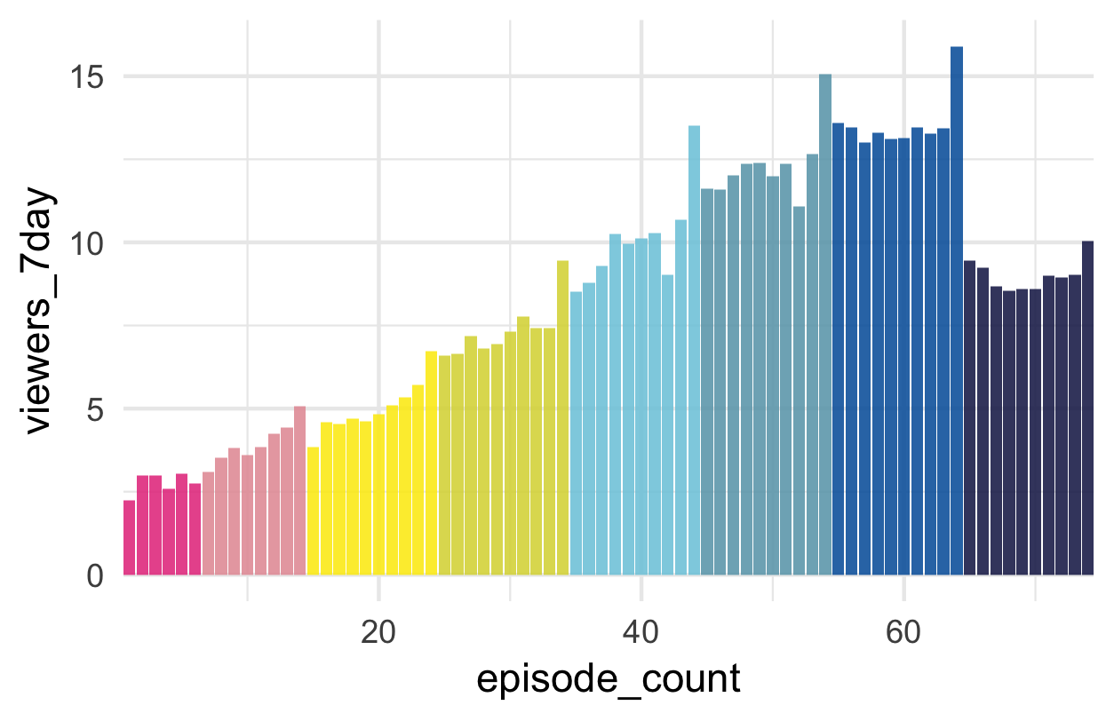

Here is the plot we wanted to create. To make it, we'll tidy the data, then use [**row_number()**](https://www.rdocumentation.org/packages/dplyr/versions/0.7.5/topics/ranking) from the dplyr package to create a continuous episode count variable, such that episode 1 from series 1 will have a value of 1, episode 1 from series 2 will have a value of 7, and so on. This new variable will be mapped onto the x-axis using ggplot2.

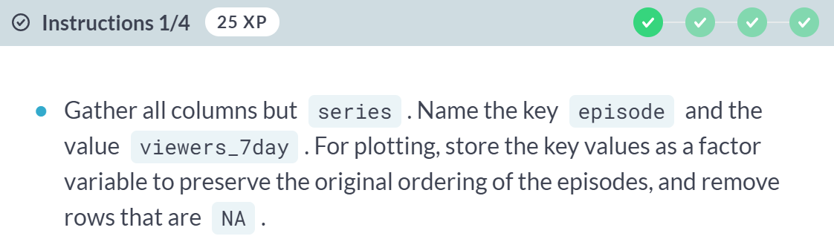  
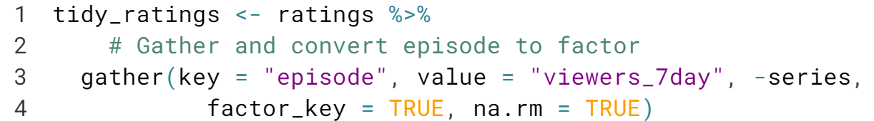

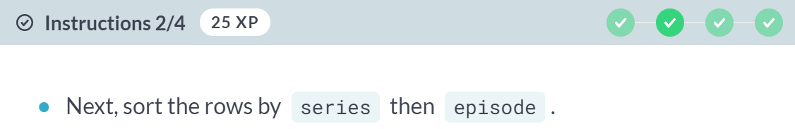  
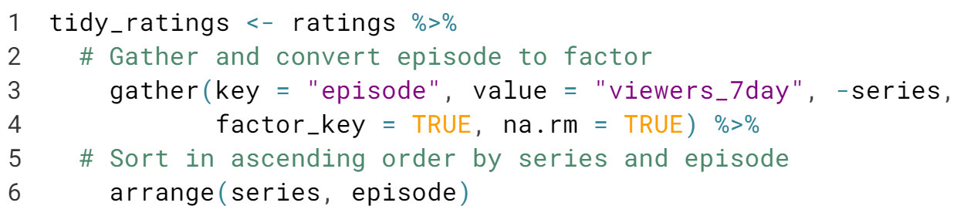

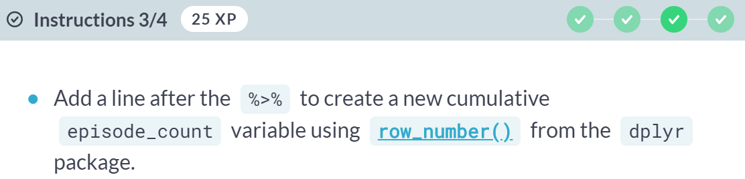

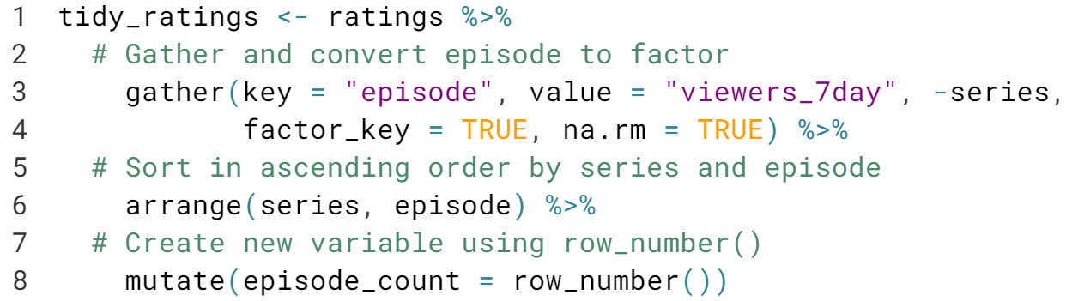

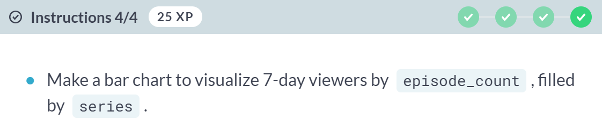

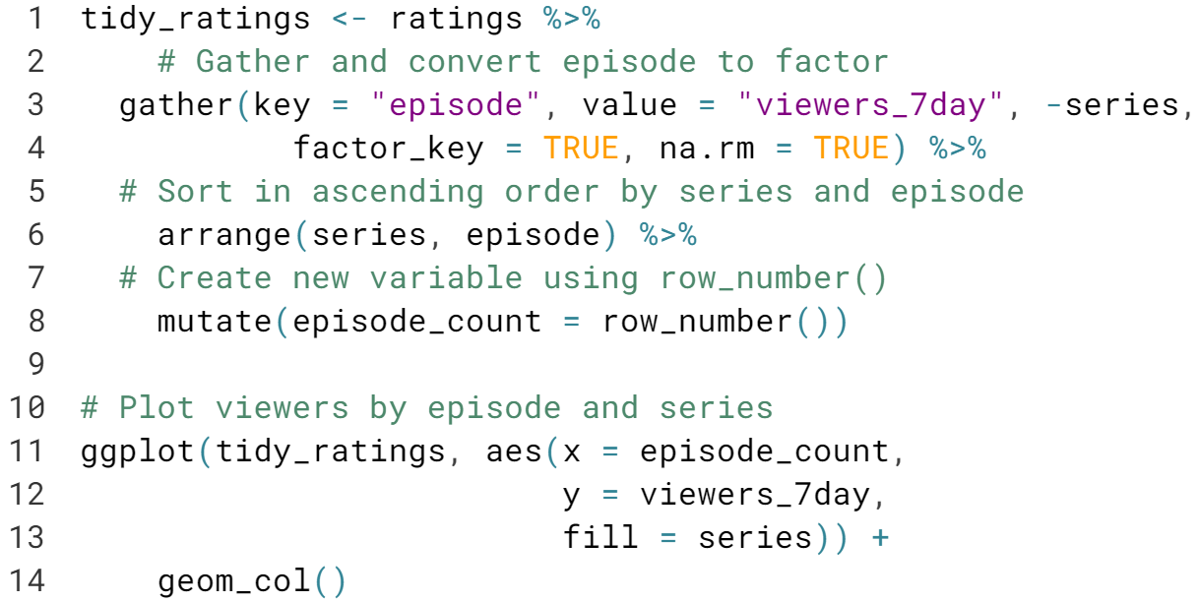

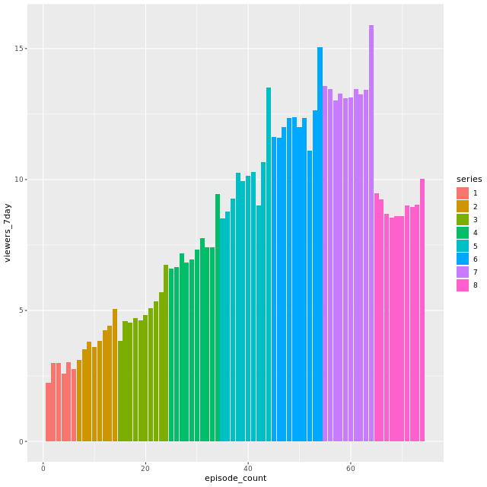  
Beautiful plot! In series 8, one of the judges accidentally tweeted out the winner's name 12 hours before the finale aired. Do you think that hurt their finale viewer numbers?

# Gather & plot non-sequential columns

In this exercise, you'll combine tidyr with [**dplyr::select()**](https://www.rdocumentation.org/packages/dplyr/versions/0.7.5/topics/select) to keep and gather non-sequential columns in the ratings2 data. You can review the select [**helper functions here**](https://www.rdocumentation.org/packages/dplyr/versions/0.7.5/topics/select). The ratings2 data includes per-episode data:

* e*_7day: viewers within a 7-day window, and
* e*_28day: viewers within a 28-day window.

Here, we'll focus on the 7-day viewers.

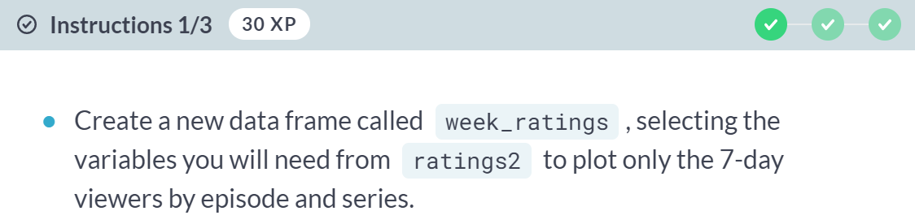

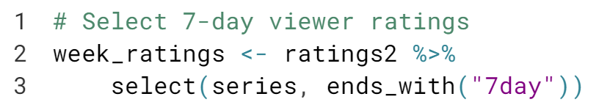

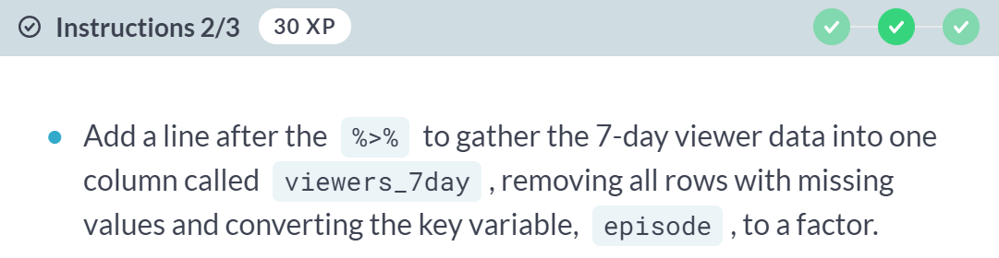  
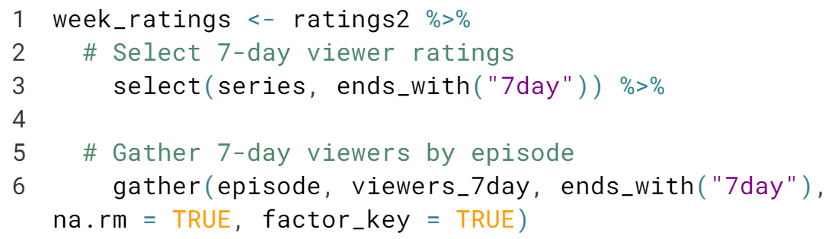

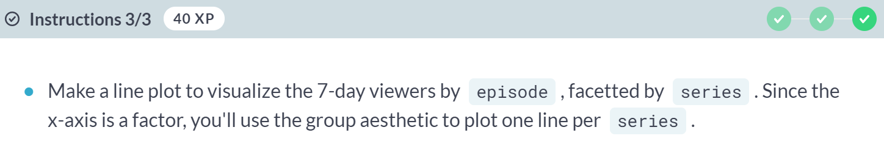

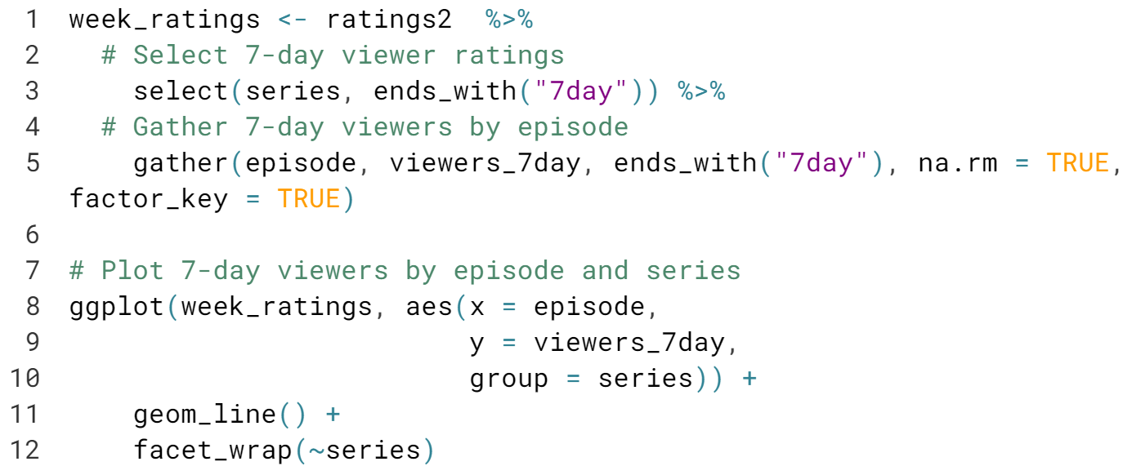

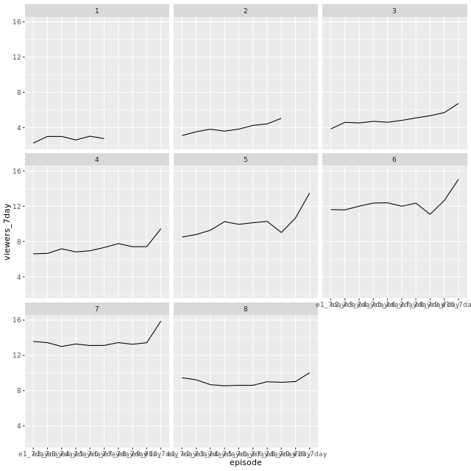  
You're done gathering! This plot tells you a lot, but the x-axis labels are a mess! We need to do more tidying to make this plot better.



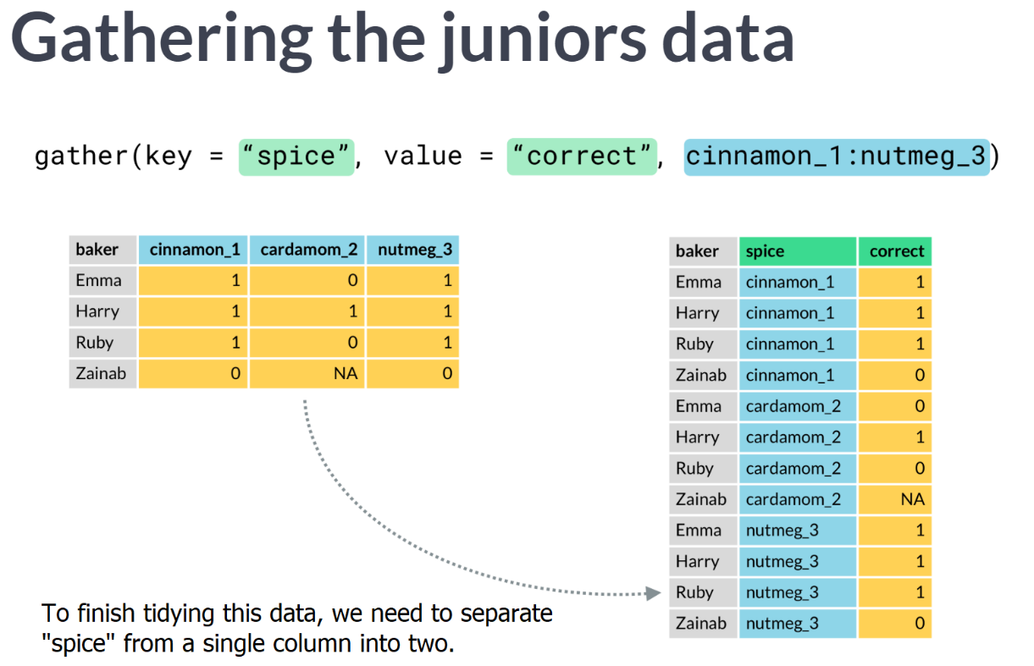

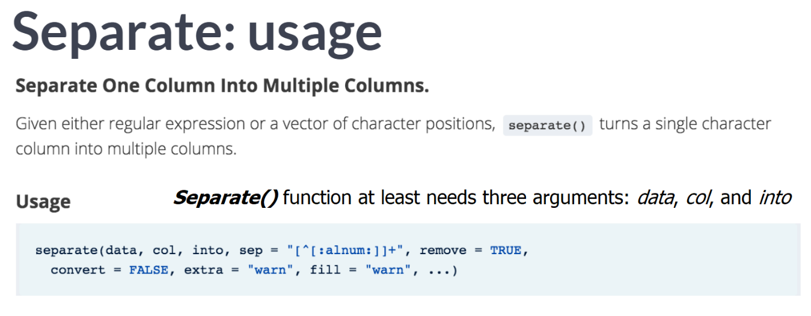  
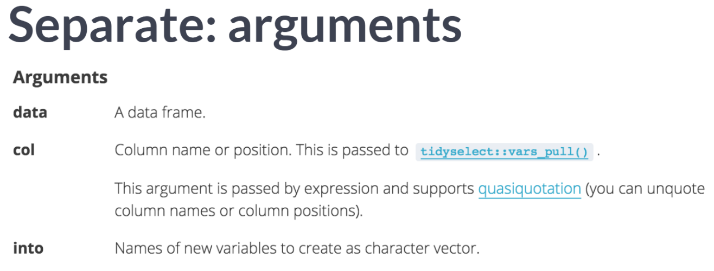

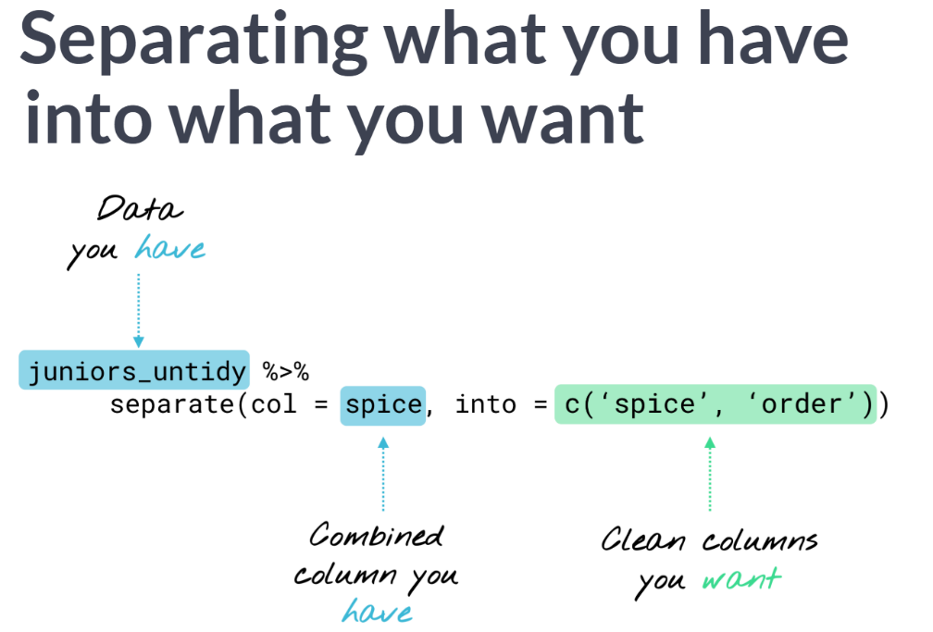

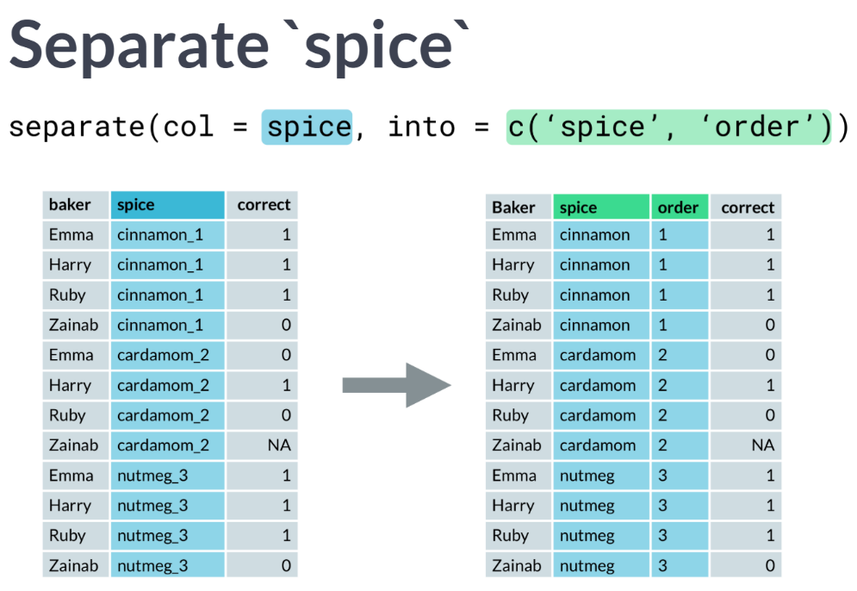  
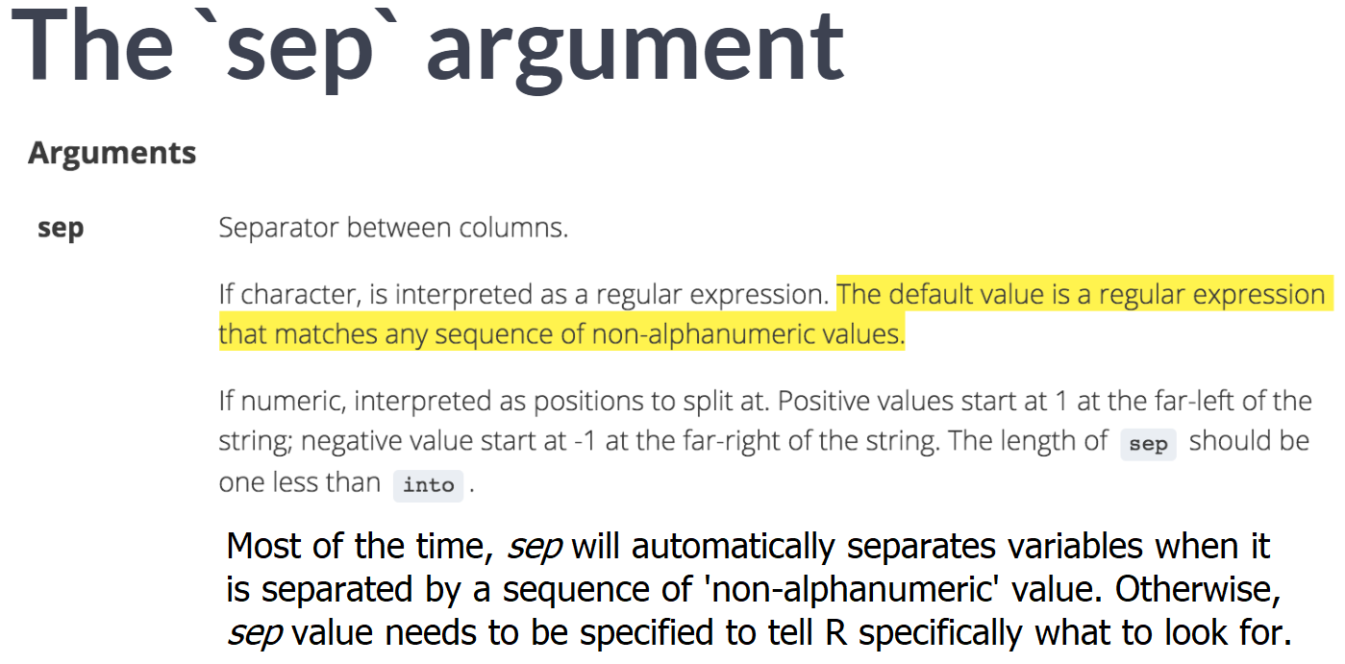

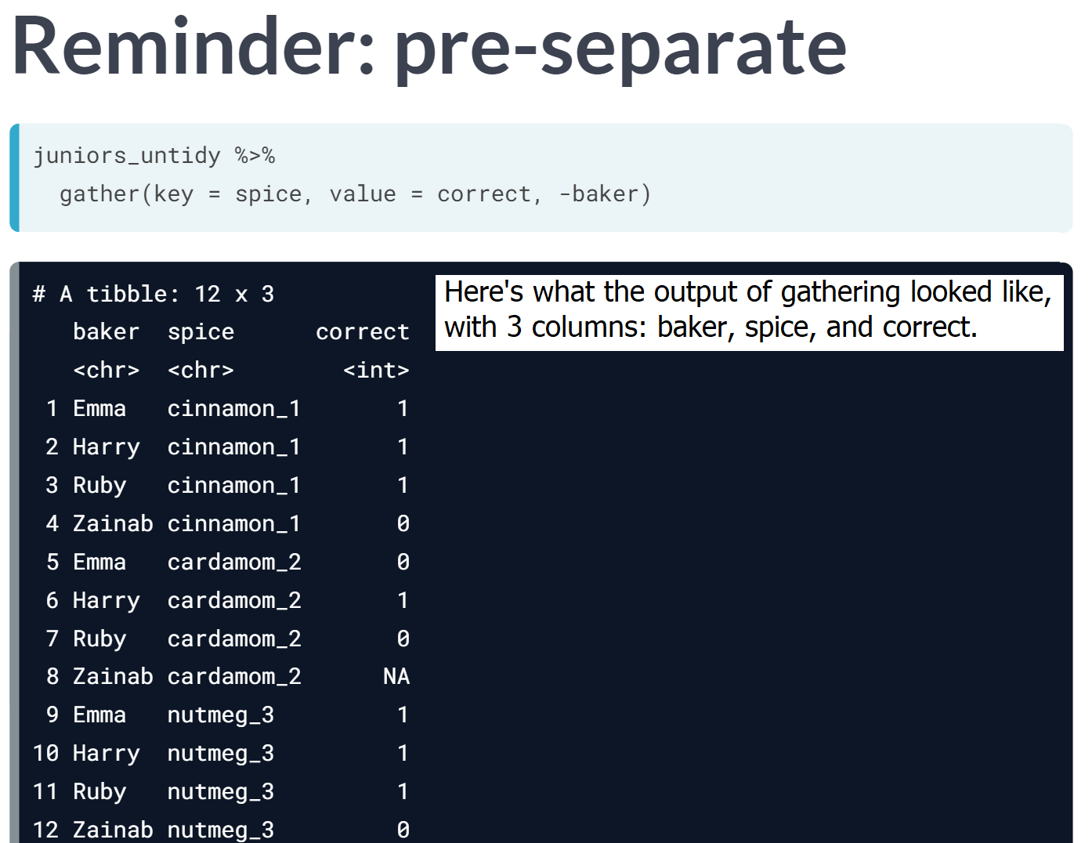

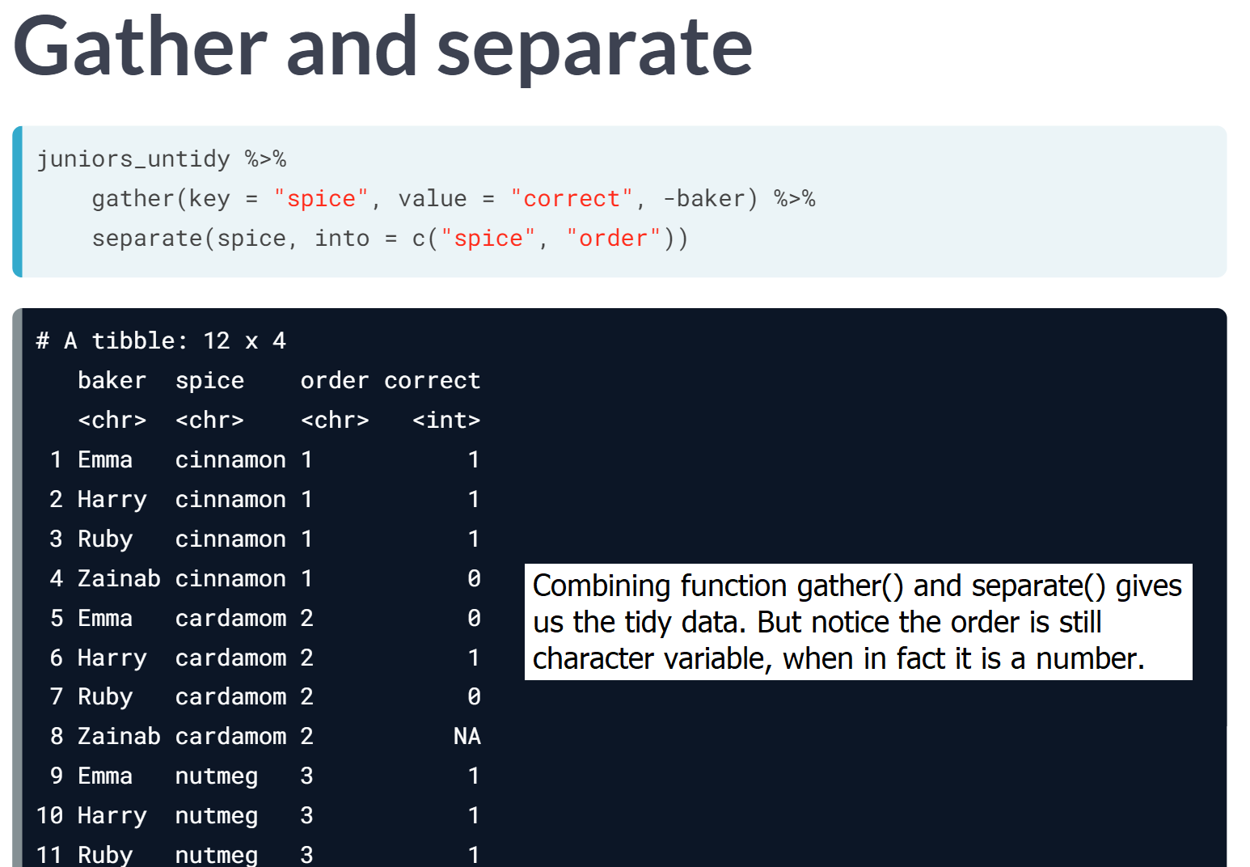

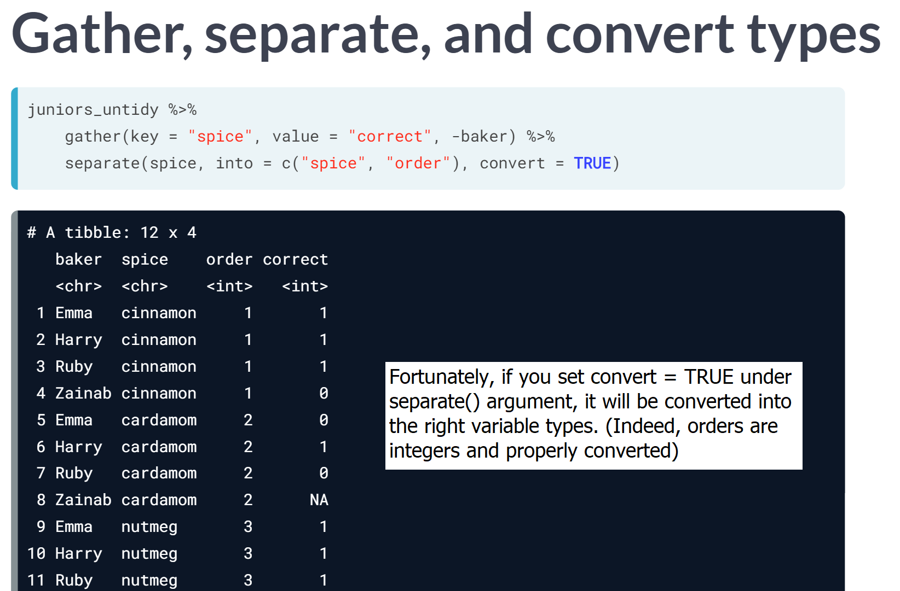

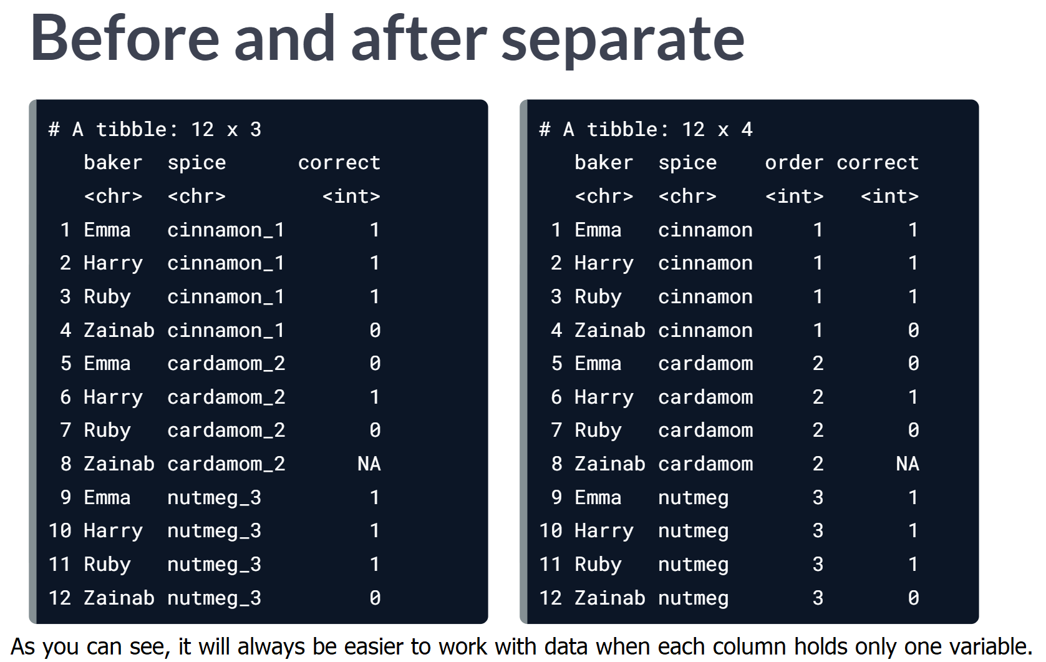

# Separate a column

To create the week_ratings data, we first selected all the columns in ratings2 that contain data about the number of 7-day viewers in millions for each series, then we gathered those 10 columns into two columns.

In this exercise, you'll use the tidyr, dplyr, and readr packages (all are loaded) to tidy and plot the week_ratings data so we can read the x-axis, which labels each episode!

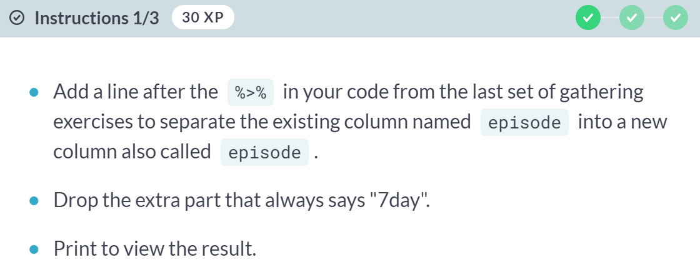

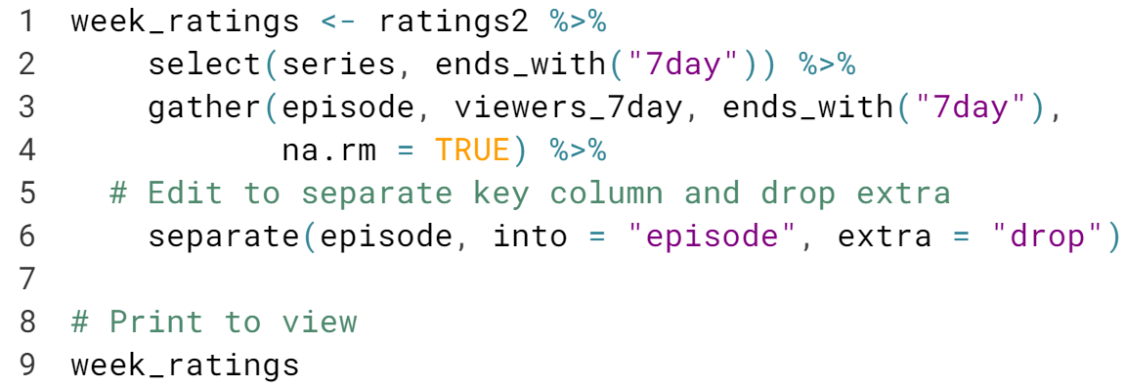  
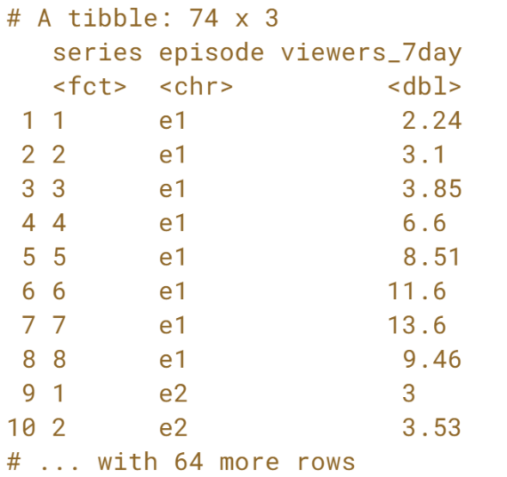

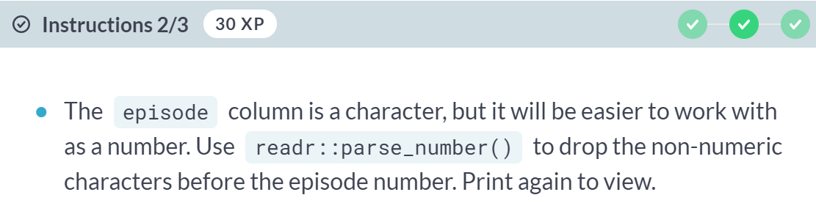

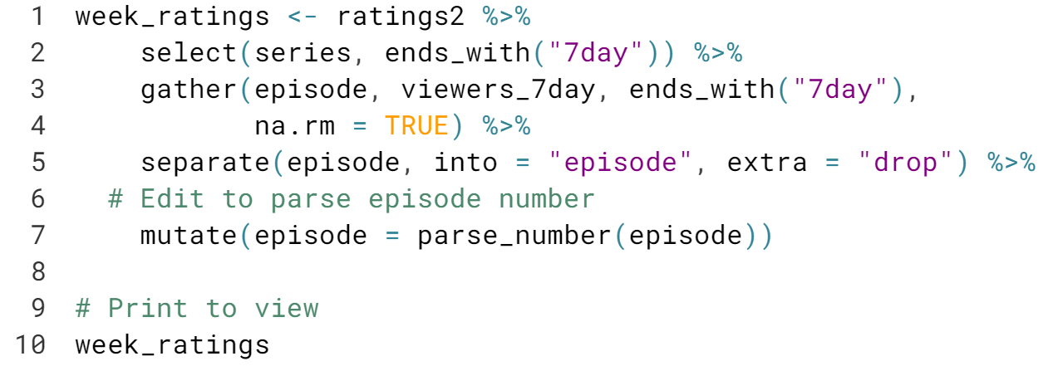  
  
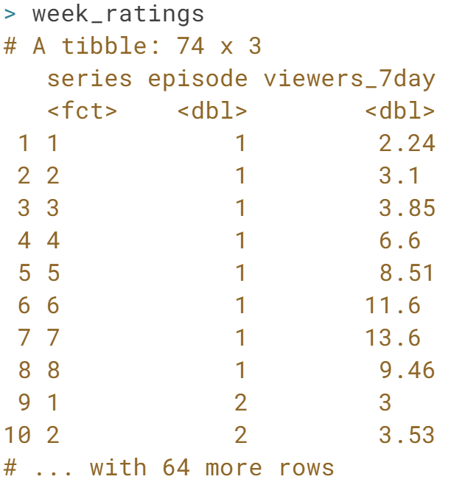

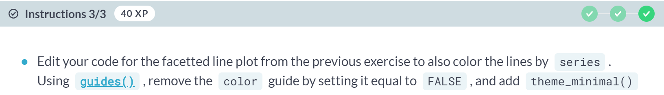

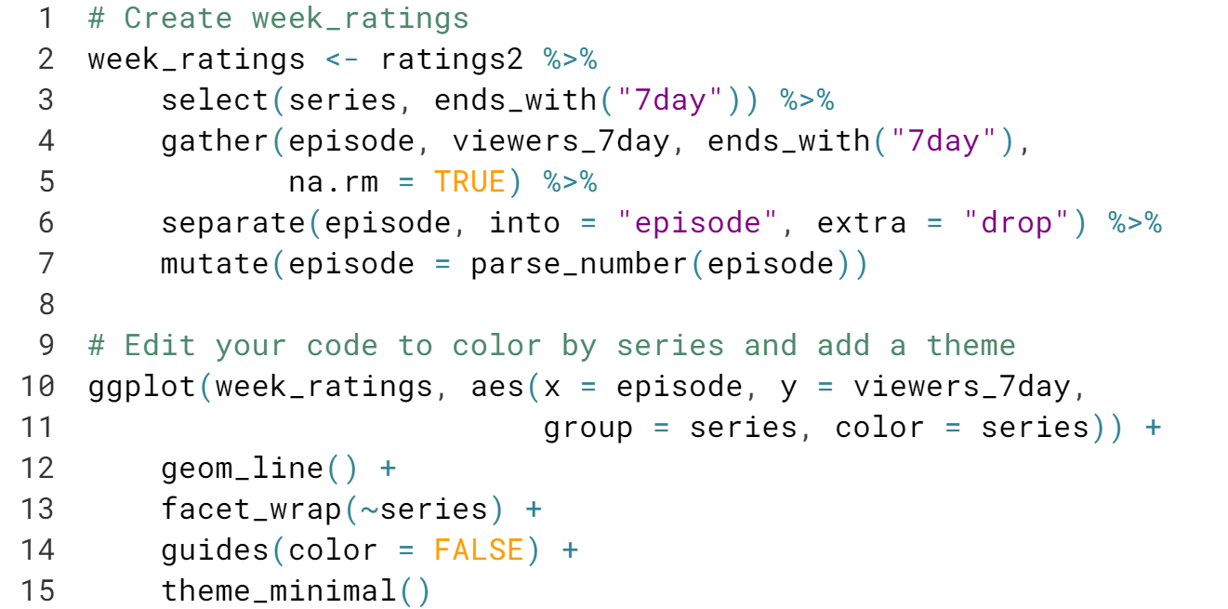  
  
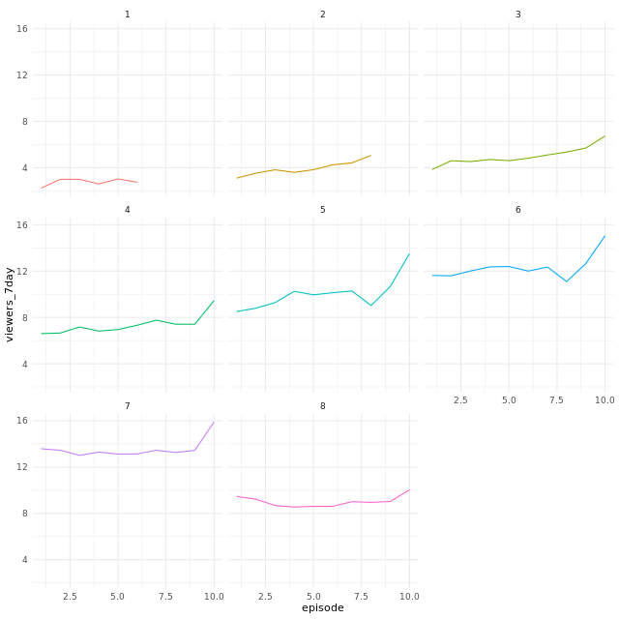

# Unite columns

In the tidyr package, the opposite of separate() is [**unite()**](https://www.rdocumentation.org/packages/tidyr/versions/0.8.1/topics/unite). Sometimes you need to paste values from two or more columns together to tidy. Here is an example usage for unite():

data %>%

unite(new_var, old_var1, old_var2)

The ratings2 dataset includes these variables:

* series: 1-8
* episode: 1-10
* viewers_millions: whole number of 7-day viewers in millions
* viewers_decimal: additional number of 7-days viewers in millions

If viewers_millions = 2 and viewers_decimal = .6, then the total number of viewers in millions is 2.6. In this exercise, you'll practice uniting these two columns into a single new column.

  
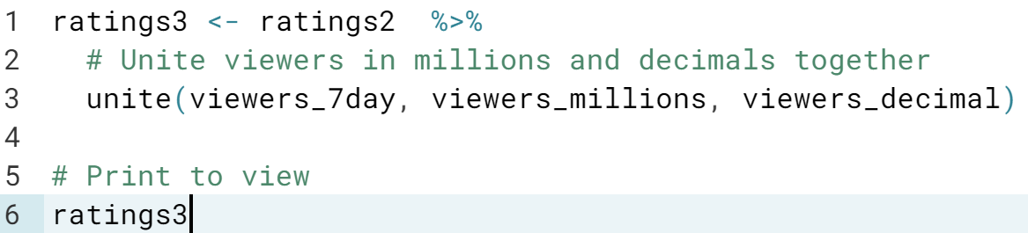  
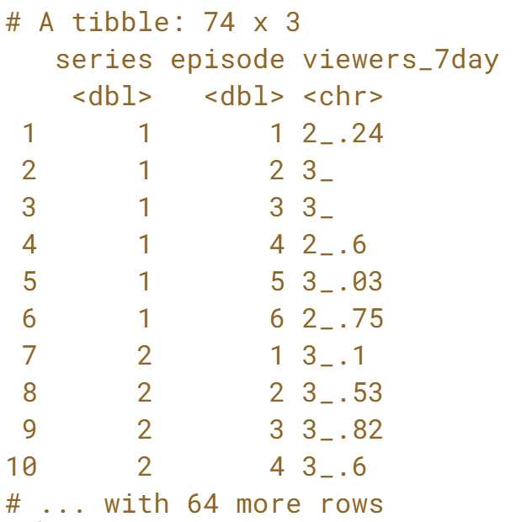

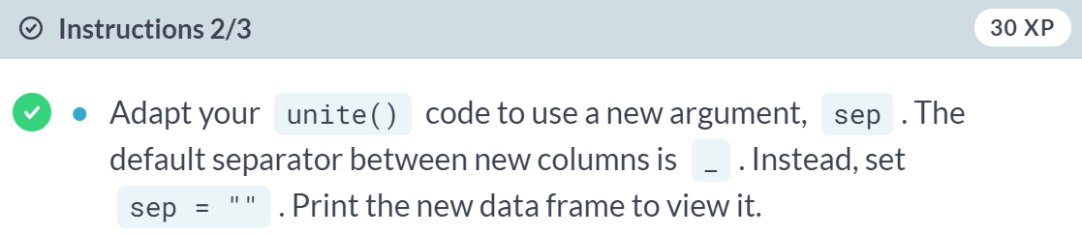  
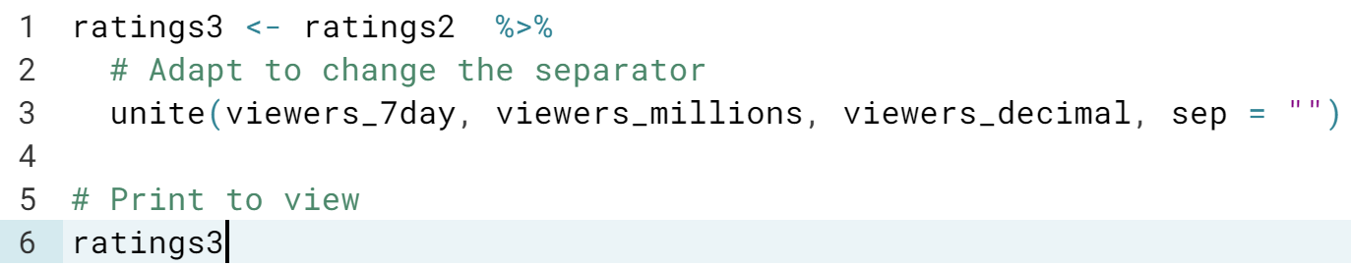  
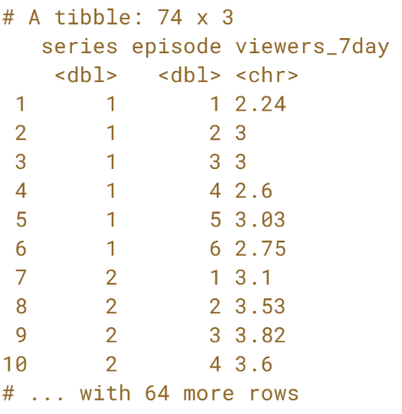  
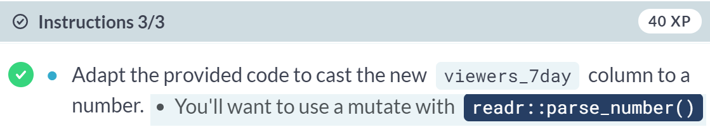  
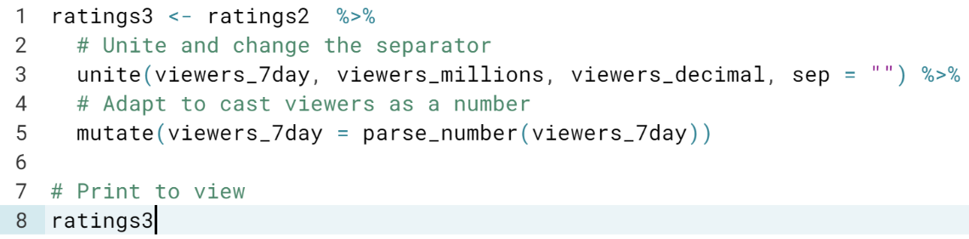  
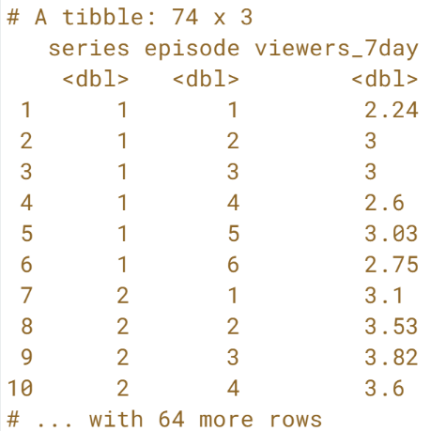



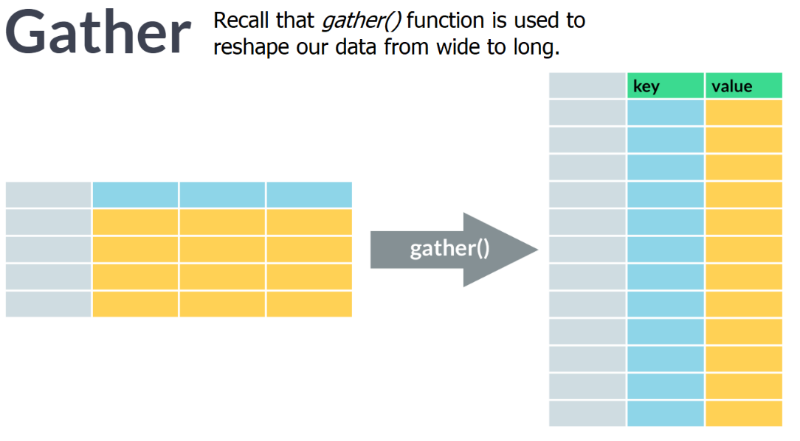

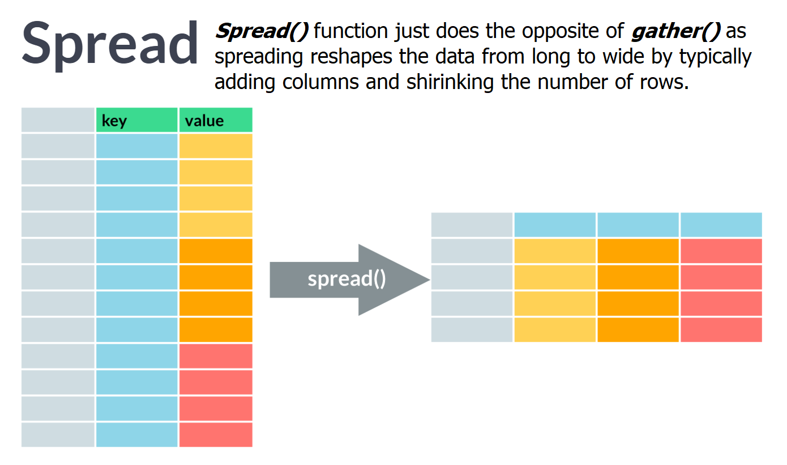  
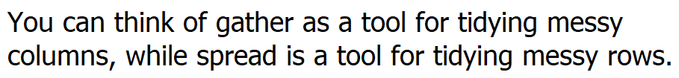

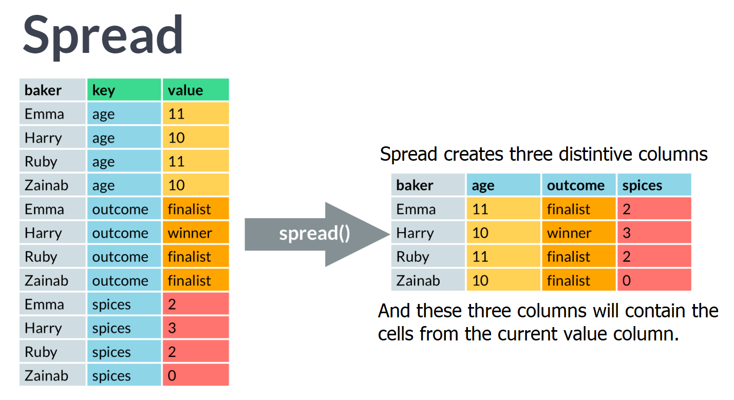

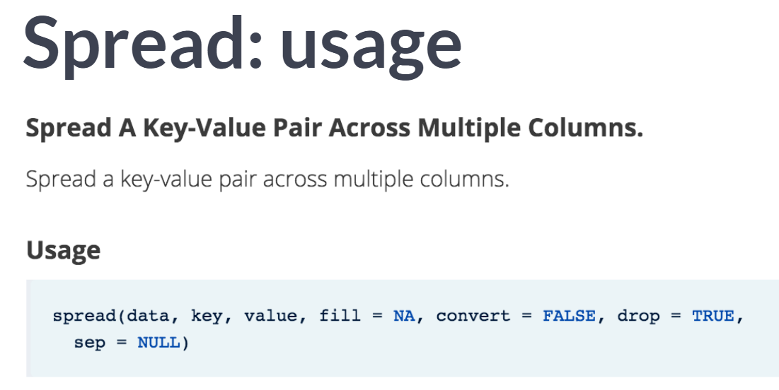

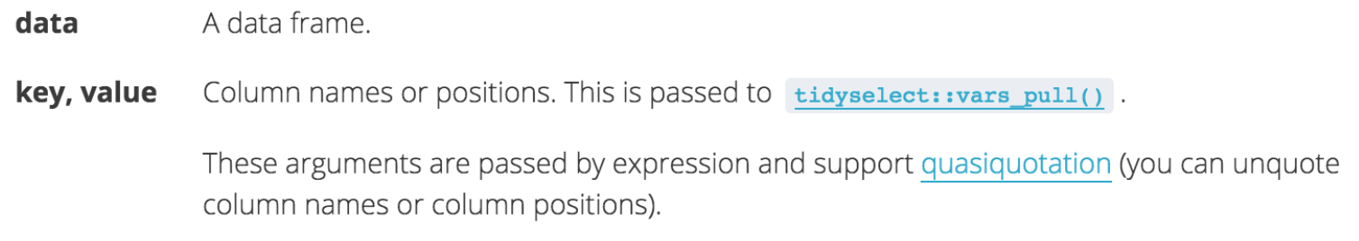

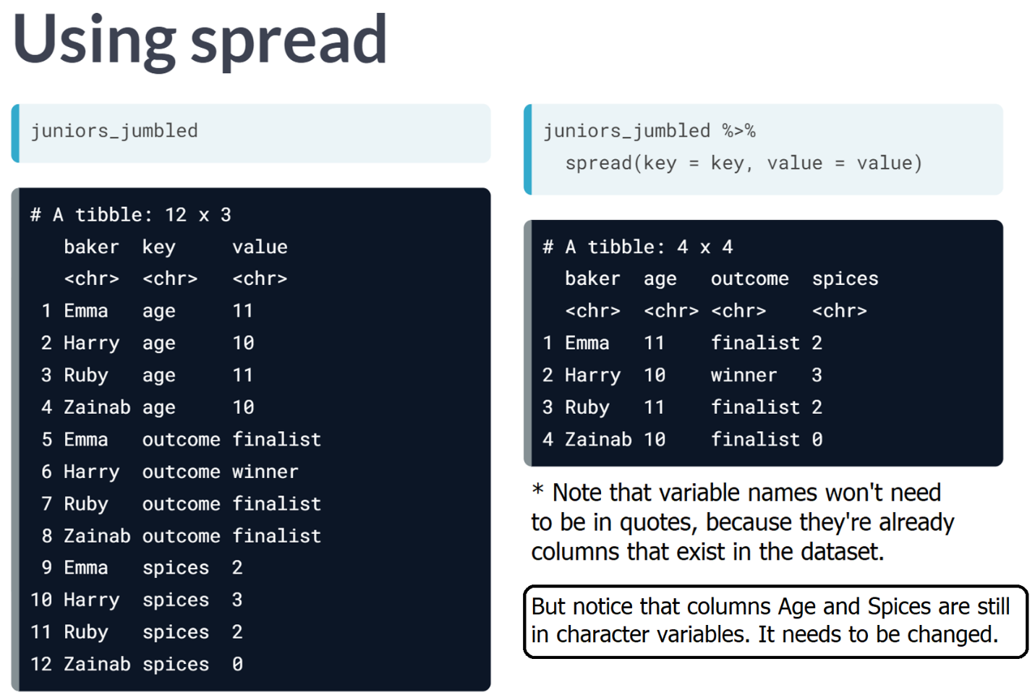

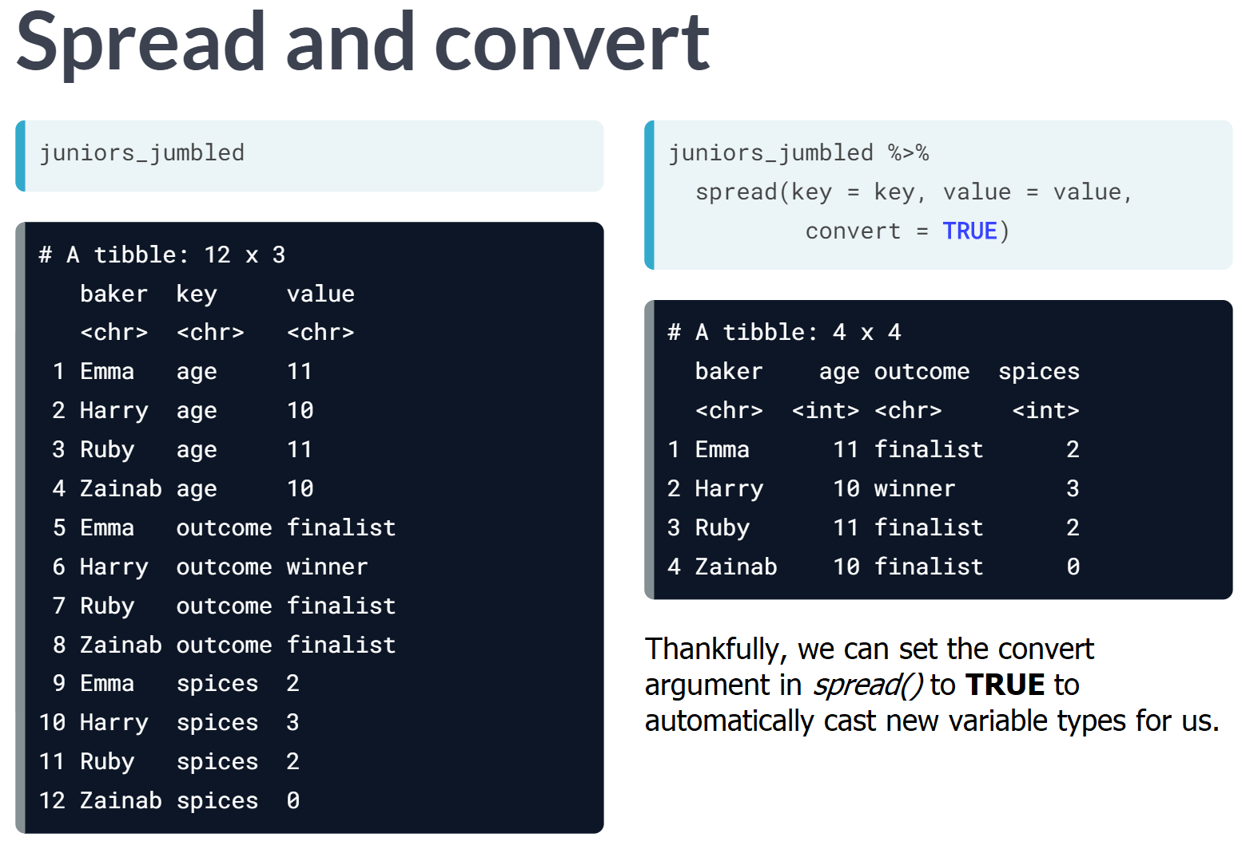

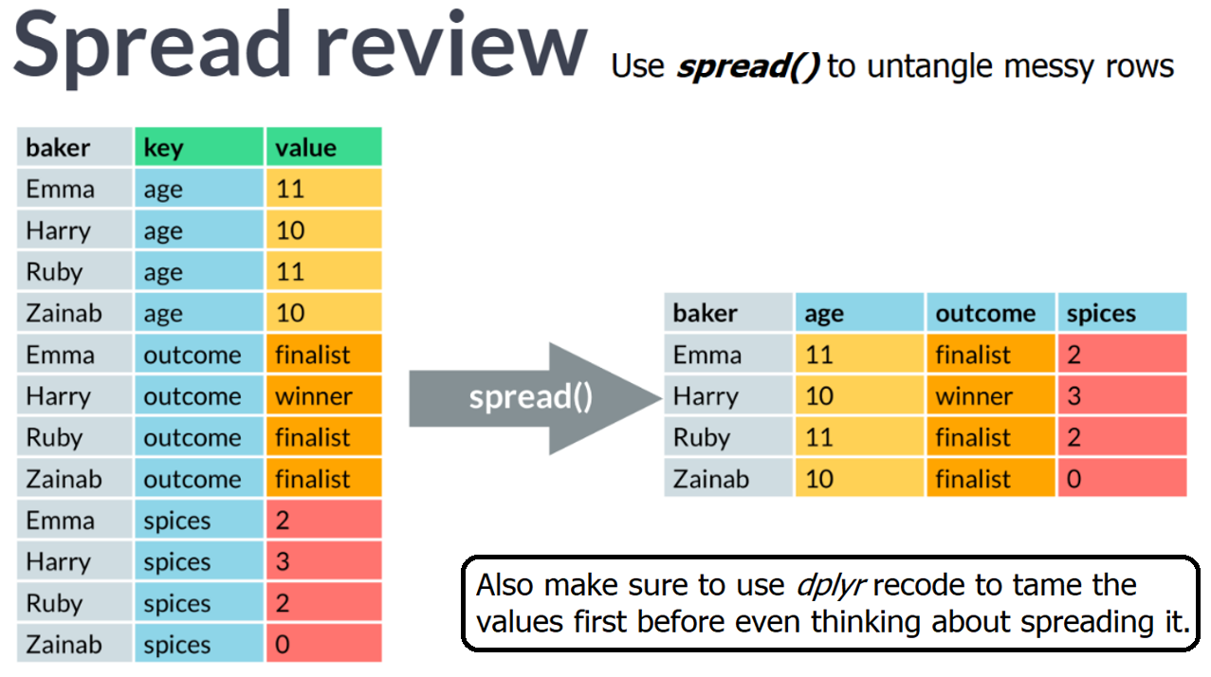

# Spread rows into columns

In this exercise, you'll use the tidyr, dplyr, and readr packages to tidy the ratings2 data after using dplyr::count(). The tidy_ratings_all data should have four variables to work with:

* series (integer: 1-8),
* episode (integer: 1-10),
* days (integer: 7 or 28), and
* viewers (numeric).

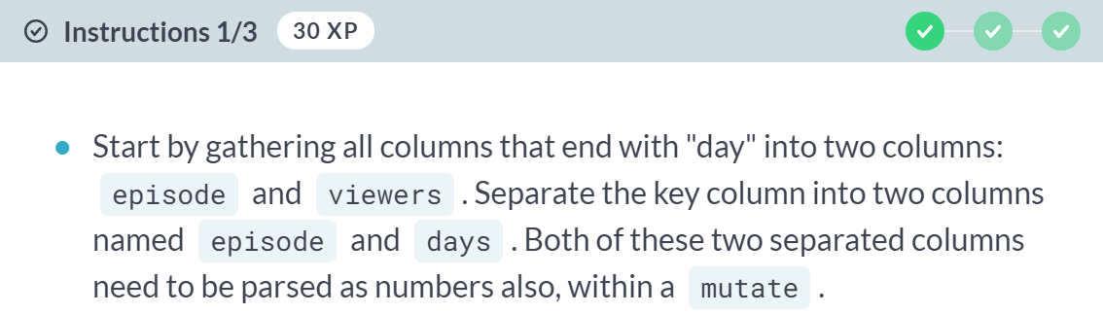  
  
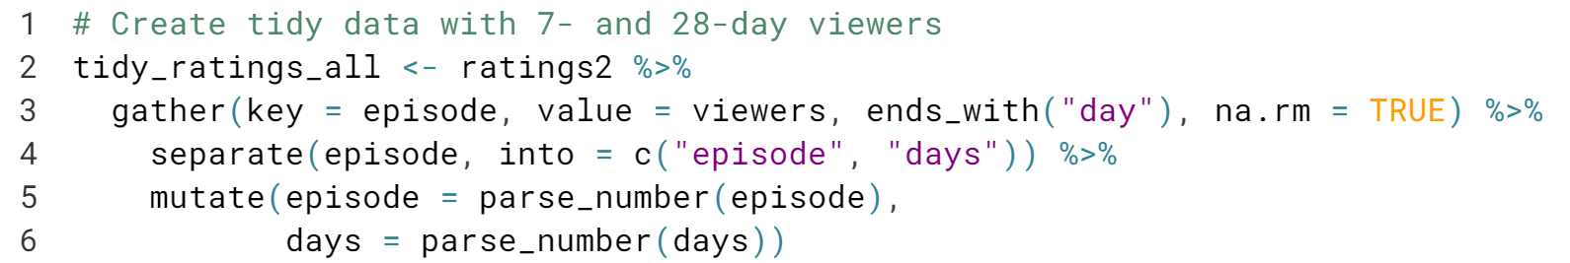

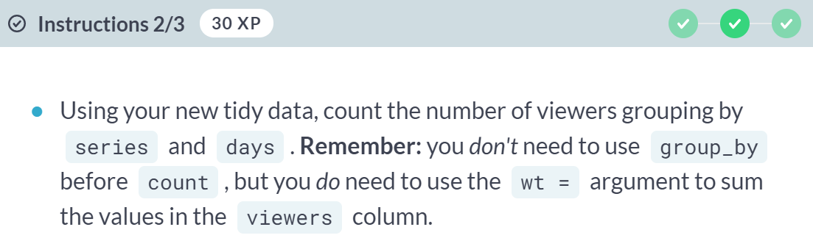

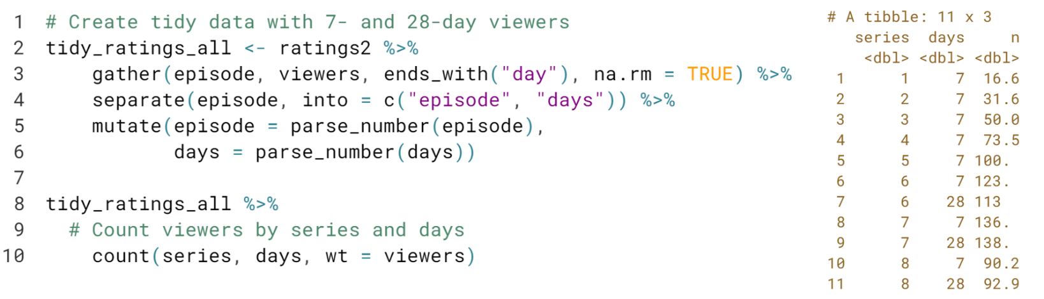

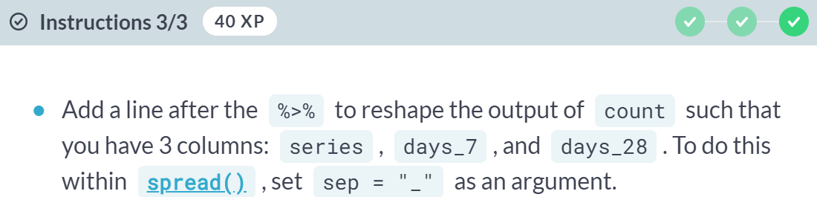

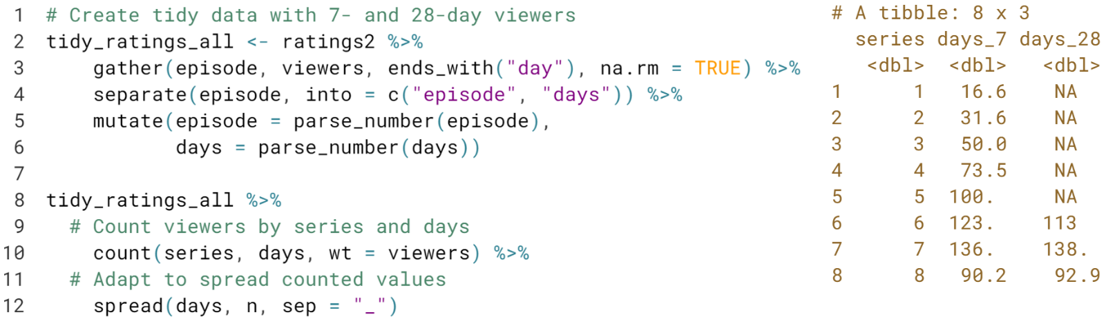

Great work! The ***sep = "_"*** argument is especially helpful when you are spreading by a numeric variable so that you don't end up with variable names that start with numbers.



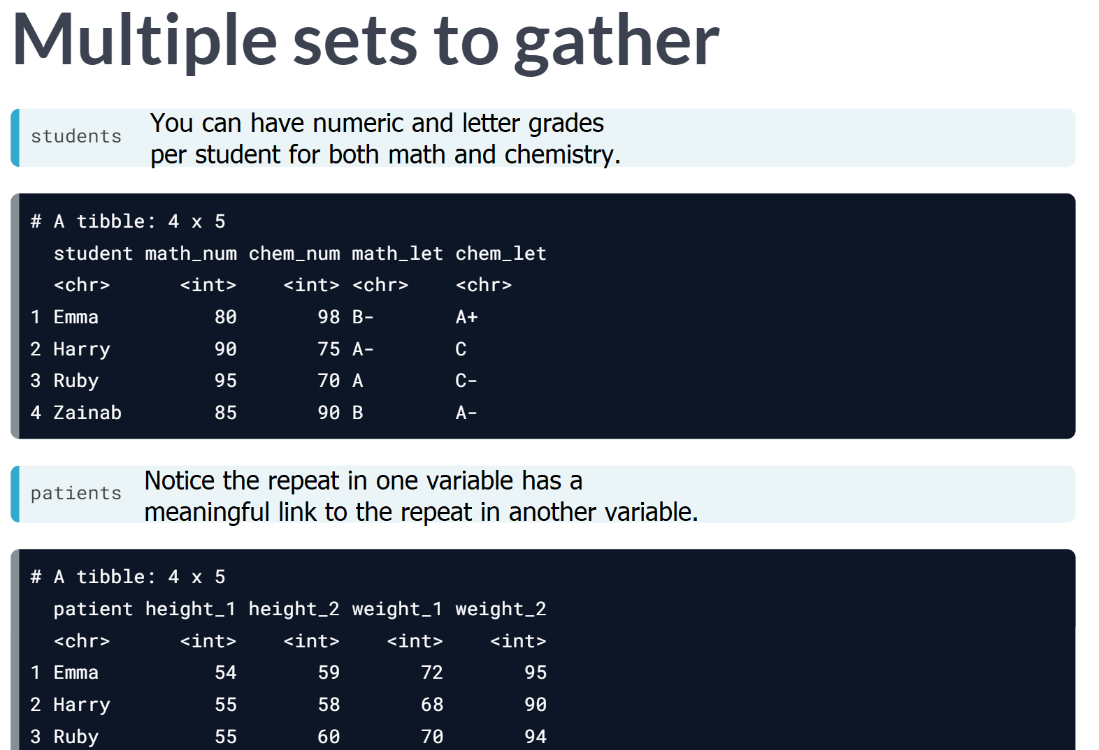

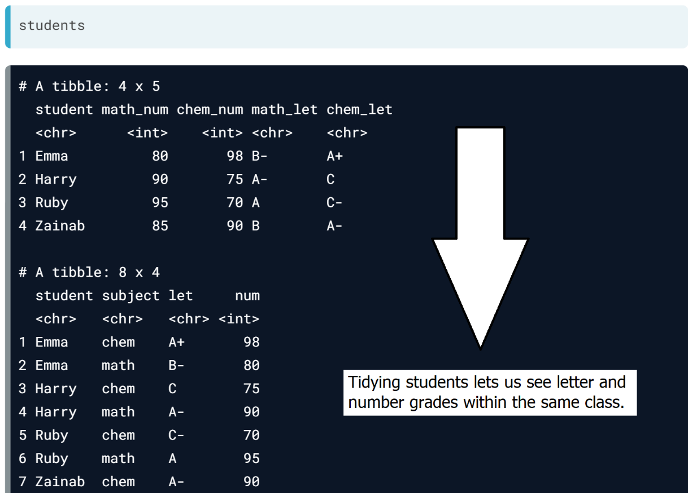

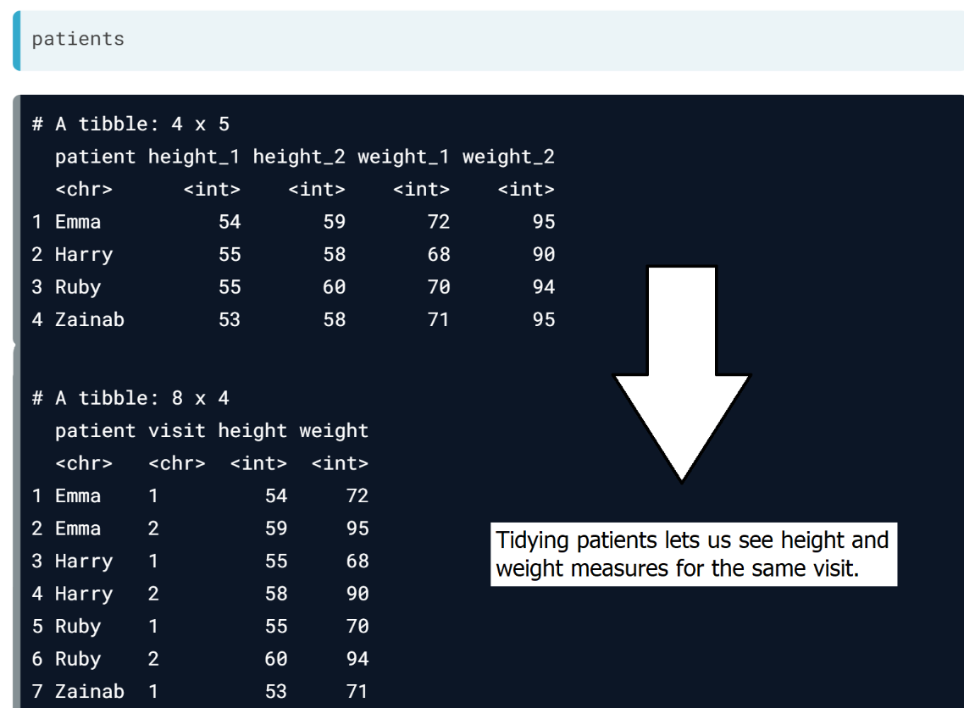

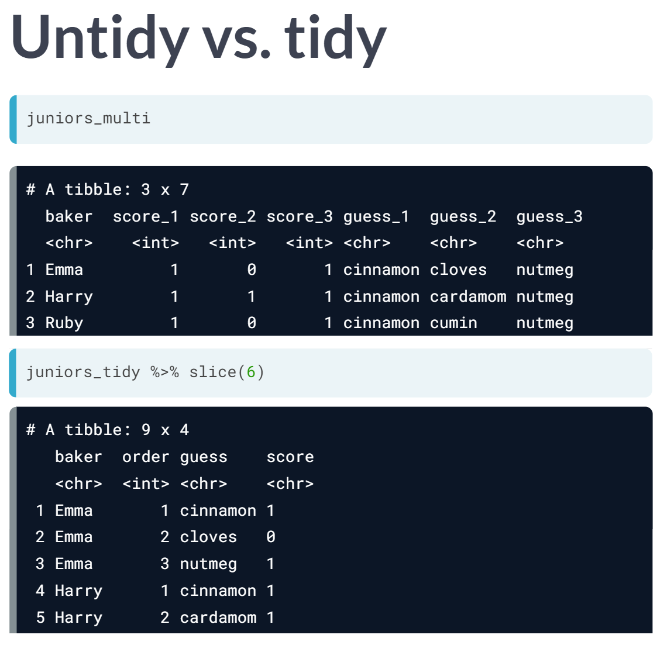

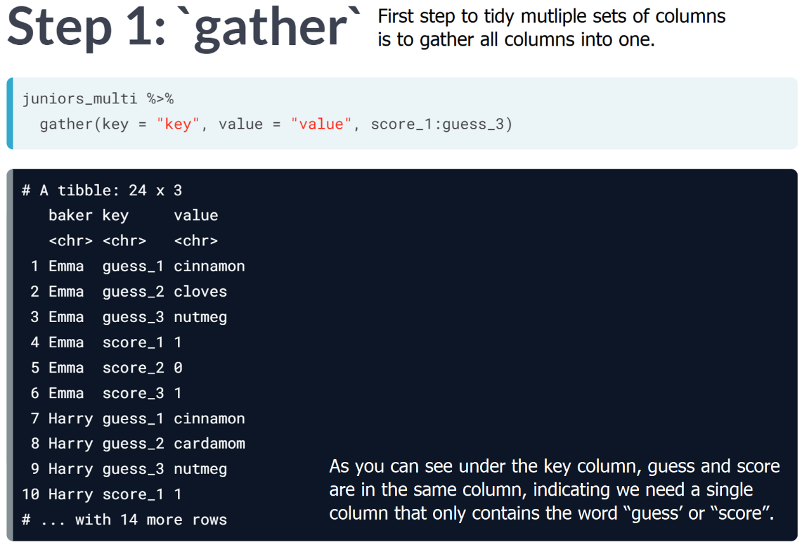  
  
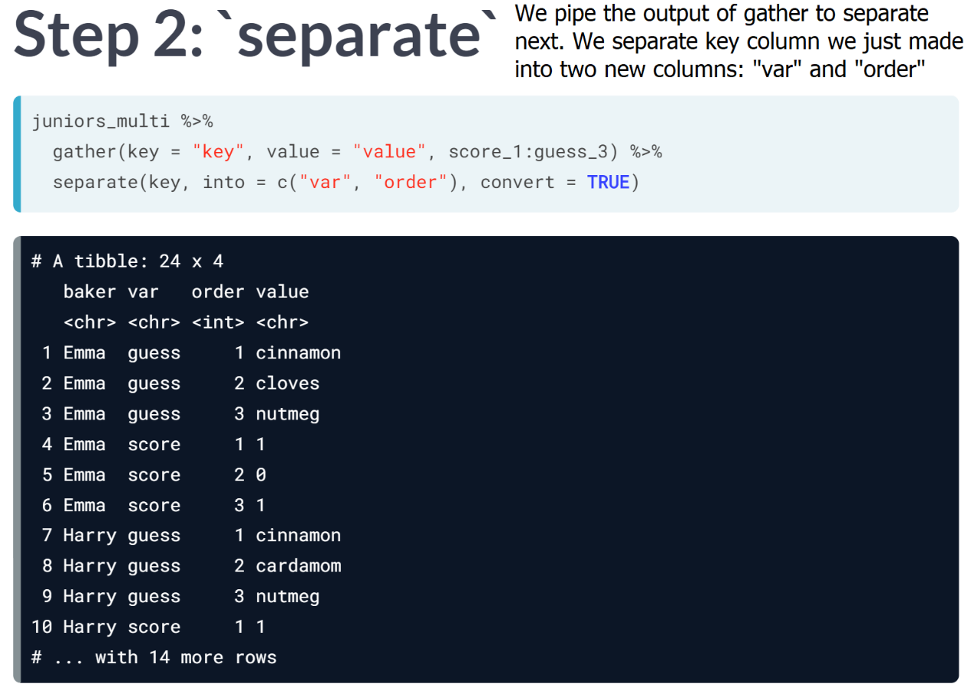

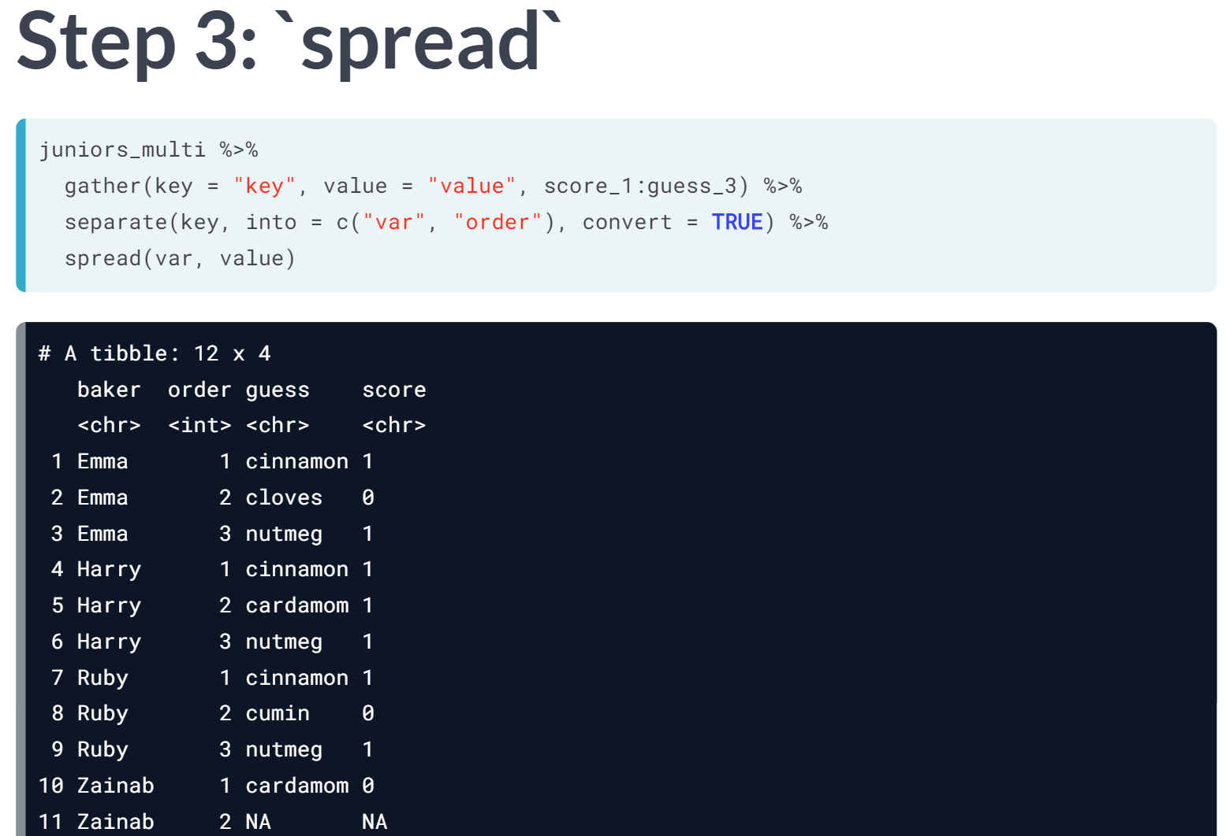  
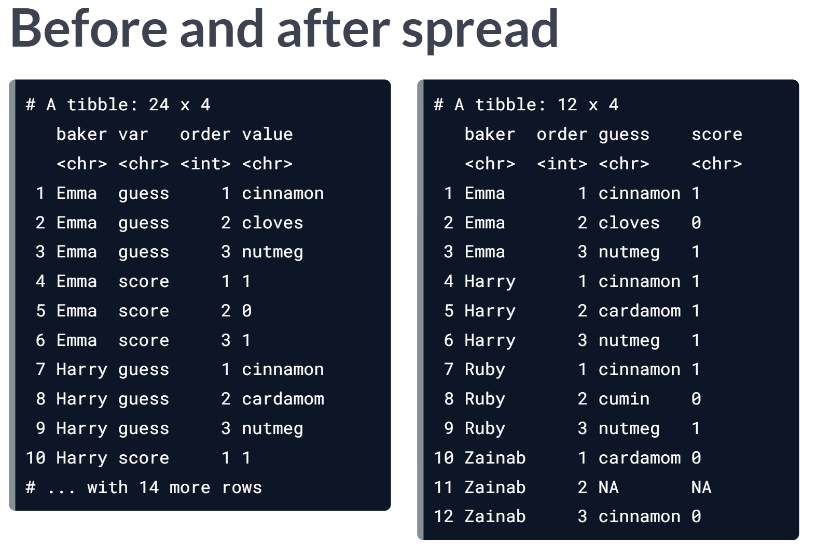  
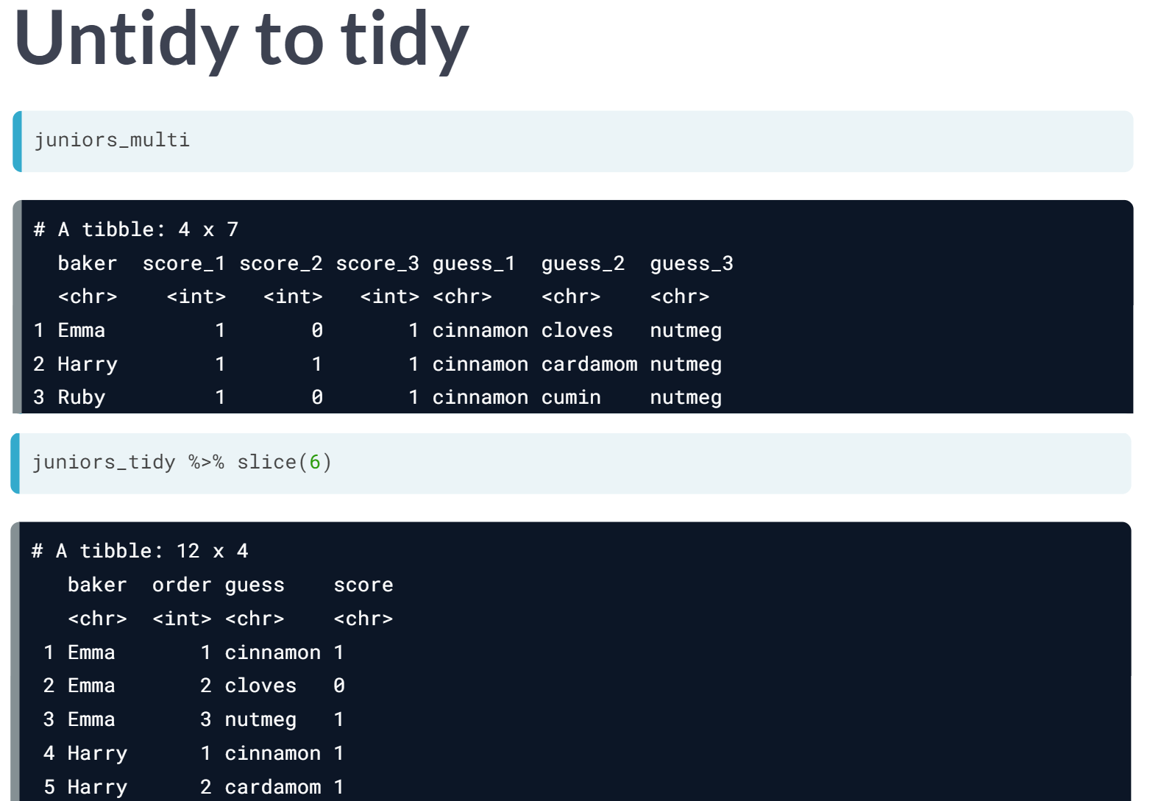

# Masterclass: Tidy I

In this upcoming three exercises, you'll tidy the ratings data to create a scatterplot to see the relationship between the number of premiere and finale UK viewers (7-day only) by series.

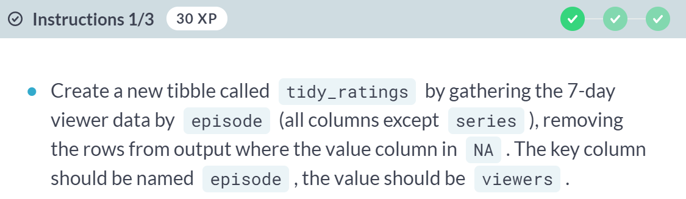  
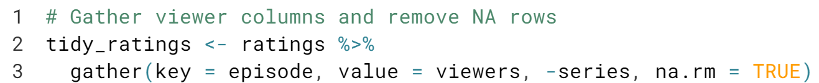

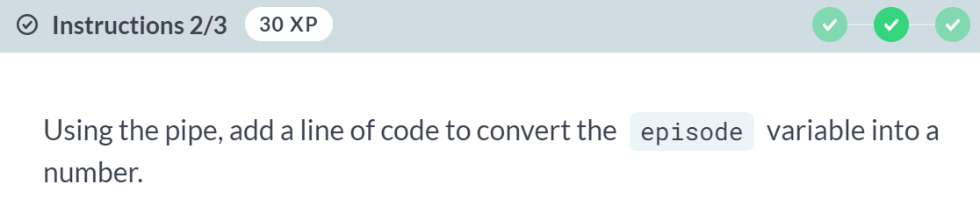

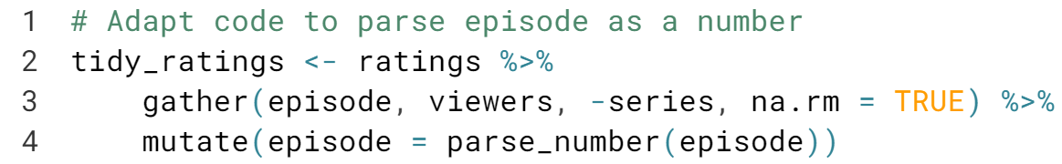

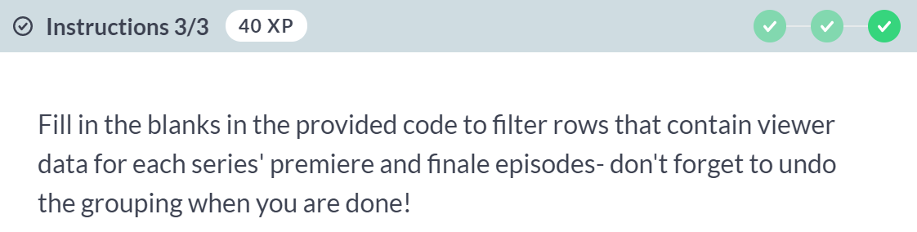

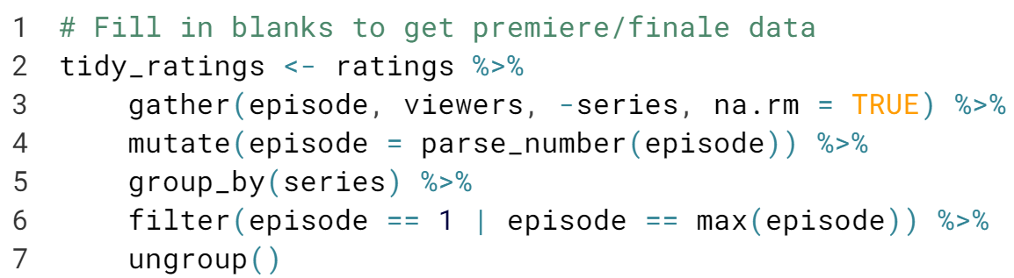  
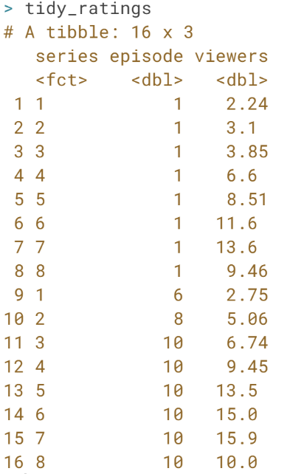

# Masterclass: Tidy II

In the previous exercise, you gathered, then did a grouped filter to make tidy_ratings. In this exercise, you'll make two charts in ggplot2 with this tidy data to see if the judge's tweet spoiled the Series 8 finale ratings.

The two plots you'll make, a slope chart and a dumbbell chart, are nice ways to show change between two data points combining geom_point() and geom_line().

You'll use these to visualize the "finale bump" in viewers between the premiere and finale episodes across series.

  


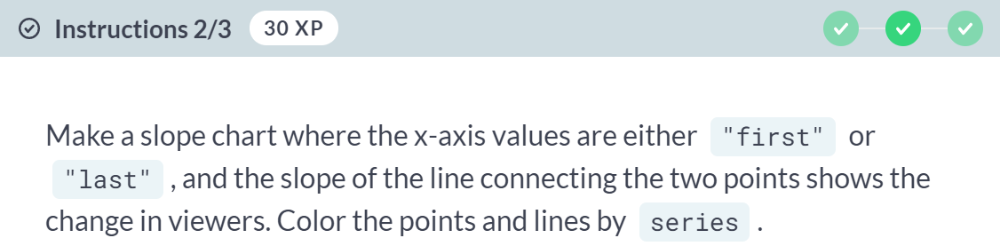  
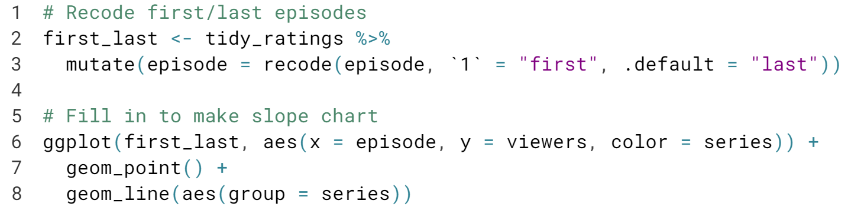

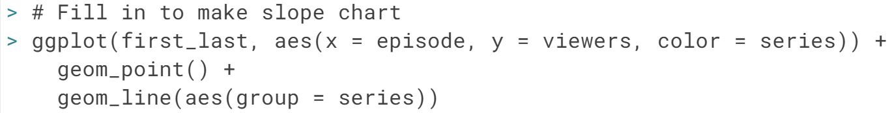

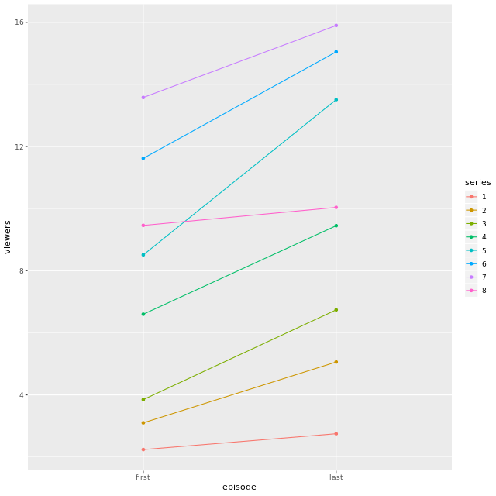

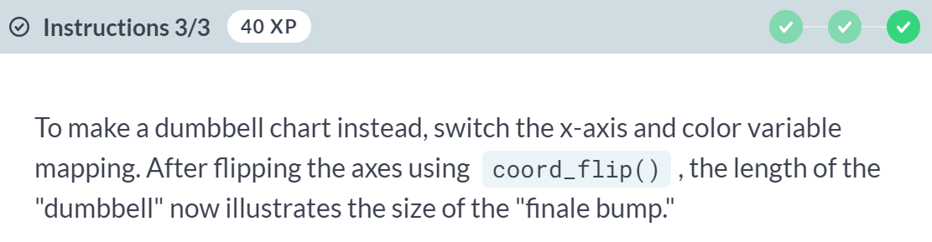  
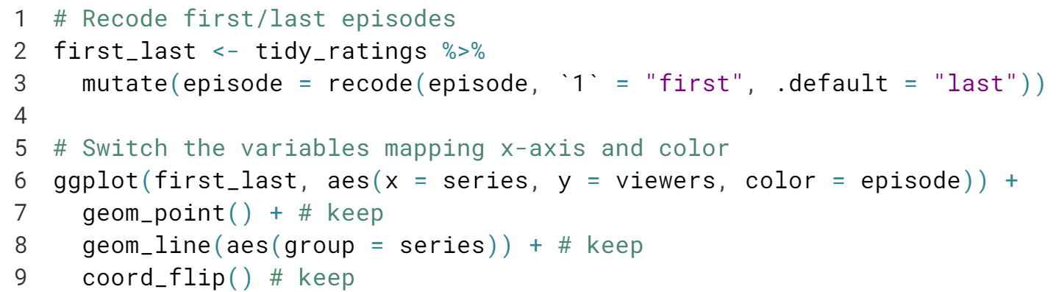

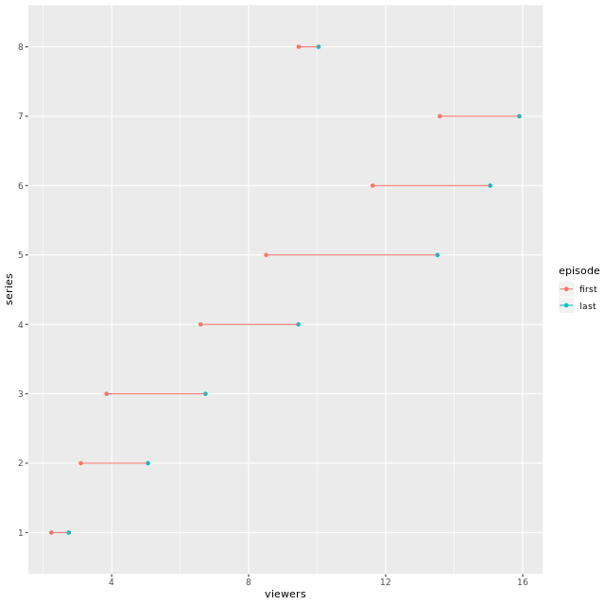

# Masterclass: Tidy III

In the previous exercise, you visualized the size of the "finale bump" in viewers for each series. From those charts, we know that finale episodes always garner more viewers than premieres. We also know that the change in viewers for series 8 seemed smaller compared to some previous series.

But the question of whether the series 8 finale viewers were "spoiled" might be best answered by comparing the relative percentage changes in premiere and finale viewers across series. In this exercise, you'll reshape first_last once more to calculate and visualize the relative finale bump.

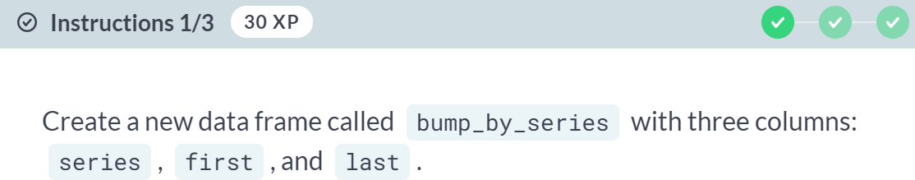

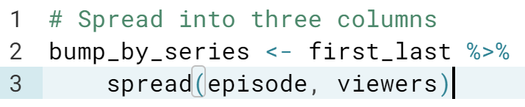

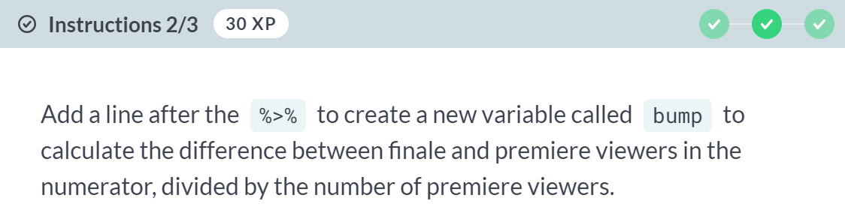

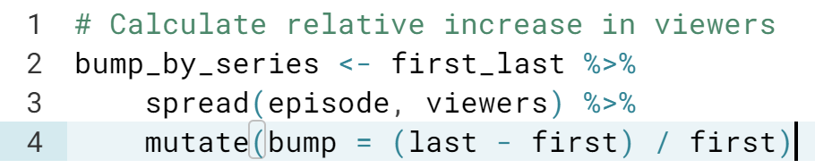

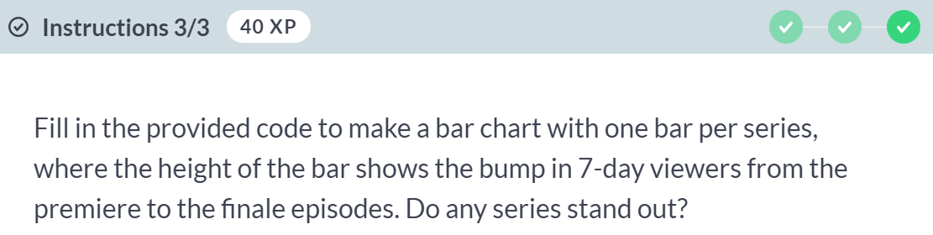

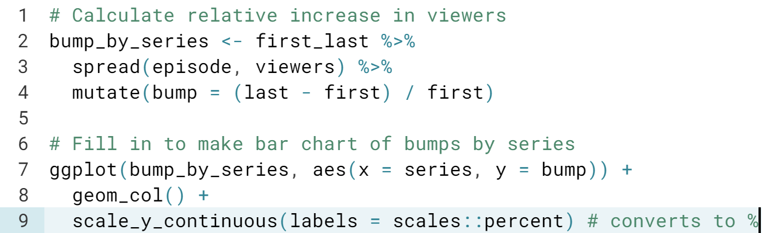

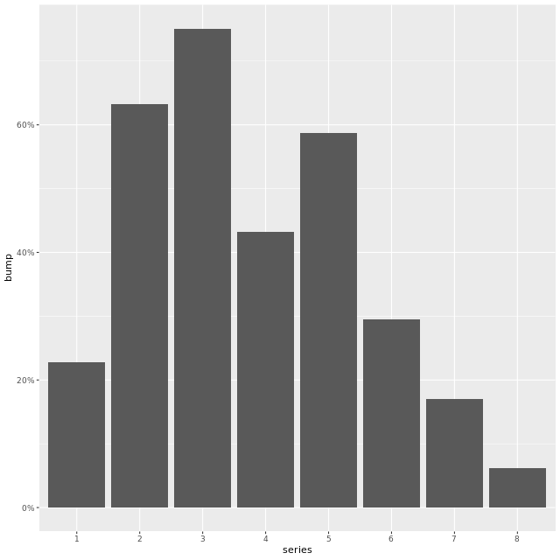  
Series 8 had the lowest 'finale bump' so far- only 6% more viewers watched the finale than the premiere. Notice that we had to ***spread*** here, because the tidy version of the data depends on the question you want to ask.

#### **Transform your data**

#### In this chapter, you will learn how to tame specific types of variables that are known to be tricky to work with, such as dates, strings, and factors.



When doing simple recoding, ***dplyr*** function is sufficient. However, when complex recoding is performed, we need to use ***case_when***, which allows you to vectorize multiple if and else if statement.

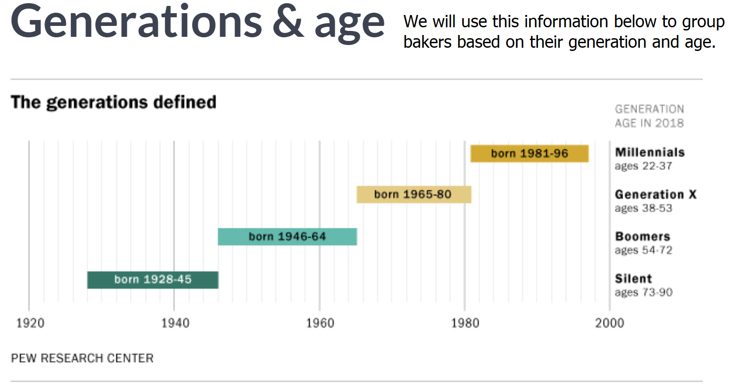  
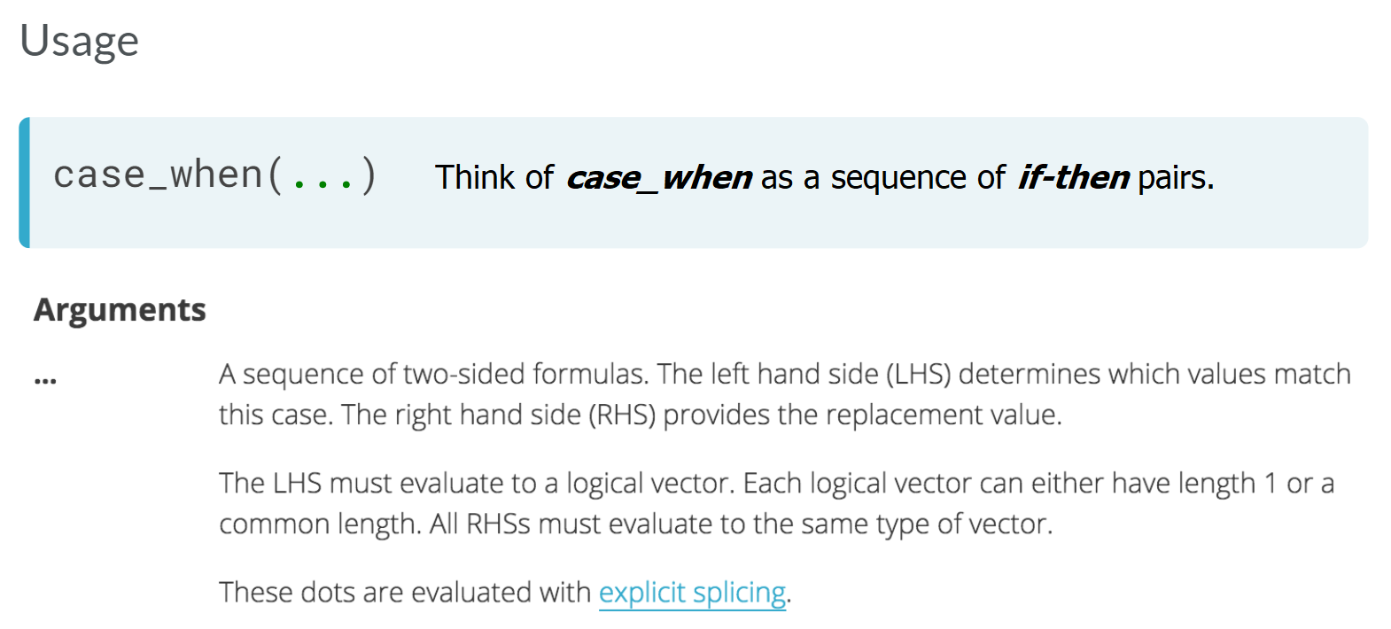

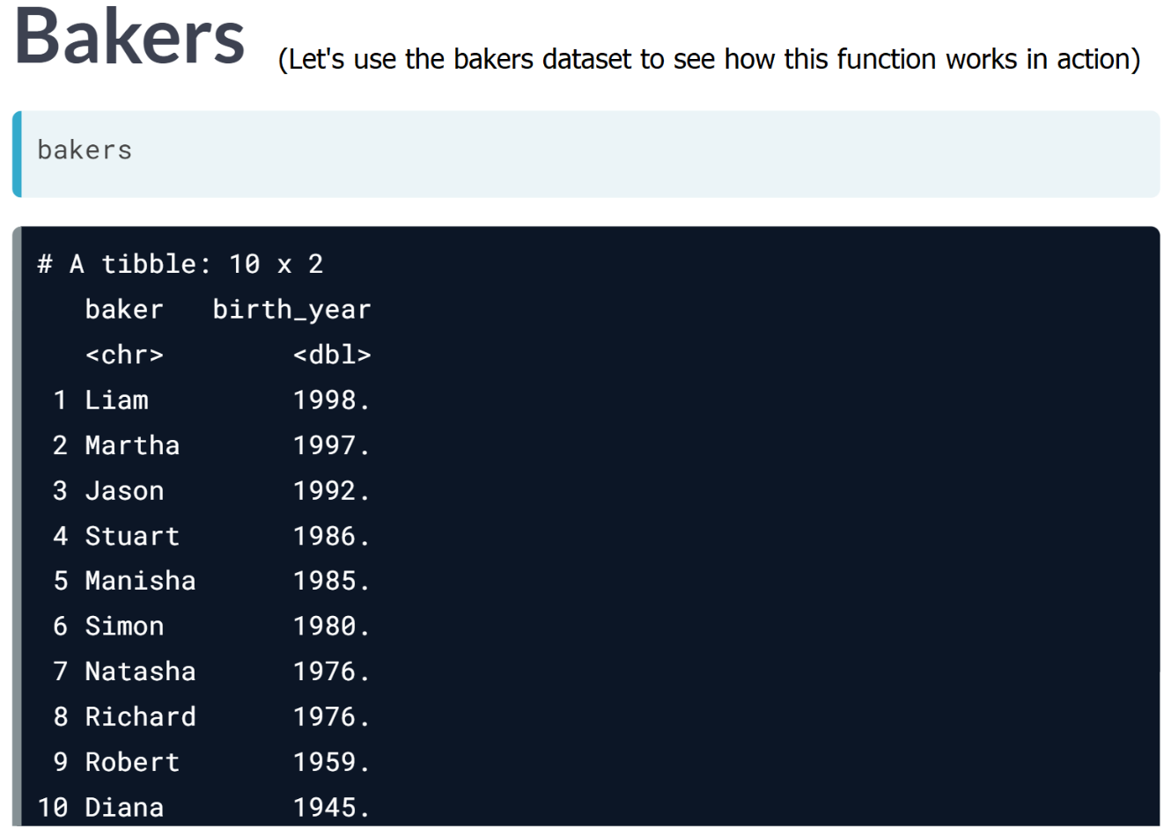  
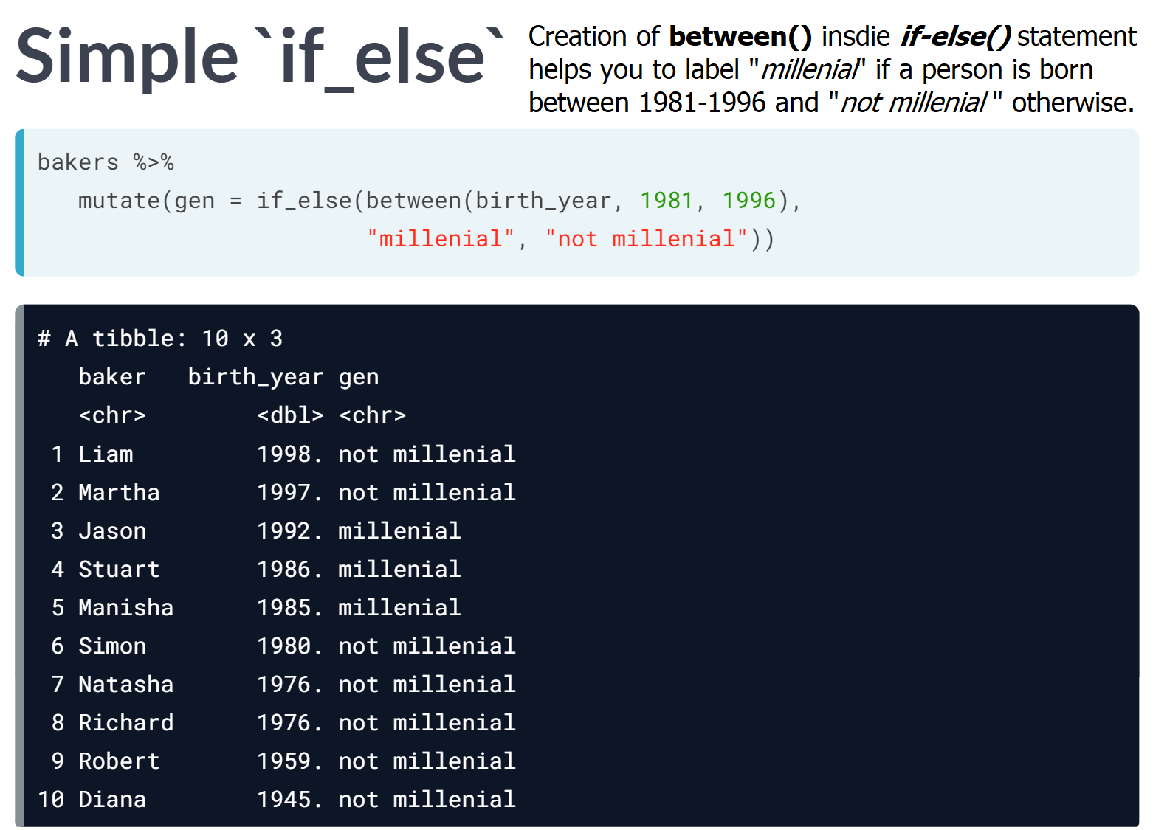

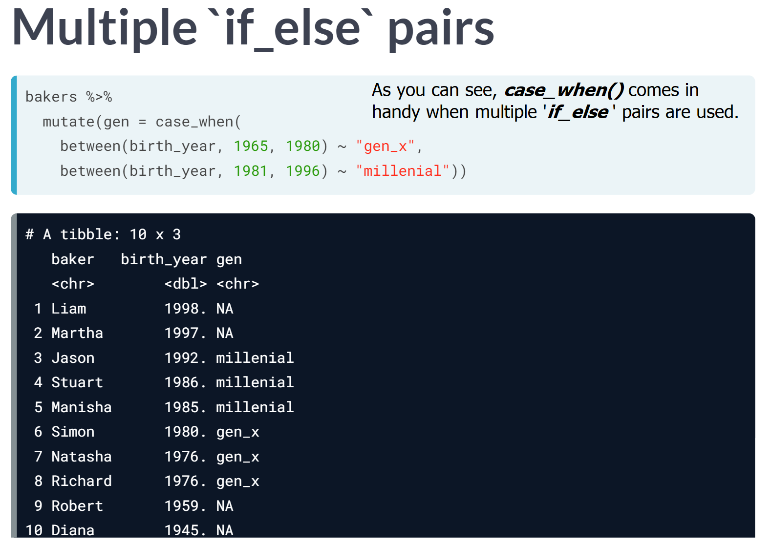  
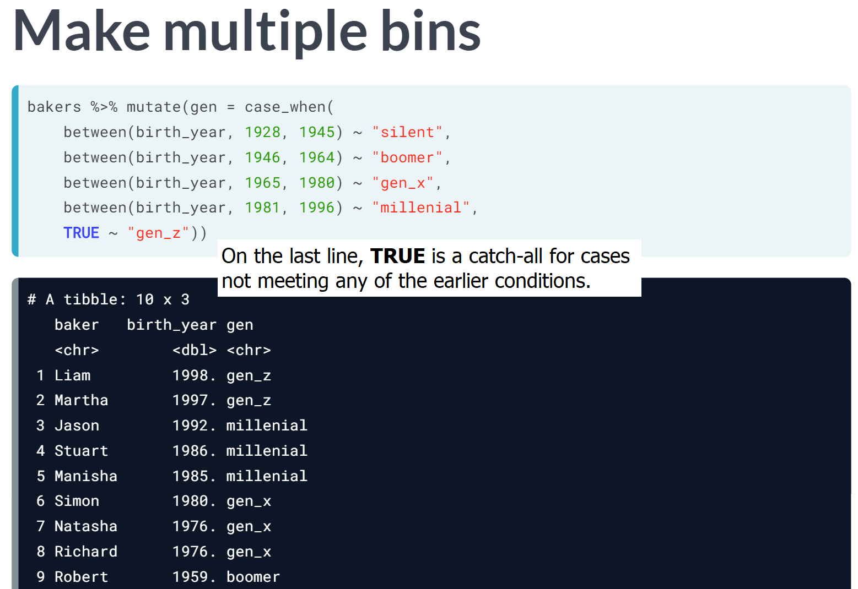

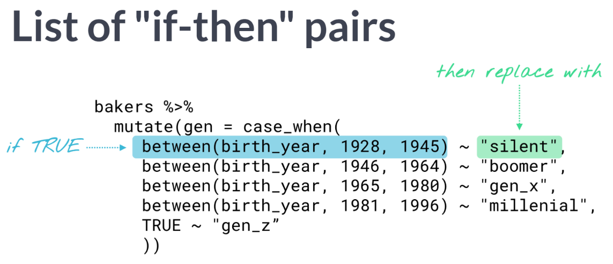

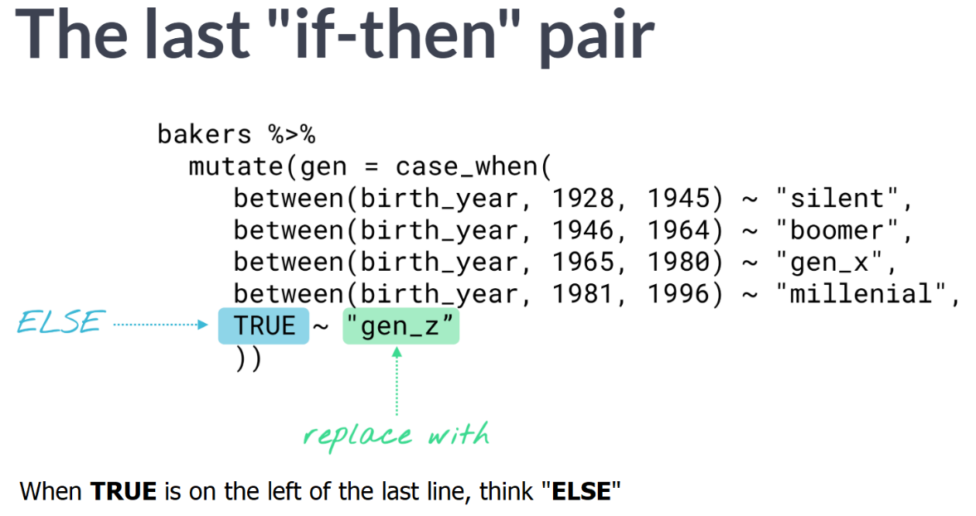  
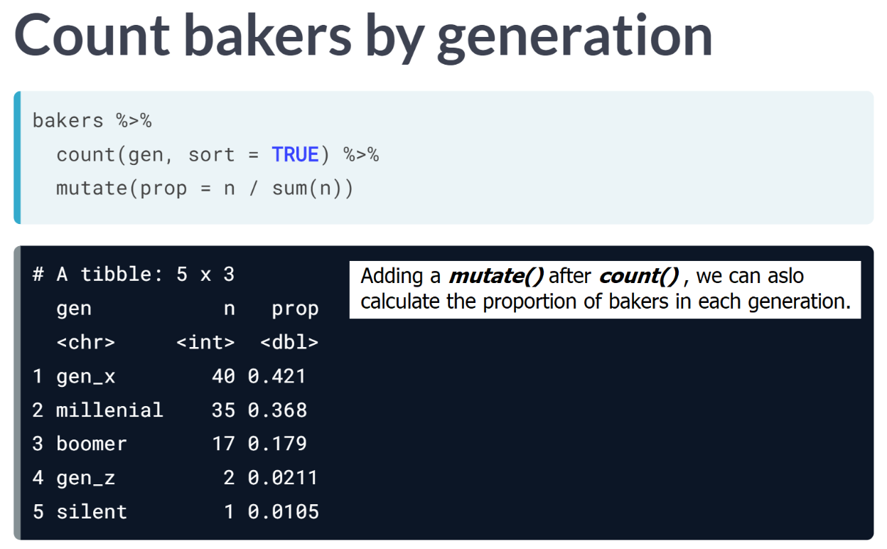

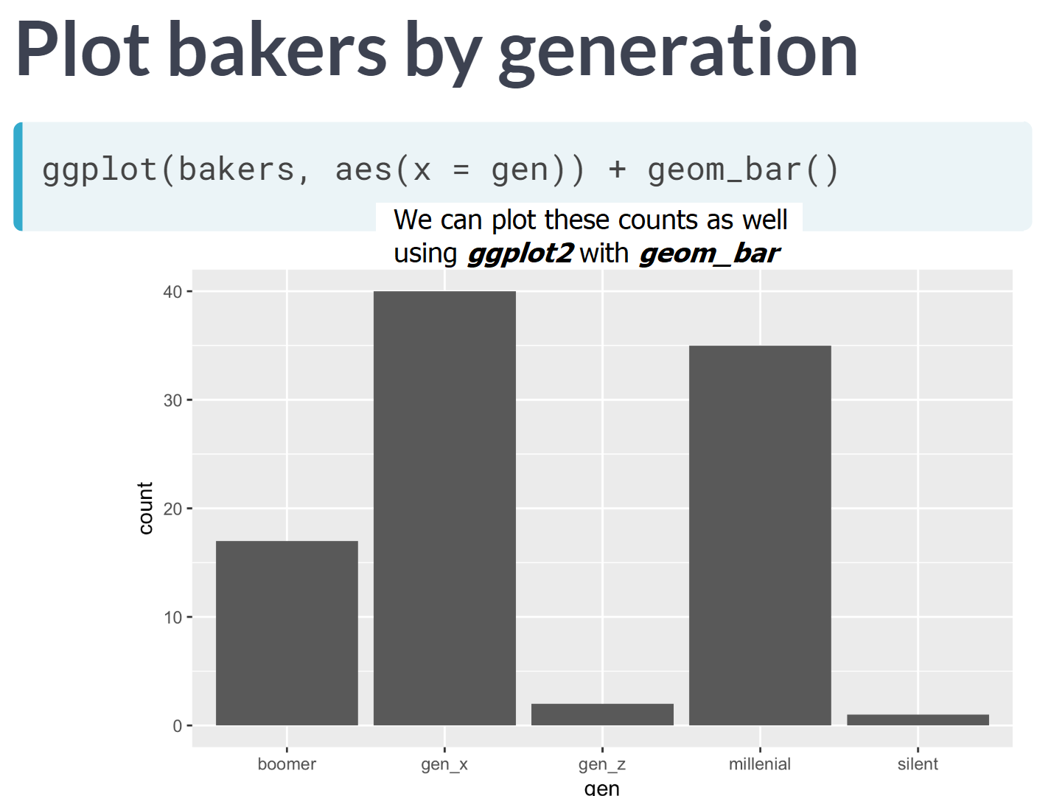

# Combine two variables

In this exercise, you'll use case_when() with the bakers data to create a new variable based on the number of times each baker was crowned as star baker or the technical challenge winner:

* If star baker is greater than technical wins, recode as super_star
* If star baker is less than technical wins, recode as high_tech
* Recode the rest as well_rounded

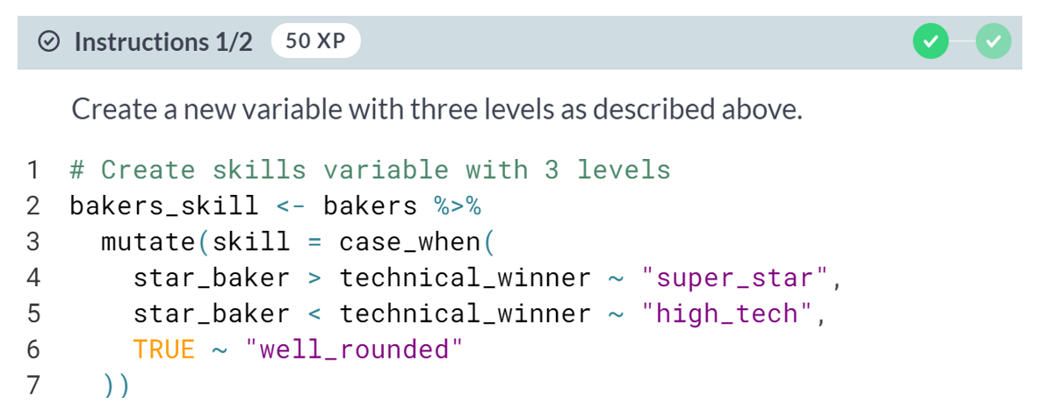  
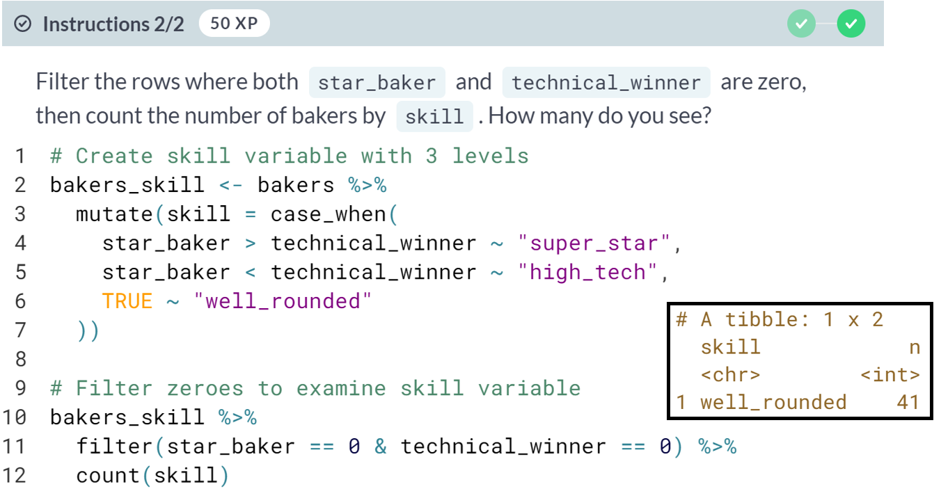

Whoops- we may not want bakers who never won star baker or the technical challenge to be called 'well-rounded'. Let's add another level to take care of this.

# Add another bin

In this exercise, you'll edit your previous code so that skill has four levels:

* If both star baker and technical wins are zero, recode as NA_character_
* If star baker is greater than technical wins, recode as super_star
* If star baker is less than technical wins, recode as high_tech
* If star baker is equal to technical wins, recode as well_rounded

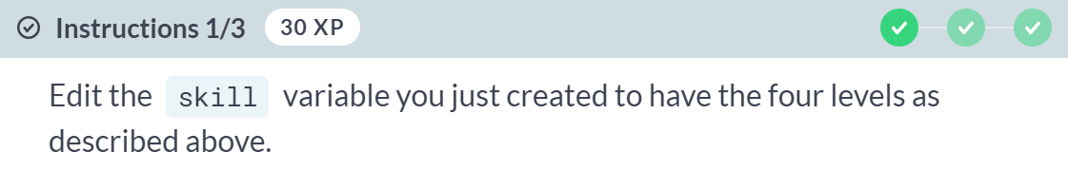  
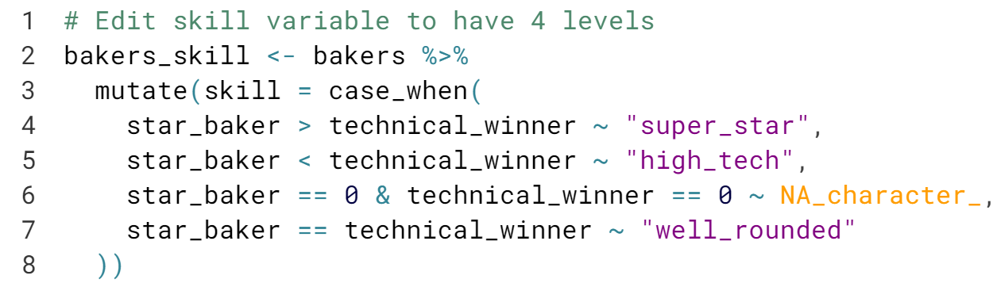

  
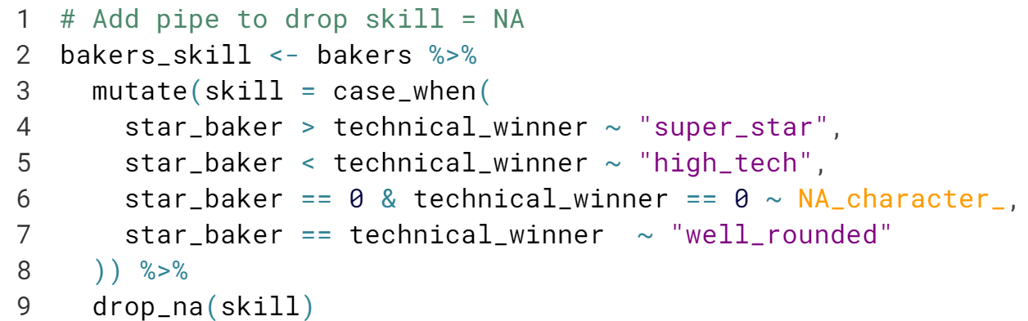

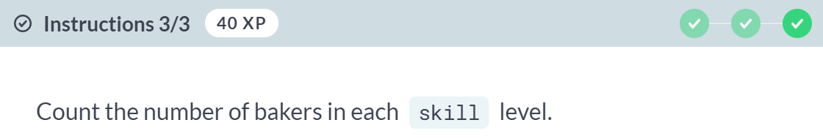  
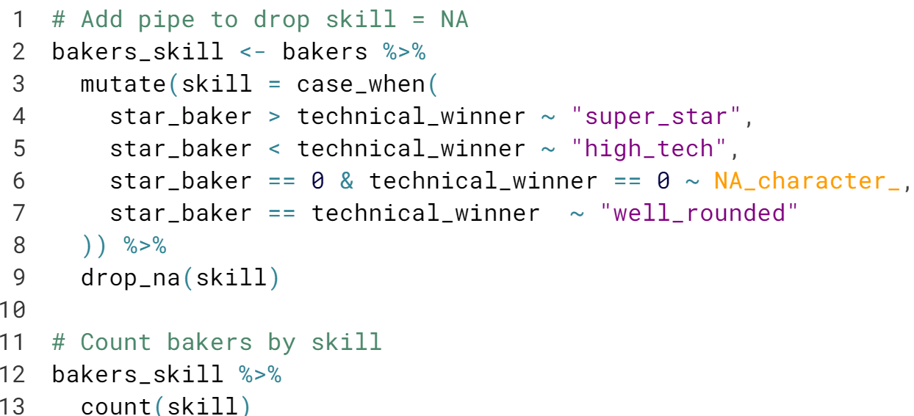  
  
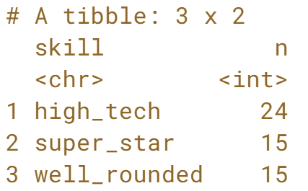

Very nice - now we only have 15 'well-rounded' bakers, and we dropped the 41 bakers who never won star baker or a technical challenge.

  
  
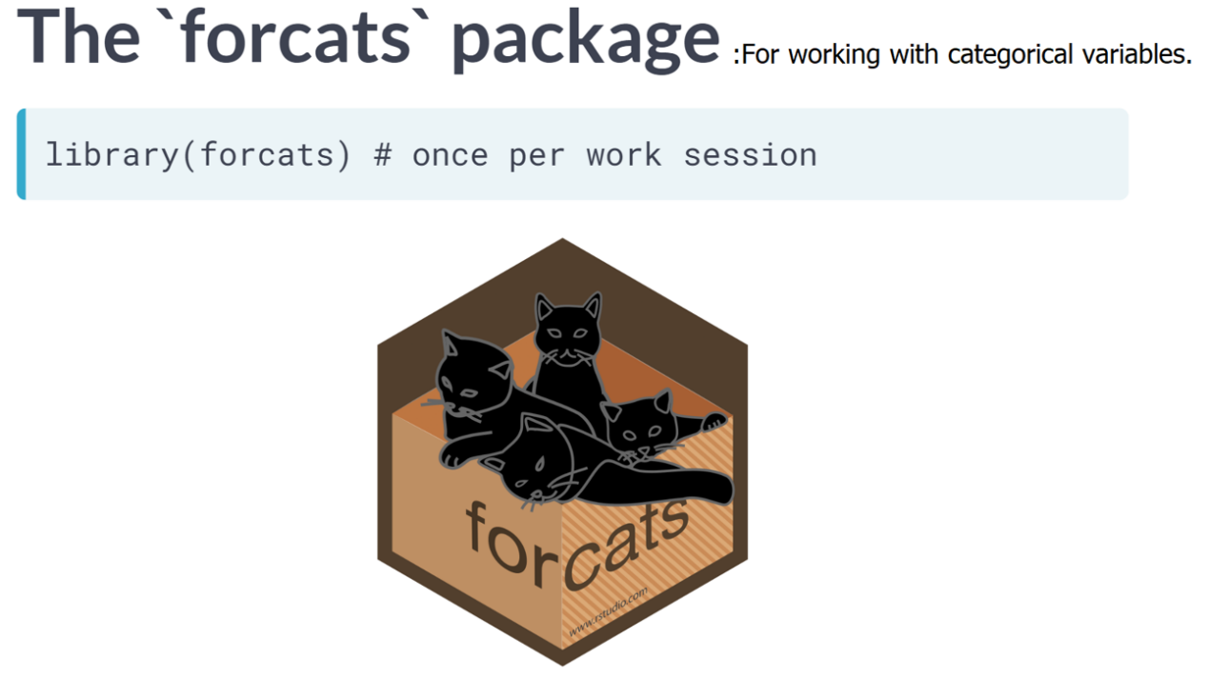  
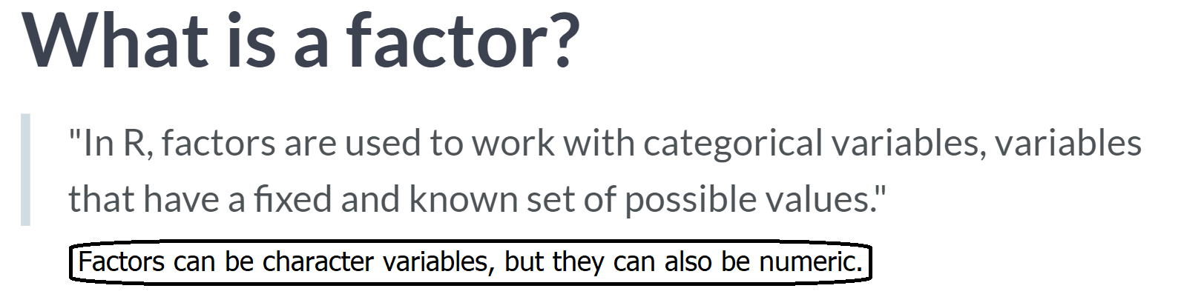  
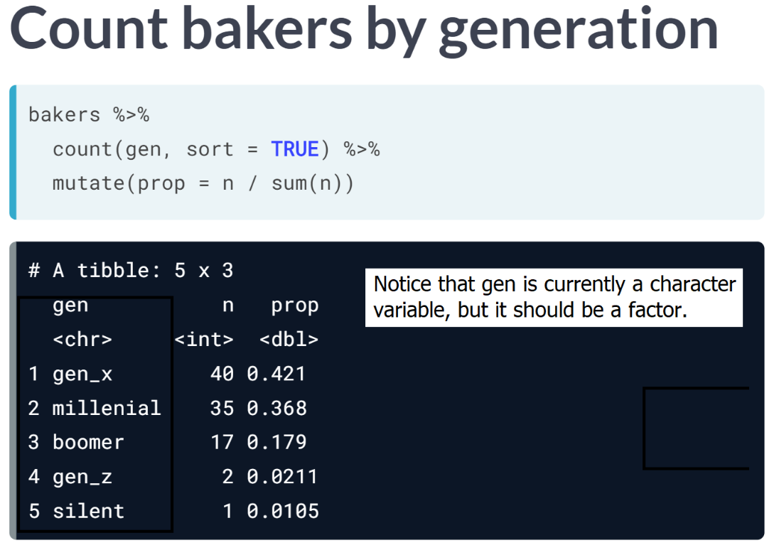

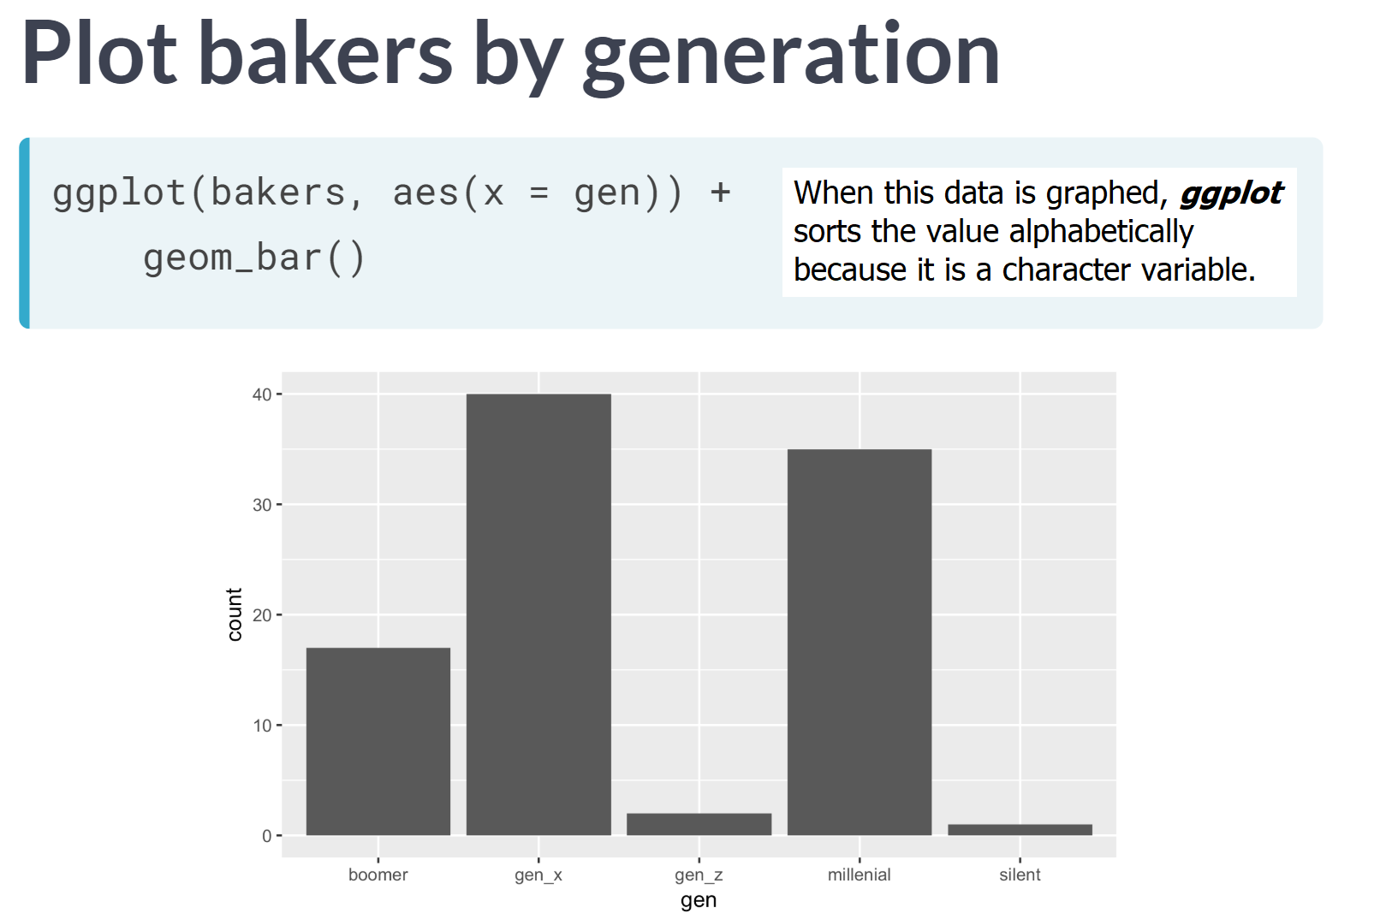  
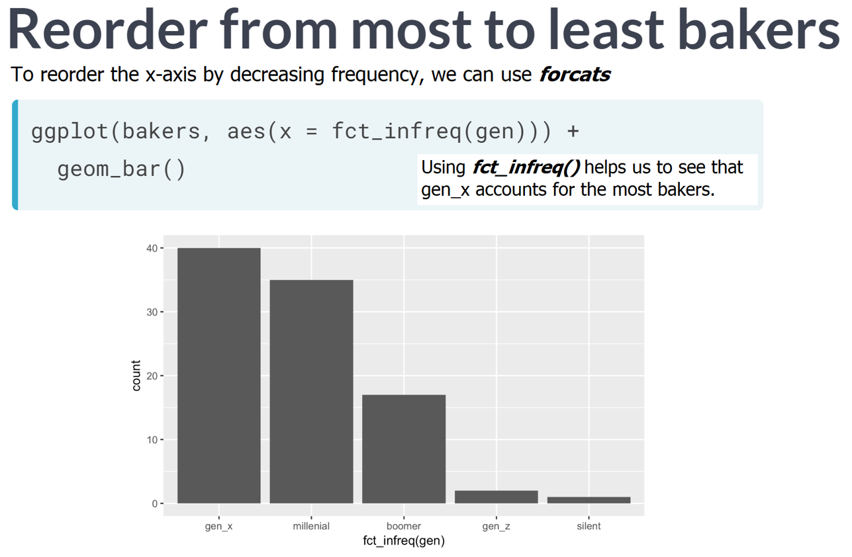

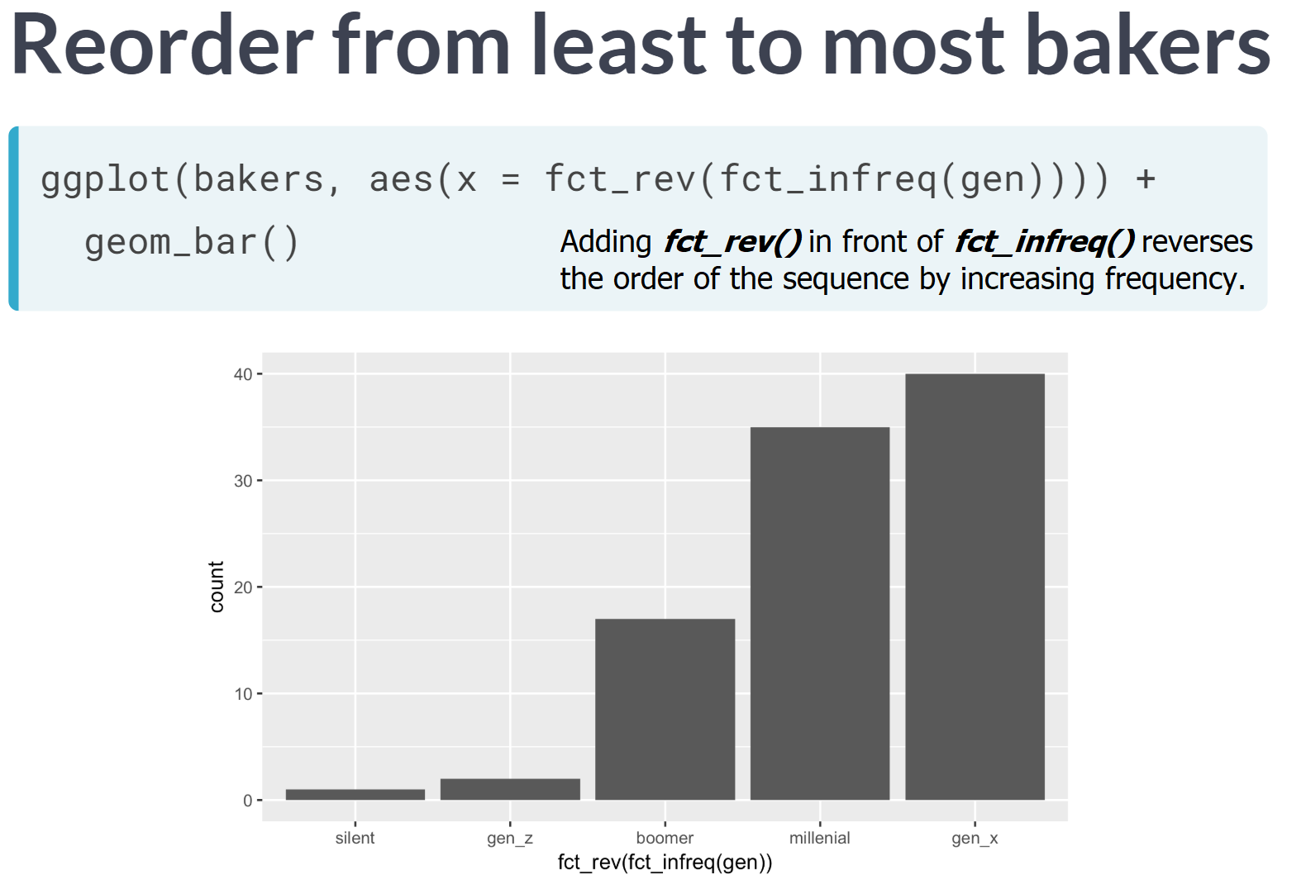

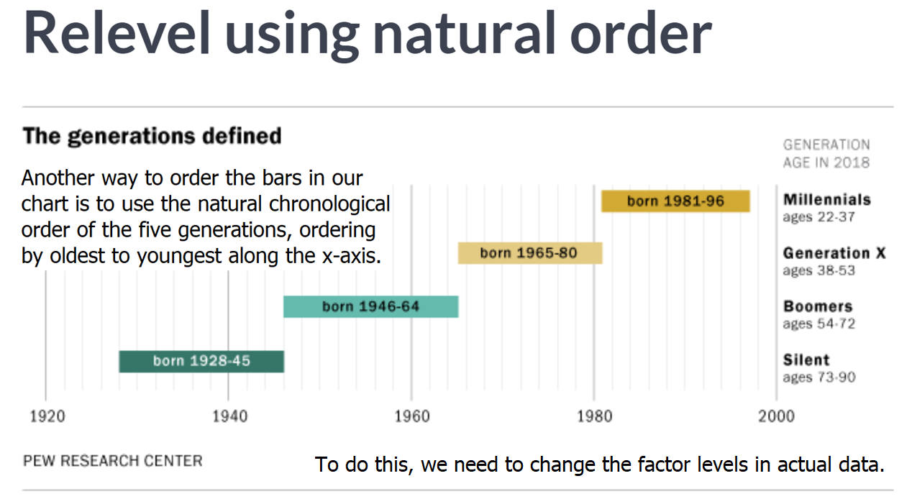

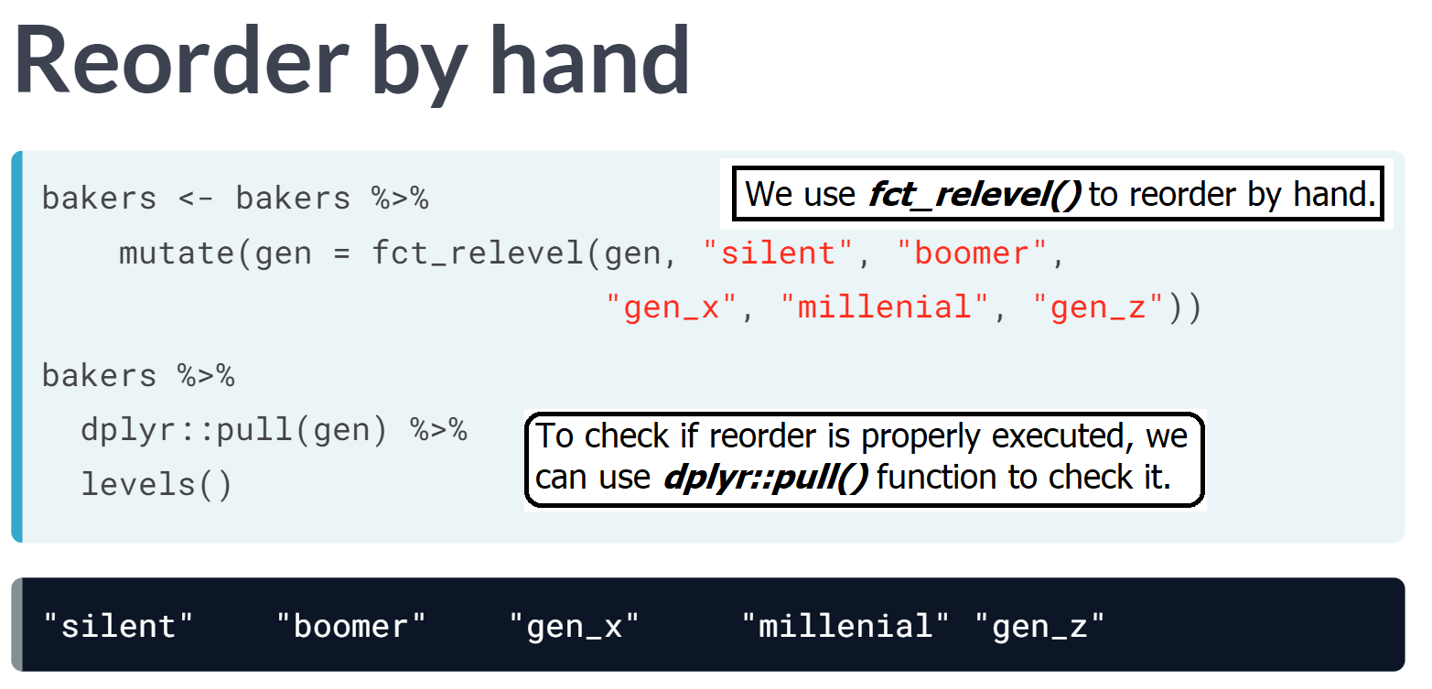

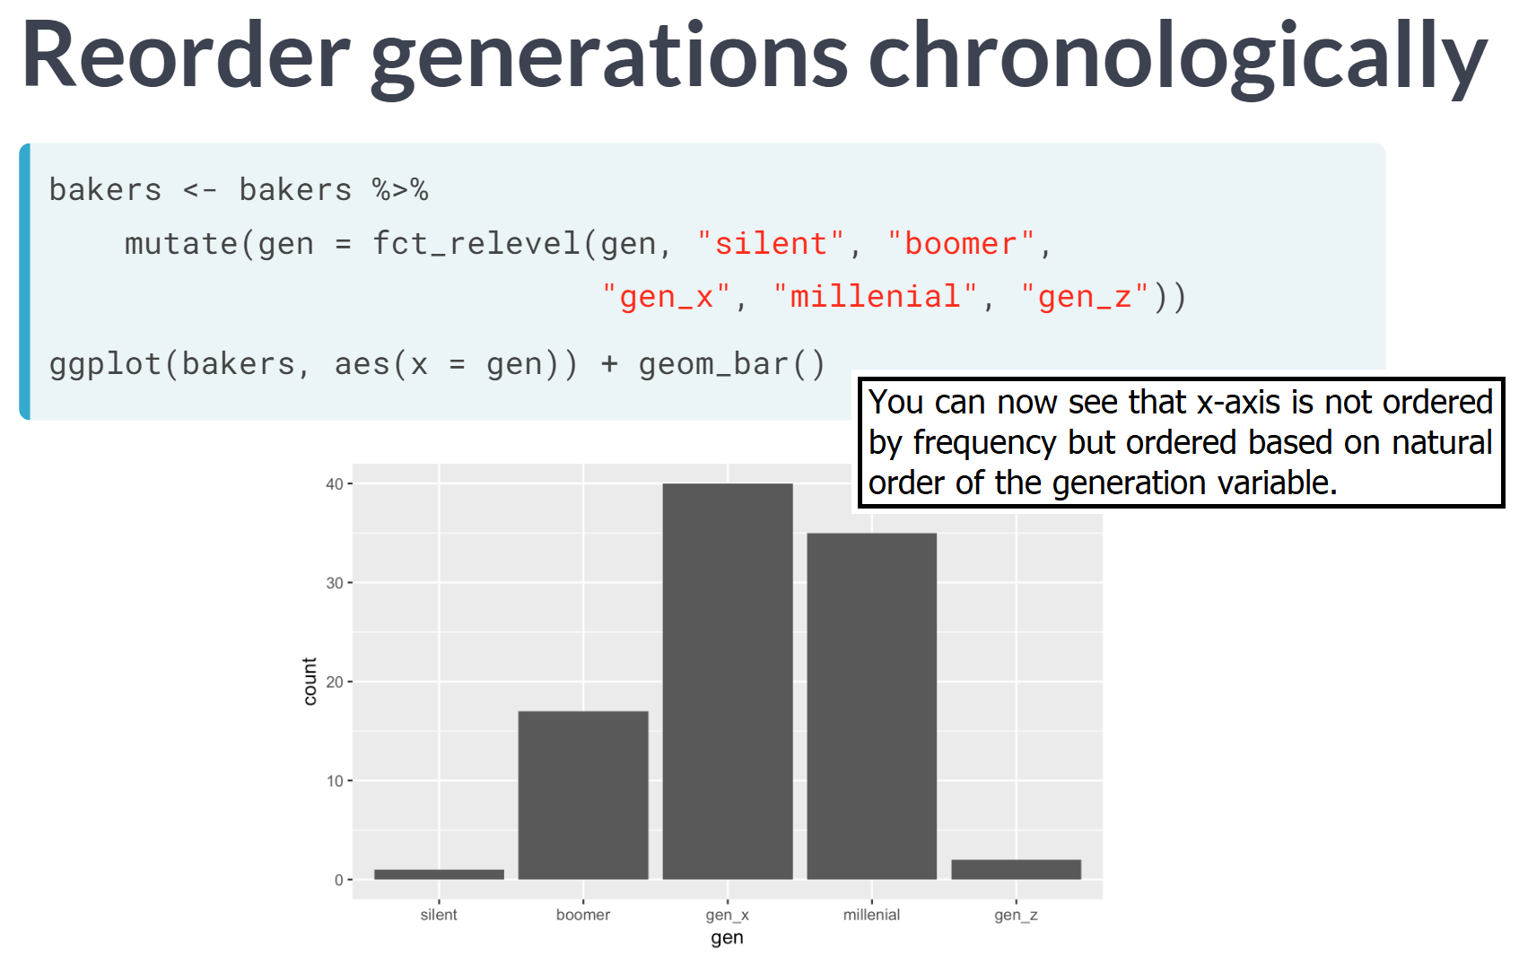

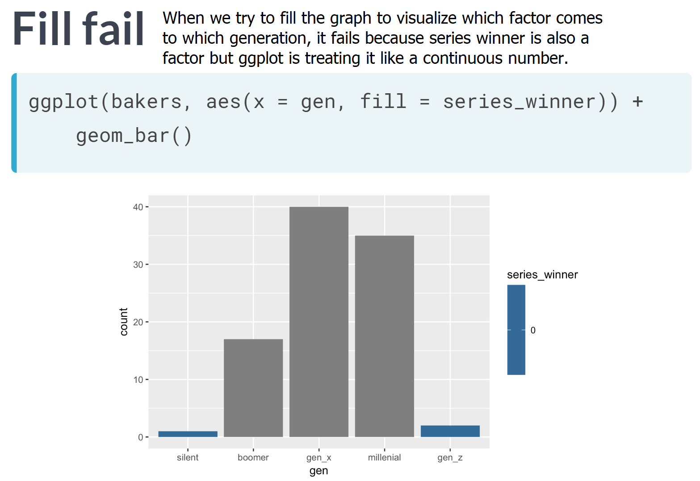

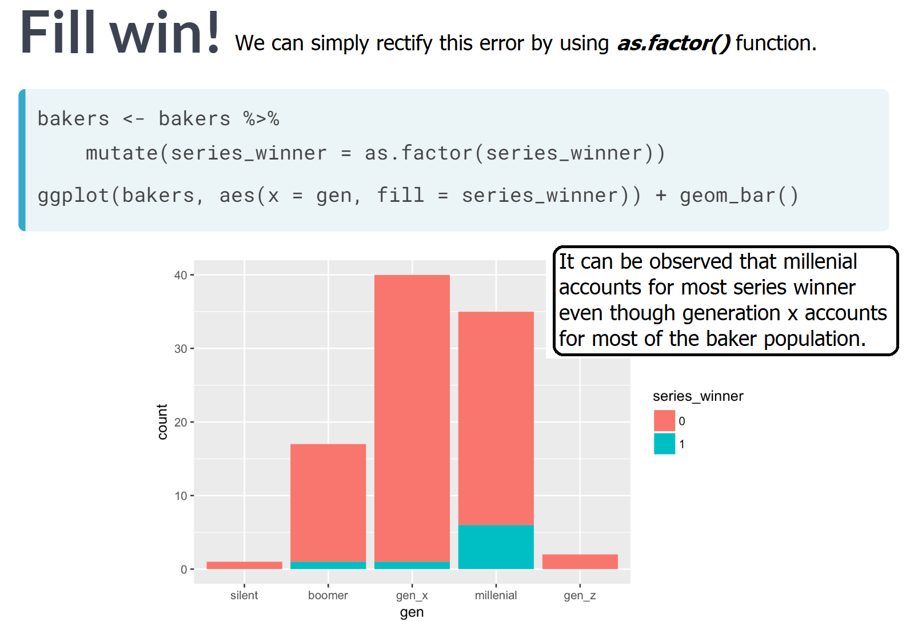

# Cast a factor and examine levels

In this exercise, you'll start where you left off in the last series of exercises, working with the bakers data to examine your new categorical variable called skill, which has three levels: well_rounded, super_star, and high_tech.

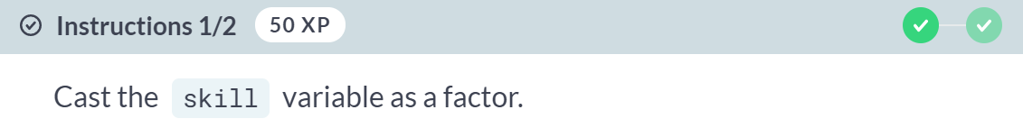

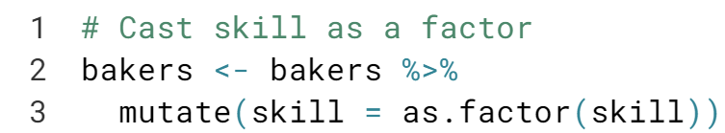

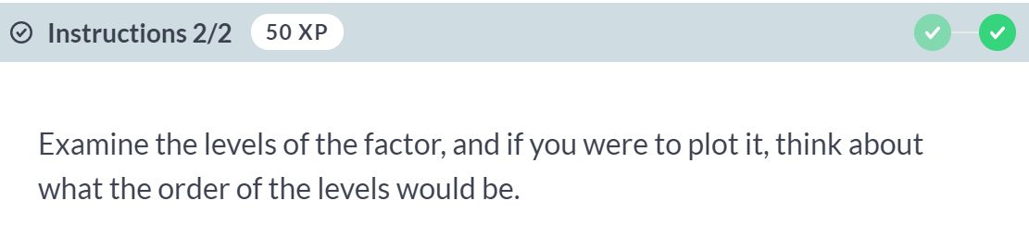  
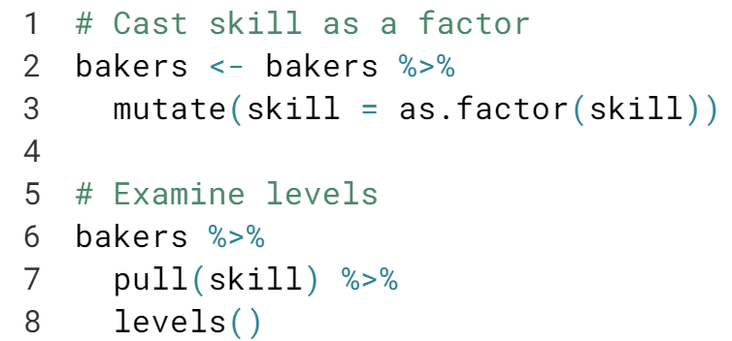  
  
Sometimes factors have a natural order to them - like beginner, intermediate, and advanced- but sometimes they don't. Know your data and know your factors!

# Plot factor counts

In this exercise, you'll use ggplot2 to make a bar chart with one per level of the skill factor we just made, where the height of the bar shows the number of bakers in each skill level.

Notice a big difference between the data here and the data we have used before to make a bar chart- here, you want the height of the bars to be represent the number of rows in the bakers data in each skill level. This is compared to bar charts we made where the height represented values in the data (when you used geom_col()).

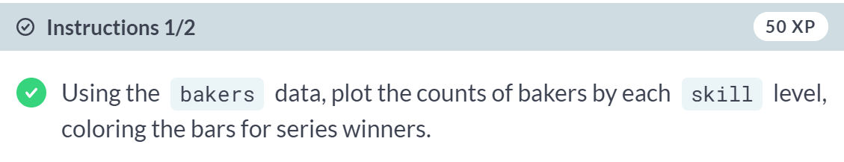

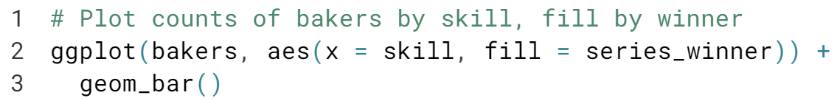  
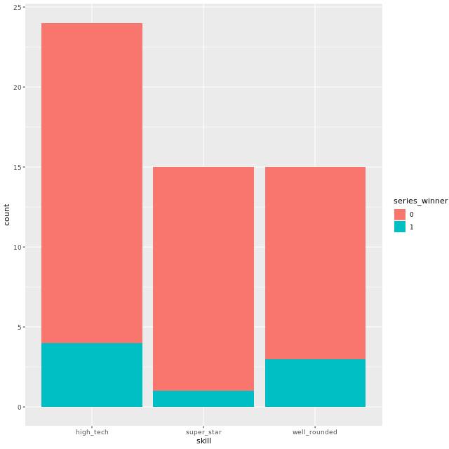



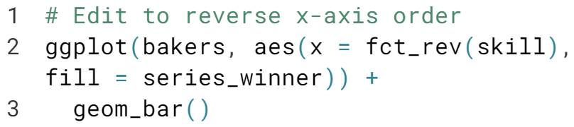

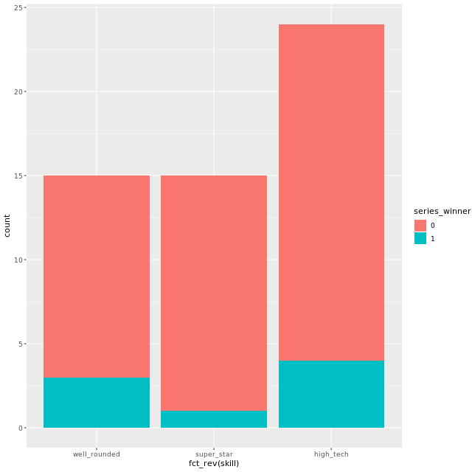  
Great job! Note that when you use function like ***fct_rev()***, ***forcats*** converts the character to a factor for your plot only.

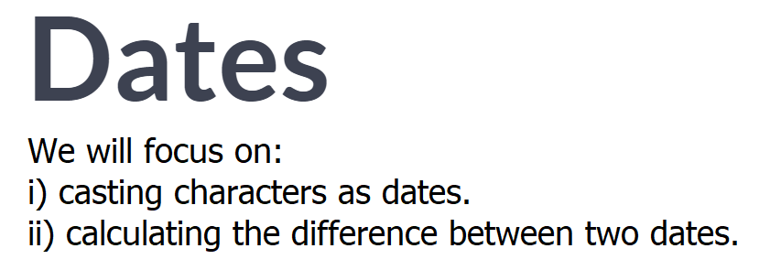



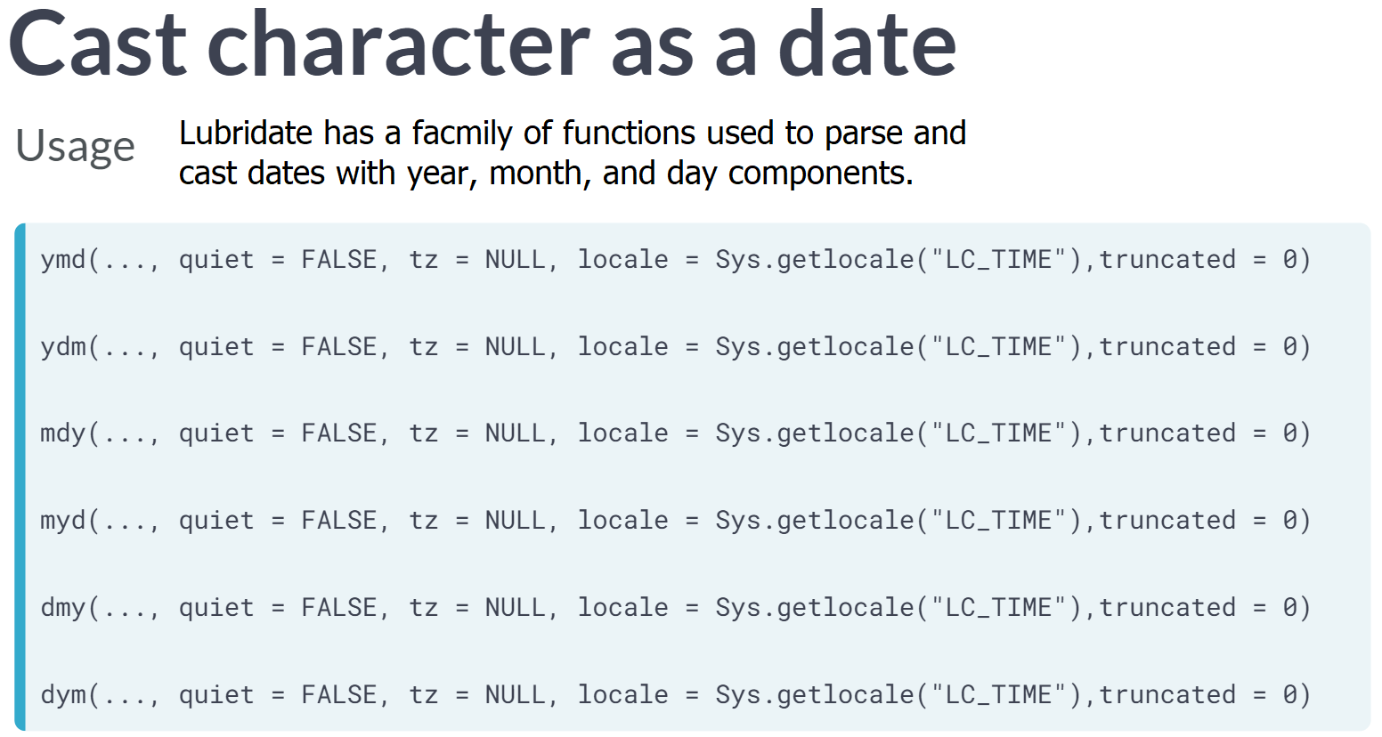

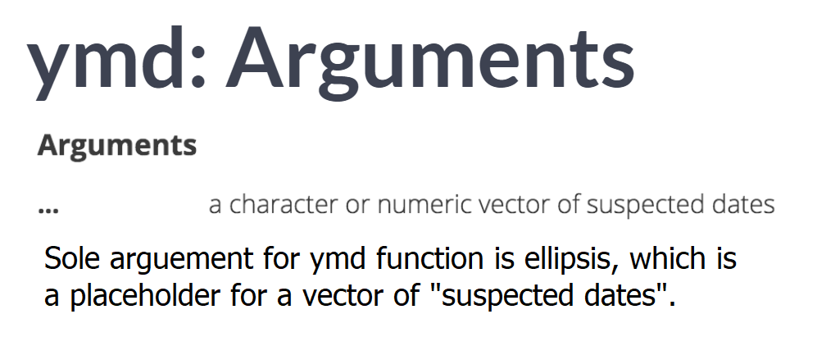

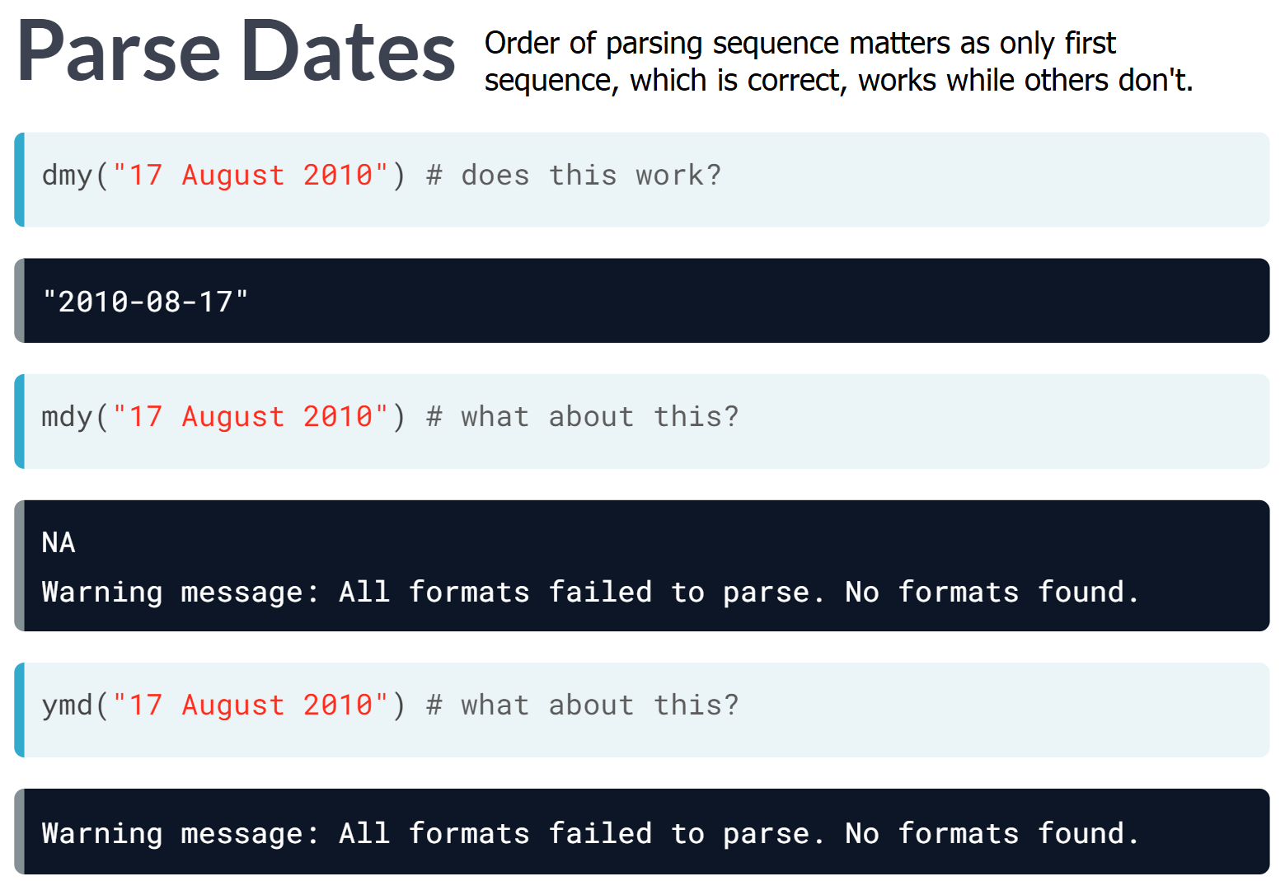

Notice the parsing method is quite different from that of ***readr***; ***Lubridate*** seems to be a more flexible way to cast dates.

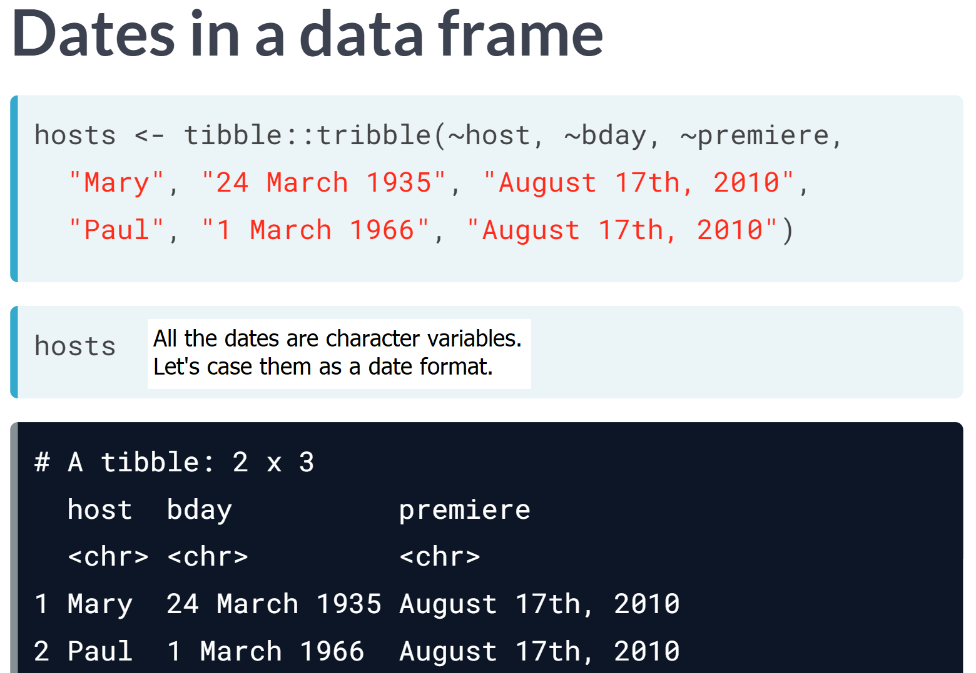

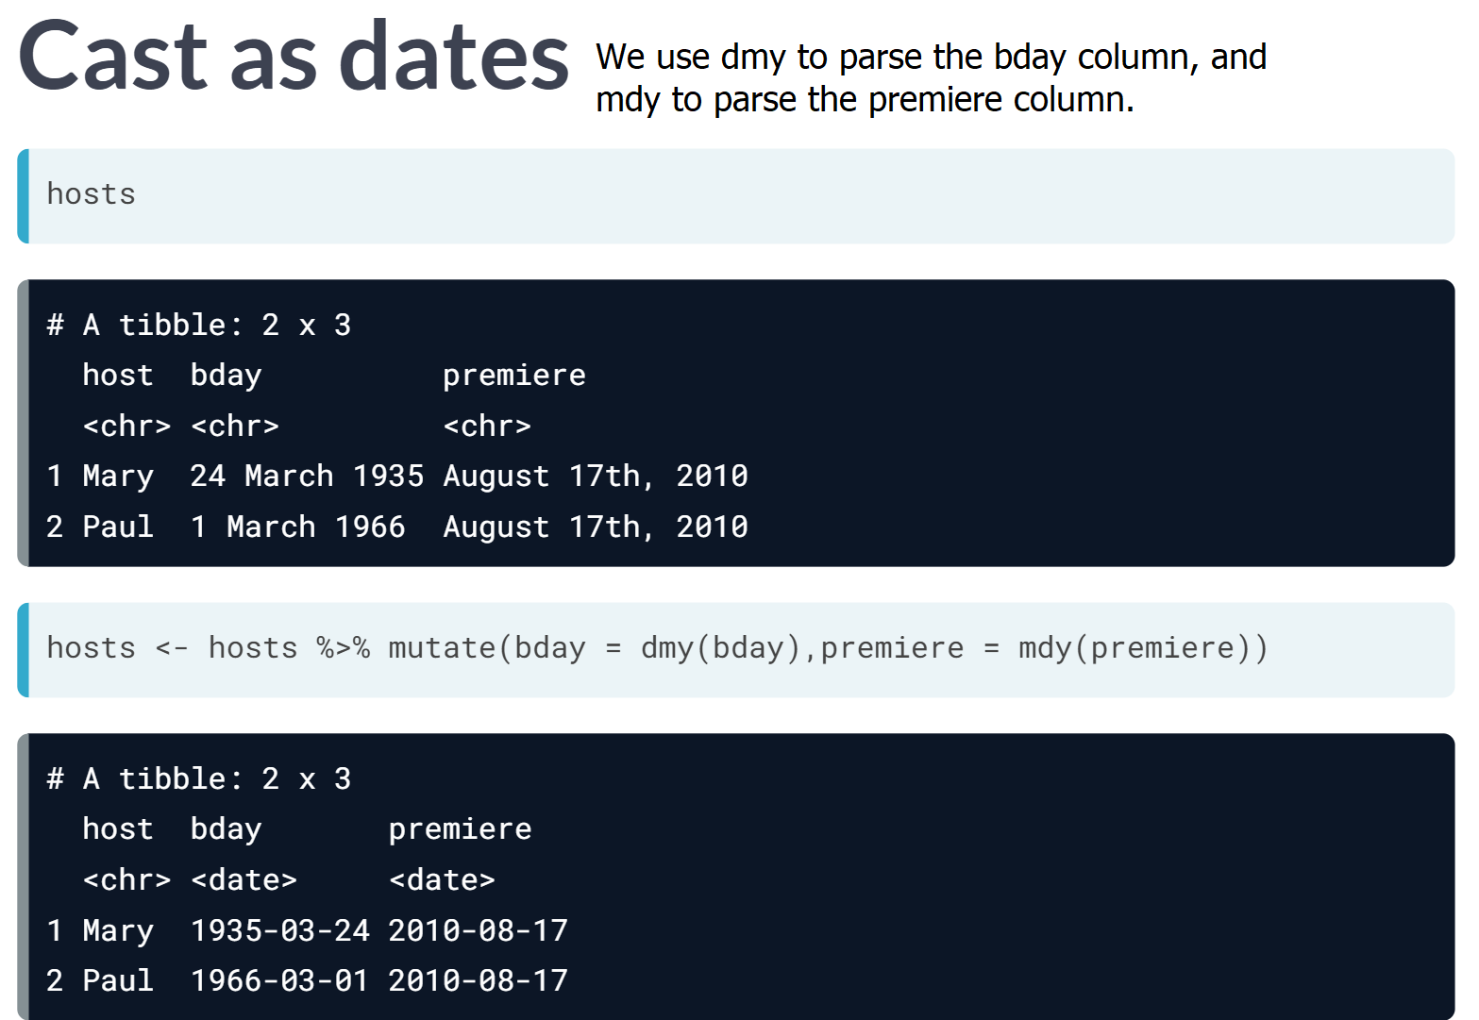

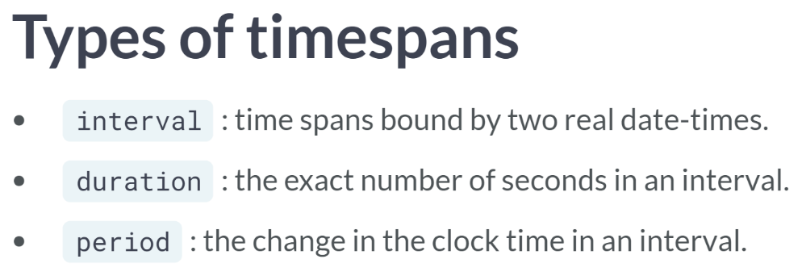

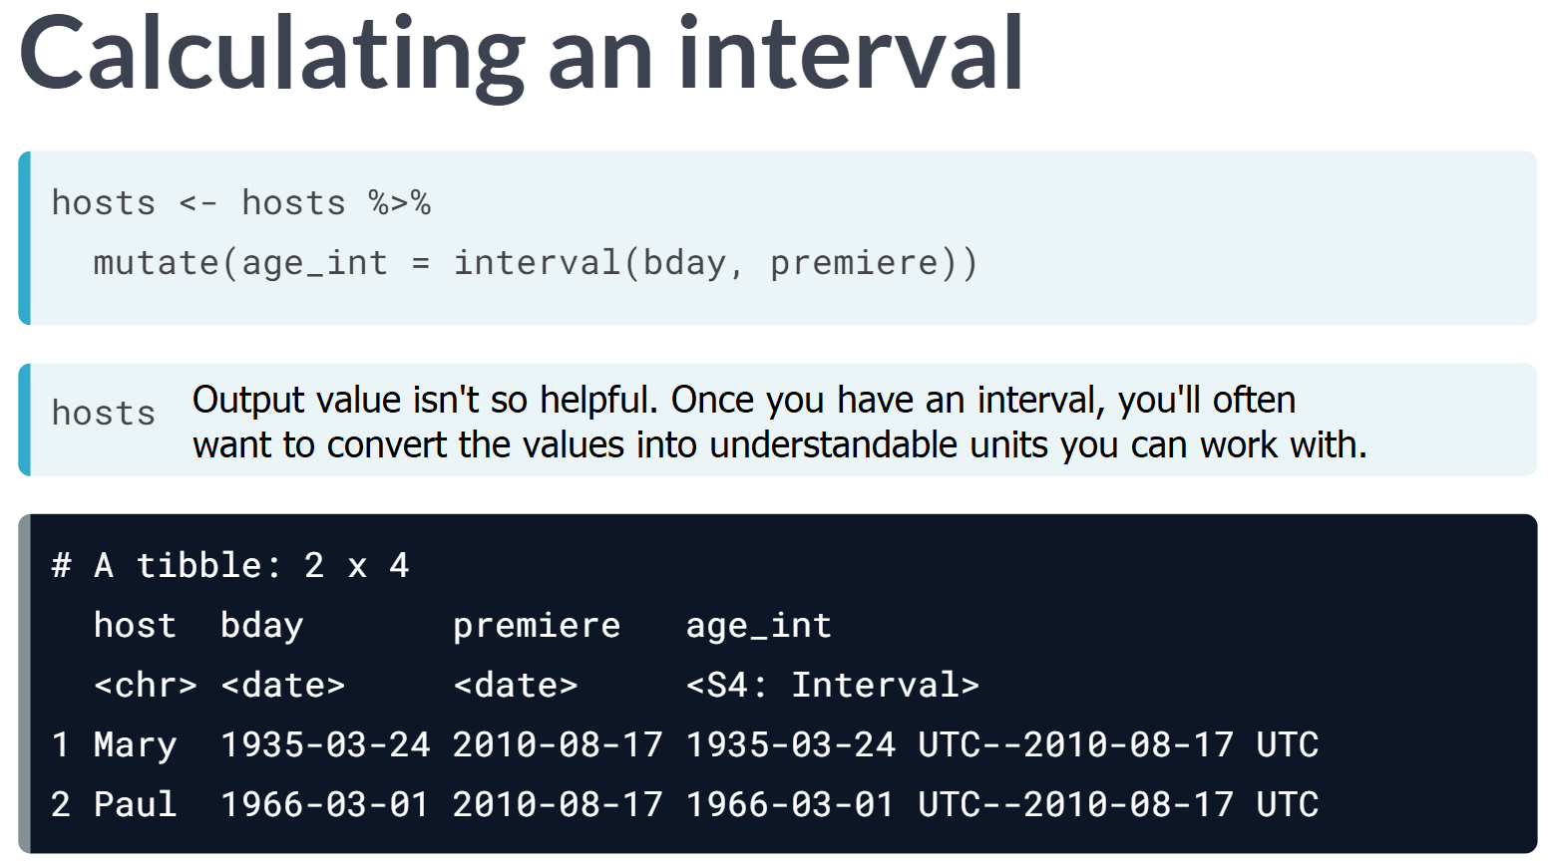  
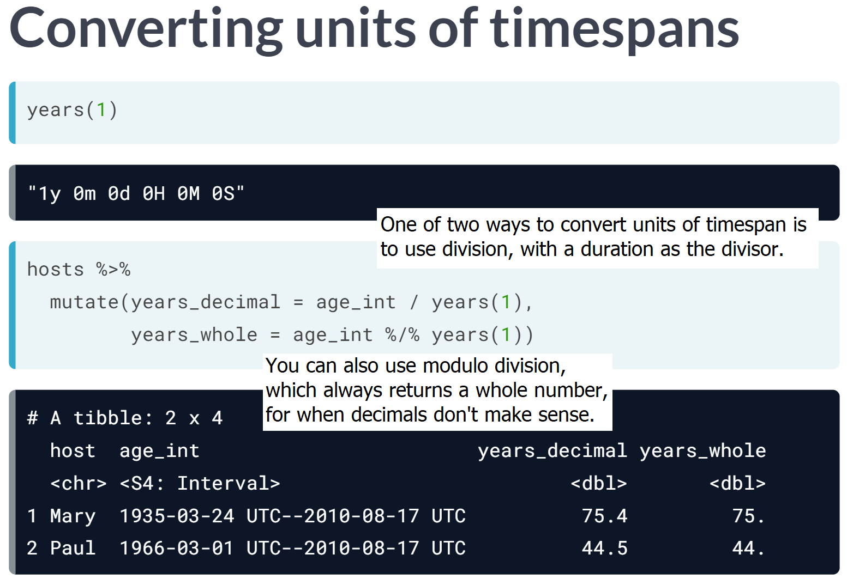

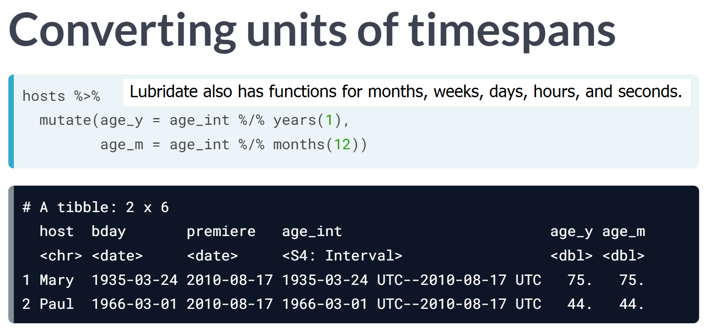

# Cast characters as dates

As we saw in the video, you can use lubridate to parse and cast a date variable within a mutate(). In this exercise, you'll practice doing this with the baker_dates data, and then go even further to extract data from the dates like the labelled month. Remember to use ?month to read about the month() function and its arguments.

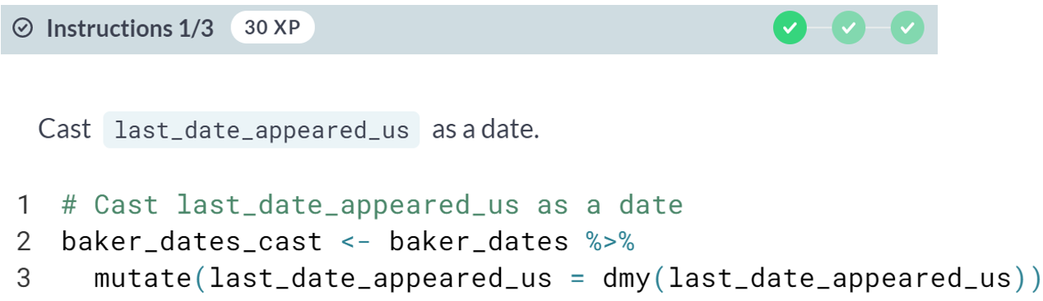  
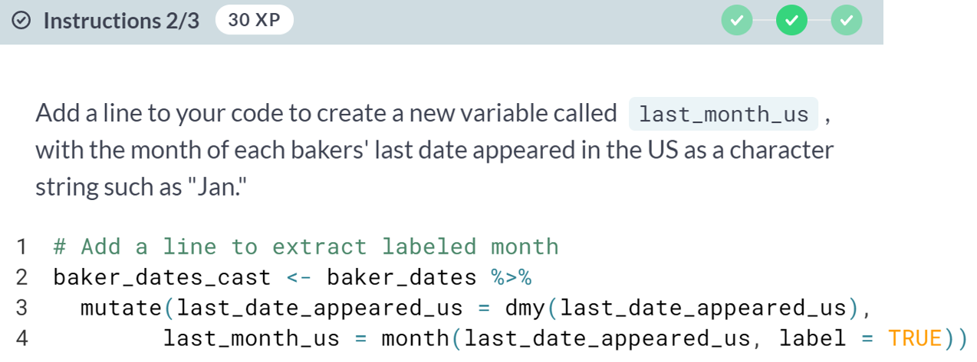

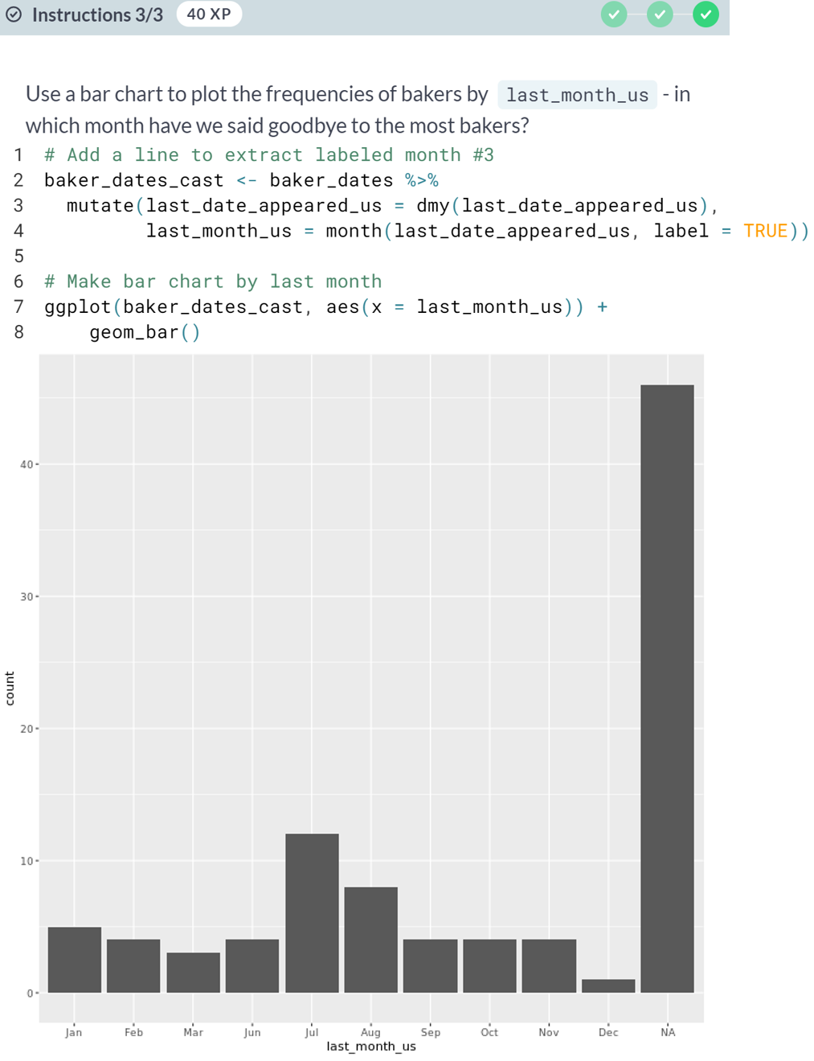  
Success! There are more functions like year for getting out other date components- you can even extract fiscal quarters or semesters!

# Calculate timespans

As we saw in the video, the first step to calculating a timespan in lubridate is to make an interval, then use division to convert the units to what you want (like weeks(x) or months(x)). The x refers to the number of time units to be included in the period. In this exercise, you'll calculate timespans with the baker_time data we just made.

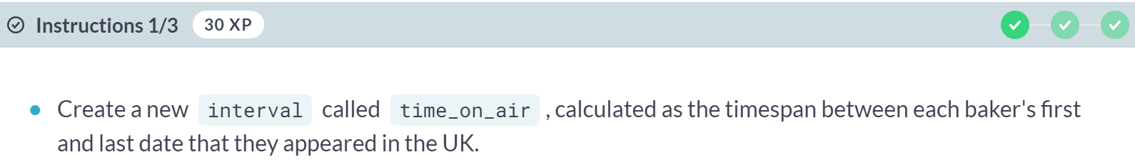  


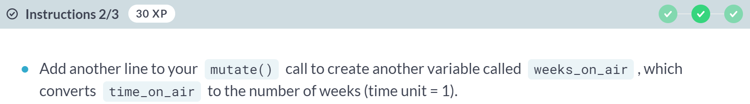

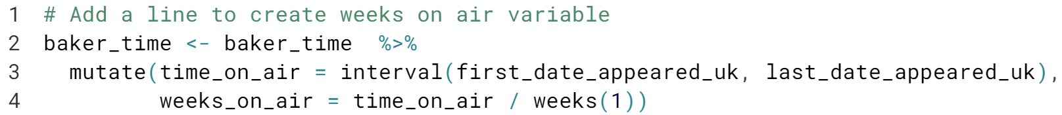

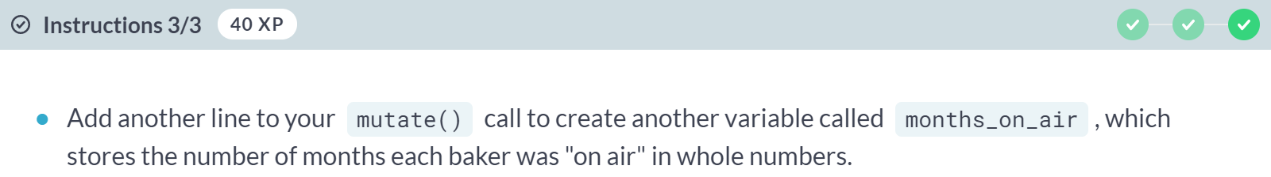

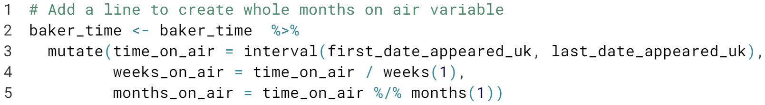

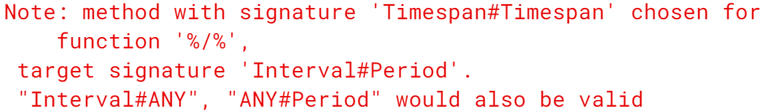  
Here again, ***lubridate*** gives you many options for working with periods from years down to picoseconds. You may also end up needing to work with durations too, which have similar functions that always start with a d from ***dyears*** to ***dpicoseconds***.



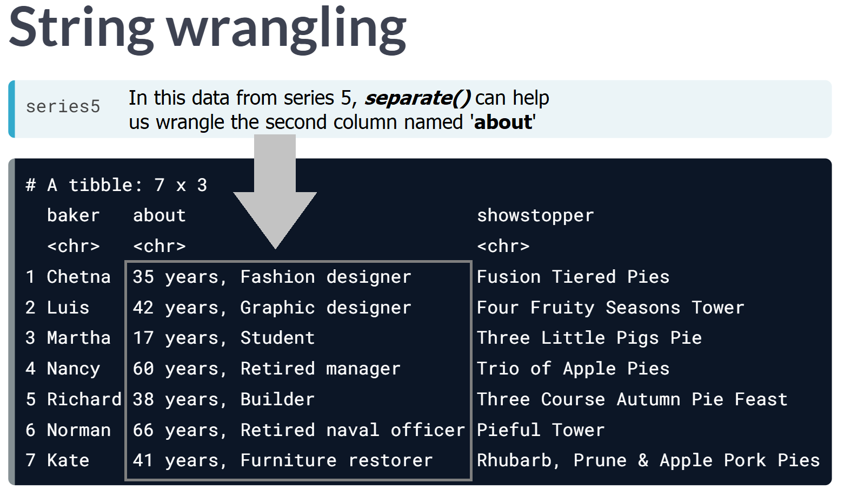  
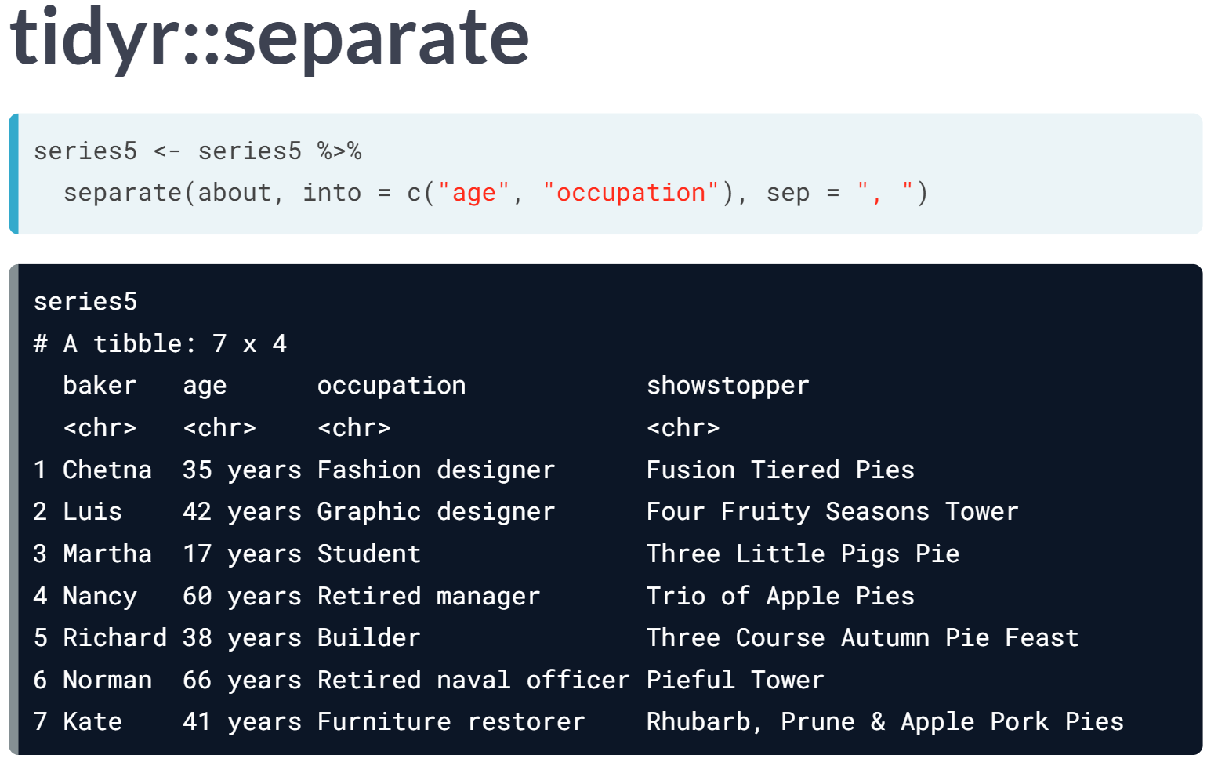

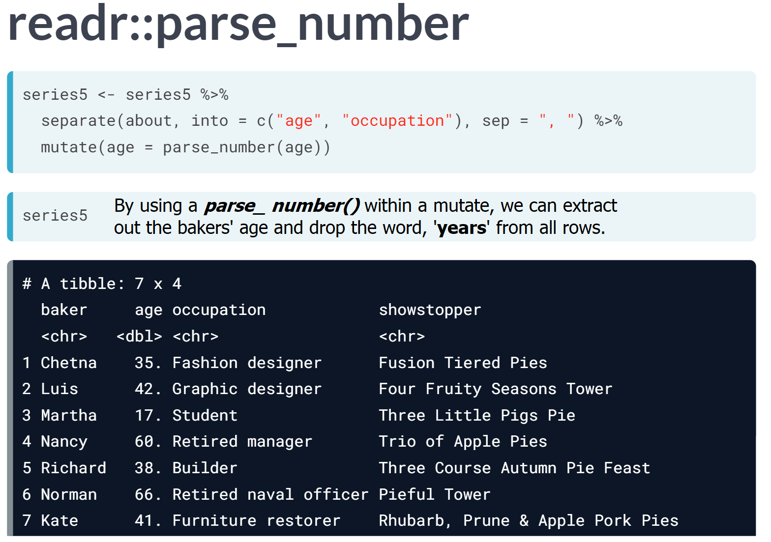  
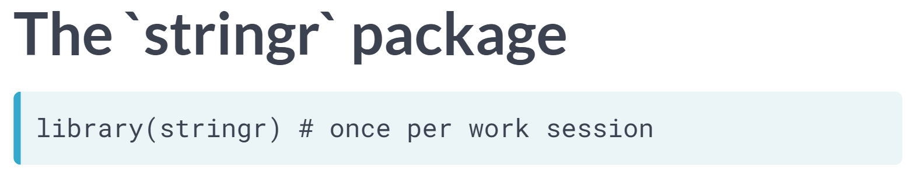  
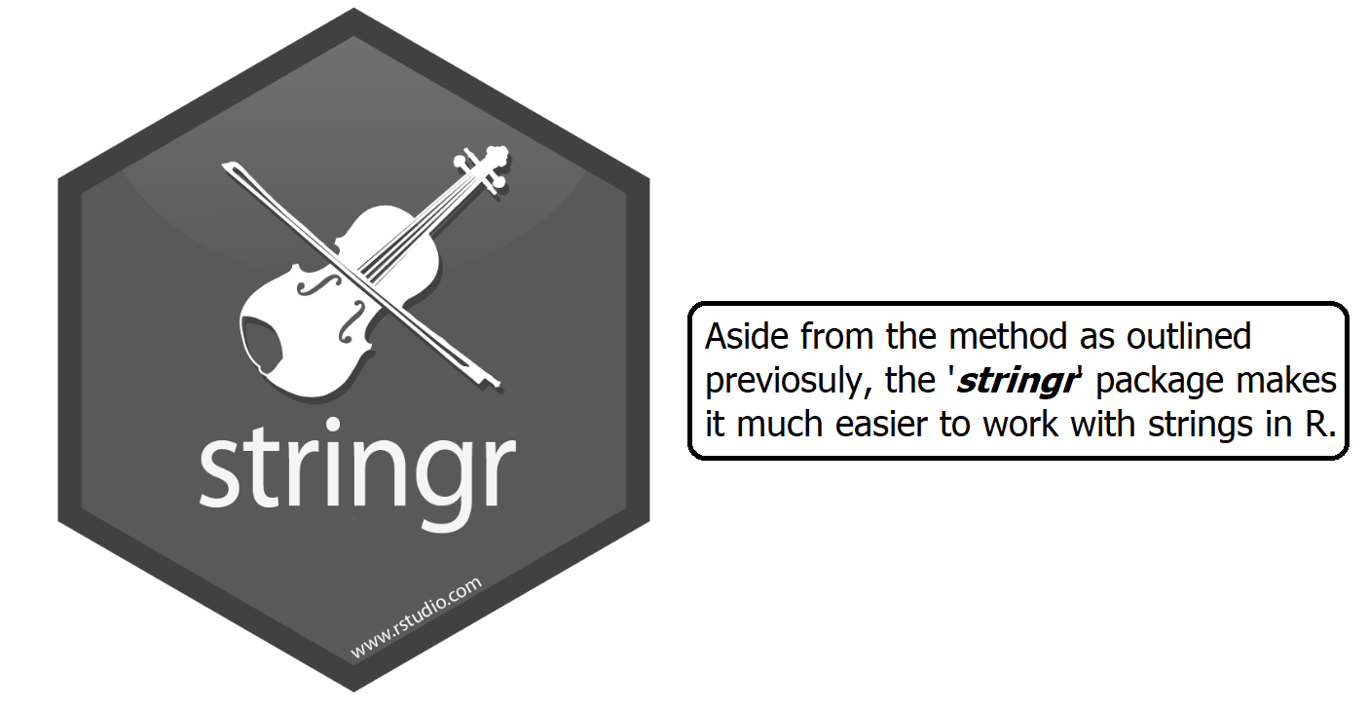

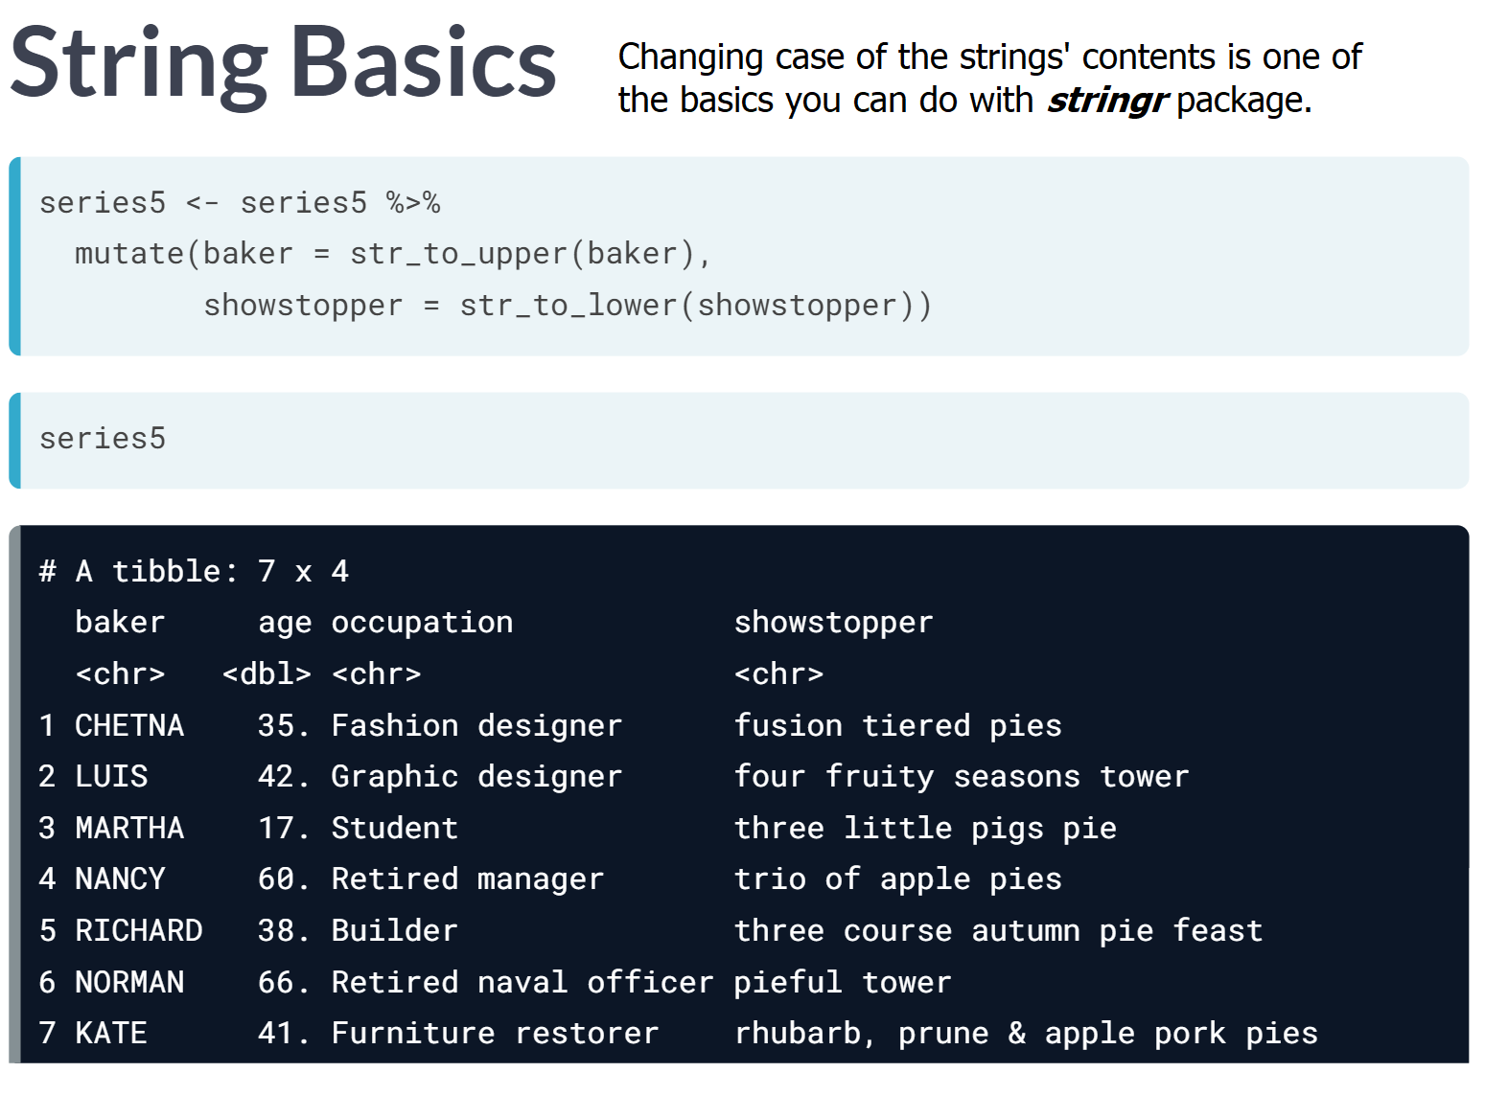  
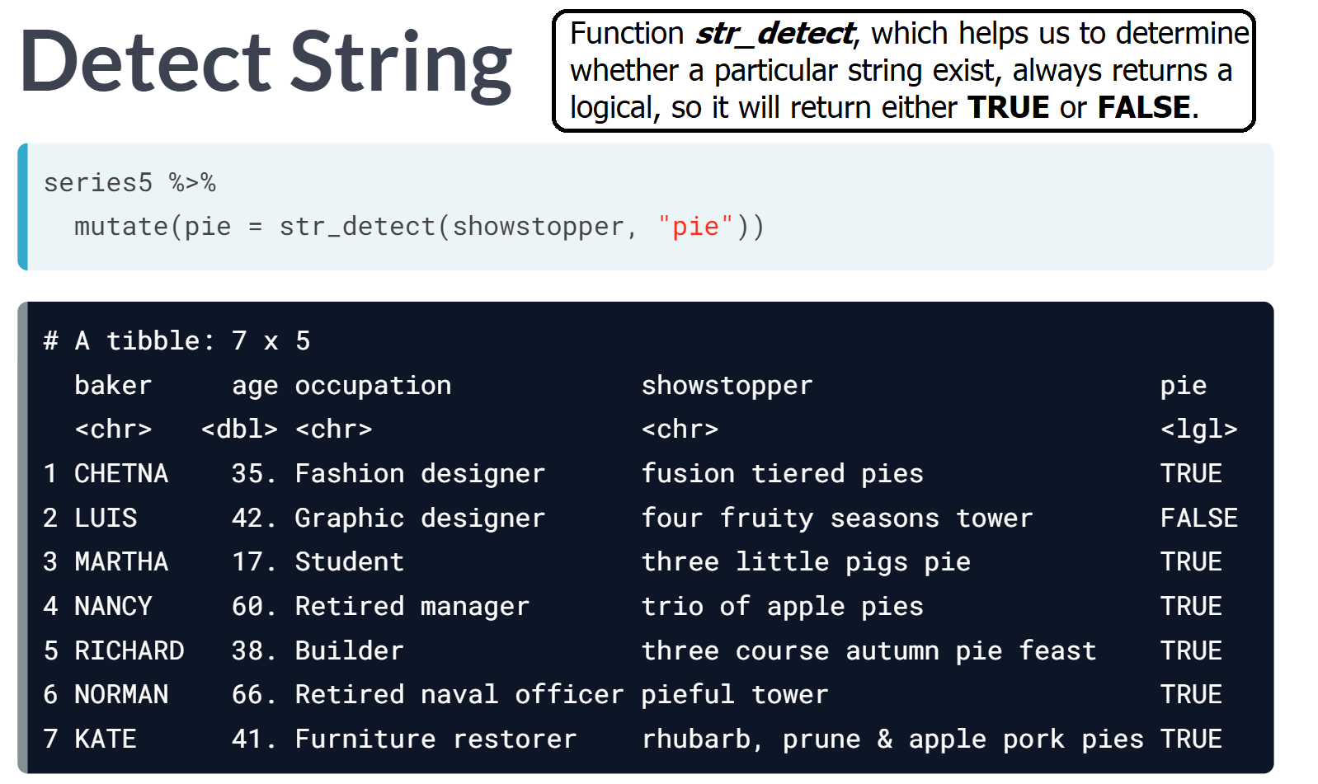

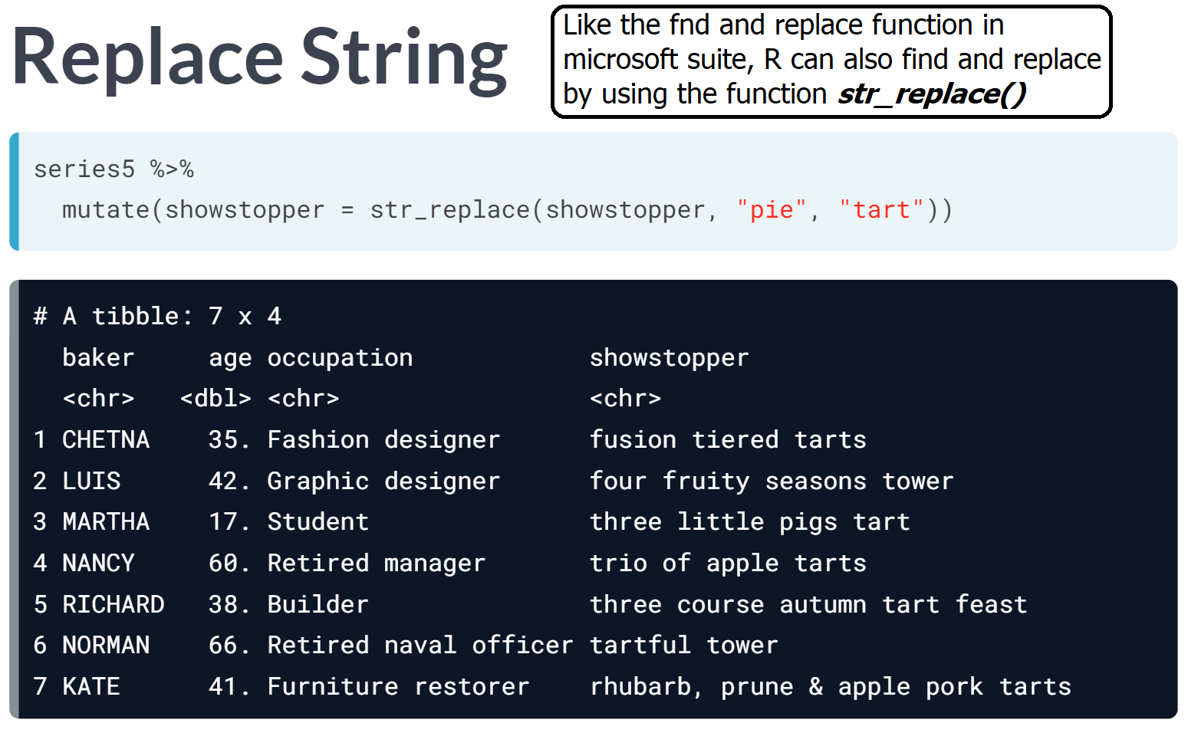  
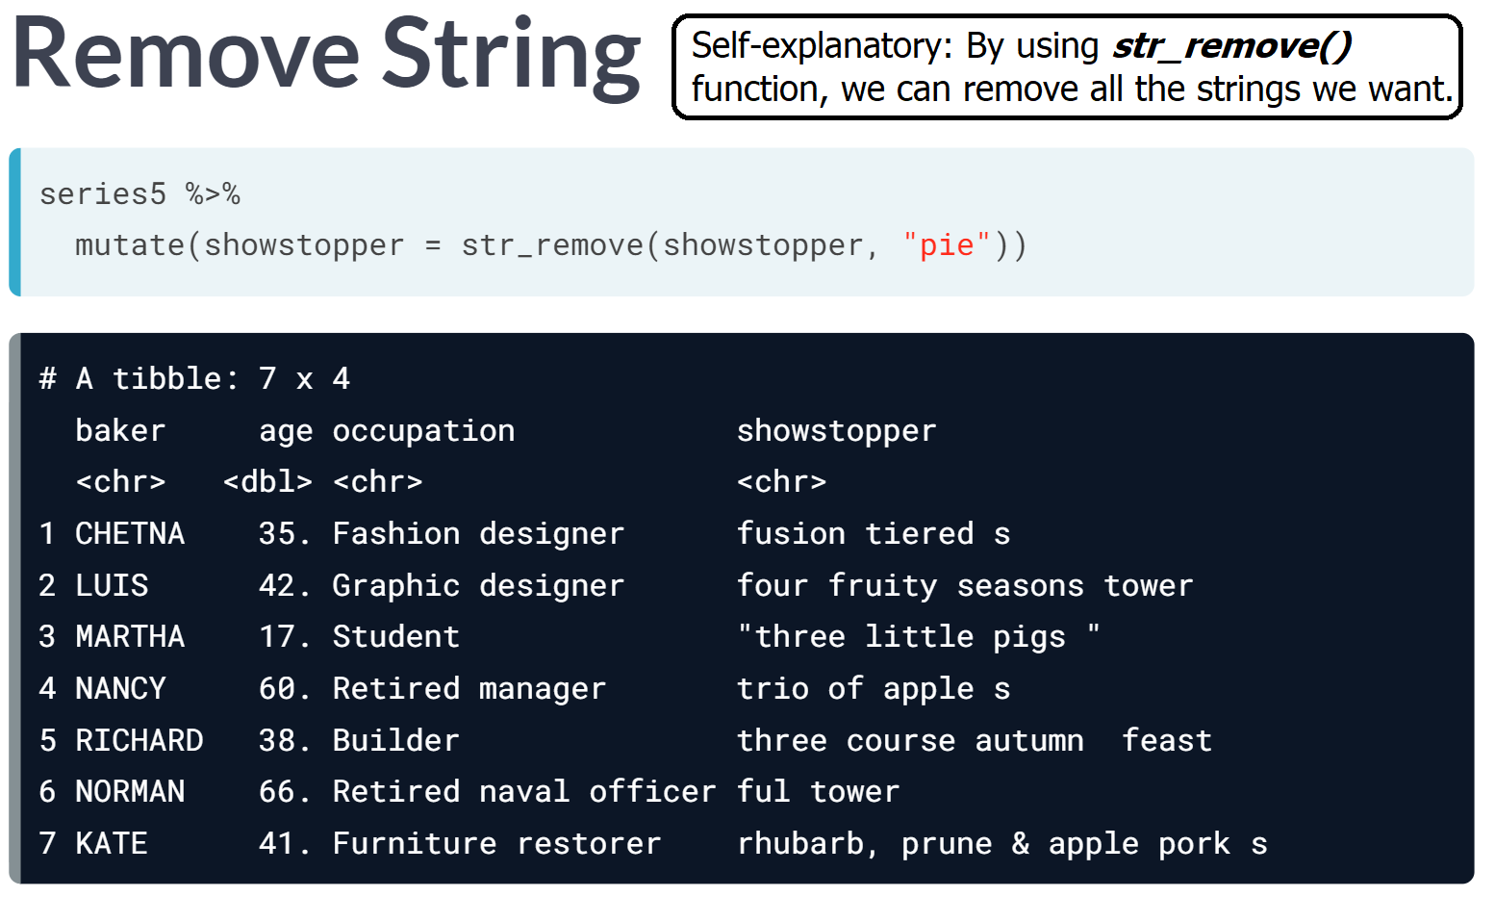

# 

# Wrangle a character variable

In this exercise, we'll wrangle the values in the position_reached variable, which looks like this right now:

bakers %>%

count(position_reached)

# A tibble: 8 x 2

position_reached n

<chr> <int>

1 Runner up 2

2 Runner Up 12

3 Runner-Up 1

4 Third Place 1

5 winner 2

6 Winner 1

7 WINNER 5

8 NA 71

Let's clean these strings up!

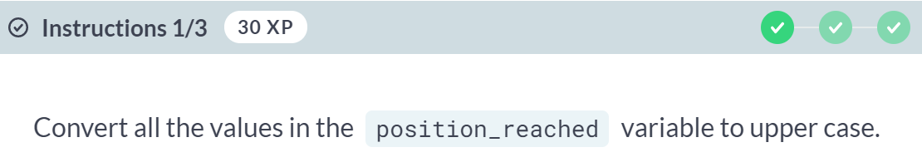  
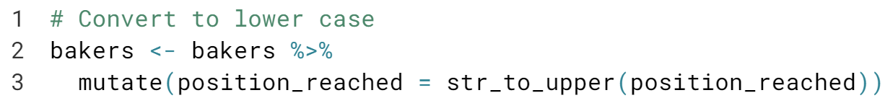

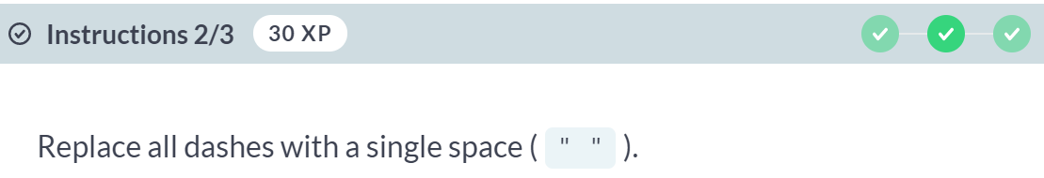  
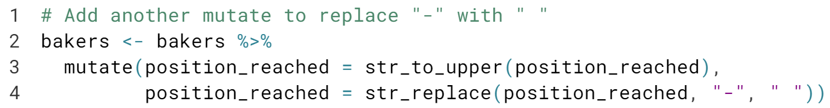

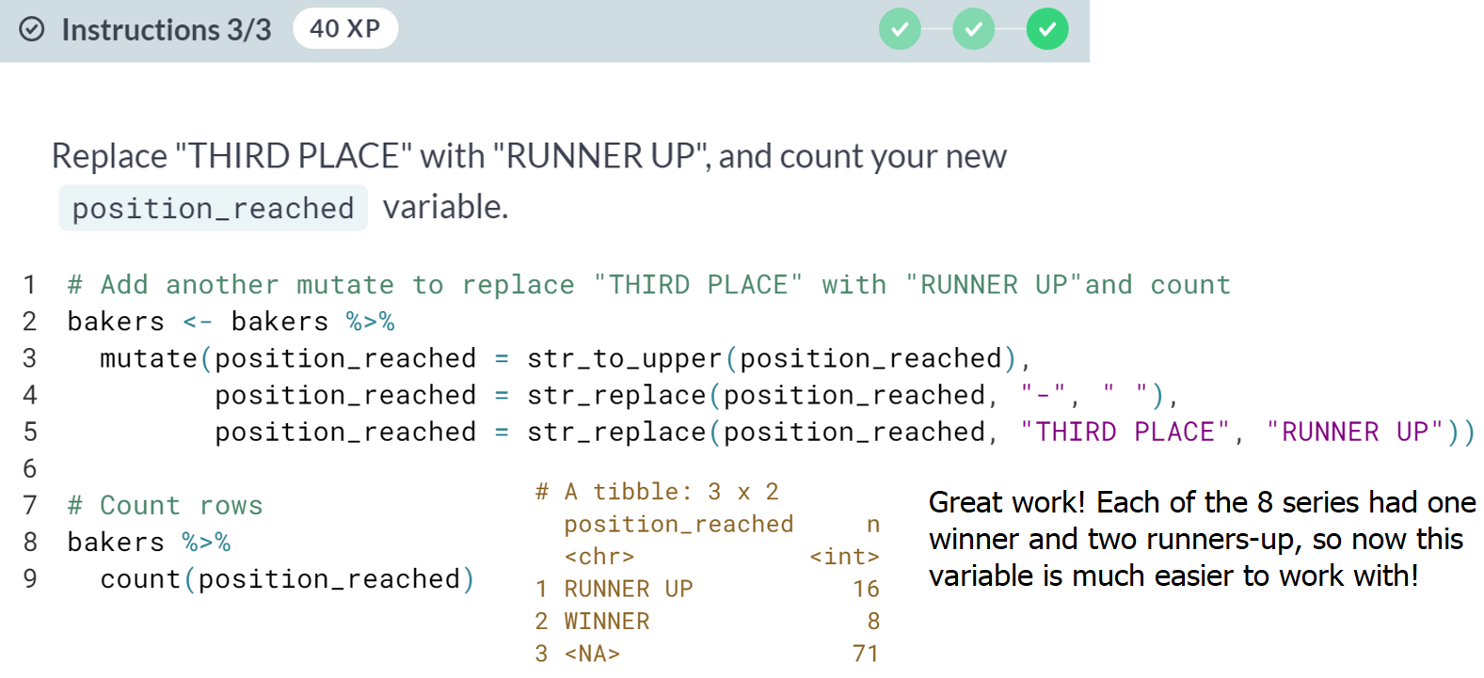

# Detect a string pattern

In this exercise, we'll wrangle each bakers' occupation from the bakers data, which is currently a character string like this:

bakers %>%

select(baker, occupation)

# A tibble: 6 x 2

baker occupation

<chr> <chr>

1 Jason Civil Engineering Student

2 Simon Rugby Coach

3 Enwezor Business consultant

4 Martha Student

5 Lee Pastor

6 Liam Student

We'll create a logical variable (TRUE or FALSE) indicating whether or not each baker is a student.

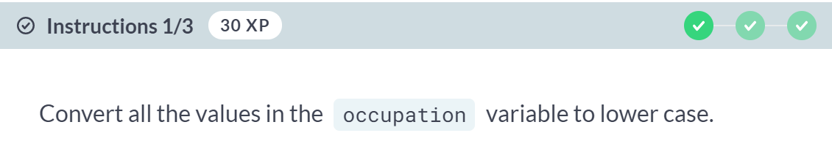

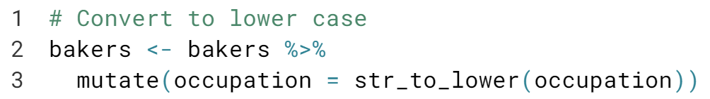  
  
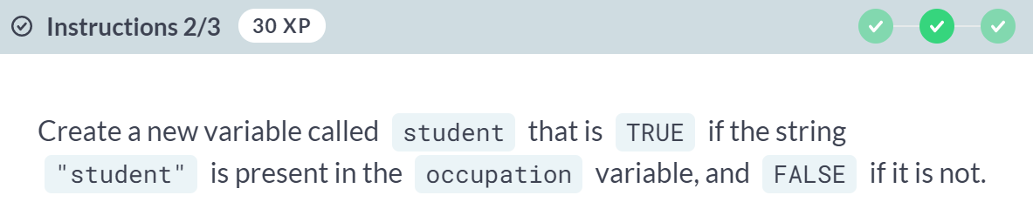

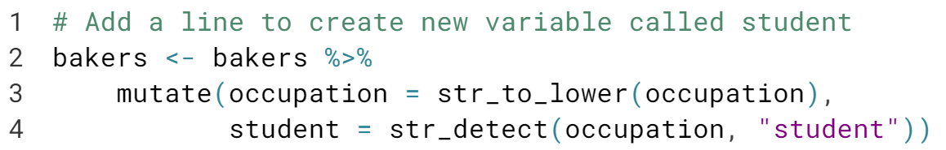



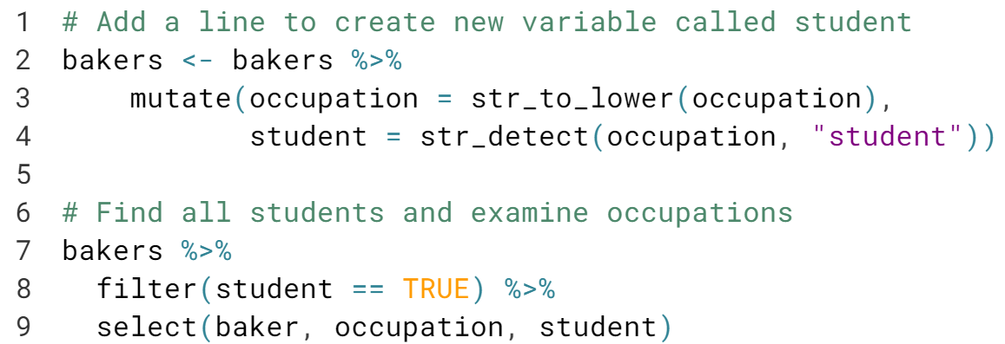

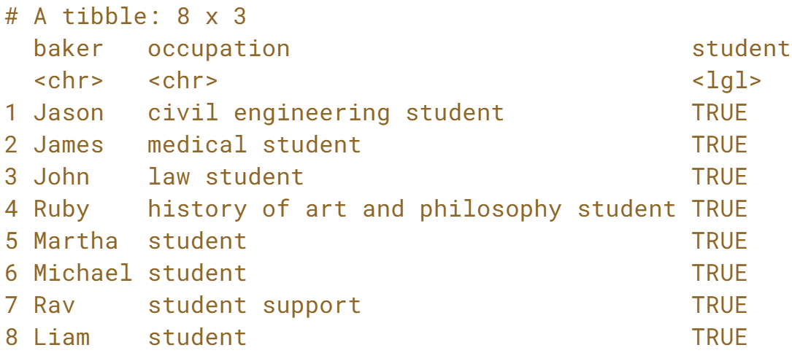  
Rav's occupation was student support, but we classified him as a student. This shows a common problem in working with data- it helps to always check your work!



